# Table Of Contents

Table Of Contents 1

1 General Information 2

1.1 Purpose and Responsibilities 2

1.2 Associated Documents 2

1.3 Equipment 2

2 Preparation 2

2.1 Pull Test Samples 3

2.2 Determine Requirements for Heavy Wires 3

2.3 Installing / Cleaning Fixture Plates 4

2.4 Loading Programs (Delvotec 5650 Only) 6

3 Bonding Wire To Substrate 7

3.1 Pre-Check for Substrate Damage 7

3.2 Bonding Process For Orthodyne Machines 7

3.3 Bonding Process for Delvotec Machine 9

4 Inspection 10

4.1 Wire Bond Zones 10

4.2 Inspecting Bond Area 10

4.3 Inspecting for Wire Defects 12

5 Cutting Substrate Resistors 13

5.1 When to Cut 13

5.2 Cutting Resistor Pattern 13

5.3 Checking With Multi-meter 14

6 Packaging 14

6.1 Packaging Assemblies 14

7 Maintenance 14

7.1 Changing the Bonding Tool 14

# General Information

## Purpose and Responsibilities

### The purpose of this procedure is to provide instructions on how to properly attach heavy copper wires to thin film substrates. This procedure is the responsibility of all the Microelectronic Technicians.

## Associated Documents

### The following documents are associated with this procedure: ISO 9001, Quality Systems Manual, Quality Assurance Manual.

## Equipment

### There are two machines that can be used to attach copper heavy wires to the substrates.

#### The first is the Orthodyne Model 20 Large Wire Bonder (see fig. 1). This is a fully manual machine, and the operator must position the substrate under the bond head for each bond. The wire length is also fixed on this machine.

#### The second is the Delvotec Model 5650 wire bonder (see fig. 2). This is an automatic machine with vision system. There is a program for each substrate and wire set configuration.

### The process is done before die attachment because of the large bonding head and high forces involved in attaching heavy wires.

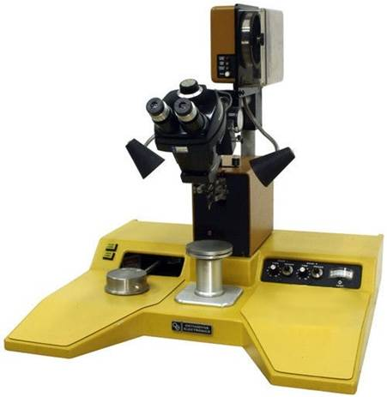 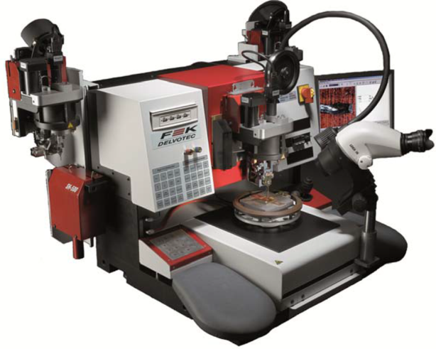*

Figure #1 Figure #2

# Preparation

## Pull Test Samples

### At least once each shift a pull test sample must be run on each machine that is in use that shift. The pull test samples will verify that the machine settings and tool setup are producing good bonds.

### A pull test sample will consist of bonding three wires to a substrate and then performing a destructive pull test using Chattilon Model DFE-II pull test stand. The pull test will be performed with a substrate (PCB #57638-01, or 73245-01 once depleted) designated for this use. The actual substrate design may vary, but will be stored under the referenced number.

### Three wires are to be bonded to the test substrate. Two on one edge, and one on the other. All are to be placed toward the outside corners, leaving one corner available to place into the clamp of the pull tester. When clamping the substrate into the pull tester, do not clamp onto a wirebond that has not been pulled yet.

### All three wires are to be pulled. Set the tester up for a peak hold measurement in grams. Record the maximum force in grams for each wire pulled on TA183. Record the number of the heavy wire bonder that the samples were produced on. If one bond breaks below 385gm, or if two bonds break below 435gm, notify the supervisor or engineer immediately, and do not use the bonder for production until good pulls are achieved. If the break occurs on the wire, out away from the bond area, and is less than 385gm, bond and pull test another sample, as the goal is to test our bonds and not wire defects.

### Pull testing should also be performed anytime the bond tool or clamp plates are changed out, or the power or time settings are adjusted.

## Determine Requirements for Heavy Wires

### Determine the heavy wire requirements by referring to the job router and the assembly drawing. Select the correct amplifier substrate and note where the heavy wires are to be located as per the assembly drawing.

### There are some drawings where there are two assembly pages, one showing a feedback capacitor and one showing a heavy wire mounted to one of the capacitor mounting pads. The operator must check the part number to see if the feedback capacitor is present on the version to be built. The last three or four digits after the last dash defines the capacitor value (ex. 4460-03-308-000). If the value is 000, there is no capacitor present, and the wire would be added.

### There may also be notes on the drawing referring to specific requirements for that assembly. An example would be; “WHEN FEEDBACK CAPACITOR IS PRESENT OMIT LEAD” (see fig. 3). To determine whether or not to attach this wire, look at the full model number. The last three or four digits after the last dash defines the capacitor value (ex. 4460-03-308-000). If the value is 000, there is no capacitor present, and the wire would be added.

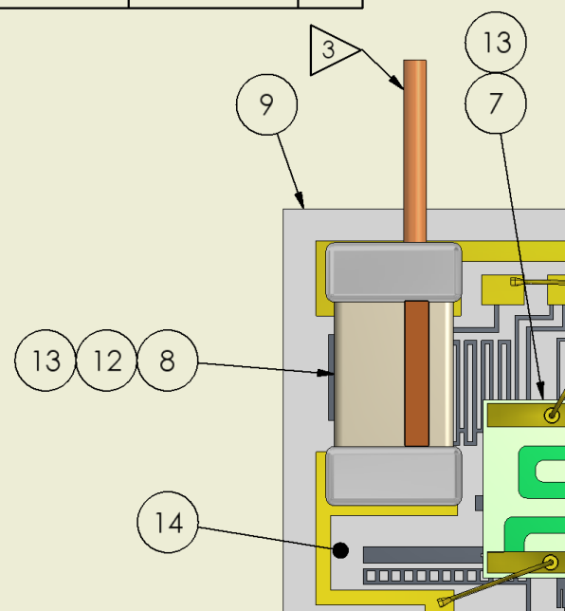

Figure #3

## Installing / Cleaning Fixture Plates

### SAFETY: Use caution when moving, mounting, or un-mounting the workstage on the Orthodyne bonders as it is held using fixed magnets. When the workstage is placed near the turnstile, the magnets will pull the bottom of the workstage to the turnstile surface. Keep your fingers clear of these mating surfaces so they do not get pinched when the magnet pulls the workstage down. Engaging the bottom of the workstage with the edge of the turnstile, tipping it up, and then sliding it across the turnstile will help to avoid pinching hazards. This action as well as moving of the workstage on the turnstile must be performed with care so that the workstage does accidentally strike the bond tool and cause damage. Also, while sliding the workstage across the turnstile watch the position of the guide plate mounting screws as these may also strike the bond tool causing damage (see fig. 4).

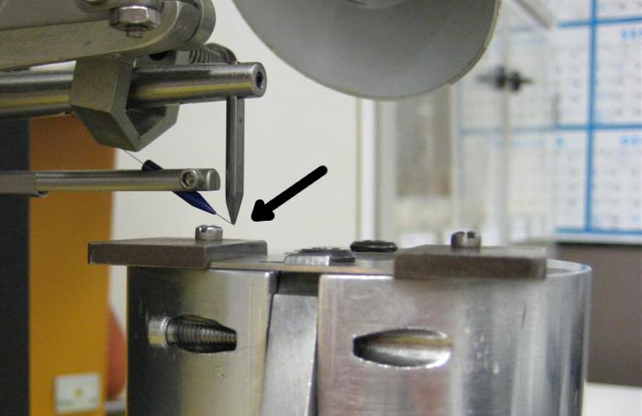

Figure #4

### Cleaning: Whenever the alignment of the plate(s) is adjusted, it is important to clean out any debris that may be accumulating. Cleaning under the plates shall be performed otherwise on an as needed basis. Reasons for cleaning under the plates should include but may not be limited to the observation of debris in working area between clamps, cracking substrates, and/or substrates not holding securely within the clamps. If any of these conditions persist repeat the process of cleaning and aligning.

### All substrates shall be processed using the same thickness clamping plates (49200-01 & 49201-01)( see fig. 5) unless otherwise specified.

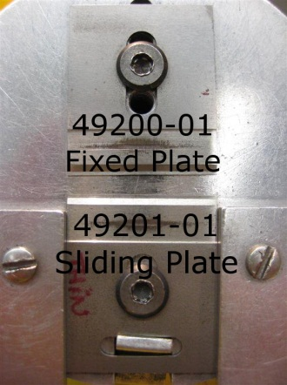

Figure #5

### On the Orthodyne machines, the plates on the workholder need to be adjusted for proper loading. To place a load on the substrate, using one hand, depress the clamping fixture thumb lever while guiding back the fixed plate at the same time so that the fixed clamp and substrates track the position of the moving clamp (see fig. 6). Once the thumb lever has been pressed down to approximately ¼ - ½ of its full travel, assure that all surfaces are in contact and tighten the screw of the fixed plate. This process sets the clamping range to match the length of the substrate. Setting the position of the thumb lever to ¼ - ½ of its full travel will provide an adequate holding force to the substrate as well as accommodating any length variation of the substrate due to tolerances.

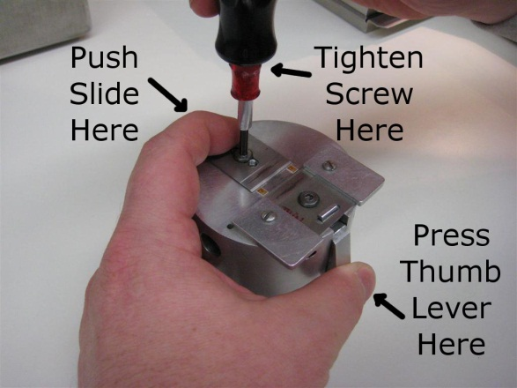

Figure #6

### At this point, the screw of the sliding plate should already be properly adjusted.

## Loading Programs (Delvotec 5650 Only)

### The Delvotec model 5650 is a fully automatic machine. It requires that the proper program be loaded prior to bonding wires to substrates. Once the program is loaded, the Delvotec machine will be able to automatically locate the substrate(s) in the fixture and apply the wires to the correct locations.

#### On the Delvotec computer, click [File] [Load…] in the upper left corner. This will open the dialog box to load a new program. The program files are named after the base PCB item number. This will be the first group of numbers in the part umber before a dash. (In the case of the old 345 series, it will include the “345-“ and then the next group of numbers.

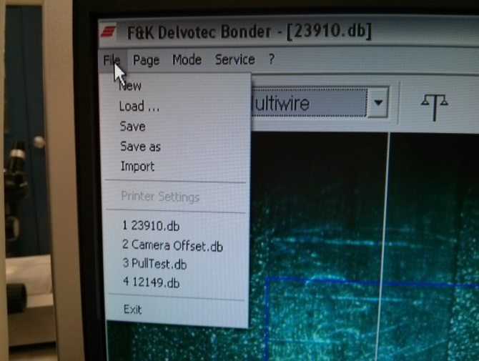

Figure #7

#### If it does not come up by default, navigate to the following directory to choose the program: C:\Program Files\Delvotec\Bonder\5650. If the required program is not in this directory, stop and notify your supervisor. This is the only directory that is maintained as the official source for programs, do not use programs from other directories. After selecting the program and clicking the [Open] button, select [Yes] or [OK] to any additional windows that open.

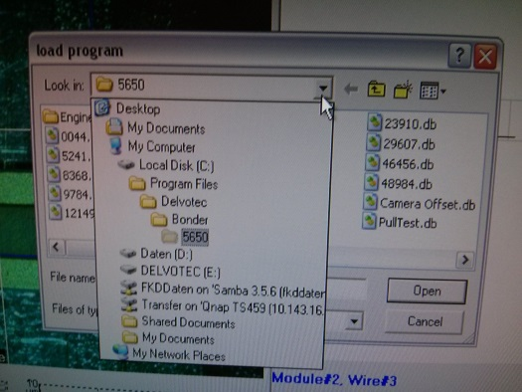

Figure #8

# Bonding Wire To Substrate

## Pre-Check for Substrate Damage

### Before applying any heavy wires, check for any cracks in substrate, passivation problems, or other process issues. If you see anything that might cause the finished amplifier to fail, scrap the substrate now before any additional labor or material costs are incurred. Make sure that the surface of the fixture is clean, and free of any ceramic chips or pieces of copper. Throughout the bonding process, if any debris is noticed, it should be removed from the work area. Also, if at any point in the process, the sliding plate begins the lift from the workstage, the hold down screw will need to be readjusted. As stated before, this screw should be tightened just enough to allow the plates to move without lifting. Making sure that the slide moves freely will ensure that the force from the clamp is being passed onto the substrate edge.

## Bonding Process For Orthodyne Machines

### If it is not already in place, place the workstage on the bonder. Place it so that the center of the working area of the clamping plates is aligned below the bond tool. Place the substrate to be bonded into the approximate center of the clamp area while holding the clamps open with the thumb lever and release the lever slowly. Letting the thumb lever snap back may damage the substrate.

### Moving the puck (see fig. 9) controls the position of the workstage under the bond tools. The single actuator button (center button if 3 buttons are present) cycles the bonder through each of its operations.

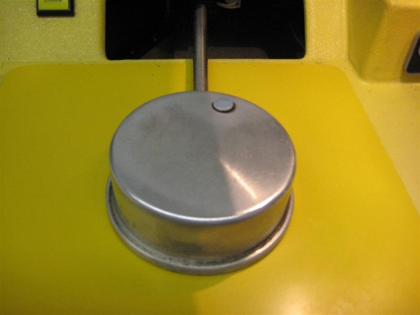 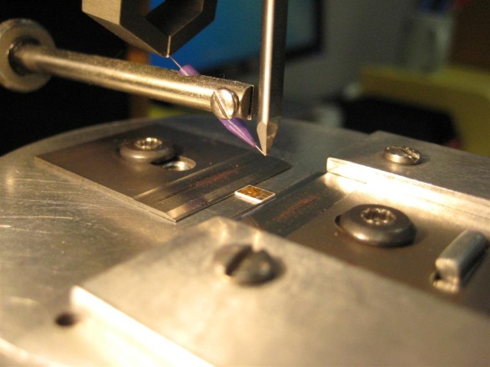

Figure #9 Figure #10

### Based on wire placement requirements from Step 2, while looking through the microscope, position the workstage so that the bond tool is positioned over the intended first bond location (see fig. 10). Once aligned, press the actuator button.

### The bond tool will then move into a search height position which will allow you to fine tune your bond position. At this point, the copper wire should be under the tool in the right hand groove. This groove is the portion of the tool used to make the first bond (see fig. 11). Once aligned, press the actuator button.

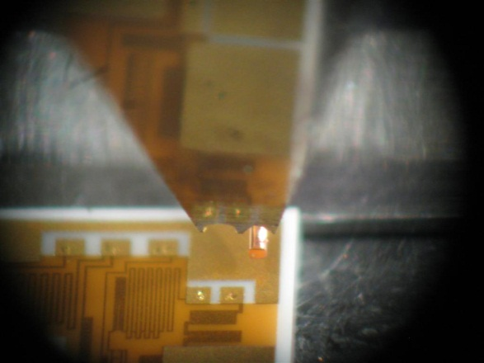 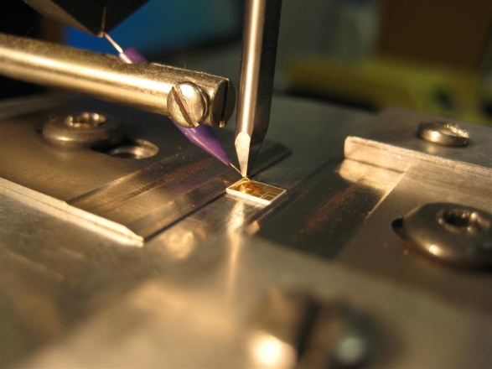

Note wire under right side of bond tool

Figure #11 Figure #12

### The bond tools will now bring the wire in contact with the substrate and make the first bond (see fig. 12). Once the bond is made, the bonder will lift the bond tool and draw out the copper wire to a preset length and wait for input from the operator (see fig. 13). The bond tool is now at a 2nd search height waiting for its position to be fine tuned if necessary (see fig. 14).

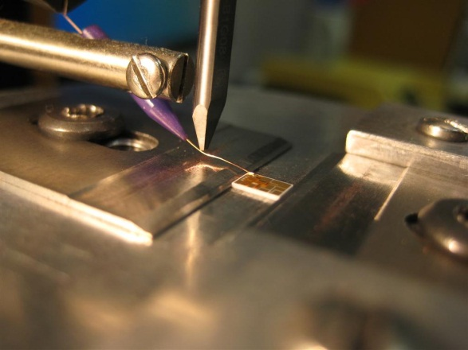 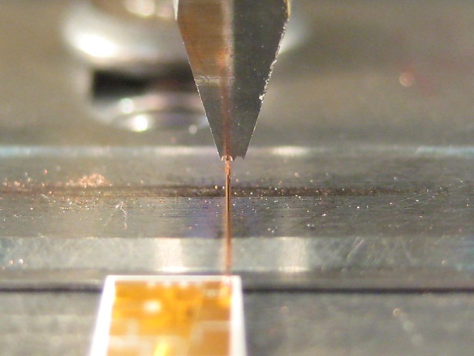

Note wire under left side of bond tool for cut-off

Figure #13 Figure #14

### Unlike the groove of the right hand side of the tool which is just a wedge style groove, the left side has a blade built in to cut the wire. To do this, the copper wire should be centered under the tool in the left hand groove. If the wire is not centered, move the puck from side to side to adjust for this difference. Press the actuator button once the wire is centered. This will cut the wire and prepare the bonder to make another bond.

### When bonding a wire that originates near the edge of a substrate, the preset wire length will be sufficient. When bonding to a gold pad from the middle of a substrate, the same process will be followed but when the fine tuning of second bond operation takes place, draw back the puck so that the length of this wire from the substrate matches the length of the preset wires.

### Before removing the completed substrate, an inspection of all wires placed on the substrate will be performed. See the inspection section below.

## Bonding Process for Delvotec Machine

### If it is not already in place, place the workstage on the bonder. The workstage attaches with two socket head screws on the sides. The screws will align the workstage, so no other adjustment is necessary. See fig. #15 for an example of a workstage.

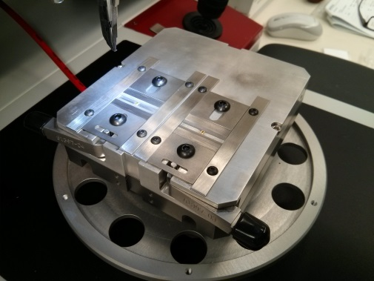

Figure #15

### Place substrates into the clamps until all positions are full. Place the substrates into the approximate centers of the clamp areas. If using a fixture with manual clamps, make sure to release the lever slowly. Letting the thumb lever snap back may damage the substrate. If using a pneumatic clamp system, flip the appropriate switch to engage the clamp. The system should be set to control the closure speed. If the clamps seem to be closing too fast, and substrate damage is possible, stop and notify your supervisor.

### To begin the bonding, make sure the Multiwire mode is selected in the pull down menu. Press the [3] (Adjust) key to start bonding (See figs. #16a and #16b). The machine will then find and bond each substrate in turn. If there are any problems, and the bonding process does not finish all substrates, the adjustments must be cleared to insure that the next group is bonded correctly. In this case, from the menus on the computer select [Page] [Clear Adjustments].

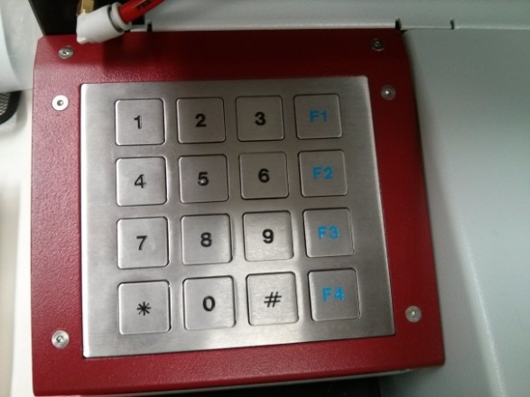 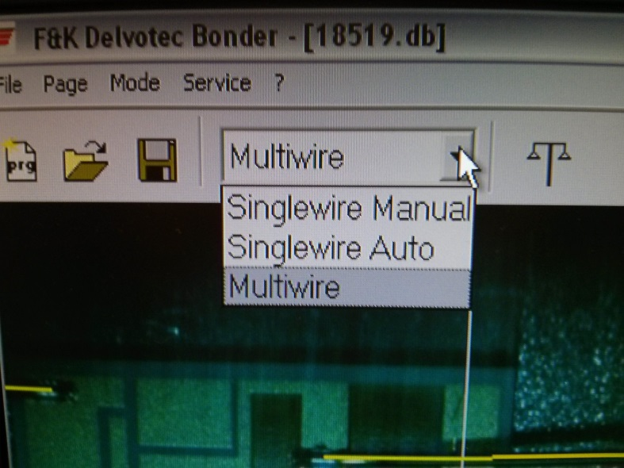

Adjust and Bond

Joystick Toggle

Figure #16a Figure #16b

### If the workstage needs to be moved to place or remove a substrate, or to inspect with the microscope, press the [*] key to toggle into joystick mode. The joystick can then be used to move the workstage around.

# Inspection

## Wire Bond Zones

### When inspecting the wire and substrate for damage, there are 4 main areas along the length of wire at the bond site to evaluate (see fig. 17). Area “A” is a short section of the wire that is not aggressively deformed during the bond, but is more brittle because of the effects of the bond. Area “B” is the actual bond, where the wire is deformed and bonded to the substrate. Area “C” is the tail, which is the part of the wire which was protruding from under the bond tool during the bonding process. Area “D” is the material left from the cutting process under the bond tool.

Unacceptable: The bond is not contained within the perimeter of the pad.

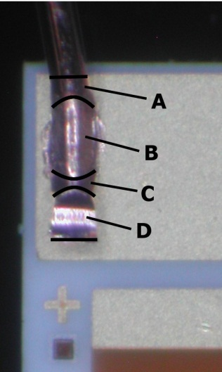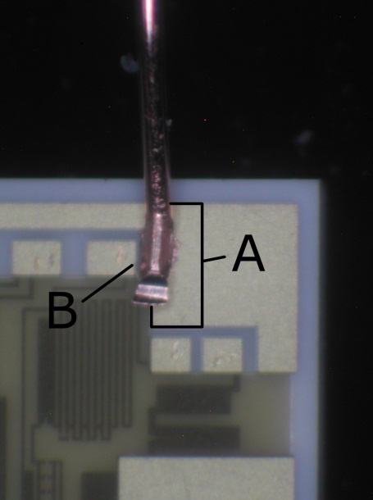

Figure #17 Figure #18

## Inspecting Bond Area

### The bond location must be completely over the gold surface. The affected area (A, B, C, & D in fig. 17) must be far enough back from the edge and end of the substrate so that all of these areas are placed within the perimeter of the gold surface on the substrate. Note that in Figure 18 these areas are 50% over the edge gold pad of the substrate. Outline “A” defines the acceptable target area which makes this bond unacceptable.

### Figure 19 shows two wire bonds. Bond A is far enough back so that the affected area does not exceed the gold pad. Bond A is an acceptable bond. Bond B is too close to the edge of the substrate and the affected area exceeds the gold pad. Bond B is unacceptable.

### The tail (“C” in Figure 17) must be short enough that it does not cause the wire to hang over other gold areas, which could cause an electrical short. It must also not interfere with the placement of other components. If the tail of bond A in Figure 19 were any longer, it may hang over the adjacent gold pad. If this were the case, it would be considered unacceptable. See Figure 20 for an example. If this happens, stop bonding and notify Engineering or a supervisor. While the tail must not be too long, it must be long enough to ensure that the cut area (“D” in Figure 17) does not become part of the bond. The minimum acceptable tail length must have a visible area of non-deformed wire between the bond area and the cut area.

### When the bonder is set up correctly, the bond area (“B” in Figure 17) will be just slightly wider than the wire diameter. The bond tool should never come down far enough to put marks on the substrate gold areas. When bonding correctly, there will be a narrow area on the top of the wire that is not deformed by the bond tool (see fig. 21).

Acceptable: Bond has narrow ridge of material that is not deformed.

Acceptable: Tail extends past bond pad, but does not touch other pads or components.

Unacceptable: Tail is too long, causing short circuit between adjacent pads.

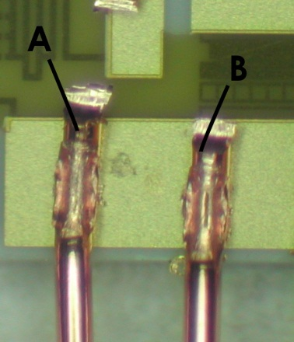 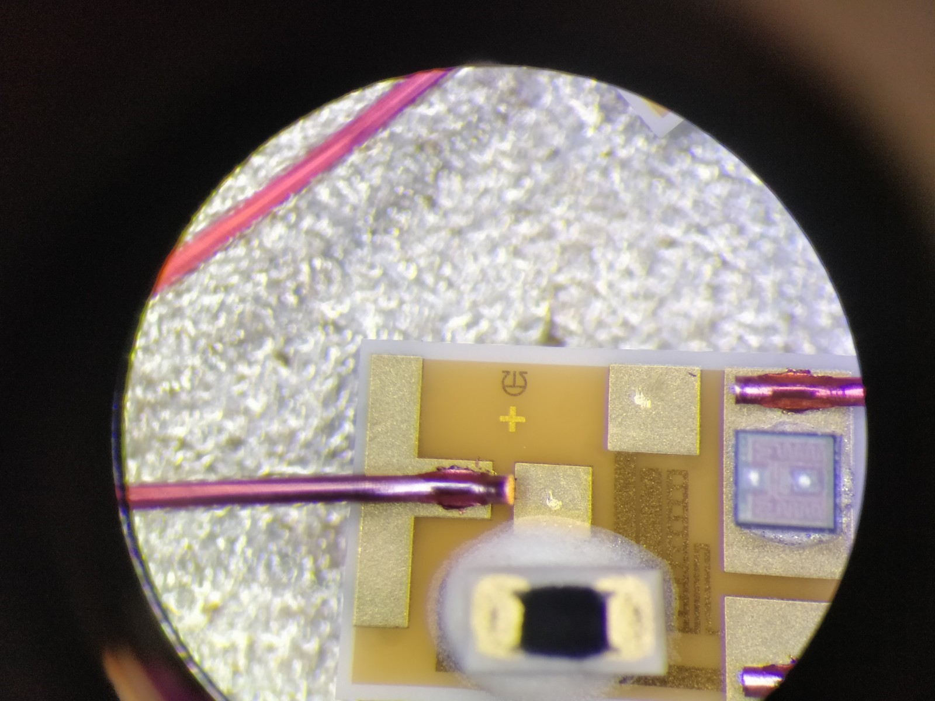 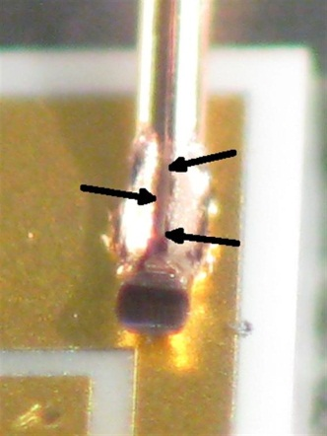

Figure #19 Figure #20 Figure #21

### The cut area (“D” in Figure 17) is formed when the previous wire is cut free by the bond tool. When the tool is in good condition, and everything is aligned correctly on the bonder, the ideal cut should look identical to Figure 17. If the tool becomes worn, or out of alignment, or if the workstage moves during the process, it may result in unacceptable cut shapes. If the cut has a excessively large fan of copper at the edge, or pieces of the wire hanging out to the sides, it could create a condition where these parts could break off later and become a contaminant in the sensor. Figures 22 and 23 show cuts that are unacceptable and will need to be scrapped unless the hanging piece of copper can be removed.

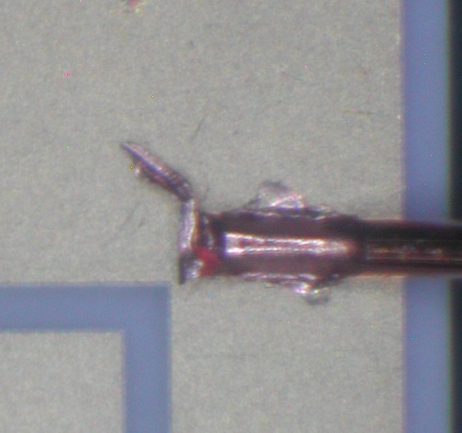 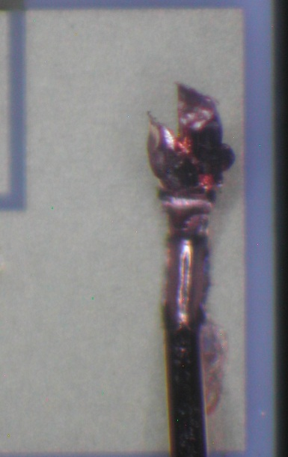

Figure #22 Figure #23

### If any of these inspection points fail to meet the requirement, the wire bonder may need to be adjusted per the bonders operating manual, the clamps may need to be realigned, or the bond tool may need to be changed. See supervisor and/or trained service personnel for assistance.

## Inspecting for Wire Defects

### On each substrate where the substrate thickness callout is 0.010”, the wire must be inspected on the backside to insure that no nicks or flat spots have been caused by the heavy wire fixture clamps. Affected substrates are:

48624-01

100-8115-00

### From the backside of the substrate, look at the wire closely where it exits the substrate. There should be no sign of any mark, nick, or flat spot in the wire. (See figure #24 for defect).

Flat spots in wire from impact with fixture clamp

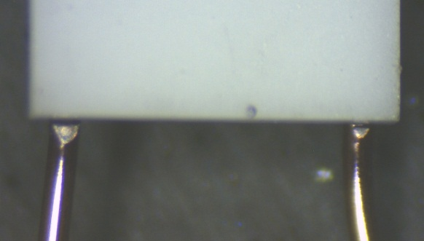

Figure #24

# Cutting Substrate Resistors

## When to Cut

### If the drawing shows an arrow with the word "CUT" or the cut symbol (see fig. 25) then the resistor that the arrow points to must be cut with a diamond scribe.

## Cutting Resistor Pattern

### Using gentle pressure, scribe a line across the resistor pattern to create a gap in the resistor. To ensure a clean cut more than one pass may be required. Make sure that the spot on the resistor pattern is chosen so that there is a complete break in the resistor between the two gold pads that it connects to (see fig. 26).



Figure #25

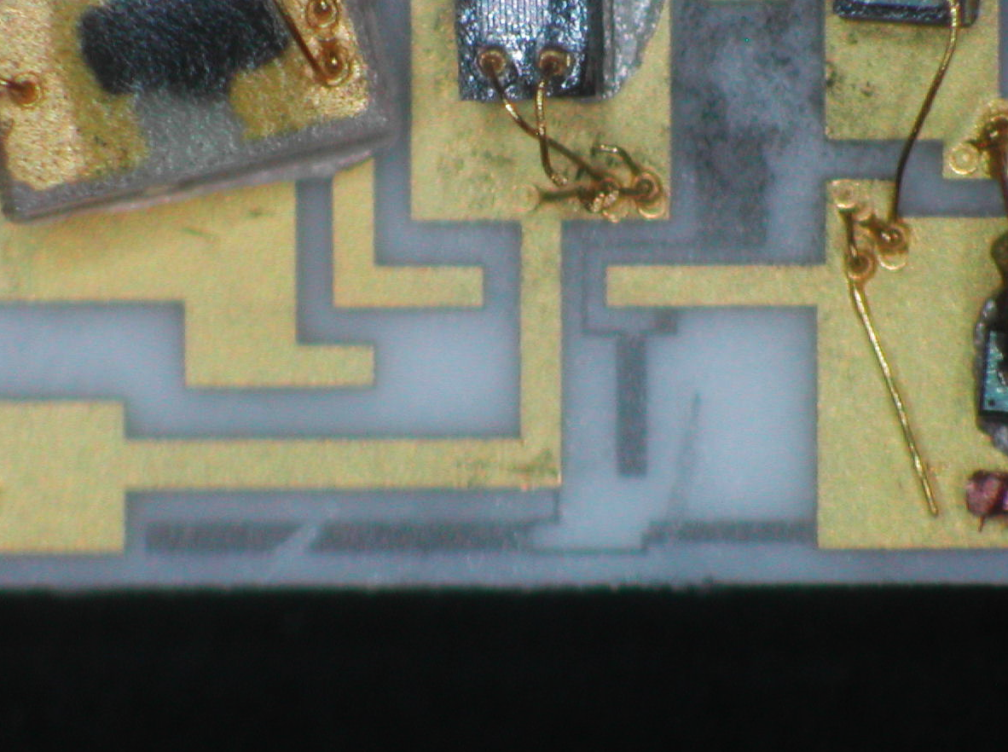

STILL A PATH BETWEEN GOLD PADS

CUT IN WRONG AREA

Figure #26

## Checking With Multi-meter

### Once all of the resistors are cut, each substrate must be checked with a digital multimeter (measuring resistance) to ensure that the resistors are completely cut through. For each resistor that is cut, place one multimeter probe onto one of the gold pads the resistor used to connect to, and the other probe onto the second pad that the resistor used to connect to. Probe color does not matter for this test. For a good cut, the multimeter must read "OL", or "--" or be blank. If any actual number is shown, including zero, the resistor was not cut, or not cut completely. In this case, the resistor cut must be redone.

# Packaging

## Packaging Assemblies

### After the substrates are bonded, place them in an approved ESD container or on a metal plate (with cover) to be transported to the assembly area. Label container/plate with model number and job number.

# Maintenance

## Changing the Bonding Tool

### Loosen set screw at the end of the transducer horn. Remove tool and replace with new tool (PCB part # 100-7343-40) and new set screw. Make sure the flat surface of the bond tool faces the operator. Position the bonding tool with the top of the tool flush with the top surface of the transducer horn. Tighten the set screw firmly. The knurls on the set screw conform to the tool surface for better coupling of ultrasonic energy. Momentarily press the TEST button on the front panel and note the meter reading on the milliamp meter. If the reading is less than 0.5 check for the following conditions:

The tool set screw is still loose or damaged.

The tool is touching the capillary or the wire is touching the tool.

The tool is to too high or too low in the transducer horn.

The clamp is touching the transducer.

### Adjust and test until the meter reads 0.5 or greater. This is mandatory for all wire sizes and proper operation of the wire bonder.

### **Ensure that tail length is not excessive after changing the bonding tool.** Review Section 4 (Inspection) for examples of conforming and non-conforming bonds.