1 GENERAL WORKMANSHIP STANDARDS FOR MICROELECTRONIC TESTING 2

1.1 Test Sequence 2

1.2 Data Records 2

1.3 Fixture and Cable Maintenance/Cleaning 3

2 Amplifier Preparation Before Test 4

2.1 Fly Wire Attachment 4

2.2 Panelized Amplifiers 4

3 GENERAL SETUP FOR ICP® ASSEMBLIES 4

3.1 Important Notes Concerning Testing ICP® assemblies 4

4 MANUAL BIAS/GAIN TESTING 5

4.1 General setup for manual testing, including fixture selection. 5

4.2 Testing Standard ICP Amplifiers 5

4.3 Testing ICP Amplifiers on T05 Headers 6

4.4 Testing 24297-XX-XXX-XXX Amplifiers 6

5 BIAS/GAIN TESTING ON ATE SYSTEM 9

5.1 ATE Overview, And When To Use ATE 9

6 DIP TESTING OF CRYOGENIC AMPLIFIERS 10

6.1 When to Perform Test 10

6.2 Dip Test Process 10

7 TEDS MEMORY CHIP TESTING 11

7.1 Test Setup 11

7.2 Test Process 13

8 BIAS CHECK AT TEMPERATURE 15

8.1 General Information and Hardware/Fixture Setup 15

8.2 Using Temperature Station Software 16

9 HI-MEG RESISTOR TESTING 20

9.1 When to Perform the Test 20

9.2 Test Setup and Process 20

10 DYNAMIC RANGE TESTING 23

10.1 Testing Process 23

11 FREQUENCY RESPONSE TESTING 23

11.1 When to Use This Test 23

11.2 Test Process 24

12 NOISE TESTING 26

12.1 Test Process 26

12.2 Data Analysis of Results 28

13 BROADBAND NOISE TESTING 28

13.1 Test Process 28

14 Surface Mount MEMS Testing 29

14.1 Test Setup 29

14.2 Running The Test 32

15 PACKAGING 33

15.1 Pre-Package Inspection 33

15.2 Acetic Acid Clean 34

15.3 Types of Containers Used to Package Amplifiers. 34

16 DELIVERY AND JOB PAPERWORK 35

16.1 Delivery 35

16.2 Job Paperwork 36

# GENERAL WORKMANSHIP STANDARDS FOR MICROELECTRONIC TESTING

## Test Sequence

### Job operations up to and including operation 360 within the MICROT and MI-TST workcenters may be performed out of order so long as the workcenter remains constant for the sequence of operations. This alternate order (alternate from the job router) may be determined as necessary by the test technician and/or Microelectronic Supervisor based on priority and/or test station availability.

## Data Records

### For each job of amplifiers that is tested in Micro, a log of this testing shall be created and stored. TA027 - Amplifier Data Log is a template of the data fields that will be captured for each Microelectronics job tested. The referenced data is input through a web based form that will in turn store all the collected data into a network database. To do this, open the TA027 web based form which can be accessed on the PCB intranet at [forms.pcb.com](http://forms.pcb.com). When accessing this web form, the default view displays all test records entered that day. Adding new entries to this form shall be initiated by pressing the “NEW” button and filling in all of the fields required for the job being tested. Below is list of some of the fields and clarification with regard to the data that is expected to be entered:

* DATE (today’s date)
* JOB#(job number)
* PART# (item number)
* PLT (plate letter)
* QTY (original released quantity)
* GOOD (final yield qty – do not fill in until all tests are complete)
* YIELD (% - auto calculated field)
* GAIN W/C (gain with input cap)
* GAIN WO/C (gain without input cap)
* BIAS W/C (bias with input cap)
* BIAS WO/C (bias without input cap)
* STATUS COLUMN (auto calculated field with notes for tech.)
  + - * + (If the final yield is below 80%, the status column will indicate to “SAVE FAILURES IN HOLD AREA!” – at this point, any scrap from this job that has not already been placed into the scrap bin shall be placed into a container or tin with the item #, job #, and failure mode if known and then be placed onto the shelf labeled “Less than 80% yield test scrap for engineering review” which is located in the nitrogen cabinet in Micro Test below the non-conforming hold area. As this material is already scrap and cannot be reworked, a TA081 form is not required. Engineering will then perform a failure analysis as needed and subsequently route the scrap to the scrap bin.
* INPUT Ω (MEMS resistance)
* OUTPUT Ω (MEMS resistance)
* 5% (general frequency response)
* -3dB (general frequency response)
* Broadband Noise (noise)
* 3 Hz-100 Hz Abs. Max. (55430 frequency response)
* 5 Hz-100 Hz Abs. Max. (55430 frequency response)
* 100 Hz-10 kHz Abs. Max (55430 frequency response)
* 10 Hz-1 kHz Abs. Max. (9815 frequency response)
* Typical Gain at 1Vrms Input (dynamic range)
* Typical Gain at Full Scale Output (dynamic range)
* % Linear (dynamic range – manually calculated)
* INPUT Ω (17275-XX)
* Misc. Comments
* LAST UPDATED (date and time GOOD qty is entered - auto calculated field)

### When processing jobs at an ATE station in Microelectronics, the test data acquired will be stored in an database controlled by the ATE group and/or engineering and does not need to be recorded in TA027. A record of the job being processed still needs to be captured in TA027 with Date, Part#, QTY, GOOD, PLT, & JOB#. Entries of jobs that were tested via ATE can be identified by having no test data and a GOOD quantity listed. Hardcopies and/or handwritten data from ATE may be provided via special request.

### Data that is not collected via ATE (i.e. from the Manual Test station) shall be recorded in TA027 - Amplifier Data Log under the heading that matches the test being performed. For each amplifier lot (job) tested, unless required via special instructions, only one sample value of each field tested needs to be recorded. Perform tests as required per The Micro Spec Database and/or via special instructions. If there are no specs or instructions related to a specific test parameter provided, this parameter does not need to be tested.

## Fixture and Cable Maintenance/Cleaning

### All fixtures used during test shall be inspected and clean per TA1039. Preventive Maintenance schedules are also in place for additional cleaning and maintenance where required.

#### For all Test System Connectors use TA1061. Process G.

### For ATE cables use TA1051, Process A, only steps 1-12, then bake out at 180F for a minimum of 10 minutes. (Do not bake at 250F, this will damage the cable!).

### T-05 Header fixtures shall be cleaned of all solder flux before being recycled to Micro production. Flux that cannot be removed with TA1051 or TA1061 processes (i.e. baked on flux) may require additional cleaning by other means. See supervision or engineering for assessment with each instance.

# Amplifier Preparation Before Test

## Fly Wire Attachment

### Some amplifiers require an additional wire to be soldered on in order to be tested. This requirement is noted on the amplifier drawing and will remain on the amplifier after being tested. Attachment of the wire shall be done by following TA1004 Hand Soldering User Guide.

### For all cases where fly wires are attached in the test area use TA1061, Process B Steps 1-4 followed by TA1051, Process A steps 1-12, then bake out at 250F for a minimum of 10 minutes.

## Panelized Amplifiers

### Panelized amplifiers that arrive in test may need to remain in panel form through all or a portion of the testing process. This requirement to remain penalized will be if the test equipment/fixture tests in an array form and will be determined by the technician at the time of test.

### Once panelized testing is complete, the amplifiers shall be singulated for additional testing and/or packaging. To do this, inspect each panel to determine the location of the intended break point. This break point is a scribe/score line, usually perforated, on only one side of the panel. All breaks shall be conducted such that forces applied will cause the scribe line to continue to crack toward the opposite side of the panel making a clean break. This is done by supporting the panel at the back side of the scribe line and applying a force, furthest from the scribe line as possible, on the side of the substrate that has the scribe line. DO NOT break in the other direction. Excessive force required may be an indicator of breaking from the wrong side. Breaking from the back of the scribe line rather than the front of the scribe line will cause an uncontrolled crack that may not break where intended. Inconsistent or non-straight breaks may also be an indicator of breaking from the wrong side.

# GENERAL SETUP FOR ICP® ASSEMBLIES

## Important Notes Concerning Testing ICP® assemblies

### Many of the amplifiers that PCB uses are ICP® devices. They are designed to use a special type of power called ICP®. Each ICP® amplifier assembly shall be powered with a compatible ICP® power supply set to 2mA ± 0.1mA current supply unless another current is noted in the Micro Spec Database. When connecting an ICP® amplifier assembly to the test setup, the ICP® power supply connects to the output lead of the amplifier. Where applicable, use 72671-01 switch box to interface between the ICP power supply and amplifier output. The readout equipment also connects to the output lead. See Figure 3-1.

### 72671-01 is a 5-input, 1-output switch box. It should be used to select between different ICP® current settings to power up amplifiers. Four ICP® power supplies should be connected to the rear BNC connectors corresponding to the labeled current settings. The “EXT” BNC can be used to connect an external power supply if desired. The “OUT” BNC should be connected to the amplifier’s output. Turning the knob on the front panel will route the selected ICP® current supply to the output BNC. The “NC” setting will disconnect the output from any ICP® current. This setting should be used when powering amplifiers from an alternate source.

### Initial setup of the ICP power supply switch box will use (3) channels of ICP current from a programmable 482C Series power supply. (1) channel will use a custom battery powered unit to provide 0.4mA (the 482C Series does not have this resolution). When using the switch box, ensure the appropriate power supply is powered on and sufficiently charged in the case of the battery supply. See Figure 3-2.

### Note: Powering ICP® Assemblies with a standard power supply will result in damage to the assembly. The output circuitry will attempt to sink as much current from the supply as possible, and will suffer almost immediate thermal damage. Always use an ICP® supply or a constant current source approved by PCB engineering.

Input

Ground

Output

Readout

(Scope, DMM, DAQ input, etc.)

ICP® Type

Assembly

Function

Generator or DAQ output

72671-01

5:1 Switch Box

**. . .**

ICP® Current Setting 4

ICP® Current Setting 1

Coupling

Capacitor

Figure ‑

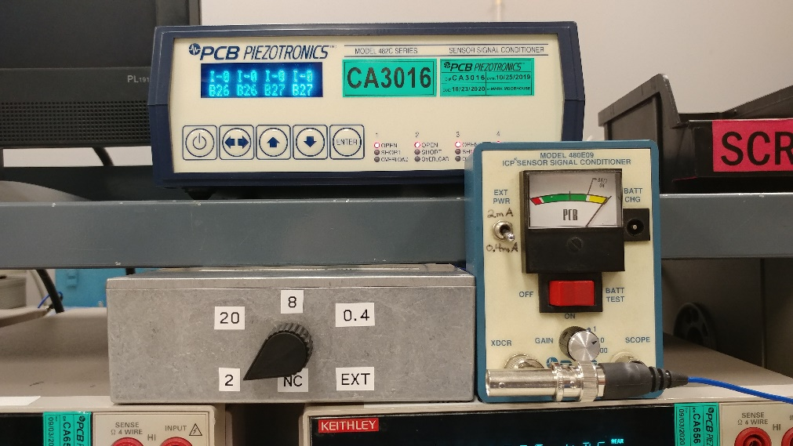

72671-01 Switch box

Programmable supply provides 2mA, 20mA, 8mA

Custom battery supply provides 0.4mA setting

External supply can be connected to back of switch box

No connection

Figure ‑2

# MANUAL BIAS/GAIN TESTING

## General setup for manual testing, including fixture selection.

### Place the device to test into the appropriate fixture. The amplifier drawing shows the orientation of Input, Output, Ground, and Power (if needed). Fixture orientations for common fixtures are shown in Figures 4-2 thru 4-4. Refer to the Micro test database for the fixture to use for a given assembly.

### When testing amplifiers with overcoats that are not solid black, the test box cover must be in place during testing because some internal parts may be light sensitive.

### Some amplifiers may have wire orientations that require jumper clips to be used to reach the fixture connections.

## Testing Standard ICP Amplifiers

### Connect the output of the ICP power supply / switch box to the output of test fixture #43046-01 (Figure 4-2), as well as to the input of the bias voltage voltmeter, and to the input of the output voltage gain voltmeter, and to channel 2 of the oscilloscope. Connect the signal generator to channel 1 of the oscilloscope, as well as to the input of the input voltmeter and to the input of test fixture #43046-01.

### Set the test system up as follows unless other test requirements are documented in the Micro Spec Database. (Refer to Figure 4-1). Set the frequency generator to 1000 Hz sine wave and 1.000V RMS .5% unless the Micro Spec Database indicates a different frequency or amplitude. Set the oscilloscope up as follows: Mode dual, CH 1 AC coupling, adjust range switch to get a single sine wave, CH 2 AC coupling, range switch set to obtain a signal level as close to the input signal level as possible. Set the trigger level in the middle with the source on CH 1. While you are testing, watch the CH 1 and CH 2 signals. Make sure they are uniform sine waves with no clipping or distortion.

### To measure bias and gain with a capacitor, on fixture #43046-01 (Figure 4-2) set the Capacitor to the ‘in’ position.

### Read the AC voltage on the back connection (amplifier output) of the gain voltmeter and the AC voltage on the back connection (amplifier input) of the gain voltmeter. (The meter has a front/rear button to switch between inputs). Divide the first reading by the second reading to get gain. Compare the gain to the ‘GAIN LOADED’ spec in the Micro Spec Database, and reject the amplifier if it is not in range.

### If the input voltage is set to 1.000 ±.005, the gain can be read directly at the output without dividing by the input reading. Remember to watch the signals on the oscilloscope and look for discrepancies such as distorted or clipped signals.

### Set the Capacitor switch to the ‘out’ position, and repeat these steps to measure bias and gain without a capacitor. Compare the bias to the ‘BIAS’ spec, and the gain to the ‘GAIN UNLOADED’ spec. Again, remember to watch the signals on the oscilloscope and look for discrepancies such as distorted or clipped signals.

## Testing ICP Amplifiers on T05 Headers

### The T05 fixture #43052-01 has 2 test positions (A & B) for testing amplifiers (Figure 4-3). There is one input connection which connects to the function generator, one output which connects to the ICP power supply, and one power connection which is only used when using position A. Place the pins on the bottom of the headers into the fixture as shown in the diagram in Figure 4-3. Connect each input wire to the corresponding alligator clip, taking care not to bend the wire more than necessary.

### Set the frequency generator to provide the required input signal. Adjust the oscilloscope to obtain a single sine wave on each channel.

### Compare the DC voltage on the Bias voltmeter to the ‘BIAS’ spec in the Micro Spec Database. Reject the part if it is not within the spec range.

### Read the AC output voltage and the AC input voltage. Divide the first reading by the second reading to get gain. Compare the gain to the ‘GAIN W/C’ spec in the Micro Spec Database, and reject the amplifier if it is not in range.

## Testing 24297-XX-XXX-XXX Amplifiers

### Connect the output of the ICP PCB power supply / switch box to the output of test Fixture 43060-01 or 43052-01 (Position A) (Figure 4-3 & 4-4), the input of the bias voltage voltmeter, the input of the output voltage gain voltmeter, and channel 2 of the oscilloscope. Connect the signal generator to channel 1 of the oscilloscope, the input of the input voltmeter and the input of the test fixture. Connect a 9V DC source unless otherwise indicated in the Micro Spec Database to the power connection on the fixture.

### Compare the DC voltage on the Bias voltmeter to the ‘BIAS’ spec in the Micro Spec Database. Reject the part if it is not within the spec range.

### Read the AC voltage on the front connection (amplifier output) of the gain voltmeter and the AC voltage on the back connection (amplifier input) of the gain voltmeter. (The meter has a front/rear button to switch between inputs). Divide the first reading by the second reading to get gain. Compare the gain to the ‘GAIN W/C’ spec in the Micro Spec Database, and reject the amplifier if it is not in range.

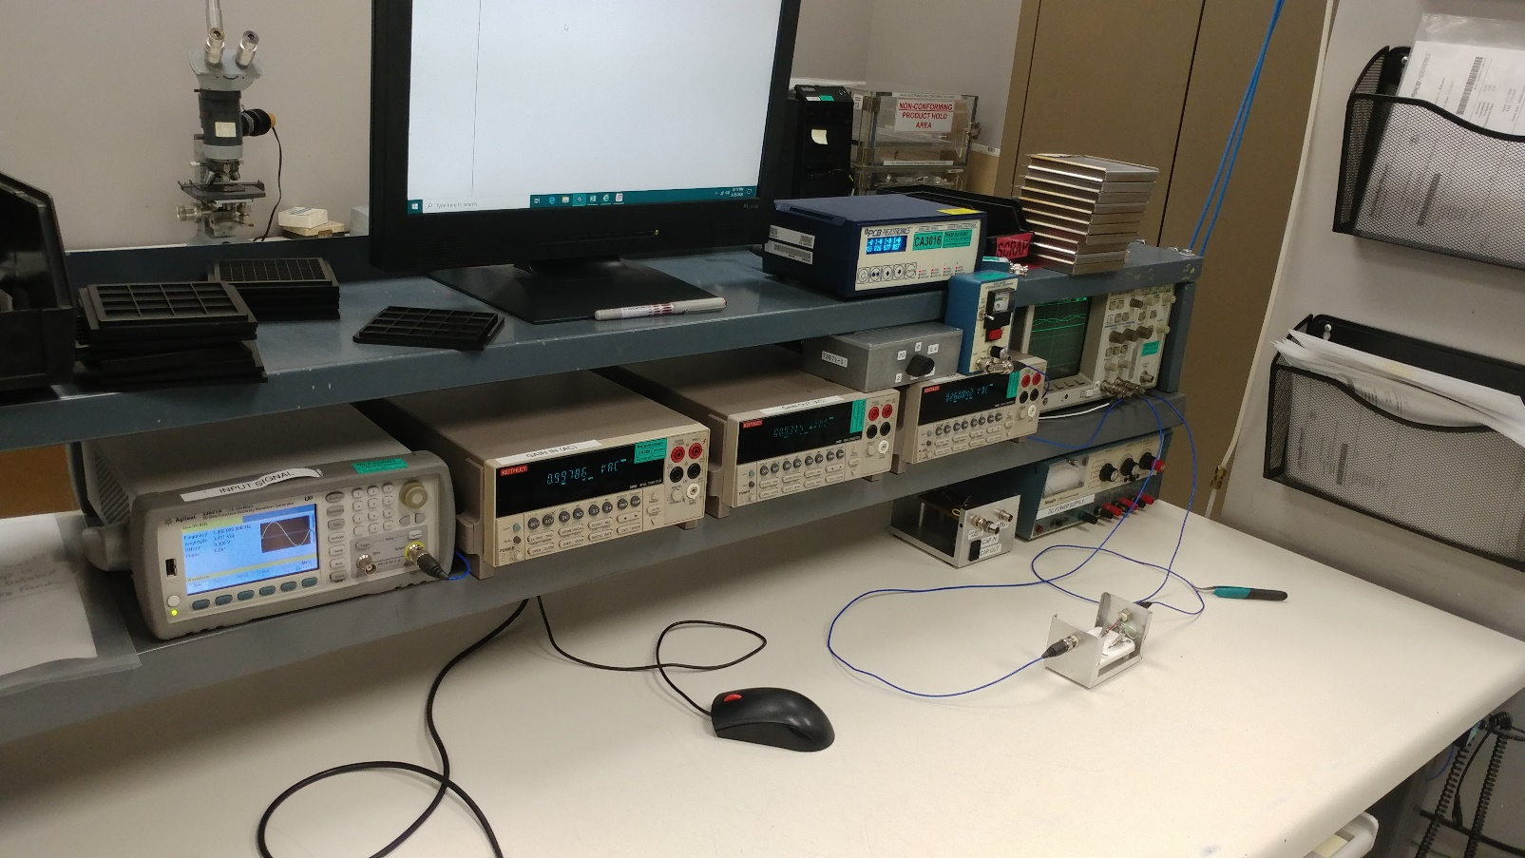

ICP POWER SUPPLY (483C Programmable)

CUSTOM BATTERY ICP be connected to back of switch boxSUPPLY (0.4mA)

FUNCTION GENERATOR

GAIN VOLTMETERS (AC)

FIXTURE

SWITCH BOX FOR ICP POWER SUPPLIES

BIAS VOLTMETER (DC)

OSCILLOSCOPE

FIXTURE INPUT

Figure ‑

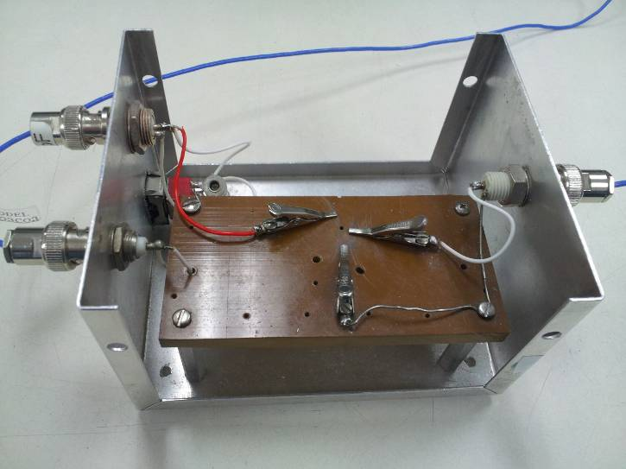

GROUND

INPUT

OUTPUT

**FIXTURE 43046**

Figure ‑

|  |  |
| --- | --- |
| Output (A) |  |
| Ground (A) |  |
| Power DC (A) |  |
|  |  |
|  |  |
|  |  |
|  |  |
|  |  |
|  |  |
|  |  |
|  |  |
|  |  |
|  |  |
| Output (B) |  |
| Ground (B) |  |
| N.C. (B) |  |

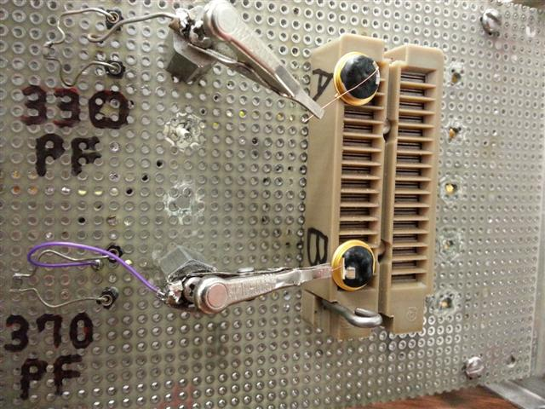

**FIXTURE 43052-01**

Input (B)

Input (A)

Figure ‑

|  |  |
| --- | --- |
| Output |  |
| - - |  |
| Power DC |  |
|  |  |
|  |  |
|  |  |
|  |  |

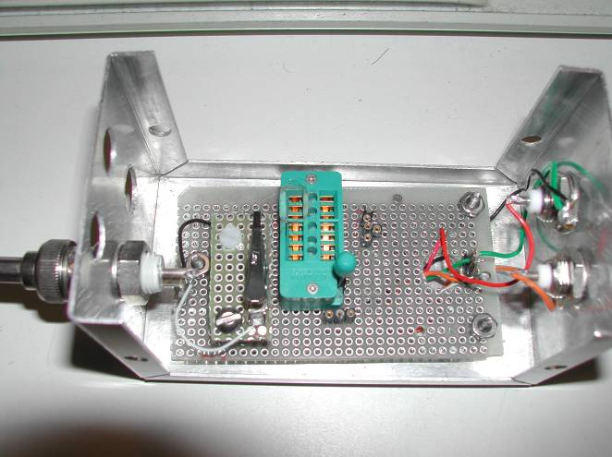

**FIXTURE 43060-01**

Input Clip Lead

Input

Output

Output and Power Socket (See table to right)

+9V Power

Close lever before testing

Figure ‑

# BIAS/GAIN TESTING ON ATE SYSTEM

## ATE Overview, And When To Use ATE

### When possible, the ATE system (Figure 5-1) shall be used to test amplifiers. In addition to reduced risk of human error, the ATE system performs more extensive testing, and tests faster than the manual bench. Each type of amplifier substrate family has its own fixture type (Figure 5-2). The fixtures hold the amplifiers between two plates, one with pockets for the amplifiers, and one with spring pins to connect to the amplifiers. During testing, the two halves are held together with quick release nuts to ensure good connections.

### Each ATE fixture is etched with the substrate type and a unique fixture number (Figure 5-2). When a lot of amplifiers are placed into an ATE fixture, the fixture number must be recorded on the front of the job paperwork, near the test step, or in the blank provided on newer routers. This will make it possible to identify the parts later if the fixture becomes separated from the paperwork.

### Follow the screen prompts to use the ATE systems software. All fields must be filled in. The software will not proceed until information is entered. If any parts fail during testing, it is possible to re-test those channels after checking the connections between the amp and fixture. Parts may also be re-tested for bias and/or gain at the manual station. If cable connectors are suspected of degraded connections resulting in false failures, a weight may be placed on top of the connector to assist the magnetic connection scheme of the connector.

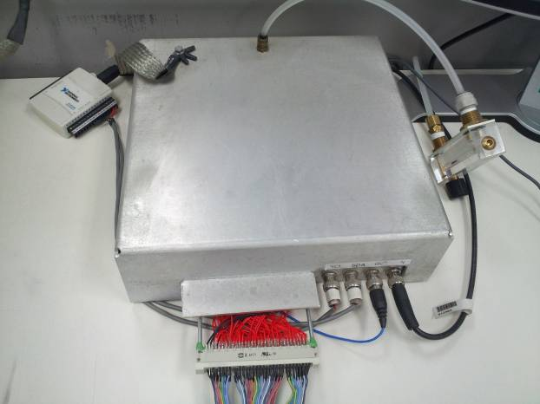

Output

ATE RELAY BOX

Figure ‑

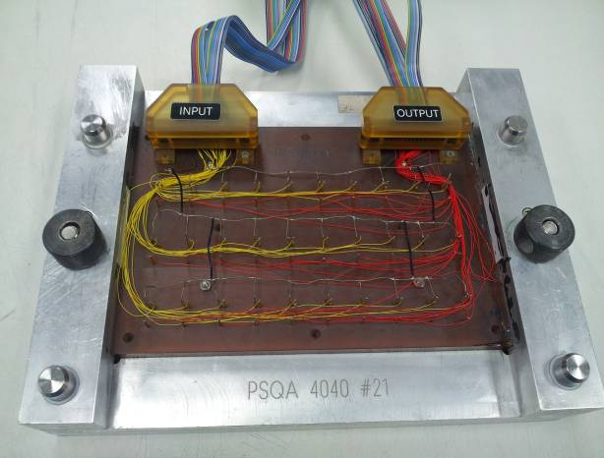

Quick Nuts must be tight before testing

Fixture Type and Unique Number

Input

Figure ‑

# DIP TESTING OF CRYOGENIC AMPLIFIERS

## When to Perform Test

### The dip test is performed on any amplifier with a “–99” variation in the part number. This variation number defines a special overcoat process for cryogenic units. To ensure that this overcoat will function properly, the units are dipped into liquid nitrogen and inspected for failure modes.

## Dip Test Process

### Place a group of amplifiers into a tray and dip the entire group into a bath of liquid nitrogen (Figure 6-1). Leave the parts in the bath for a minimum of one minute or until they stop boiling, whichever is longer. Remove the parts from the bath and allow them to return to room temperature.

### Examine each amplifier under a microscope. Look for damage to the amplifier that should be readily apparent. If any wire bonds look as though they have been severely distorted (a wavy appearance), reject that amplifier. Also, if there is a small crack in the overcoat starting near the capacitor and heading toward other components or wire bonds, reject the amplifier. Even if the crack has not propagated far from the capacitor, it is still cause for concern, as it may spread over time. Small cracks from the capacitor to the closest edge of the substrate are OK.

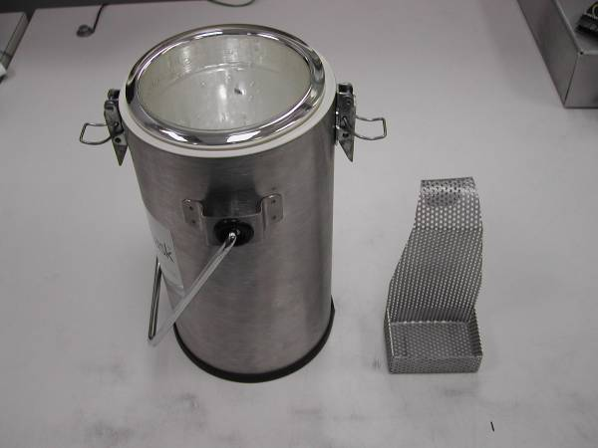

PARTS TRAY (Place amps in tray and hang from lip of container)

LIQUID NITROGEN (Fill far enough that tray is covered when inserted)

Figure ‑

# TEDS MEMORY CHIP TESTING

## Test Setup

### Testing the Teds chip is done on Fixture 43206-01 (Figure 7-3). Connect a DS94904 USB Dongle to an open USB port on the computer. Attach the male 10-32 connector end of the 009M86 cable to the BNC to 10-32 connector adaptor (070A02) and adaptor to fixture 43206-01. The opposite end of the cable shall be attached to the USB Dongle (Figure 7-1 & Figure 7-2).

### Place the amplifier on the metal base, and connect probe #2 to the output of the amplifier. (If the amplifier does not have a backside ground point, connect probe #1 to the amplifier ground connection, place a shorting connector on BNC #1, and switch the 200pF cap to ‘bypass’.) In order to perform this test, the signal at the end of the 10-32 connector needs to be connected to the output and ground of the amplifier (center pin of 10-32 connector to output and the shield of the 10-32 connector to the amplifier ground).

### If the above mentioned fixture (43206-01) is not applicable for the assembly being tested, this connection may be achieved by either using test probes directly on the amplifier or by connecting the 10-32 connector directly to a test fixture already in use at the time of test.

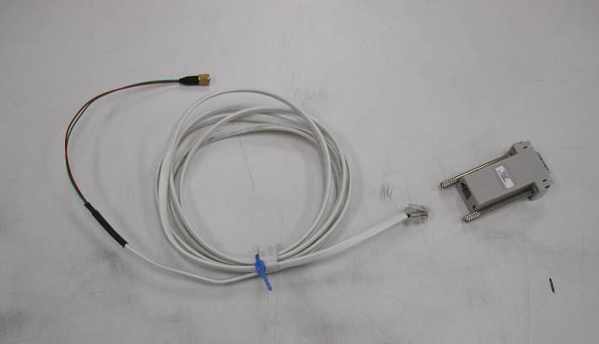

009M86 Cable

This end attached to the USB Dongle

Figure ‑

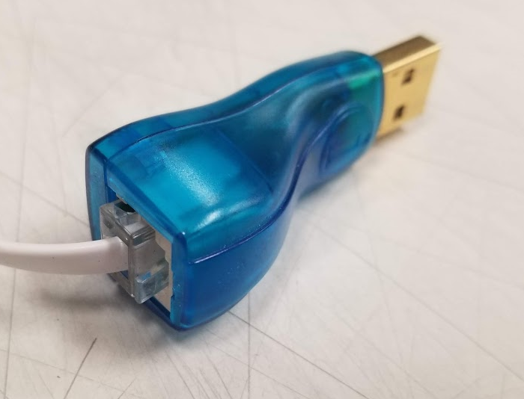

Figure ‑2

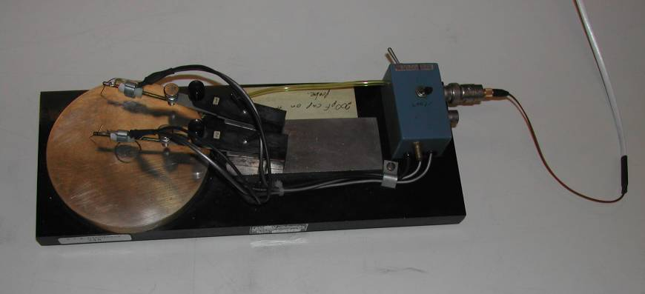

**Fixture 43206-01**

Metal Base (Ground)

Connect BNC to 10-32 Adapter (070A02)

Connect 009M86 Cable Here

Probe #2 – Connect to Amplifier Output

Figure ‑3

## Test Process

### Open the computer program “One Wire Test USB” (EE241).

### If desired, entering the quantity to test will display the results for all units under test for the duration of the test (Figure 7-4).

### Click “Start Test” (Figure 7-4).

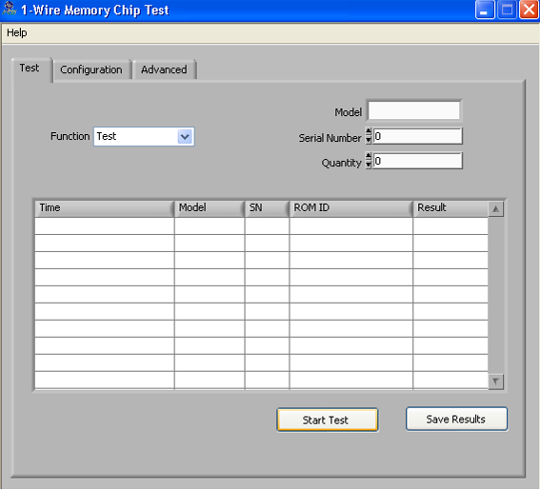

Figure 7‑4

### When prompted with “Is the Documentation Correct”, click “Yes” (Figure 7-5).

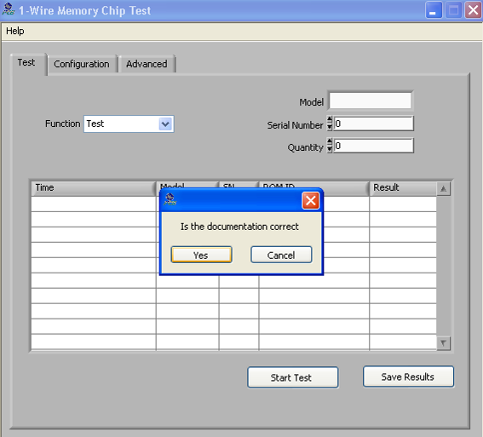

Figure 7‑5

### Test will run and display results (Figure 7-6). Select the appropriate response.

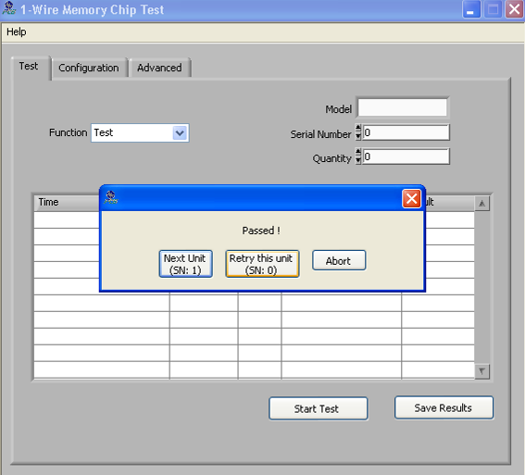

Figure 7‑6

### When prompted to save results, Click “Cancel” (Figure 7-7). Results do not need to be saved.

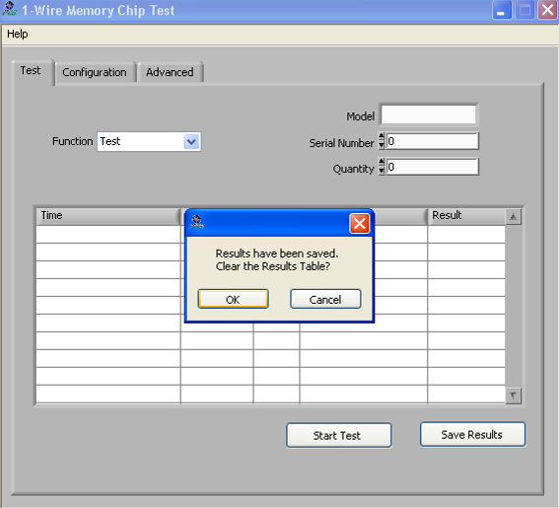

Figure 7‑7

### When finished, click the “X” to close the software.

# BIAS CHECK AT TEMPERATURE

## General Information and Hardware/Fixture Setup

### Routing of individual amplifier assemblies will indicate whether or not bias testing over temperature is required. Bias temperature testing is controlled by the temperature test database software. When the software is started, the user will need to log in with their username and password. After logging in, the main window will be displayed (Figure 8-1). Do not turn on the oven yet. The parts must be at room temperature when the software first starts recording data.

### Parts are placed into one of the ATE fixtures, or the temperature oven fixture (#43075-01). As in ATE testing, the fixture number must be recorded on the job paperwork to prevent parts from being mixed in the test area.

### When testing voltage amplifiers (VAMP in description) that end in -000 (or have no onboard hi-meg resistor), for the circuit to function properly, a Hi-Meg resistor must be present from input to ground. To achieve this, attach Fixture # 60720-01 to the input of the ATE fixture.

## Using Temperature Station Software

### To log in the channels with parts on them, click on the ‘LOG IN’ button. In the log in window (Figure 8-2) select the channels that have parts connected and click ‘CONTINUE’. (To select an entire group at once, click on the first part, hold the shift button, and click on the last part.)

### On the second login screen (Figure 8-4) use the barcode scanner to scan in values for the model number and job number. Next, select the proper control channel. For the bottom oven, select ‘CH-902 TEMP’, and for the top oven select ‘CH-901 TEMP’.

### Make sure the ‘Auto Number’ box is checked, and enter a ‘1’ in the serial number box. Click on the ‘LOGIN’ button to log in the first channel. Continue to click on the ‘LOGIN’ button until all of the parts are logged in. The window will close automatically after all parts are logged in, and another window will open showing information on all the channels.

### If all the information on the screen matches what was entered, click on ‘OK’ to close the window and automatically take the first reading and update the status of each channel. The status will be displayed on the right side of the window as a color code (Figure 8-1). If some channels are not passing, it may be because of connection issues, and the fixture or connections may need to be opened and closed. When satisfied with the status of all channels, click ‘START LOGGING’ to begin the test.

### Turn on the oven and ensure that it is set to the correct temperature. After a minimum of 30 minutes has elapsed, look at the channel status area. The test is complete when all the channels have a status of either failed or complete. Note those channel numbers that have failed.

### When the router calls for checking current sensitivity at temperature, Use the ‘CONFIGURE EXCITATION’ button (Figure 8-1) to open the ICP Current window (Figure 8-3) and change the ICP current from 2mA to 6mA. Wait for the software to acquire new data, and look at the channel status area to see if the higher current caused additional channels to fail, and note those channels. Use the ‘CONFIGURE EXCITATION’ button again to change the ICP current back to 2mA.

### Use the log out button to log out the channels being tested, and turn off the oven. Remove the fixture from the oven. If it is one of the ATE fixtures (Figure 5-2), place it on the cooling platform (Figure 8-7) to help cool it quickly and improve cycle time. If the cooling platform has an automatic fan, it will come on when the fixture is set down, otherwise the fan will need to be turned on.

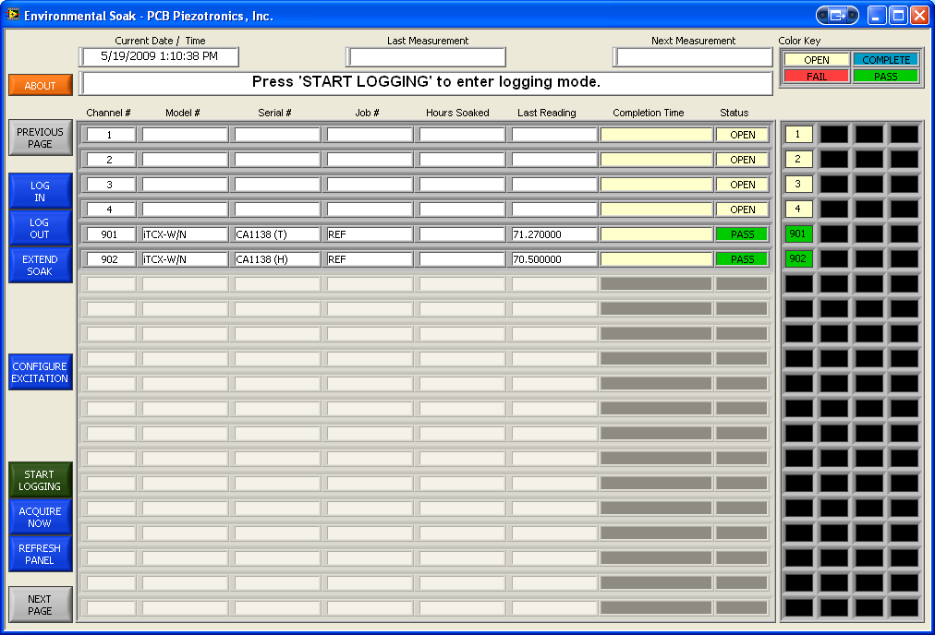

Detail of up to 20 channels

Change current from 2mA to 6mA

Click ‘START LOGGING’ to begin test

‘AQUIRE NOW’ to check pass/fail before starting test

Status of all 60 channels. Color code shown at top of screen

Log parts into system

Figure ‑

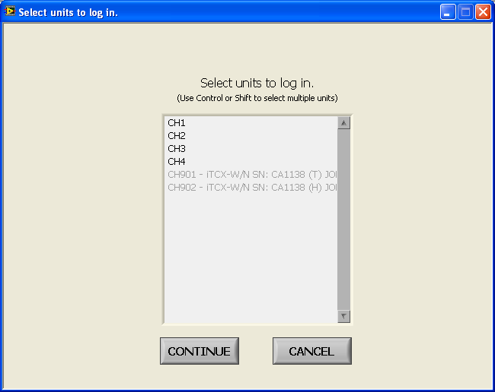

Figure ‑

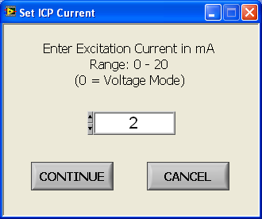

Figure ‑

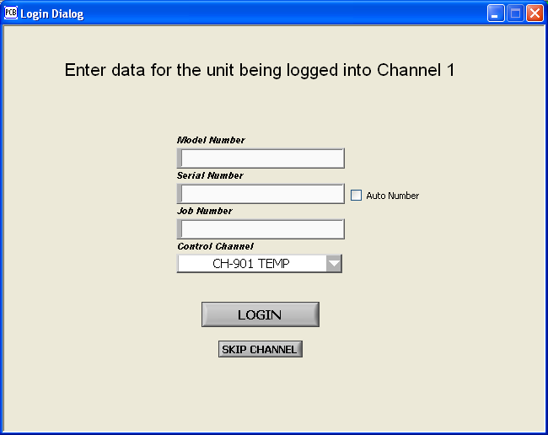

Figure ‑

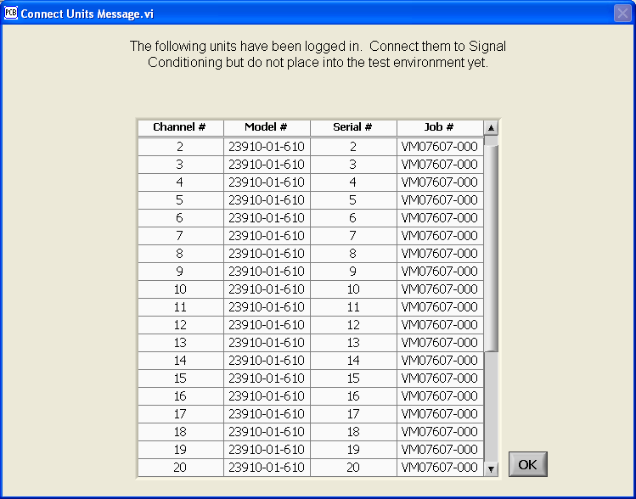

Figure ‑

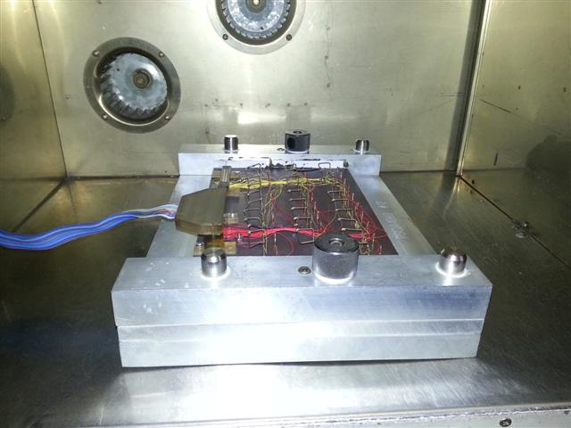

Figure ‑

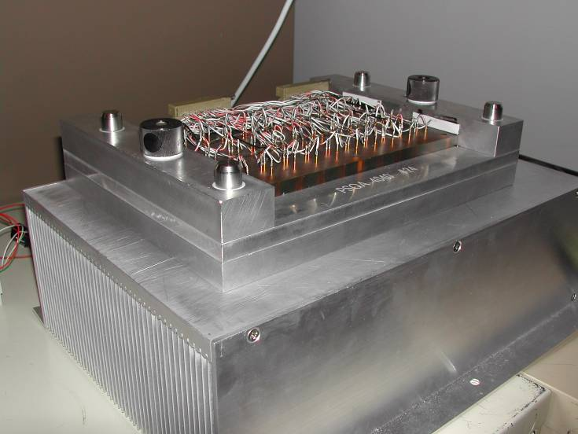

ATE Fixture (Hot from oven)

Cooling platform with heat fins underneath

Figure ‑

# HI-MEG RESISTOR TESTING

## When to Perform the Test

### The Hi-Meg resistor used on most amplifiers is a critical component. The larger values are much more difficult to manufacture than the smaller values, therefore there are two different sample sizes for testing. On any amplifier with a Hi-Meg value of 6e10 or less, two pieces from the lot shall be tested. In the event that any of the measured values is less than 100KΩ (1e05Ω) then this unit shall be considered scrap (307 - Shorted) and another unit shall be tested until a total of two samples are selected that are greater than 100 kΩ. If either of the samples then fails the Hi-Meg test, the entire lot shall be tested. On any amplifier with a Hi-meg value greater than 6e10, 100% of the parts shall be tested. On charge amplifiers that are tested on the ATE system, the test system will check the Hi-Meg value, and a manual test is only necessary on those parts that fail the ATE system check. Amplifiers which have Hi-Megs that are not electrically or physically accessible do not need to be manually tested (i.e. T-05 Amps) and are identified in the Micro Spec Database.

## Test Setup and Process

### For all Microelectronics production jobs, the Keithley 6517 series electrometer should be used with software program EE259.

### When the program is started, the first step is to configure the electrometer to measure correctly. This calibration shall also be repeated with each new job being tested. This is a semi-automatic self-calibration to null out the stray leakage in the meter and test fixture. The main screen is shown in Figure 9-1. Click on the “Configure Meter” button in the lower left. The configure window should appear, as shown in Figure 9-2. Follow the instructions in the window. When the “Continue” button is clicked, another window will appear briefly as the auto-cal is performed (Figure 9-3).

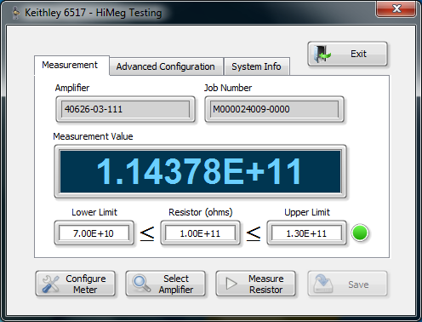

Figure ‑

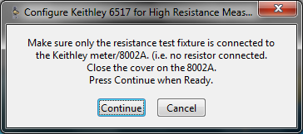

Figure ‑

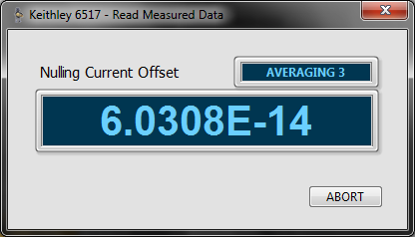

Figure ‑

### To measure the Hi-Meg values on a job, click on the “Select Amplifier” button on the main screen. This will bring up another window to enter amplifier information. See Figure 9-4. Use the barcode scanner to scan in the amplifier number and the job number from the job paperwork. Click the “Continue” button when done.

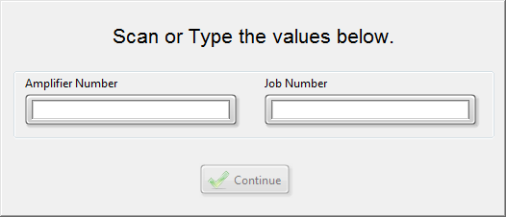

Figure ‑

### If the amplifier entered is not found in the test database, the program will continue, but will ask for the tolerance of the resistor to be tested. See Figure 9-5. Enter the correct value to continue the test. Also notify engineering that the model in question needs to be entered into the database. If the tolerance is unknown, see engineering.

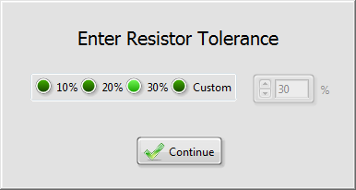

Figure ‑

### Connect an amplifier to the test posts (See Figure 9-6). It may be necessary to use additional test clips to reach both posts. Make sure none of the wires touch the metal plate under the posts. Charge amplifiers must be connected so that the input is on the right-hand side ( -Post) and the ground lead is on the left-hand side (+Post). Voltage amps also use the input and ground leads, but polarity is not important. Refer to the amplifiers drawing for lead location. Close and latch the lid. Note that the lid must remain closed during the test. Bypassing the lid interlock cable will result in invalid data being read on the display.

### From the main screen, click the “Measure Resistor” button to begin a measurement. A measurement window will briefly appear, and when it closes, the measured value will be displayed in the main window. The LED icon will show green for a passing result, or red for a failing result. Parts that fail should be segregated from the rest of the job. When the measurement is complete, and the “Save” button becomes available, the results shall be saved to the database by pressing the save button.

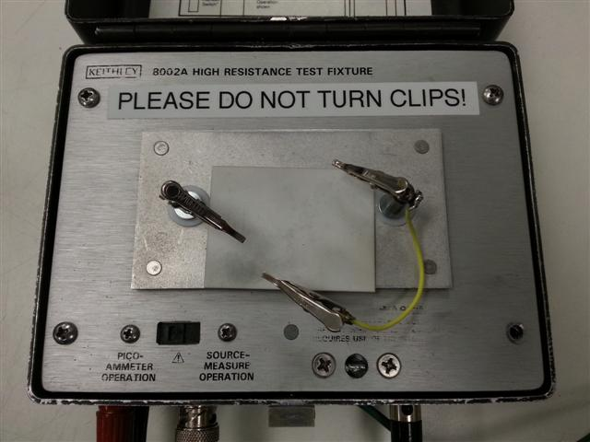

Extra clip if needed

Right (-) Post

Left (+) Post

Figure ‑

# DYNAMIC RANGE TESTING

## Testing Process

### When testing dynamic range, record all test data in TA027 - Amplifier Data Log under the heading Dynamic Range (Gain at 1 Vrms, Full Scale Output, and % Linearity (manually calculated)).

### Set the test system up as follows: Set the output signal level of the frequency generator to 1000 Hz sine wave. Set the signal level of the function generator so that signal at the output of the amplifier is at Full Scale Output (Typically 3.535Vrms or 5Vpk unless an alternate range is specified in the Micro Spec Database). Remember that Vrms=0.707 x Vpk). Connect the output of the ICP power supply / switch box to the output of the test fixture, the bias voltage voltmeter, the output voltage gain voltmeter and channel 2 of the oscilloscope. Connect the signal generator to channel 1 of the oscilloscope and the input of the test fixture. Set the oscilloscope up as follows: Mode dual, CH 1 AC coupling, CH 2 AC coupling range switch set to obtain a signal level as close to the input signal level as possible. Set the trigger level in the middle with the source on CH 1. Watch the CH 1 and CH 2 signals. Make sure they are uniform sine waves with no clipping or distortion.

### Place the part in the test fixture and set the test fixture capacitor in. If the amplifier does not have a Hi-Meg resistor, set the 6E10 fixture Hi-Meg on. Adjust the range switch on the scope for CH1 and CH2 so that it uses as much of the oscilloscope screen as possible. Examine the output for any distortion, especially on the negative portion of the sine wave. If output is distorted, put aside and retest at the end. If still distorted, discard into scrap box. Calculate gain at full output, Vout/Vin. Set the amplifier output voltage to 0.707 Vrms, read output voltage/gain. Calculate the % linearity from 1Vrms input to Full Scale Output.

1Vrms out: Gain (1Vrms-out) =Vout/Vin

Full Scale: Gain(FS-out)=Vout/Vin

%Linearity = (Gain (FS-out)/Gain (1Vrms-out))*100

### If the linearity of any amplifier is less than 99% or greater than 101%, put amplifier aside and re-test at the end to verify. If it is still out of spec during retest notify supervision and/or engineering.

# FREQUENCY RESPONSE TESTING

## When to Use This Test

### Follow this process to test the response of any items that do not have their own procedure for frequency testing. Refer to the Micro Spec Database for specs (Some older items may still have the requirements called out in the router). Test all amplifiers in job lot unless otherwise instructed.

## Test Process

### Frequency response testing is done using the HP3562A analyzer. When the assembly under test cannot be connected with standard connectors (10-32 or BNC), or with micro clip cables, use fixtures #56001-01, 43046-01, or 43206-01 as necessary to match amp lead configuration. See Figure 11-1 for general test setup with the 56001-01 fixture.

### Use the following table to set up the analyzer, and the connection scheme in Figure 11-1 to make the proper connections to the equipment and the UUT. Note that the power supply shown is for reference only, and any ICP type supply may be used.

HP3562A Set-up Menu for Frequency Response (Reference only)

|  |  |  |  |  |
| --- | --- | --- | --- | --- |
| MEASUREMENT | MEAS MODE | SWEPT SINE |  |  |
|  |  | A-GAIN | Off |  |
|  | AVG | NUMBER AVGS | 2 | ENTER |
|  |  | AUTO INTGRT |  |  |
|  | FREQ | START FREQ | 10 | HZ |
|  |  | STOP FREQ | 100 | kHz |
|  | SOURCE | SWEEP DOWN |  |  |
|  |  | SWEEP RATE | ** | Sec/Dec |
|  |  | SOURCE LEVEL | 100 | mV rms |
|  | RANGE | AUTO1 UP & DOWN |  |  |
|  |  | AUTO2 UP & DOWN |  |  |
|  | INPUT COUPLE | CHAN1 AC |  |  |
|  |  | CHAN2 AC |  |  |
|  |  | GROUND CHAN1 |  |  |
|  |  | GROUND CHAN2 |  |  |
|  | CAL | AUTO ON |  |  |
| ACTIVE TRACE | A |  |  |  |
| SELECT DATA | MEAS DISP | FREQ RESP |  |  |
| DEFINE TRACE | COORD | Mag (dB) |  |  |
|  | SCALE | Y AUTO SCALE |  |  |
| CONTROL | START |  |  |  |

** The step between sweep rate can change depending on setup.

Choose any rate between 9 and 14 for this testing.

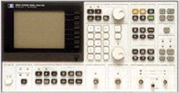

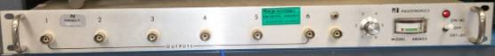

56001-01

INPUT

CAP

Output

Input

Figure ‑

### To make a measurement, Press Marker X X Value 100Hz, then select either Hold X Left or Hold X Right (depending on measurement direction relative to 100Hz, then Scroll the marker wheel to move the cursor to the relative dB point (ΔY). Note that 5% = 445 mdB. Compare the ΔX to the test spec and plot if required.

### Results of Frequency Response tests shall be recorded in TA027 - Amplifier Data Log under the heading Frequency Resp and Noise. Under this heading there is a column to record the 5% point and the -3dB point in Hz. When testing amplifier model 55430-01, rather than looking for a specific frequency relative to dB, there is a requirement to record +/- dB at specific frequencies relative to another. These ranges are listed in the Micro Spec Database and the results are to be recorded in TA027 - Amplifier Data Log under the heading 55430. Hardcopy plots are only generated via special request.

### If plotting is required, insert paper into plotter. Then press the following keys: HP-IB PLOT SELECT DATA TICK MARKS RETURN START PLOT. If both 5% and 3dB points are to be recorded only one plot is necessary. When a plot is generated (5% or 3dB) the other measured value may be hand written on the plot denoting Frequency and dB. See Figure 11-2.

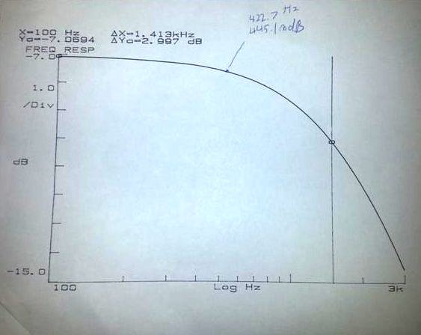

Figure ‑

# NOISE TESTING

## Test Process

### The connections for this test are the same as frequency response with the following changes. The source is removed from the analyzer and the source input on the amplifier test fixture is shorted to ground. Note: The input cap must stay in the circuit when the input is shorted. The value of the input capacitor required will be listed in the Micro Spec Database.

### Set up the analyzer for Noise testing. Use the following chart as a guide for navigating to the proper keys on the HP3562A. Once the start key is pressed, wait for the required number of averages to complete. The screen plot should resemble the paper plot as shown in Figure 12-1.

HP3562A Set-up Menu for Noise (Reference only)

|  |  |  |  |  |
| --- | --- | --- | --- | --- |
| MEASUREMENT | MEAS MODE | LOG RES |  |  |
|  | SELECT MEAS | PWR SPEC |  |  |
|  |  | CHAN 2 ACTIVE |  |  |
|  | AVG | NUMBER AVGS |  | ENTER |
|  |  | STABLE MEAN |  |  |
|  | FREQ | START FREQ | 50 | HZ |
|  |  | FREQ SPAN | 3 | Dec |
|  | SOURCE | OFF |  |  |
|  | RANGE | AUTO2 UP & DOWN |  |  |
|  | INPUT COUPLE | CHAN2 AC |  |  |
|  |  | GROUND CHAN2 |  |  |
| ACTIVE TRACE | A |  |  |  |
| SELECT DATA | MEAS DISP | PWR SPEC2 |  |  |
| DEFINE TRACE | COORD | MAG dB (for dB) or MAG log (for V) |  |  |
|  | SCALE | Y-Auto |  |  |
|  | UNITS | P SPEC UNITS |  |  |
|  |  | V/√Hz (√PSD) |  |  |
| CONTORL | START |  |  |  |

Cursor reading

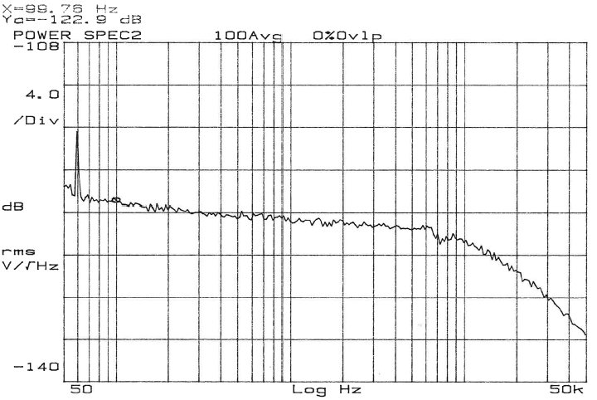

Record Noise value for 100 Hz, 1 kHz and 10 kHz

Figure ‑

## Data Analysis of Results

### Move the “X” cursor to 100 Hz. If the noise measurement is not in the range of the 100 Hz requirement from Table 1, the unit shall be considered non-conforming and handled accordingly.

### Move the “X” cursor to 1 kHz. If the noise measurement is not in the range of the 1 kHz requirement from Table 1, the unit shall be considered non-conforming and handled accordingly.

### Move the “X” cursor to 10 kHz. If the noise measurement is not in the range of the 10 kHz requirement from Table 1, the unit shall be considered non-conforming and handled accordingly.

# BROADBAND NOISE TESTING

## Test Process

### The connections for this test are the same as for standard Noise Testing (Section 12).

### Set up the analyzer to measure log resolution for four (4) decades. Channel 1 input, AC coupled and grounded. Stable mean averaging at least five (5) samples. Channel 1 range at analyzer minimum (3.99 mV). Trigger on free run. View power spectrum 1, using linear magnitude and units of V/√ Hz.

### Start the measurement and allow analyzer to collect data.

### Use the analyzer marker to view data at desired frequencies. (Typical frequencies of interest include 1 Hz., 10 Hz., 100 Hz., 1 kHz., and 10 kHz.). This is the spectral noise from the test sensor in V/√Hz.

### Use the following math to calculate broadband noise: First, multiply the trace by itself. Then, integrate the result. Next, take the square root. Locate the marker on the analyzer to 10 kHz. This is the broadband noise of the test sensor in volts.

# Surface Mount MEMS Testing

## Test Setup

### The connections for this test are shown in Figure 14-1.

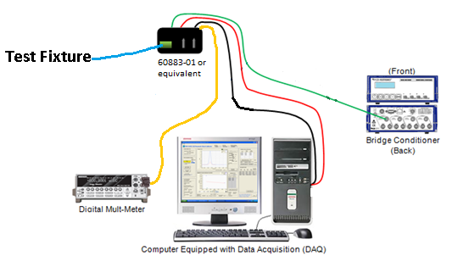

Figure ‑

#### Insure that the signal conditioner is in full bridge mode. The display should show a “B” for each of the four channels on the display (Figure 14-2). If it does not, use the arrow keys to navigate in the menu and select “INPT” (See Figure 14-3). In the input screen, use the arrow keys to move the cursor and select each channel in turn. Move the cursor to the right of each channel number, and scroll through the choices until “BRG FULL” is displayed, then hit enter (Figure 14-4).

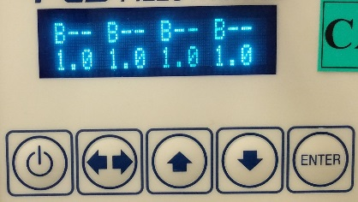

Figure ‑

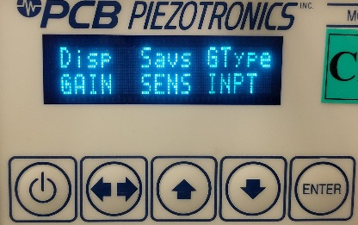

Figure ‑

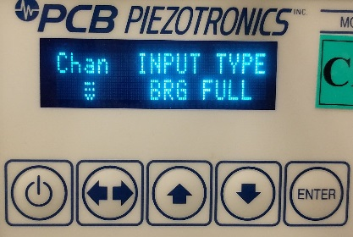

Figure ‑

### Open the “DC Sensor Test Program,” click DC MEMS Sensor Test (make sure Excel is not open)

#### Select the Manual Test tab. Click the manual test button and then select “Excitation” as the measured parameter. Wait until the units changes from ohms to volts to indicate a valid reading.

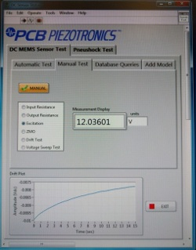

Figure ‑

#### If the excitation measured by the software is not 12V +/- 0.05V, the signal conditioner needs to be adjusted. If it adjustment is required, use the arrow keys to navigate in the menu and select “EXCv” (See Figure 14-6). Then use the arrow keys to move the cursor and select each channel in turn. Move the cursor to the right of each channel number, and adjust the number value until the voltage displayed by the software is correct (Figure 14-7).

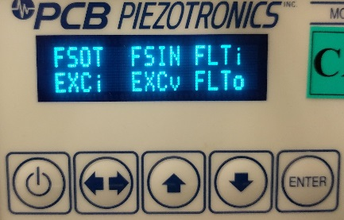

Figure ‑

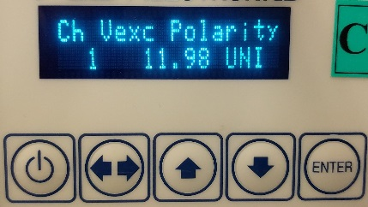

Figure ‑

#### While still in the Manual Test tab, click on the “Drift Test”. Wait until the units next to the number readout change to “uV” to know that the test is complete. (Running the drift test in manual re-sets the computer DAQ card so that the first reading during the test is valid.)

## Running The Test

### Place an assembly into the fixture (60883-01). Use the slot indicated in Figure 14-8. Be sure to place the assembly in the correct orientation as shown (Figure 14-8). Note that the location to be used is marked with an X above the location. The orientation of the assembly must also be aligned such that side arrow points to the internal gold trace that is wider relative to the other three. Lower the clamp over the assembly until it locks in place (Figure 14-9).

### Enter Model (40002-05), Serial Number (wafer and location if no SN), and Job Number. See Figure 14-10. The model number may be selected from the pull down menu. For 40002-05, it will default to z-axis, and this selection should not be changed.

### Select “pre-pneushock/shaker” (Figure 14-10)

### Select the “Test” Button (Figure 14-10)

### Select the “Save” Button if you have not already done so (Figure 14-10)

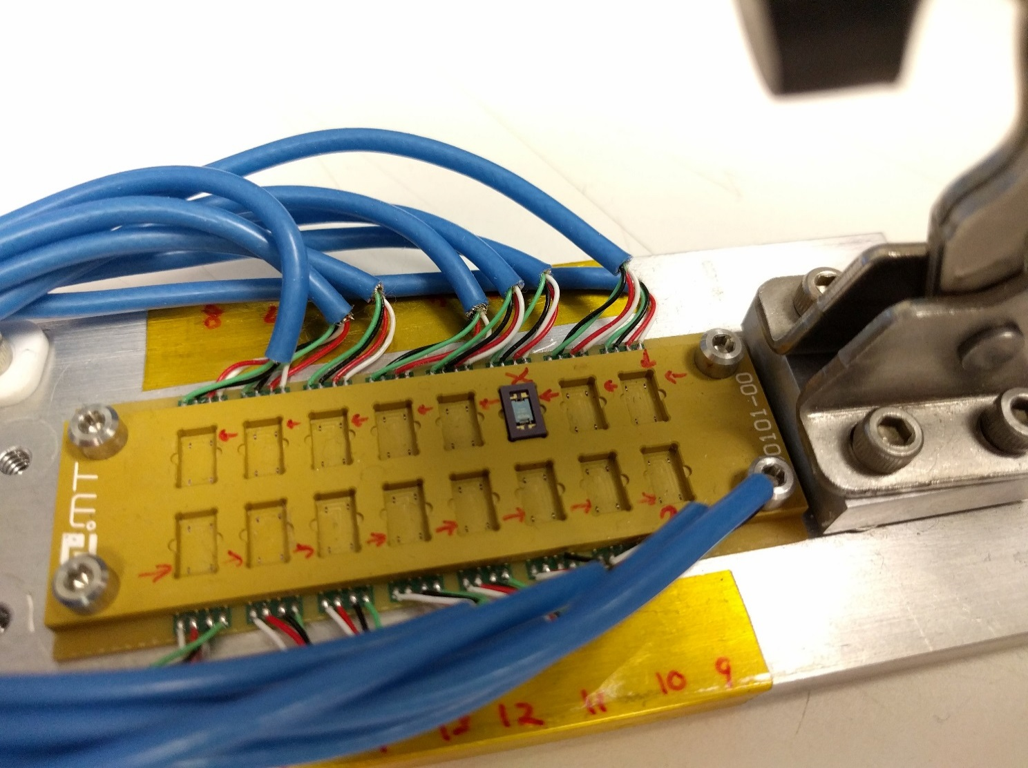

Figure ‑

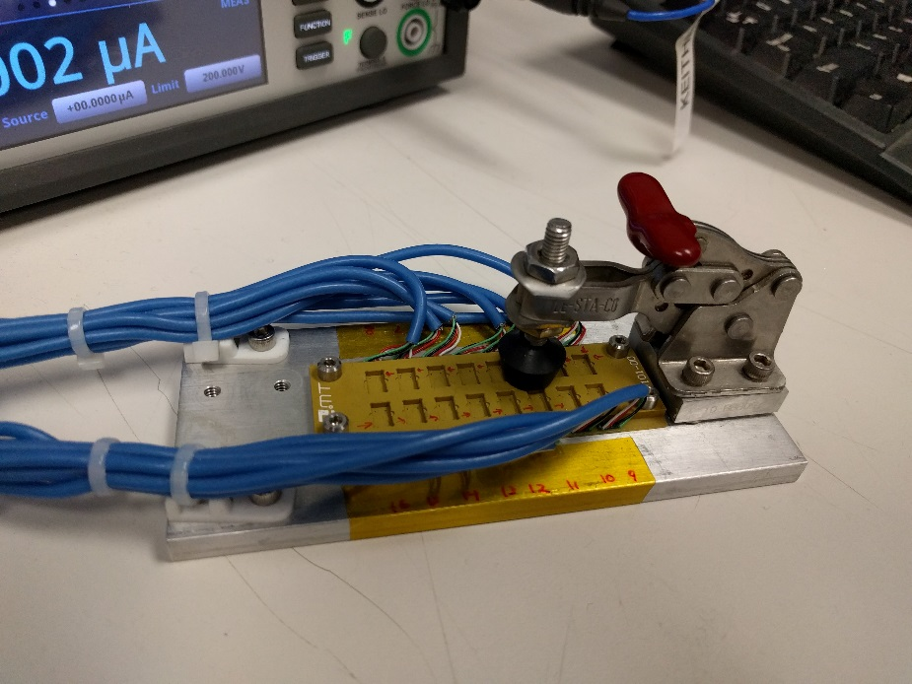

Figure ‑

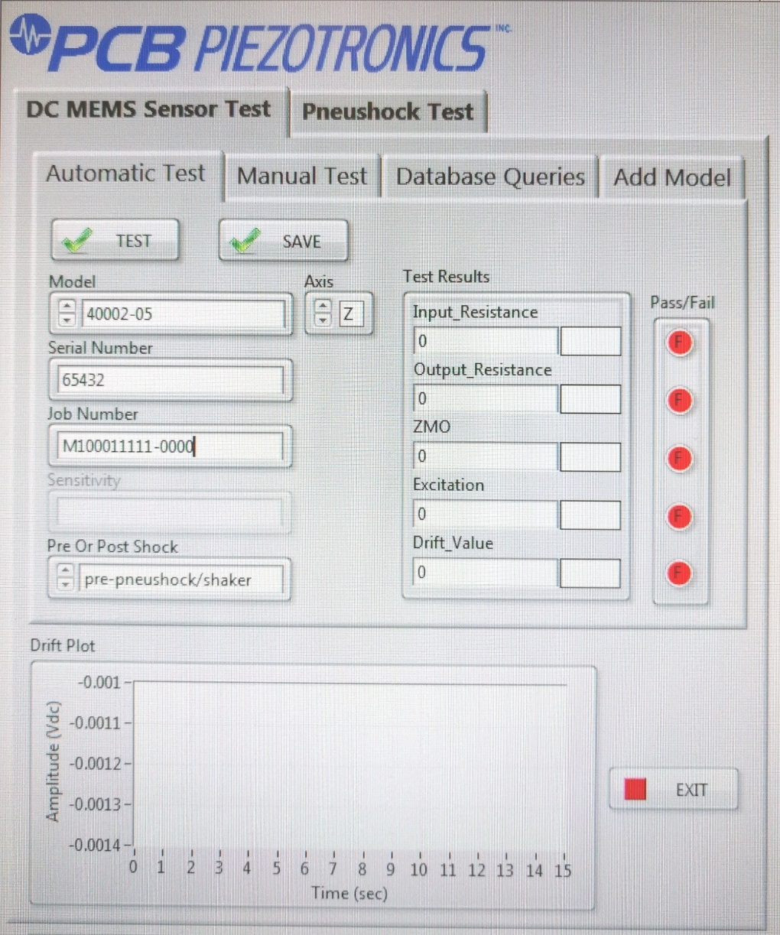

Figure ‑

# PACKAGING

## Pre-Package Inspection

### Any amplifier assembly that has an exposed capacitor must be inspected prior to packaging for delivery. Often, the overcoat material can migrate partially onto these capacitors, and prevent them from being used properly.

### Any overcoat epoxy that migrates onto the top surface of a feedback cap that is intended to be left exposed must be completely removed by lightly scraping. If 100% of the top surface cannot be exposed, the amplifier shall be considered non-conforming. If too much epoxy has migrated, it is not possible to rework the amplifier without damage, and it must be considered scrap. Refer to the images in Figure 15-1 to determine if a unit requires re-work by scraping.

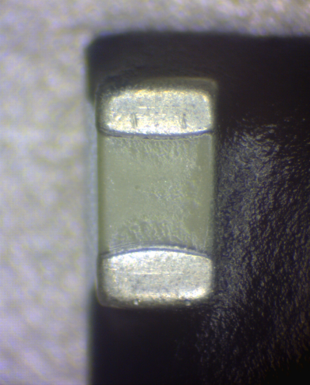 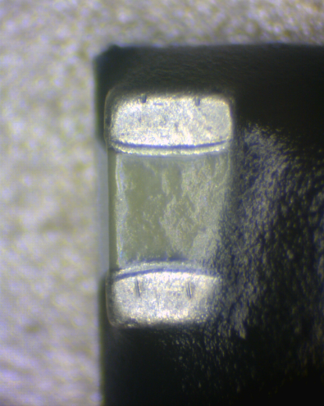 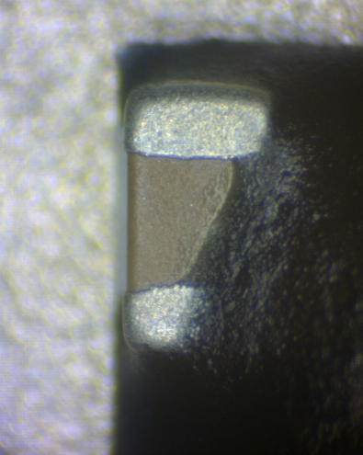

Conforming Non-Conforming Non-Conforming

No Rework Required Scraping Required Non-Reworkable (Scrap)

Figure 15-1

## Acetic Acid Clean

### If copper leads are highly corroded, they can be cleaned per the following: Place amplifiers in an acetic bath (3% v/v) for 4 minutes. Agitate the pieces gently to provide even coverage to the copper leads. After 4 minutes, remove pieces from the acetic bath and then perform a post cleaning using TA1061, Process F. Bake out ar 250F for a minimum of 10 minutes. Inspect copper leads for corrosion. If corrosion is still visible repeat the above process. If the corrosion has been successfully removed, the amplifiers are now ready to be delivered to production.

## Types of Containers Used to Package Amplifiers.

### Amplifiers with a rigid encapsulating overcoat (i.e. FP4401) NOT on a T-0X Header are to be packaged in 4” x 4” Waffle Pack STAT-PRO® 150 Black Conductive Poly cases (H44-400500-62C02 or equivalent) with locking clips fully engaged.

### Amplifiers with a rigid encapsulating overcoat (i.e. FP4401) on a T-0X Header are packaged in clamshell cases (Protektive Pak #57006 conductive box or equivalent) with T-0X Header pins fully inserted into the insertion grade (firm) foam. The case shall also include a cushion grade (soft) foam insert to hold the amplifiers in place during transport.

### Amplifiers with no overcoat, Sylgard (-99) overcoat, and all MEMS Devices are to be packaged “singulated” in tacky gel containers such that the amplifiers will not migrate within the container during transport. Where possible, use light pressure when loading Gel-Pak to promote adhesion. For MEMS devices, use a minimum of Tack “8”. Otherwise, Tack “3”, “4” or “5” should be used to prevent damage upon removal. Hinged 2x2 Gel-Paks of Tack “8” (100-15903-80) for sub-assemblies and 4”x4” vacuum release containers (GelPak VR-44 Series) for MEMS sensors are preferred but may be substituted with a 3.5"x4.5"x0.5"conductive hinged GelPak container (100-9008-00) when required based on availability or when the vacuum release container will not hold the amplifiers securely.

### All gel type containers are to be inspected for contamination on the gel surface prior to placing items in them. If any debris or heavy film is apparent on the gel, the surface should be cleaned with a piece of packing tape and/or isopropyl alcohol and a lint free cloth. If the gel becomes torn, or if the adhesion is still not acceptable after cleaning, the gel container must be discarded.

# DELIVERY AND JOB PAPERWORK

## Delivery

### Unless otherwise directed, all finished amplifiers that have no subsequent operations besides 998, shall be routed to Inventory Control so they can be received into inventory and stocked.

### Before routing any amplifiers to Inventory Control, the packaged part quantity must be verified against the quantity printed on the packaging label. Verification of this count shall be denoted by initialing next to the quantity on the label.

### Some jobs may require delivery directly to a group (i.e. to DC/MEMS) or person (i.e. an engineer) which will be defined in the job routing. This may be determined by the workcenter of the operation subsequent to the last test operation, an engineer’s initials in the job description if routing to an engineer, or other special instructions within the job routing.

### When routing to another group for further processing, place the packaged amplifiers along with job paperwork into a black ESD travel box and affix a label to the end denoting job, model, and quantity.

### If processing parts on a TA081 and the next operation is not 998 (for receipt into inventory), route according to the rework instructions. If batch processing these jobs to leave the Micro area, stage these jobs on the “OUTGOING STAGING AREA-NOT GOING TO INVENTORY CONTROL” shelf to avoid inadvertent delivery to Inventory Control.

## Job Paperwork

### After completing all operations on a job, place the completed jobs paperwork in the “jobs to be scanned” bin located in the Micro test area.

### If routing amplifiers directly to a group or person where there are subsequent incomplete operations, deliver the job paperwork with the amplifiers.