Table of Contents

1 Test Setup 1

1.1 Test Schedule 1

1.2 System Startup 1

1.3 Select and Place Cartridge 2

1.4 Using the Dage Software 2

2 Production Testing 4

2.1 Test Process for Wire Pull 4

2.2 Test Process For Ball Shear 5

# Test Setup

## Test Schedule

### Testing a bond shall consist of doing a destructive wire pull and then shearing the associated ball bond. If the wire is bonded with a security bond at the tail, shearing the security bond is optional. If sheared, the security bond is to be sheared in a direction perpendicular to the wire direction. If the bond process makes use of a stand-off-stitch for the tail bond, shearing the stitch ball is mandatory. It should also be sheared perpendicular to the wire direction.

### The following table (Table 1-1) indicates when to perform testing during standard production. The testing must be performed as indicated before any other items are wirebonded.

|  |  |  |  |
| --- | --- | --- | --- |
| When To Test | What Wirebond Machine | What Assembly | What Bonds |
| At The Start of Every Shift | Each Machine in Use | 50351-01 | All Bonds on 1pc. |
| After Every Capillary Change | Machine with New Capillary | 50351-01 | All Bonds on 1pc. |
| After Every Wire Spool Change | Machine with New Spool | 50351-01 | All Bonds on 1pc. |
| When Operator Has Quality Concern | Machine in Question | Assembly In Question | As Needed |

Table 1‑1

## System Startup

### The equipment used for the testing is a Dage Optima Pull/Shear tester. The machine itself must be powered on before the computer is powered on. The power switch for the machine is located on the lower left hand side of the machine. After turning on equipment power, wait until the workstage lamps light and go out and then power on the computer.

### Once the computer is running, locate the icon for the Dage Paragon software, and double click to start the program. The main program screen is shown in Figure 1-1.

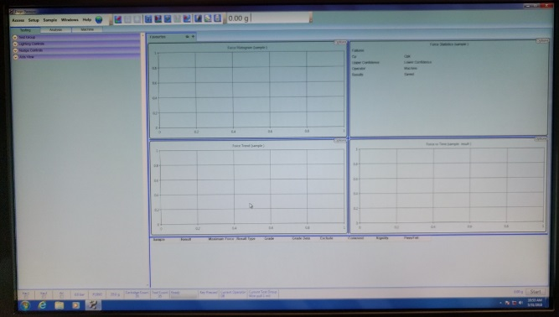

Figure 1‑1

### **CAUTION:** Once the software has started, it will need to home the table axis before the machine can be used. The table will move to its maximum extents during this operation. Be sure to keep hands, tools, and other materials away from the table while it homes.

## Select and Place Cartridge

### Each type of test the Dage can perform requires a cartridge with a specific force range and tool type. For gold wire pull testing, there is a 100g maximum range cartridge with a hook tool on it. For gold ball shearing, there is a 250g maximum range cartridge with a shearing tool on it.

### Select the cartridge for the test being performed. If the cartridge is not on the machine a cartridge change must be performed.

### 

Figure 1‑2

## Using the Dage Software

### To begin a test, select “Sample”, “New” from the menus. See Figure 1-3.

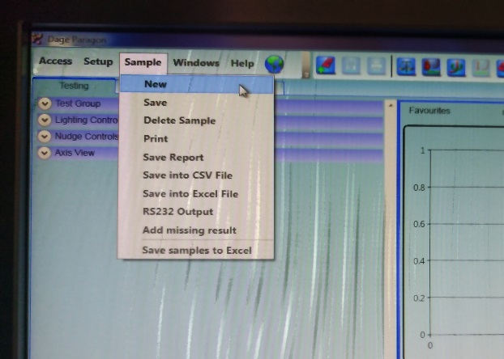

Figure 1‑3

### On the resulting window, choose the test type at the top (pull vs. shear, see Figure 1-4), and enter the relevant test info (Job, Item, Machine, and number of samples, see Figure 1-5). The Item and Machine are selected from a pull down list. If the item is not in the list, see engineering. The number of samples will usually be 1. This is the number of individual substrates to be tested.

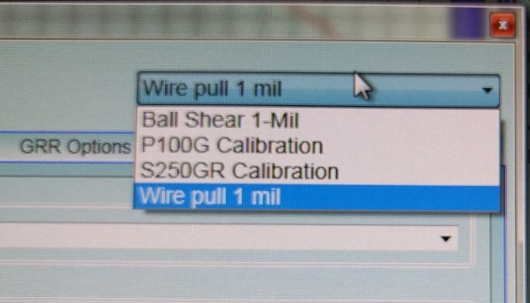

Figure 1‑4

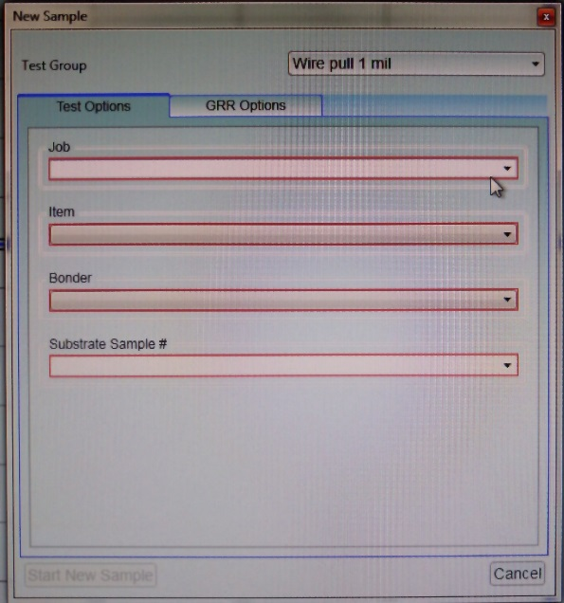

Figure 1‑5

### Once the test information is entered, the software will return to the main screen and the system is ready to begin testing.

# Production Testing

## Test Process for Wire Pull

### The assembly to be tested must be held securely during the tests. The recommended option is to place the sample(s) into a wirebonder fixture (See TA1053 for appropriate fixture for the substrate) and ensure the cams are all tightened. Place the fixture onto the workstage and turn on the vacuum if vacuum is desired.

### Using the left side joystick, maneuver the workholder and position a sample wire over the hook on pull tester, but not touching the hook. The right joystick moves the hook up/down and rotates the hook. Make sure not to damage the wire, component or hook.

### When the hook is in position under one of the wires, press the “T” button on the right hand keypad (Figure 2-1) to start the test. The hook will lift and break the wire.

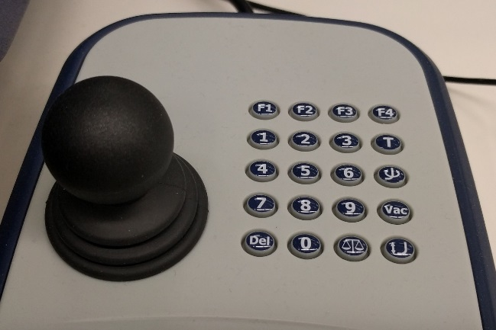

Figure 2‑1

### If the test is successful, the grading window will appear, and the type of break can be selected. Each wire pull must be graded. Select “Ball” if the entire ball lifted from the pad, select “Tail” if the tail lifted free, select “Neck” if the wire broke at or close to the top of the ball. Otherwise, select “Wire” if the wire broke somewhere in the middle.

### If something went wrong and the wire was not pulled, there will be a window with a garbage can in the lower left. Clicking this will remove the result and move to the next wire to be pulled.

### If the pull was successful, but the force was out of spec, there will be a warning displayed in a yellow bar at the bottom of the grading window (Figure 2-2). If a pull is out of spec, do not proceed with production. Contact the supervisor and/or manufacturing engineer.

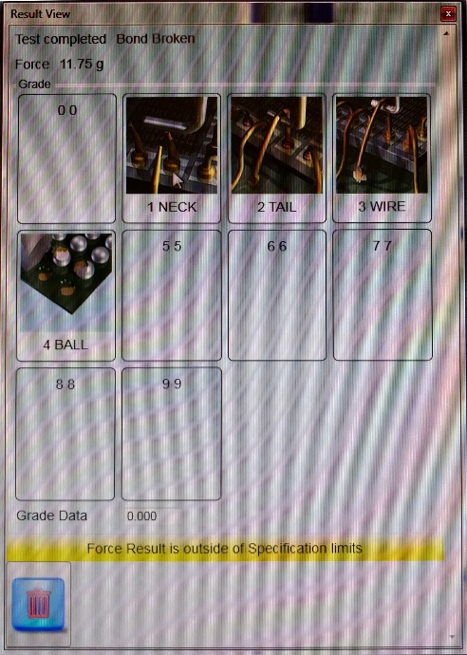

Figure 2‑2

### Once a pull is successful, the hook will return to the start position. Use the joysticks to move the stage to the next wire position and repeat the pull process and grading. Once all of the wires on a substrate are pulled, click on the “save” icon, or click on “save” under the sample menu.

## Test Process For Ball Shear

### The assembly to be tested must be held securely during the tests. The recommended option is to place the sample(s) into a wirebonder fixture (See TA1053 for appropriate fixture for the substrate) and ensure the cams are all tightened. Place the fixture onto the workstage and turn on the vacuum if vacuum is desired.

### Using the left side joystick, maneuver the workholder and position a sample gold ball next to the shear tool, but not touching the tool. The right joystick moves the tool up/down and rotates the tool. Rotate the tool so that the flat is facing the ball. The machine will always move the tool in the direction of the flat, no matter which way it is facing.

### Move the tool down until it touches the surface that the ball is on. (The machine will stop driving the vertical axis when it senses contact.) With the tool touching this surface, click the “Null the tool” icon. (Figure 2-3)

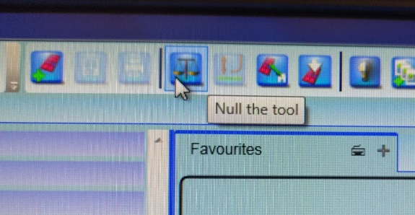

Figure 2‑3

### Once the null is done, raise the tool up slightly (about the height of the ball). If necessary, make any final adjustments to tool position. The tool should be placed so that the entire ball will be within the flat area of the tool when it shears. When ready, press the “T” button on the right hand keypad (Figure 2-1) to start the test.

### If the test is successful, the grading window will appear, and the type of shear can be selected. Each shear must be graded. Select “Pad Lift” if some or all of the original pad came off the die or substrate and exposed silicon or ceramic underneath, select “Ductile” if some gold is left on the pad and the rest is still part of the ball. Otherwise, select “Interface” if all of the gold came off the pad.

### If something went wrong and the test failed in some way, there will be a window with a garbage can in the lower left. Clicking this will remove the result and move to the next gold ball to be sheared.

### If the shear was successful, but the force was out of spec, there will be a warning displayed in a yellow bar at the bottom of the grading window (Figure 2-2). If a shear is out of spec, do not proceed with production. Contact the supervisor and/or manufacturing engineer.

### Once a shear is successful, the tool will return to the start position. Use the joysticks to move the stage to the next ball position and repeat the shear process and grading. If the ball is on a new die, the Nulling process should be repeated. Once all of the balls on a substrate are sheared, click on the “save” icon, or click on “save” under the sample menu.