**Referenced Documents**

Procedure No. Document Description

TA1039 General Workmanship for TA

TA1288 Ultrasonic cleaner Setup

TA1074 Foreign Object Debris

TA1276 Vapor Degreaser setup

**Contents**

PROCESS A: HEATED ULTRASONIC CLEANING WITH LENIUM® 3

PROCESS B: BRUSH CLEANING WITH LENIUM® 5

PROCESS C: LENIUM® SOAK 7

PROCESS D: HEATED ULTRASONIC CLEANING WITH IPA 9

PROCESS E: BRUSH CLEANING WITH IPA 11

PROCESS F: ISOPROPYL ALCOHOL (IPA) SOAK 13

PROCESS G: GENERAL SURFACE CLEANING 14

PROCESS H: VAPOR DEGREASER CLEANING 15

PROCESS J: UNHEATED ULTRASONIC CLEANING WITH LENIUM® 16

PROCESS K: UNHEATED ULTRASONIC CLEANING WITH IPA 18

APPENDIX A 20

SURFACE CLEANING 20

CRITICAL FIXTURES 22

NON-CRITICAL FIXTURES 23

ALL OTHER FIXTURES: 24

CLEANROOM TRANSPORT BOX CLEANING 25

STANDARD ESD TRANSPORT BOX CLEANING 25

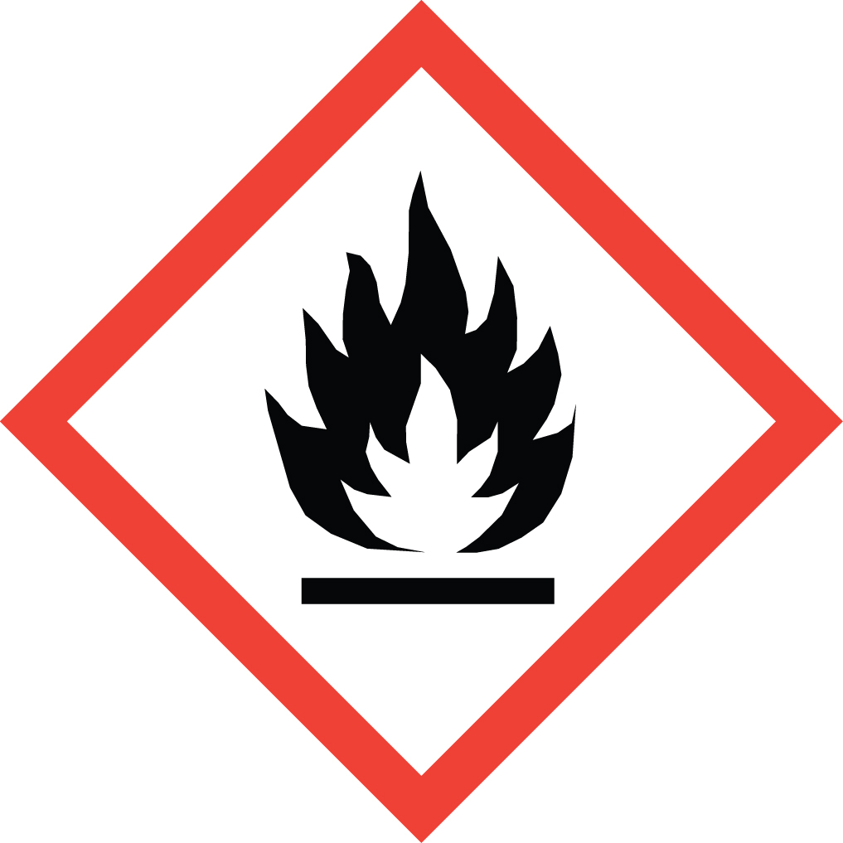 

**IPA (Isopropyl Alcohol) – Highly Flammable!**

The processes outlined in this procedure involve the use of Isopropyl Alcohol (IPA). This is a highly flammable material that can be ignited by the smallest of sparks. Extreme care must be observed at all times during its use. IPA evaporates easily at room temperature and forms an invisible vapor. These vapors are heavier than air, and will flow for long distances along surfaces. If the vapor contacts a distant ignition source, it may flash back to the Beaker/container.

When working with IPA in volumes greater than 16 fl. oz., the work area must be vented to the outside, or through a suitable filtration system.

***Lenium® ES***

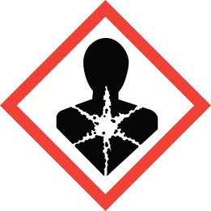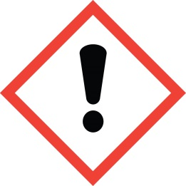

*Ingestion of Lenium® may be harmful, and prolonged exposure will cause skin irritation. Wearing finger cots or gloves (nitrile rubber or latex) during its use, and washing hands with soap and water after its use, is recommended.*

PROCESS A: HEATED ULTRASONIC CLEANING WITH LENIUM®

**Guidelines**

Use this process to clean:

* + Heavily contaminated machined parts
  + Heavily contaminated subassemblies
  + Heavily contaminated fixtures and tooling
  + Final sensor wash

Do **NOT** use this process to clean assemblies that contain the following. Use **TA1041 Process D**.

* Dow Corning® SYLGARD® 184 silicone elastomer
* Uncoated amplifiers with exposed wire bonds. Use **Process F**.
* 1838 Green epoxy

Do **NOT** use this process to clean:

* Hardened flux

**Required Equipment\***

Personal Protective (Lenium® see safety section)

Equipment (PPE): ESD grounding strap**, chemical goggles, and finger cots or gloves (nitrile rubber or latex)

1st Clean Solvent: Lenium® ES (Stainless steel beaker/container)

2nd Clean Solvent: Lenium® ES (Stainless steel beaker/container)

Rinse Solvent: Lenium® ES (ESD squirt bottle)

Equipment: Heated ultrasonic cleaner filled with tap water, ventilation system**, ionizing blower, and

oven (250° F)

\**Refer to B.O.M. 52800-01 for equipment part numbers*

*\*\*ESD grounding strap and ventilation system not applicable at PMC*

**Procedure:**

1. Turn on ventilation system
2. Plug in ESD strap.
3. Put on chemical goggles.
4. Follow Ultrasonic Setup. See TA1288 for the Ultrasonic model being used.
5. Wipe the selected beaker/container clean of debris and residue from previous operator.
6. Gently place parts into beaker/container. Ensure units with delicate components are appropriately spaced to avoid damage. Use fixtures as specified in the documentation.
7. Add Lenium® to the beaker/container to cover all the parts.
8. Run cycle for 10 minutes with heat on Set Temp 35°C.
9. Put on gloves.
10. Lift the beaker/container out of the insert tray.
11. Rinse parts with fresh Lenium®.
12. Remove used Lenium® from beaker/container, rinse container with fresh Lenium®.
13. Place parts into a clean container.
14. Place parts on an ionizing table for a minimum of one (1) minute or blow off with clean air.
15. Dry parts in 250 F oven for (15) minutes minimum.

PROCESS B: BRUSH CLEANING WITH LENIUM®

**Guidelines**

Use this process to clean:

* + Flux from solder connections

Do **NOT** use this process to clean:

* + Assemblies that contain Dow Corning® SYLGARD® 184 Silicone Elastomer. Use **Process E**.
  + Uncoated amplifiers with exposed wire bonds. Use **Process F**.
  + 1838 epoxy

**Required Equipment\***

Personal Protective Refer to **Safety** section on Lenium® usage

Equipment (PPE):

Pre-Clean Solvent: Lenium® ES

Amber glass with stainless steel pump, back-flow check valve, and lid

Label: Blue “Lenium® PRE-CLEAN 1” with NFPA codes

Pre-Clean Brush: Horse or camel hair bristle with quill, tin, or stainless steel handle

Label: Blue “Lenium® #1”

Final-CleanSolvent: Lenium® ES

Amber glass with stainless steel pump, back-flow check valve, and lid

Label: Red “Lenium® FINAL CLEAN 2” with NFPA codes

Final-Clean Brush: Horse or camel hair bristle with quill, tin, or stainless steel handle

Label: Red “Lenium® #2”

In Process Brush: Double-Ended Applicator Brush (GEP, DC/MEMS, Halifax Sub-Assemblies, and Cable Groups Only)

Pressurized Air: Air bulb, filtered air nozzle, dusting spray, or ionizing blow-off gun

Equipment: Microscope with 10X magnification

*\*Refer to B.O.M. 52800-01 for equipment part numbers.*

**Controls:**

* In process brush – double-ended applicator brush is cleaned, using **Process A**, on the 1st day of each month. The brush is labeled with the expiration date, 3 months after the issue date.
* Brushes may be cleaned or replaced as contaminants become evident. Clean brushes per **Process A**.
* Brushes must be replaced on the 1st day of each month.
* Container lids must be wiped clean daily. For each container, fill bowl with solvent and use low-lint wipe. Lids may be wiped more frequently as contaminants become evident.
* Container lids may be cleaned per **Process A**.
* Containers must be emptied and cleaned prior to replenishing solvents. Dispose of remaining solvent, rinse inside of container with fresh solvent, then fill container with fresh solvent.

**Procedure:**

1. Review **Guidelines**, **Equipment**,and **Controls** sections of this process.
2. Excess flux may be picked free and blown off with pressurized air prior to brush cleaning.
3. Pre-clean solder connections with Blue “Lenium® #1” labeled brush and Lenium® until flux is no longer visible.
4. Blow off excess Lenium® with pressurized air.
5. Final-clean solder connections with Red “Lenium® #2” labeled brush until no residue is visible.
6. Blow off excess Lenium® with pressurized air. Tip the unit over while blowing out excess Lenium® to aid in removal of contaminants from blind areas.

**Note:** If performing any testing (e.g. Standardize Sensitivity) allow product to air dry for two (2) minutes minimum.

1. Visually inspect parts for contamination under scope with **10X** magnification. Be sure to check inside holes, sleeves and recesses.

PROCESS C: LENIUM® SOAK

**Guidelines**

Use this process to clean:

* + Crystals
  + Thin metal diaphragms
  + Electrodes
  + Charge pickup assemblies
  + Uncoated amplifiers

Do **NOT** use this process to clean:

* + Assemblies that contain Dow Corning® SYLGARD® 184 Silicone Elastomer. Use **Process E**.
  + Uncoated amplifiers with exposed wire bonds. Use **Process F**.
  + 1838 epoxy

**Required Equipment\***

Soaking Solvent: Lenium®

Container: Stainless steel beaker/container

Rinse Solvent: Lenium®

Container: ESD squirt bottle

Equipment: Oven (250° F)

*\*Refer to B.O.M. 52800-01 for equipment part numbers*

**Controls:**

* Open beaker/container of Lenium® must be covered during extended periods of non-use to minimize evaporation and to keep contaminants out.
* Open beaker/container of Lenium® must be replaced at a minimum of once per shift, or more frequently depending on level of contamination (i.e. discoloration or visual particulates). To replace Lenium®, dispose of remaining solvent, rinse inside of beaker/container with fresh Lenium®, then fill container with fresh Lenium®.

**Procedure:**

1. Place product in beaker/container of solvent and allow to soak for ten (10) minutes minimum.

**NOTE:** Wear gloves/finger cots for all remaining steps. The parts are now clean and will be contaminated by handling.

1. Remove parts from the beaker/container and drain the solvent into a waste container.
2. Rinse parts thoroughly with virgin Lenium® over a waste Lenium® container.
3. Place parts into a clean container.
4. **Dry** parts in 250 F oven for **five (5) minutes** minimum

PROCESS D: HEATED ULTRASONIC CLEANING WITH IPA

**Guidelines**

Use this process to clean:

* + Machined parts
  + Subassemblies
  + Fixtures and tooling
  + Final sensor wash

Do NOT use this process to clean:

* Hardened flux

**Required Equipment\***

Personal Protective

Equipment (PPE): ESD grounding strap**, chemical goggles, and finger cots or gloves (nitrile rubber or latex)

Cleaning Solvent: Isopropyl Alcohol (IPA)

Stainless steel beaker/container.

Rinse Solvent: Isopropyl Alcohol (IPA)

ESD squirt bottle

Equipment: Heated ultrasonic cleaner filled with tap water, ventilation system**, ionizing blower, and

oven (250° F)

* *Refer to B.O.M. 52800-01 for equipment part numbers*

\*\**ESD grounding strap and ventilation system not applicable at PMC*

**Procedure:**

1. Turn on ventilation system.
2. Put on chemical goggles.
3. Plug in ESD strap.*
4. Follow Ultrasonic Setup. See TA1288 for the Ultrasonic model being used.
5. Wipe/rinse the selected beaker/container with IPA to remove any debris or residue from the previous operator.
6. Gently place parts into beaker/container. Ensure units with delicate components are appropriately spaced to avoid damage. Use fixtures as specified in the documentation.
7. Add IPA to beaker/container to cover all parts.
8. Place beaker/container into Ultrasonic and run cycle for 15 minutes @ 35ºC.
9. Put on gloves.
10. Lift the beaker/container out of the insert tray.
11. Rinse parts thoroughly with virgin IPA and dispose of waste in the appropriate container.
12. Place parts into a clean container.
13. Place parts on an ionizing table for a minimum of one (1) minute or blow off with clean air.
14. Dry parts in 250 F oven for fifteen (15) minutes minimum.

PROCESS E: BRUSH CLEANING WITH IPA

**Guidelines:**

Use this process to clean:

* + Flux from solder connections where Dow Corning® SYLGARD® 184 Silicone Elastomer is present
  + 1838 EPOXY

Do **NOT** use this process to clean:

* + Uncoated amplifiers with exposed wire bonds. Use **Process F**.

**Required Equipment\***

Pre-Clean Solvent: Isopropyl Alcohol (IPA)

Container: Dissipative HDPE with stainless steel pump, back-flow check valve, and lid

Label: Clear “IPA PRE-CLEAN 1” with NFPA codes

Pre-Clean Brush: Horse or camel hair bristle with quill, tin, or stainless steel handle

Label: Clear “IPA #1”

Soaking Solvent: Isopropyl Alcohol (IPA)

Container: Stainless Steel beaker/container

Final-CleanSolvent: Isopropyl Alcohol (IPA)

Container: Dissipative HDPE with stainless steel pump, back-flow check valve, and lid

Label: Black “IPA FINAL CLEAN 2” with NFPA codes

Final-Clean Brush: Horse or camel hair bristle with quill, tin, or stainless steel handle

Label: Black “IPA #2”

In Process Brush: Double-Ended Applicator Brush (GEP, DC/MEMS, Halifax Sub-Assemblies, and Cable Groups Only)

Pressurized Air: Air bulb, filtered air nozzle, dusting spray, or ionizing blow-off gun

Equipment: Microscope with 10X magnification

*\*Refer to B.O.M. 52800-01 for equipment part numbers*

**Controls:**

* In process Brush – Double-Ended Applicator Brush is cleaned, using **Process D**, on the 1st day of each month. The brush is labeled with the expiration date, three months after the issue date.
* Brushes may be cleaned or replaced as contaminants become evident. Clean brushes per **Process D**.
* Brushes must be replaced on the 1st day of each month.
* Container lids must be wiped clean daily. For each container, fill bowl with solvent and use low-lint wipe. Lids may be wiped more frequently as contaminants become evident.
* Container lids may be cleaned per **Process D**.
* Containers must be emptied and cleaned prior to replenishing solvents. Dispose of remaining solvent, rinse inside of container with fresh solvent, then fill container with fresh solvent.
* Open beaker/container of IPA must be covered during extended periods of non-use to minimize evaporation and to keep contaminants out.
* Open beaker/container of IPA must be replaced at a minimum of once per shift, or more frequently depending on level of contamination (i.e. discoloration or visual particulates). To replace IPA, dispose of remaining solvent, rinse inside of beaker/container with fresh IPA, then fill container with fresh IPA.

**Procedure:**

1. Review **Guidelines, Equipment, and Controls** section of this process before performing operations.
2. Excess flux may be picked free and blown off with pressurized air prior to brush washing.
3. Pre-clean solder connections with Clear “IPA #1” labeled brush and IPA until flux is no longer visible.
4. Place product in beaker/container of IPA and allow to soak for one (**1**) minute minimum.
5. Remove product from the soak and blow off IPA with pressurized air.
6. Final-clean solder connections with Black “IPA #2” labeled brush and IPA until no residue is visible.
7. Blow off excess IPA with pressurized air. Tip the unit over while blowing out excess IPA to aid in removal of contaminants from blind areas.

**Note:** If performing any testing (e.g. Standardize Sensitivity) allow product to air dry for two (**2**) minutes minimum.

1. Visually inspect parts for contamination under scope with 10X magnification. Be sure to check inside holes, sleeves and recesses.

PROCESS F: ISOPROPYL ALCOHOL (IPA) SOAK

**Guidelines**

Use this process to clean:

* + Crystals
  + Thin metal diaphragms
  + Electrodes
  + Charge pickup assemblies
  + Uncoated amplifiers

**Required Equipment\***

Soaking Solvent: Isopropyl Alcohol (IPA)

Container: Stainless steel beaker/container

Rinse Solvent: Isopropyl Alcohol (IPA)

Container: ESD squirt bottle

Equipment: Oven (250° F) Not applicable at Precision Machining Center PMC

*\*Refer to B.O.M. 52800-01 for equipment part numbers*

**Controls:**

* Open beaker/container of IPA must be covered during extended periods of non-use to minimize evaporation and to keep contaminants out.
* Open beaker/container of IPA must be replaced at a minimum of once per shift, or more frequently depending on level of contamination (i.e. discoloration or visual particulates). To replace IPA, dispose of remaining solvent, rinse inside of beaker/container with fresh IPA, then fill container with fresh IPA.

**Procedure:**

1. Place product in beaker/container of solvent and allow to **soak** for ten (**10**) minutes minimum.

**NOTE:** Wear gloves/finger cots for all remaining steps. The parts are now clean and will be contaminated by handling.

1. Remove parts from the beaker/container and drain the solvent into a waste container.
2. Rinse parts thoroughly with virgin IPA over a waste IPA container.
3. Place parts into a clean container.
4. Dry parts in 250 F oven for five (5) minutes minimum.

PROCESS G: GENERAL SURFACE CLEANING

**Guidelines:**

Use this process to clean:

* + Weld joints
  + Uncured epoxy
  + Fixtures and tools

**Required Equipment\***

Personal Protective

Equipment (PPE): Lenium® see safety section

Cleaning Solvent: Isopropyl Alcohol (IPA) or Lenium® ES*

Applicators: Low-lint wipes, cotton tipped swabs, foam swabs, gauze pads, and brushes (horse or camel hair bristle with quill, tin, or stainless steel handle)

Pressurized Air: Air bulb, filtered air nozzle, dusting spray, or ionizing blow-off gun

Equipment: Microscope with 10X magnification

*\*Refer to B.O.M. 52800-01 for equipment part numbers*

**Procedure:**

1. Moisten applicator with solvent and wipe part clean.

**NOTE:** Wear gloves for all remaining steps. The parts are now clean and will be contaminated by handling.

1. Blow off excess solvent with pressurized air until visibly dry.
2. Visually inspect parts for contamination under scope with 10X magnification. Be sure to check inside holes, sleeves and recesses.

PROCESS H: VAPOR DEGREASER CLEANING

**Guidelines:**

Use this process to clean:

* + Fixtures and tools

Only METAL fixtures are to be cleaned in the Aero Tron, unless there is Engineering approval.

Any questions about material compatibility see Engineering.

**Required Equipment\***

**Detail recipes for PFT specific**

**Reference** TA1276 **for setup**

PROCESS J: UNHEATED ULTRASONIC CLEANING WITH LENIUM®

**Guidelines**

Use this process to clean:

* + Contaminated machined parts
  + Contaminated subassemblies
  + Contaminated fixtures and tooling

Do **NOT** use this process to clean assemblies that contain the following. Use **Process D**.

* Dow Corning® SYLGARD® 184 silicone elastomer
* EPO-TEK® 353ND epoxy
* Hysol® FP4323 epoxy encapsulant.
* 1838 Green epoxy

Do **NOT** use this process to clean:

* Flux

**Required Equipment\***

Personal Protective (Lenium® see safety section)

Equipment (PPE): ESD grounding strap**, chemical goggles, and finger cots or gloves (nitrile rubber or latex)

1st Clean Solvent: Lenium® ES (Stainless steel beaker/container)

2nd Clean Solvent: Lenium® ES (Stainless steel beaker/container)

Rinse Solvent: Lenium® ES (ESD squirt bottle)

Equipment: Ultrasonic cleaner filled with tap water, ionizing blower, and

oven (250° F)

\**Refer to B.O.M. 52800-01 for equipment part numbers*

*\*\*ESD grounding strap not applicable at PMC*

**Procedure:**

1. Turn on ventilation system
2. Plug in ESD strap.
3. Put on chemical goggles.
4. Follow Ultrasonic Setup. See TA1288 for the Ultrasonic model being used.
5. Wipe the selected beaker/container clean of debris and residue from previous operator.
6. Gently place parts into beaker/container. Ensure units with delicate components are appropriately spaced to avoid damage. Use fixtures as specified in the documentation.
7. Add Lenium® to the beaker/container to cover all the parts.
8. Run cycle for 20 minutes.
9. Put on gloves.
10. Lift the beaker/container out of the insert tray.
11. Rinse parts with Lenium®.
12. Remove used Lenium® from beaker/container, rinse container with fresh Lenium®.
13. Place parts into a clean container.
14. Place parts on an ionizing table for a minimum of one (1) minute or blow off with clean air.
15. Dry parts in 250 F oven for (15) minutes minimum.

PROCESS K: UNHEATED ULTRASONIC CLEANING WITH IPA

**Guidelines**

Use this process to clean:

* + Machined parts
  + Subassemblies
  + Fixtures and tooling

Do NOT use this process to clean:

* Flux

**Required Equipment\***

Personal Protective

Equipment (PPE): ESD grounding strap**, chemical goggles, and finger cots or gloves (nitrile rubber or latex)

Cleaning Solvent: Isopropyl Alcohol (IPA)

Stainless steel beaker/container.

Rinse Solvent: Isopropyl Alcohol (IPA)

ESD squirt bottle

Equipment: Ultrasonic cleaner filled with tap water, ionizing blower, and

oven (250° F)

* *Refer to B.O.M. 52800-01 for equipment part numbers*

\*\**ESD grounding strap and ventilation system not applicable at PMC*

**Procedure:**

1. Turn on ventilation system.
2. Put on chemical goggles.
3. Plug in ESD strap.*
4. Follow Ultrasonic Setup. See TA1288 for the Ultrasonic model being used.
5. Wipe/rinse the selected beaker/container with IPA to remove any debris or residue from the previous operator.
6. Gently place parts into beaker/container. Ensure units with delicate components are appropriately spaced to avoid damage. Use fixtures as specified in the documentation.
7. Add IPA to beaker/container to cover all parts.
8. Place beaker/container into Ultrasonic and run cycle for 20 minutes.
9. Put on gloves.
10. Lift the beaker/container out of the insert tray.
11. Rinse parts thoroughly with virgin IPA and dispose of waste in the appropriate container.
12. Place parts into a clean container.
13. Place parts on an ionizing table for a minimum of one (1) minute or blow off with clean air.
14. Dry parts in 250 F oven for fifteen (15) minutes minimum.

APPENDIX A

SURFACE CLEANING

This section applies to various surfaces including but not limited to:

Benchtops

Equipment

Containers

Shelves

1. Reference Figure 2.
2. Wear cleanroom gloves before wiping any surfaces.
3. Use pre-wetted wiper.

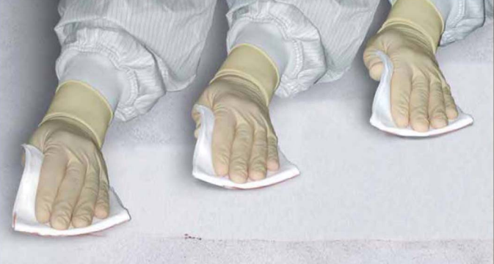

Figure 1

1. Reference Figure 2.
2. Fold wipe into quarter folds.
3. Wipe in one direction, overlapping each subsequent wipe by ~25%.
4. Wipe from cleanest to least clean areas . . . from top to bottom or left to right of a surface.
5. Keep track of which areas of the wiper have been used. Throughout the cleaning, unfold the wiper as it becomes contaminated and always use a clean portion of the wiper.
6. Dispose of wiper (do not reuse).

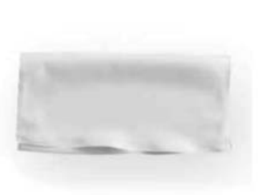

Figure 2

CRITICAL FIXTURES

This section applies to all fixtures that are used with high impedance parts (e.g. quartz, ceramic, insulators, electrodes, or any part that comes in contact with them) and fixtures with complex shapes that are not easily wiped clean. These fixtures include, but are not limited to:

Element preload fixtures

Crystal alignment fixtures

Package fixtures

Spring loaded preload fixtures

176 element accel comp fixtures (element has exposed crystals)

Transportation fixtures with blind holes

ISO7 fixtures must be cleaned AFTER use (on one job) so that they are clean and ready for the next job.

1. Inspect fixture (threads, small crevices, blind holes, alignment surfaces) at 10X minimum magnification ensuring no particles present.
2. Use clean gray-line air to blow off any remaining visible particles
3. Re-clean as needed.
4. After use (on one job), place fixtures on ‘dirty’ fixture rack in appropriate bins to be sent for cleaning.
5. Fixture rack will be removed from ISO7 room daily for cleaning per TA1041 process A unless otherwise specified.
6. 3D Printed fixtures and plastic fixtures are cleaned per TA1041 process G alcohol only.
7. After cleaning, fixtures will be returned to ‘clean’ fixture rack inside of the ISO7 room.

ISO8 Fixtures must be cleaned BEFORE use (on one job).

1. Clean fixtures per TA1041 process A unless otherwise specified.
2. 3D Printed fixtures and plastic fixtures are cleaned per TA1041 process G alcohol only.
3. Inspect fixture (threads, small crevices, blind holes, alignment surfaces) at 10X minimum magnification ensuring no particles present.
4. Use filtered air to blow off any remaining visible particles.
5. Re-clean as needed.
6. After use (on one job), return fixtures to fixture rack in appropriate bins.

NON-CRITICAL FIXTURES

This section applies to all fixtures that are not used with high impedance parts (e.g. quartz, ceramic, insulators, electrodes, or any part that comes in contact with them) and fixtures with flat shapes that are easily wiped clean. These fixtures include, but are not limited to:

Spot weld fixtures

Polarity check fixture

Calibration manifolds

Air collets

Vise

Flat Trays

Bolt stretcher

Beakers

1. Wipe all fixtures with lint free cloth dampened with IPA to remove handling particles, machining or welding residue.
2. Inspect fixture threads, small crevices and blind holes at 10X minimum magnification ensuring no particles present.
3. Use clean gray line air to blow off any remaining visible particles.
4. Re-clean as needed

ALL OTHER FIXTURES:

This section applies to all fixtures that were not mentioned above. These fixtures include, but are not limited to:

Sandblast fixtures

Polish fixtures

1. Cleaning per TA1039 as needed.

CLEANROOM TRANSPORT BOX CLEANING

1. Cleanroom transport box must be cleaned prior to entering the ISO 7 cleanroom.
2. Wipe down transport box by dampening a lint free cloth in IPA Alcohol wipe inside and outside.
3. Inspect cloth after wiping for signs of contamination, repeat steps above if visible discoloration present.
4. Cleaned and inspected parts and fixtures now may be placed in cleanroom transport box.

STANDARD ESD TRANSPORT BOX CLEANING

1. Expect standard ESD transport box to contain FOD (TA1074) and must be cleaned prior to use with ISO 7 or ISO8 parts or fixtures.
2. Wipe down transport box by dampening a lint free cloth in IPA Alcohol wipe inside and outside of box and cover, dry using filtered air or under ionizer.
3. Inspect cloth after wiping for signs of contamination, repeat step two if visible discoloration present.
4. Parts and fixtures may now be transferred from cleanroom transport to the standard ESD transport box.