This procedure is a General Guideline for cleaning components and in-process assemblies. Other methods stipulated in the assembly procedure or router shall supersede these instructions.

INDEX

**Process A** – HEATED Ultrasonic Cleaning with Isopropyl Alcohol (IPA) Page **4**

* + - * Machined parts
      * Subassemblies
      * Fixtures and tooling
      * Final sensor wash

**Process B** – HEATED Ultrasonic Cleaning with Lenium® ES Page **5**

* + - * Heavily contaminated machined parts
      * Heavily contaminated subassemblies
      * Heavily contaminated fixtures and tooling
      * Final sensor wash

**Process C** – Automated Vapor and Ultrasonic Cleaning with Aerotron Page 8

*Process C *may be used as an alternative to TA1051 processes A and B for “Parts Preparation”*

* + - * Machined parts
      * Machined fixtures and tooling
      * PC Boards

**Safety:**

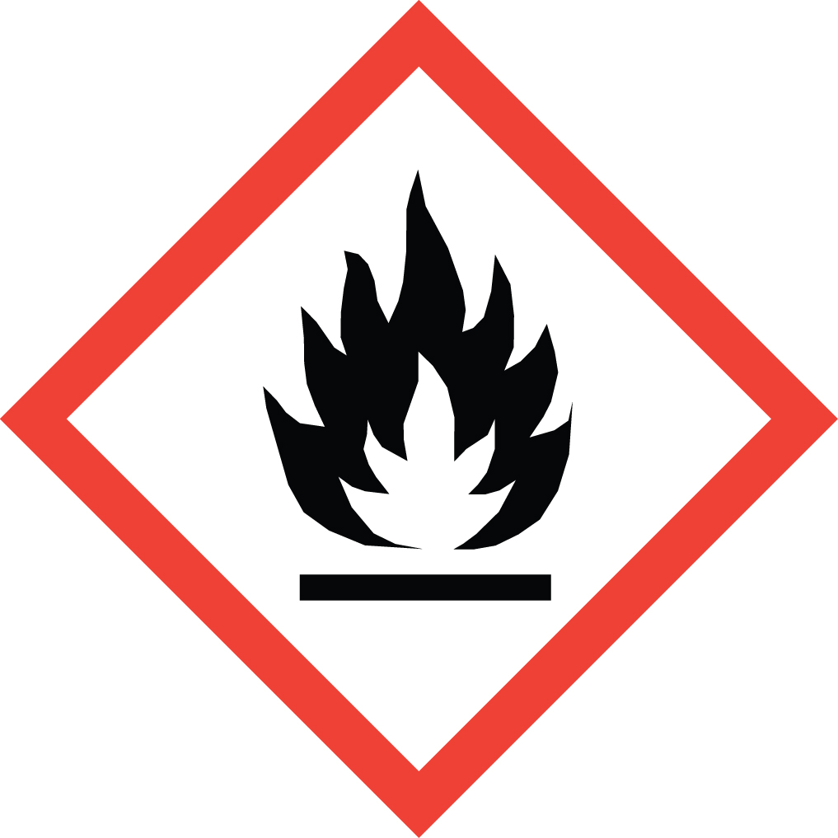 

IPA (Isopropyl Alcohol) – Highly Flammable!

The processes outlined in this procedure involve the use of Isopropyl Alcohol (IPA). This is a highly flammable material that can be ignited by the smallest of sparks. Extreme care must be observed at all times during its use. IPA evaporates easily at room temperature and forms an invisible vapor. These vapors are heavier than air, and will flow for long distances along surfaces. If the vapor contacts a distant ignition source, it may flash back to the Beaker/Container.

When working with IPA in volumes greater than 16 fl. oz., the work area must be vented to the outside, or through a suitable filtration system.

***Lenium® ES***

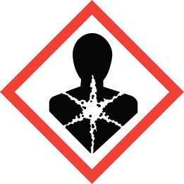 

*Ingestion of Lenium® may be harmful, and prolonged exposure will cause skin irritation. Wearing finger cots or gloves (nitrile rubber or latex) during its use, and washing hands with soap and water after its use, is recommended.*

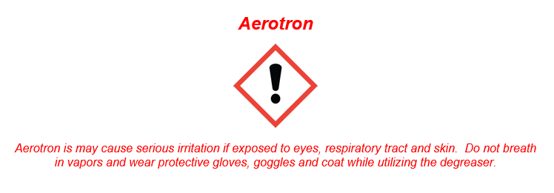

**Process A – HEATED Ultrasonic Cleaning with IPA**

**Guidelines:**

Use this process to clean:

* + Machined parts
  + Subassemblies
  + Fixtures and tooling
  + Final sensor wash

Do **NOT** use this process to clean:

* Hardened flux

**Required Equipment (refer to B.O.M. 52800-01 for equipment part numbers)**

Personal Protective

Equipment (PPE): *ESD grounding strap, chemical goggles, and finger cots or gloves (nitrile rubber or latex)

Cleaning Solvent: Isopropyl Alcohol (IPA)

Container: Stainless steel Beaker/Container.

Rinse Solvent: Isopropyl Alcohol (IPA)

Container: ESD squirt bottle

Equipment: Heated ultrasonic cleaner filled with tap water, *ventilation system, ionizing blower, and

oven (250° F)

*ESD grounding strap and ventilation system not applicable at PMC

**Procedure:**

1. *Turn on ventilation system.
2. Put on chemical goggles.
3. *Plug in ESD strap.
4. Follow Ultrasonic setup see **TA1288** for the desired Ultrasonic model being used.
5. Wipe the selected Beaker/Container clean to remove any debris or residue from the previous operator.
6. Gently place parts into Beaker/Container. Ensure units with delicate components are appropriately spaced to avoid damage. Use fixtures as specified in the documentation.
7. Add IPA to Beaker/Container to cover all parts.
8. Place Beaker/Container into Ultrasonic and run cycle for 25 min @ 35C.
9. Put on gloves or finger cots.
10. Lift the Beaker/Container out of the insert tray.
11. Rinse parts thoroughly with virgin IPA and dispose of waste in the appropriate container.
12. Place parts into a clean tray.
13. *Place parts on an ionizing table for a minimum of **one (1) minute**.
14. **\*Dry** parts in 250 F oven for **sixty (60) minutes** minimum.
15. **\*PMC may use miraclean dryer or air blast dry.**

**Process B – HEATED Ultrasonic Cleaning with Lenium®**

**Guidelines:**

Use this process to clean:

* + Heavily contaminated machined parts
  + Heavily contaminated subassemblies
  + Heavily contaminated fixtures and tooling
  + Final sensor wash

Do **NOT** use this process to clean assemblies that contain the following, use **TA1051-Process A**.

* Dow Corning® SYLGARD® 184 silicone elastomer
* EPO-TEK® 353ND epoxy
* Hysol® FP4323 epoxy encapsulant.

Do **NOT** use this process to clean:

* Hardened flux

**Required Equipment (refer to B.O.M. 52800-01 for equipment part numbers)**

Personal Protective (Lenium® see safety section)

Equipment (PPE): *ESD grounding strap, chemical goggles, and finger cots or gloves (nitrile rubber or latex)*

1st Clean Solvent: Lenium® ES

Container: Stainless steel Beaker/Container

2nd Clean Solvent: Isopropyl Alcohol (IPA)

Container: Stainless steel Beaker/Container

Rinse Solvent: Isopropyl Alcohol (IPA)

Container: ESD squirt bottle

Equipment: Heated ultrasonic cleaner filled with tap water, *ventilation system, ionizing blower, and

oven (250° F)

*ESD grounding strap and ventilation system not applicable at PMC

**Procedure:**

1. *Turn on ventilation system
2. *Plug in ESD strap.
3. Put on chemical goggles.
4. Follow Ultrasonic setup see **TA1288** for the desired Ultrasonic model being used.
5. Wipe the selected Beaker/Container clean of debris and residue from previous operator.
6. Gently place parts into Beaker/Container. Insure units with delicate components are appropriately spaced to avoid damage. Use fixtures as specified in the documentation.
7. Add Lenium to the Beaker/Container to cover all the parts.
8. Run cycle for **“10 min” with heat on Set Temp 35°C.**
9. Put on gloves or finger cots.
10. Lift the Beaker/Container out of the insert tray.
11. Remove used Lenium from Beaker/Container.
12. Gently place parts back into Beaker/Container. Insure units with delicate components are appropriately spaced to avoid damage. Use fixtures as specified in the documentation.
13. Add IPA to the Beaker/Container to cover all the parts.
14. Place the Beaker/Container into the insert tray in the ultrasonic cleaner.
15. Follow Ultrasonic setup see **TA1288** for desired Ultrasonic model being used.
16. Run cycle for **“25 min” with heat on Set Temp 35°C.**
17. Put on gloves or finger cots.
18. Lift the Beaker/Container out of the insert tray.
19. Rinse parts with virgin IPA and dispose of waste in the appropriate container.
20. Place parts into a clean tray.
21. *Place parts on an ionizing table for a minimum of **one (1) minute**.
22. **\*Dry** parts in 250 F oven for **sixty (60) minutes** minimum.
23. **\*PMC may use miraclean dryer or air blast dry.**

**Process C – Automated Vapor and Ultrasonic Cleaning with Aerotron**

**Guidelines:**

Use this process to clean:

* + Machined parts
  + Machined Fixtures and tooling
  + PC Boards

**NOTE: See TA1276 for instructions**