Contents

[1 General 2](#_Toc4577891)

[1.1 Purpose 2](#_Toc4577892)

[1.2 Responsibilities 2](#_Toc4577893)

[2 Palomar 8000i Automatic Bonder 2](#_Toc4577894)

[2.1 Safety 2](#_Toc4577895)

[2.2 Loading Programs 2](#_Toc4577896)

[2.3 Machine Startup Procedure 3](#_Toc4577897)

[2.4 Palomar Documentation 4](#_Toc4577898)

[2.5 Machine Shutdown Procedure 4](#_Toc4577899)

[3 Palomar 2460V Automatic Bonder 5](#_Toc4577900)

[3.1 Safety 5](#_Toc4577901)

[3.2 Screen Navigation 5](#_Toc4577902)

[4 Machine Start Up 6](#_Toc4577903)

[4.1 Facilities Supplies 6](#_Toc4577904)

[4.2 Switch and Control Settings 6](#_Toc4577905)

[5 Loading Prgrams 8](#_Toc4577906)

[5.1 Navigate to Program Load Menu 8](#_Toc4577907)

[5.2 Select Program To Load 9](#_Toc4577908)

[6 Workstage Preparation 11](#_Toc4577909)

[6.1 Fixture Setup 11](#_Toc4577910)

[7 Bonder System Setup 13](#_Toc4577911)

[7.1 Servo Setup 13](#_Toc4577912)

[7.2 Pattern Recognition System 15](#_Toc4577913)

[8 Running Production 15](#_Toc4577914)

[8.1 First Piece Check 15](#_Toc4577915)

[8.2 Pattern recognition errors 16](#_Toc4577916)

[8.3 Flameoff Errors 16](#_Toc4577917)

[8.4 Inspection and Rework 17](#_Toc4577918)

[9 Program Revisions 17](#_Toc4577919)

[9.1 Change Tracking 17](#_Toc4577920)

[10 Pull Testing Gold Wires 18](#_Toc4577921)

[10.1 Procedure 18](#_Toc4577922)

[11 Program Storage Maintenance 18](#_Toc4577923)

[11.1 Backup Scheduling 18](#_Toc4577924)

[11.2 Backup Procedure 18](#_Toc4577925)

[12 Wirebonding Terms And Features 19](#_Toc4577926)

[12.1 Gold Bond Features 19](#_Toc4577927)

# General

## Purpose

### To provide operating instructions for gold wirebonding on both the automatic wire bonders and the manual bonder.

## Responsibilities

### The Microelectronics Supervisor is responsible for maintaining this procedure. The Microelectronics Technicians are responsible for this procedure being carried out effectively.

# Palomar 8000i Automatic Bonder

## Safety

### The 8000i is a computer controlled machine with several axis of automatic movement. As such, there is a potential for injury by being struck, pinched, or crushed by moving parts. At any time, if there is an immediate potential for machine damage or injury, the machine can be shut down by pushing the Emergency Stop button, located on the right side of the front panel.



Emergency Stop

Emergency Stop Button

### There is a safety partition that covers the working area of the machine. ***Operators are not to try and reach under this partition while it is in place. To access the work area, the partition must be raised***. The partition has safety interlocks to prevent machine operation when it is opened***. These safety interlocks are not to be bypassed unless engineering or Palomar service personnel are servicing the machine***.

## Loading Programs

### The wirebond program filenames on the model 8000i are named based on the base amplifier number. The base number is the first block of numbers before a dash. When the amplifier number begins with 345-, the base number (and filename) will consist of the next four digits after the “345-“. (i.e. 0044 for item 345-0044-03-111).

### Only released programs are to be used in production. Programs must be selected from the default parts directory. Do not use programs from the engineering directory or any other sub-directory. If a program with the required name is not in the default directory, then it has not been released to bond on the machine yet.

## Machine Startup Procedure

### Utilities Verification

#### Verify that the utility air is at 60 PSI on the gage on the front of the machine. Verify that the key switch is in the “OFF” position.

### Software Startup

#### Turn on the computer on the top of the machine. Wait for windows to boot. Turn on monitors if necessary.

#### Once the PC boots into Windows select the Palomar account button and enter “ptibonder” as the password.

#### Click on the “8000 – Client” icon to open the 8000 software. The Bond Service will start automatically. Once the Bond Service successfully starts, the 8000 client will appear with the following “8000 Locked” dialog displayed:

\*

#### Enter “cbtadmin” in the “User name” field. The “Password” is also “cbtadmin”. Press the “OK” button to complete the login. The following dialog will appear:

\*

#### Click “Yes” to complete the power up procedure and “Home” the bonder. The software will then guide the user when the proper time to turn on the Key Switch.

#### On the key switch and e-stop panel (see below), turn the key to the “START” position for a few seconds. Then, move the key back two clicks to the “PROGRAM” position.

\*

#### Once the main unit has power, the axis should begin the homing process (make sure all safety interlock covers are in place). If the homing does not happen automatically, initiate the homing process by selecting “Reset” from the Machine menu at the upper left of the screen. Respond “Yes” to the question box to begin the reset.

## Palomar Documentation

### Full operation documentation is on the machine in PDF format. The path to the documentation files is: C:\Palomar\Support\Docs\Archive8000-6000. The most important file is “8000i Operations Manual (MAWD25124-502).pdf”.

## Machine Shutdown Procedure

### Click on the “Machine1” tab. Under “File”, click on the “Registry Backup”. When the dialog box is displayed, click on the save button. (NOTE: The File name will automatically have today’s date and the machine serial number.)

### Close the 8000i Client program by selecting “File” then “Exit”. When the dialog box is displayed, Click “Continue” to close the program.

### On the Power Key Switch located on the right side of the unit, turn the key counter clockwise to the OFF position.

### Shut down Windows normally (Start menu > Shut Down). Windows will shut down and the PC will turn off automatically. Turn the monitor(s) off.

# Palomar 2460V Automatic Bonder

## Safety

### The 2460V is a computer controlled machine with several axis of automatic movement. As such, there is a potential for injury by being struck, pinched, or crushed by moving parts. At any time, if there is an immediate potential for injury, the machine can be shut down by pushing the **Emergency Stop** button, located on the lower right of the front panel.

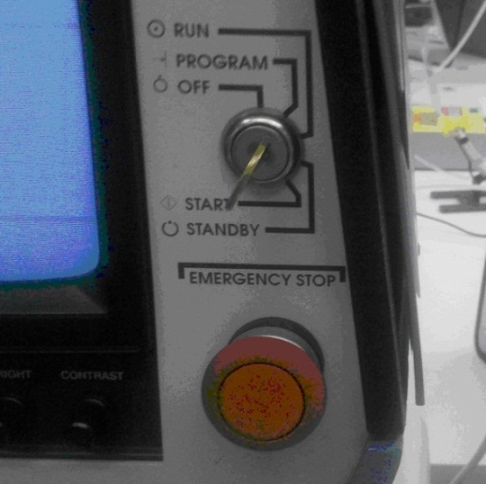

Emergency Stop Button

## Screen Navigation

### Throughout this procedure, when required to move the crosshairs on the screen, the operator is to use the two jog wheels on the front of the machine to move the table until the crosshairs are in the required position.

### When reference is made to pressing keys, they are either located on the freestanding keyboard to the right of the machine, or directly under the jog wheels on the main housing.

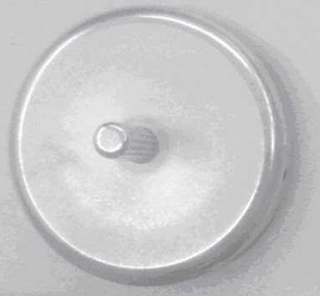 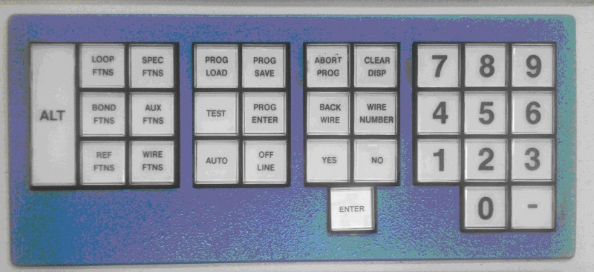

Jog Wheel Keyboard

# Machine Start Up

## Facilities Supplies

### Make sure that the vacuum pump in the facilities closet is turned on.

### Turn on nitrogen to the bonder using the switch on the right rear of the bench. The gauge is for reference only, and is only an indication that the nitrogen is turned on.

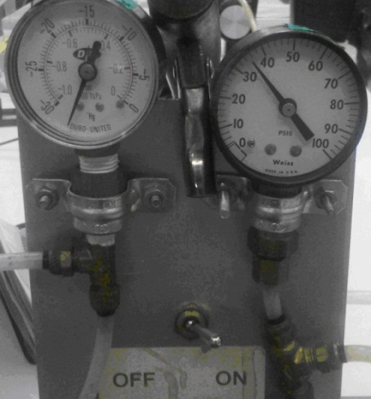

### Turn the power key to the "START" position until the bonder beeps, the turn it to the "RUN" position. The bonder will initialize and heat up. If at any point a program change needs to be made, this switch will need to be turned to the "PROGRAM" position, and turned back to "RUN" when the changes are finished.

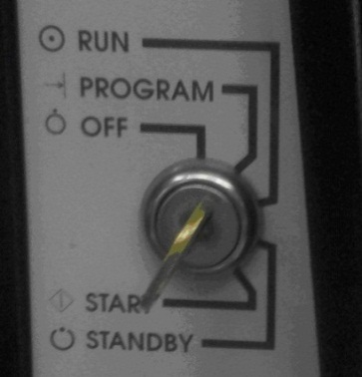

## Switch and Control Settings

### Set both Auto light control switches all the way counterclockwise to "PROGRAM" position.

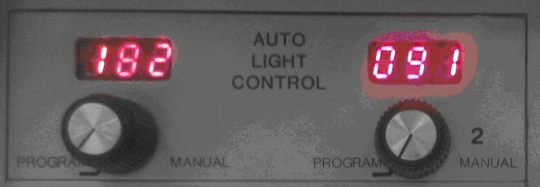

### Set switch on Adaptive Bonding System to "RUN" position.

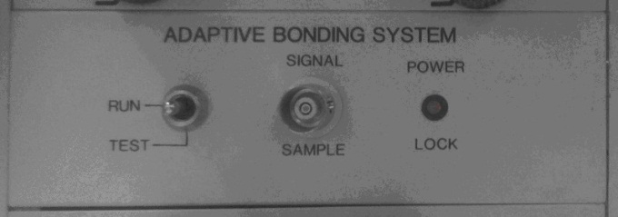

### For all items except PCB’s MEMS chips, set controller setpoint for heated workstage to 135ºC. Do not bond on the machine if the current temperature is outside of the range of 120 ºC to 140 ºC. When wirebonding to PCB’s MEMS chips, set the controller setpoint to 175ºC. Do not bond on the machine if the current temperature is outside of the range of 170 ºC to 180 ºC. When switching items from MEMS back to standard product do not forget to lower the temperature back to 135 ºC.

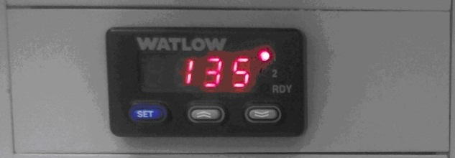

### Set the Negative EFO switches:

#### Power - "ON"

#### Sensitivity - "LOW"

#### Negative EFO - The EFO power level is to be set by the operator as necessary to achieve proper and consistant ball formation. It is desirable to have it in the "LOW" position, but if that results in inconsistent ball size formation or increased flame-offs, it may be moved to the “HIGH” position.

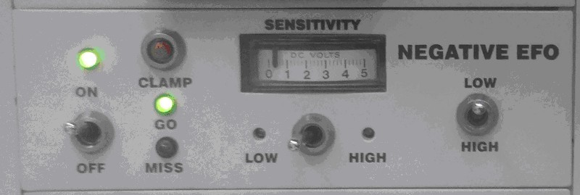

### Insure the Wire Tension Switch is set to the up position, and the flow is set between 2-14 SCFH.

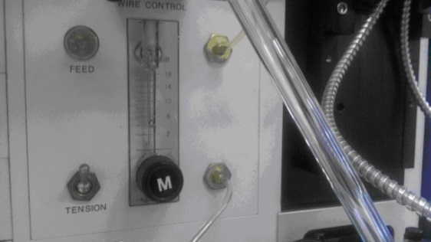

### Set the Flow Rate switch to "ON" Note that the flow rate is variable. It is set during initial bonder setup. Do not adjust the FLOW RATE control during normal operation.

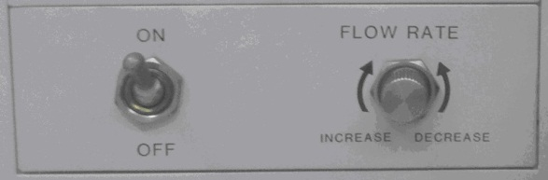

### Insure that the Wire Despooler power switch is on (Red light will be lit).

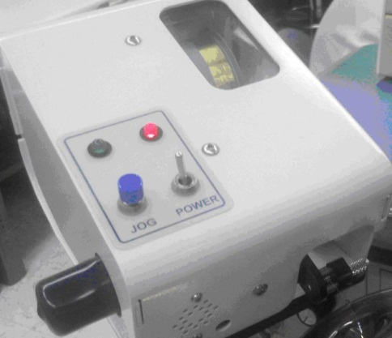

# Loading Prgrams

## Navigate to Program Load Menu

### Press the following key sequences into the keyboard:

Keys:    Result: 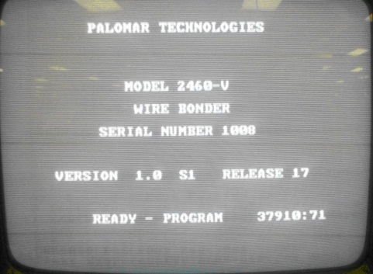

Main Screen

Keys: 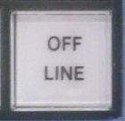 Result: 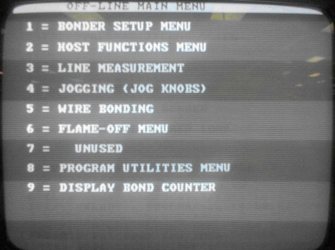

Off-Line Menu

Keys: 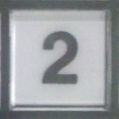 Result: 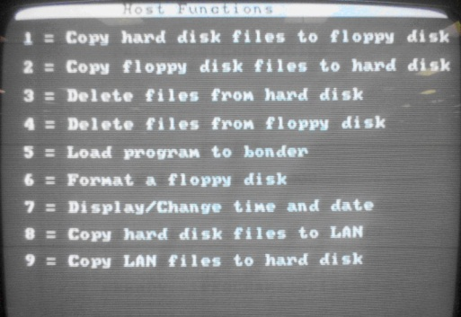

Host Function Menu

Keys: 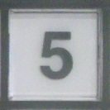 Result: 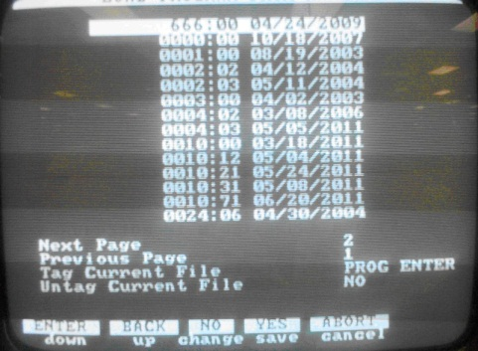

Program Listing

## Select Program To Load

### The program number has a four to eight digit numerical base, a period, and a two digit numerical variation.

### Find the base amplifier number on the first page of the job paperwork in the "Item" field. For most amplifiers it will be the digits before the first dash. (In the case on the left, the base number is 17822.) For older amplifiers that begin "345-", these leading digits are dropped, and the second group of four numbers is used. (In the case on the right, the base number is 0080.



Page #1 of Job Paperwork

 

Example of Job Routers Showing Where To Find Base Amplifier Number

### If there is more than one variation of a program on the wirebonder, refer to the TA155 form for that model to select the proper variation. Selection may only be made from the list of variations that have not been labeled as obsolete on the form.

### Refer to the Description column on TA155 to decide what variation is appropriate for the item to be bonded.



Example of Form TA155 - Three Active Options To Choose From

### Note that the program date on the wirebonder may not match the active date on Form TA155. The date on the wirebonder will reflect the last change to the variation, including any changes in Power/Force/Time settings that may have been made to accommodate bonder wear between services, or bondability variations due to alternate suppliers. Minor adjustments to Power, Force, and/or Time are not considered to be program variations, rather they are periodic adjustments to accommodate random variations in the process.

# Workstage Preparation

## Fixture Setup

### A note about wirebond fixtures: Regardless of any procedure to the contrary, wirebond fixtures are not to be wiped off. Due to the sharp edges of the pockets, even a cleanroom wipe is likely to be cut on the pocket edges and leave fibers behind. If the operator notices ceramic particle build-up on the fixtures, they may be blown off with a small amount of air or nitrogen.

### Select the proper fixture for the assemblies that are to be bonded. The fixture used depends on the substrate or housing that the assembly is built on. Refer to the table below to select the proper fixture. If the substrate or housing does not appear in the list below, stop production and notify the supervisor and/or engineering. The use of double sided kapton tape to mount the assemblies to any fixture with an appropriate amount of flat area may be approved in the event that a permanent fixture is not yet available but must be pre-approved by engineering with each use.

|  |  |  |
| --- | --- | --- |
| **Substrate to Automatic Wirebonder Fixture Cross Reference Table** | | |
| **Substrate** | **Substrate Description** | **Fixture Required** |
| 100-0078-30 | SUBSTRATE TN A26 GENERIC 120x160 | 54955-01 |
| 100-2937-80 | SUBSTRATE TN A1037 MINI THERM 70x100 | 54956-01 OR 68481-00 |
| 100-7077-70 | SUBSTRATE TK T517B TEDS QAMP .290DIA | 54979-01 |
| 100-7154-20 | SUBSTRATE TK T638A SEAWOLF .685DIA | 54980-01 |
| 100-7208-40 | SUBSTRATE TN CT-483 SHK FILT 160x160 | 54957-01 |
| 100-7284-20 | SUBSTRATE TK AA2001 2-POLE QAMP .290DIA | 54981-01 |
| 100-7988-30 | SUBSTRATE TN A4030 | 54957-01 |
| 100-8100-60 | SUBSTRATE TN A4040 STD QAMP 125x170 | 54958-01 OR 67345-00 |
| 100-8115-00 | SUBSTRATE TN A4060 MINI VAMP 70x100x10 | 54956-01 OR 68481-00 |
| 11230-01 | SUBSTRATE TK T590B 401/402'S 160x275 | 54985-01 (Panel) |
| 2191-01 | SUBSTRATE TN 2191 VELOCITY .370HEX | 54982-01 |
| 24613-01 | SUBSTRATE TN MICROSENSOR 160x85x30 | 54983-01 |
| 310-0068-00 | SUBSTRATE TN A3005 OSCILLATOR .347HEX | 54987-01 |
| 310-2320-90 | SUBSTRATE TN A1030 FILT VAMP 120x160 | 54955-01 |
| 31190-01 | 3991 SUBSTRATE | 54957-01 |
| 3930-01 | SUBSTRATE TN 3930 2-POLE VAMP .275HEX | 54988-01 |
| 40355-01 | SINGLE CERAMIC PACKAGE (3991) | 67301-00 |
| 410-0031-00 | SUBSTRATE TN PSQA7 GAIN-N 125x165 | 54955-01 |
| 410-9441-50 | SUBSTRATE TN PSQA2A STD A=2.1 120x160 | 54955-01 |
| 410-9441-80 | SUBSTRATE TN PSQA8C PROT. VAMP 145x185 | 54963-01 |
| 44858-01 | SUBSTRATE, THICK FILM (25 per array) | 54984-01 |
| 4629-01 | SUBSTRATE Q TN 4629 (SQR OLD MINI) | 54989-01 |
| 46406-01 | SUBSTRATE, THICK FILM .230" X .150" | 54961-01 |
| 46451-01 | SUBSTRATE V TN (THIN MINI VAMP) | 54956-01 OR 68481-00 |
| 47317-01 | SUBSTRATE TK MICROPHONE .580x.165 | 45406-01 |
| 48624-01 | SUBSTRATE V TN (THIN MINI VAMP) | 54956-01 OR 68481-00 |
| 52581-01 | METALLIZED SUBSTRATE | 54957-01 |
| 53414-01 | SUBSTRATE, THICK FILM (25 per array) | 54984-01 |
| 55330-01 | SUBSTRATE TK 120x335 MEMS CRASH W. DIODE | 54737-02 |
| 55332-01 | SUBSTRATE TK .290DIA T517B TEDS QAMP | 54742-01 |
| 56287-01 | SUBSTRATE REWORK | 54957-01 |
| 58190-01 | SUBSTRATE - MEMS (3503C) | 70555-00 |
| 58192-01 | HOUSING | 68702-00 |
| 60170-01 | SUBSTRATE TN 175x240x15 TEDS QAMP | 54979-01 |
| 64546-01 | SUBSTRATE TN 160x160 TEDS QAMP | 54957-01 |
| 64937-01 | SUBSTRATE TN MINI LS320 W. TRIM 70x85 | 69105-00 |
| 64993-01 | SUBSTRATE 125 X 235 | 66150-01 |
| 65749-01 | SUBSTRATE TK 150x230 TEDS VAMP | 54961-01 |
| 700-0987-40 | SUBSTRATE TN PSQA49 GENERIC | 54957-01 |
| 7613-01 | SUBSTRATE Q TN 7613 (REC. STD QAMP) | 54961-01 |
| 8424-01 | SUBSTRATE V TN 8424 (SQR SHK FILT) | 54957-01 |
|  |  |  |
| **Exceptions:** |  |  |
|  | - If assembled on a T-05 Header (37788-01 or 45388-01), disregard the above list and use a T-05 Header Fixture (34150) |  |
|  | - If assembled on a T-08 Header (2920-01), disregard the above list and use a T-08 Header Fixture (64904-00) |  |

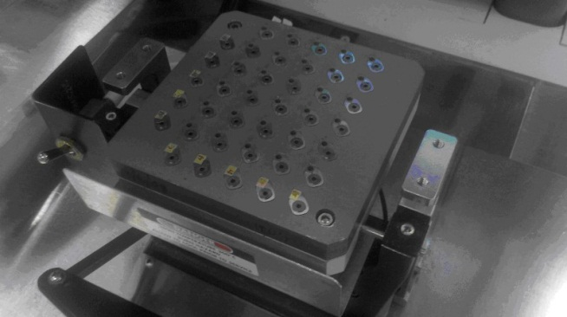

Fixture Mounted On Workstage

### Place the substrates into the pockets of the vacuum fixture making sure they are flush with the bottom of the pocket. Orient the parts the same way as the sub assembly drawing shows. (Parts arrayed in panel form are pushed against the provided pegs.) Turn on vacuum switch on the workstage to hold substrates and check for leaks and make sure parts do not move easily. If the fixture uses cam clamps, use a hex wrench to close the clamps securely against the substrates.

### Once a program and parts are loaded, the bonder servo and vision systems must be set up, and the wire re-threaded. This setup should be done whenever the vacuum fixture is changed, the program is changed, or a new capillary is installed.

# Bonder System Setup

## Servo Setup

### Press Key_OffLine 1_Key 1_Key 1_Key

### Turn the auto light control to manual and adjust the light to achieve the desired viewing on the monitor.

### Using the jog wheels, move the work stage over to the reference surface. This is the surface of the fixture that the back of the substrate or panel is sitting against. Usually it is the bottom of the pockets. Turn off the vacuum, unclamp the substrate and remove it if necessary.

### Press Spec_Func_Key to focus the camera.

### Use the jog wheels to locate the crosshairs on the reference surface.

### Press Spec_Func_Key again to focus on the reference surface.

### Press Enter_Key and the capillary will touch this surface and record this height in the bonder program.

### Press Key_2 to find the new focus height.

### Press Spec_Func_Key to focus on the reference surface again.

### Press Enter_Key The capillary will touch this surface and record this as the focus height in the program.

### Press 3_Key find new EFO height.

### Press Key_Abort Key_2 for camera offset.

### If removed, place the substrate back into the pocket and turn on the vacuum.

### Press 1_Key Spec_Func_Key

### The camera will focus. Move the crosshair to an open area of gold on the substrate.

### Press Start_Key and the capillary will come down touch the substrate and leave a mark on the gold.

### Move the crosshair to the center of this mark

### Press Enter_Key.

### Press 1_Key again to check offset. Repeat this step until the mark and cross hair are centered.

### Press Key_Abort Key_Abort.

### Now the bonder must be re-threaded. Press Key_Abort Key_Abort Key_Abort Key_OffLine 6_key.

### Enter wire set number from any of the wire sets where the 2nd bond reference surface is the same as the surface where the re-thread stitch will be made.

### Press 3_Key Start_Key to open clamps (When clamps are open the machine will beep). Feed the wire through the capillary and pull through excess wire that may have been crimped or damaged by tweezers.

### Press Start_Key Key_Abort 1_Key to close the clamps.

### Jog to an open area of gold on the substrate and press Start_Key or Enter_Key. The wire will be bonded to the pad, and a new ball formed at the capillary. Be sure to remove the wire that was bonded to the substrate by this operation.

## Pattern Recognition System

### NOTE: This section may be skipped if the program pattern recognition in known to be good. The most common example of this situation would be if the next job to be run is the same part number as the previous job.

### Before bonding check that the pattern recognition system will find and bond all parts correctly. From the main menu press auto, then #3 (No bonding option menu), then #1 (auto walk through). The bonder will cycle through the program. Make sure that all the bonds are in the correct places based on the drawing. If there seems to be problems recognizing parts or if bonds are not in the correct places the program will need adjustments. See your supervisor or authorized person to make those changes.

# Running Production

## First Piece Check

### Press Key_Abort Key_Abort Key_Abort until you reach the Main Menu.

### Press Auto_Key .

### Press Key_2 (Bonding Options Menu).

### Press 1_Key (Automatic, stop 1st bond). The bonder will then cycle through the pattern recognition process. The bonder will stop and wait before making the first bond.

### Press Enter_Key or Start_Key to begin bonding.

### After the first part has been bonded, abort the run.

#### Whenever a new program is loaded, the first piece bonded must be verified against the released assembly drawing for wirebond placement accuracy before bonding remaining assemblies. If the newly placed bonds do not match the bond pad locations of the assembly drawing, stop and see your supervisor and/or engineering before going further.

#### Whenever a new plate of parts is started, it is recommended that the first part be checked visually for problems.

### The remaining parts may now be bonded.

## Pattern recognition errors

### If the bonder fails to recognize one of the bond locations, it will beep and text at the bottom of the screen will inform the operator that there is a pattern recognition error.

### When a part is not recognized it must be manually referenced. This is done by moving the cross hairs to the two opposing dominant features of the die. At each feature, press start or enter.

## Flameoff Errors

### If the bonder has a flame-off error, it will beep and text at the bottom of the screen will inform the operator that there is a flame-off error.

### When a flameoff error occurs, press yes to enter flameoff menu. Then Press #1 (Position and flame-off bond). Move the crosshairs to an open area of gold, and press enter or start. If you don't get another flameoff error, proceed to bonding. If you still get an error, the machine must be re threaded. Press clear disp. Press #3 (rethread wire) and follow the previous procedure for re threading wire.

### Always remember when fixing a flameoff error the program returns to where the error occurred. If there is already a good bond there, press **NO** to skip to the next location if there isn't a bond there press start or enter to make that bond.

## Inspection and Rework

### After the bonding is complete the work stage moves to an unload position.

### At this point press: Key_Abort Key_OffLine .

### Key in the number of a wireset used in the program. At this point, inspect all bonds to insure that none were missed aligned poorly (this means that any bond that is not fifty percent over the intended bond pad must be replaced). Start with the first piece bonded, and check for missing or misaligned bonds.

### When you find bonds that need rework, proceed as per below.

### press: Key_Abort Key_OffLine Key_5.

### Key in the number of the wireset for the bond(s) that need rework.

### Press Enter_Key or Start_Key.

### Move the crosshairs to the second bond location and press Enter_Key or Start_Key.

### The new bond will be made. Any bad or misaligned bonds must be removed and replaced manually.

### After all the parts are checked press Key_Abort 3_Key.

### This will move the work stage to an unload position. Turn off the vacuum switch on the workholder, and remove the parts to the lettered plate.

### Sign off the relevant information on the job paperwork for wirebonding. Scrap information is recorded on the first page of the paperwork.

# Program Revisions

## Change Tracking

### Whenever a new program is created, a new revision is created, or a major feature is changed on an existing program, the approval of this new program, revision, or change must be associated with an approval sign-off from engineering or supervision in the AWB Program Revision Log (TA155). This approval is the record of acceptance for the creation, update, or change to the program as well as verification that the change has been saved to the hard drive of the wire bonder.

### A major feature would include but may not be limited to adding a wirebond, eliminating a wirebond, or changing the target bond pad (bond orgination or destination) on a substrate or component.

# Pull Testing Gold Wires

## Procedure

### Refer to Wire Bond Testing Procedure TA1036.

# Program Storage Maintenance

## Backup Scheduling

### Programs shall be backed up on the network on a quarterly schedule.

## Backup Procedure

### Turn off wire bonder.

### Attach keyboard to the front panel.

### Re-start wire bonder.

### Once the operating system has loaded, press “CTRL C” on the keyboard.

### If prompted to Terminate Batch Job, type “Y” for Yes and press enter.

### At the command prompt type “D:” and press enter.

### At the D:\> prompt type “wbondbk” and press enter.

### When the backup is complete, turn off the wire bonder, open the side panel of the bonder, and remove the SD card from the back of the host.

### Using a PC on the PCB network, point to “R:\Production\MICRO\wbondbk”.

### Within this directory, create a new folder labeled with the date the backup is being performed.

### Copy the files from the SD card to the folder just created.

### Return the SD card to the host of the wirebonder, close the side panel, and remove the keyboard.

### Note: The SD card must be returned to the host before continuing normal operation.

# Wirebonding Terms And Features

## Gold Bond Features

### Image showing all the features of a typical gold wirebond.

**Neck**

### 

**Security Bond**

**Tail**

**Loop**

**Ball**

### Closeup of typical gold ball.

### 