­This procedure is a General Guideline for cleaning components and in-process assemblies. Other methods stipulated in the assembly procedure or router shall supersede these instructions.

**INDEX**

**Process A** – Brush-Cleaning with Lenium® Page **5**

* Flux removal (Primary Method)

**Process B** – Brush-Cleaning with Isopropyl Alcohol (IPA) Page **7**

* Flux removal (Secondary Method)
* Weld joints

**Process C** – Stir Plate Cleaning Page **9**

* Memory rings

**Process D** – Unheated Ultrasonic Cleaning with Isopropyl Alcohol (IPA) Page **10**

* Machined parts
* Subassemblies
* Fixtures and tooling

**Process E** – Unheated Ultrasonic Cleaning with Lenium® Page **11**

* Heavily contaminated machined parts
* Heavily contaminated subassemblies
* Heavily contaminated fixtures and tooling

**Process F** – Isopropyl Alcohol (IPA) Soak Page **13**

* Crystals
* Thin metal diaphragms
* Electrodes
* Charge pickup assemblies
* Uncoated amplifiers

**Process G** – General Surface Cleaning Page **14**

* Weld Joints
* Uncured epoxy removal
* Fixtures and tools

**Process H** – Acid Wash (*Machine shop only*) Page **15**

* Annular tungsten masses

**Process I** – Automated Vapor and Ultrasonic Cleaning with Aerotron Page 19

*\*Process I may be used as an alternative to TA1061 processes D and E for “Parts Preparation”*

* + - * Machined parts, fixtures and tooling
      * Sensor Assemblies
      * Microelectronics Department (WIP)
      * PC Boards

**Safety:**

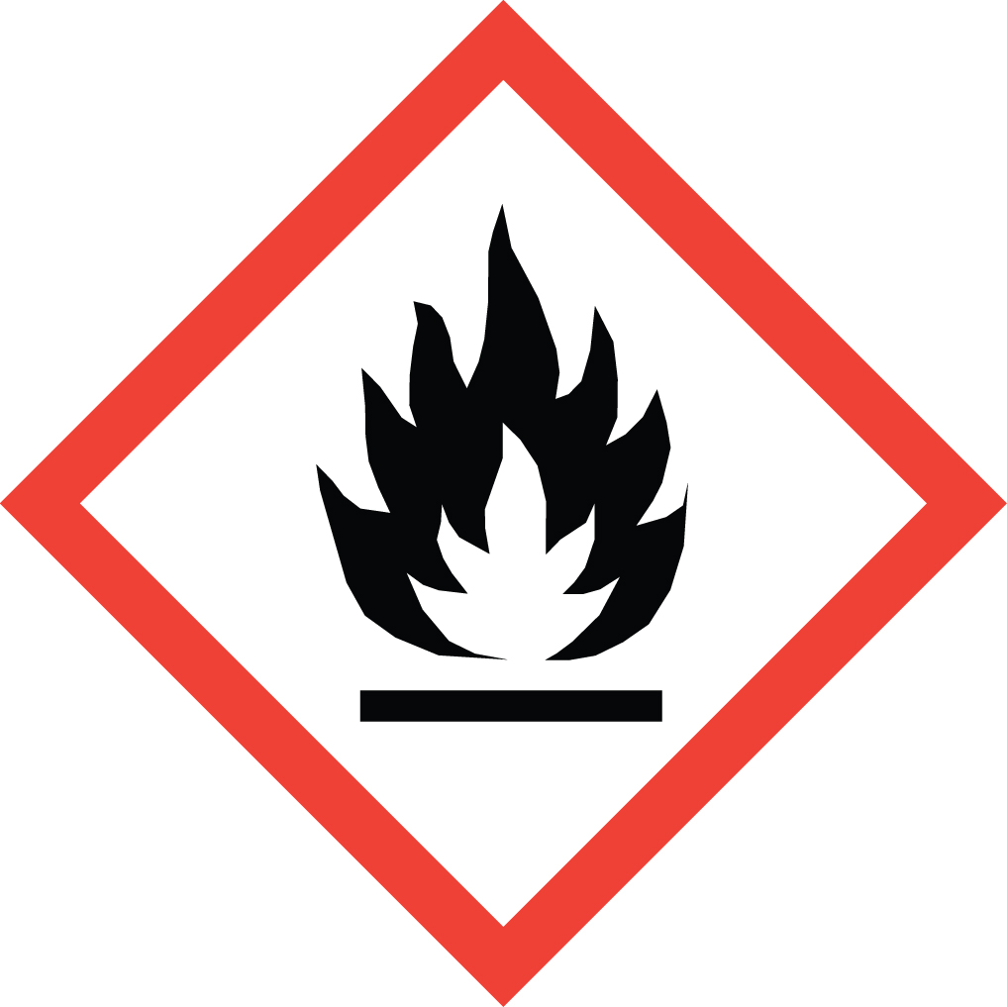 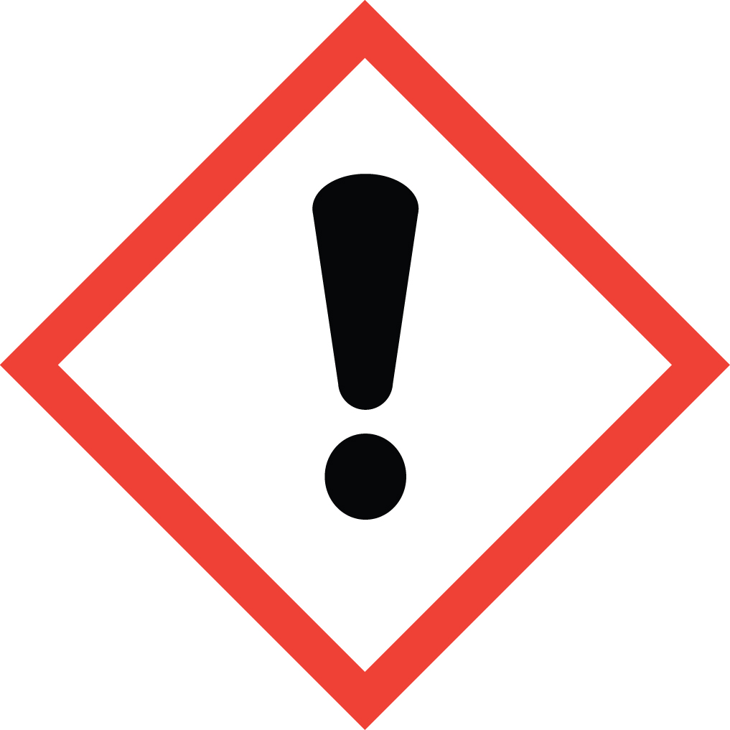

IPA (Isopropyl Alcohol) – Highly Flammable!

The processes outlined in this procedure involve the use of Isopropyl Alcohol (IPA). This is a highly flammable material that can be ignited by the smallest of sparks. Extreme care must be observed at all times during its use. IPA evaporates easily at room temperature and forms an invisible vapor. These vapors are heavier than air, and will flow for long distances along surfaces. If the vapor contacts a distant ignition source, it may flash back to the Beaker/Container.

When working with IPA in volumes greater than 16 fl. oz., the work area must be vented to the outside, or through a suitable filtration system.

***Lenium® ES***

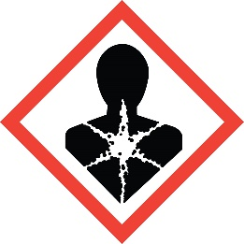 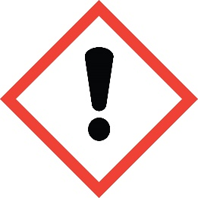

*Ingestion of Lenium® may be harmful, and prolonged exposure will cause skin irritation. Wearing finger cots or gloves (nitrile rubber or latex) during its use, and washing hands with soap and water after its use, is recommended.*

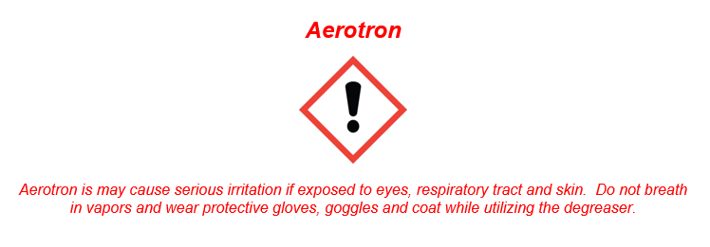

**Process A – Brush Cleaning with Lenium®**

**Guidelines:**

Use this process to clean:

* + Flux from solder connections

Do **NOT** use this process to clean:

* + Assemblies that contain Dow Corning® SYLGARD® 184 Silicone Elastomer. Use **TA1061-Process B**.
  + Uncoated amplifiers with exposed wire bonds. Use **TA1061-Process F**.

**Required Equipment (refer to B.O.M. 52800-01 for equipment part numbers)**

Personal Protective (Lenium® see safety section)

Equipment (PPE): Finger cots or gloves (nitrile rubber or latex)

Pre-Clean Solvent: Lenium® ES

Container: Amber glass with stainless steel pump, back-flow check valve, and lid

Label: Blue “LENIUM PRE-CLEAN 1” with NFPA codes

Pre-Clean Brush: Horse or camel hair bristle with quill, tin, or stainless steel handle

Label: Blue “LENIUM #1”

Final-CleanSolvent: Isopropyl Alcohol (IPA)

Container: Dissipative HDPE with stainless steel pump, back-flow check valve, and lid

Label: Black “IPA FINAL CLEAN 2” with NFPA codes

Final-Clean Brush: Horse or camel hair bristle with quill, tin, or stainless steel handle

Label: Black “IPA #2”

In Process Brush: Double-Ended Applicator Brush (GEP, DC/MEMS, Halifax Sub-Assemblies, and Cable Groups Only)

Pressurized Air: Filtered air nozzle, dusting spray, or ionizing blow-off gun

Equipment: Microscope with 10X magnification

**Controls:**

* In process Brush – Double-Ended Applicator Brush is cleaned, using TA1061-Process D, on the 1st day of each month. The brush is labeled with the expiration date, 3 months after the issue date.
* Brushes may be cleaned or replaced as contaminants become evident. Clean brushes per **TA1061-Process D**.
* Brushes must be replaced every other month on the 1st day of the month.
* Container lids must be wiped clean daily. For each container, fill bowl with solvent and use low-lint wipe. Lids may be wiped more frequently as contaminants become evident.
* Container lids may be cleaned per **TA1061-Process D**.
* Containers must be emptied and cleaned prior to replenishing solvents. Dispose of remaining solvent, rinse inside of container with fresh solvent, then fill container with fresh solvent.

**Procedure:**

1. Review **Guidelines**, **Equipment**,and **Controls** sections of this process.
2. Excess flux may be picked free and blown off with pressurized air prior to brush cleaning.
3. Pre-clean solder connections with Blue “LENIUM #1” labeled brush and Lenium until flux is no longer visible.
4. Blow off excess Lenium with pressurized air.
5. Final-clean solder connections with Black “IPA #2” labeled brush and IPA until no residue is visible.
6. Blow off excess IPA with pressurized air. Tip the unit over while blowing out excess IPA to aid in removal of contaminants from blind areas.

**Note:** If performing any testing (e.g. Standardize Sensitivity) allow product to **Air Dry** for two (**2**) minutes minimum.

1. Visually inspect parts for contamination under scope with **10X** magnification. Be sure to check inside holes, sleeves and recesses.

**Process B – Brush Cleaning with IPA**

**Guidelines:**

Use this process to clean:

* + Flux from solder connections where Dow Corning® SYLGARD® 184 Silicone Elastomer is present

Do **NOT** use this process to clean:

* + Uncoated amplifiers with exposed wire bonds. Use **TA1061-Process F**.

**Required Equipment (refer to B.O.M. 52800-01 for equipment part numbers)**

Personal Protective

Equipment (PPE): Finger cots or gloves (nitrile rubber or latex)

Pre-Clean Solvent: Isopropyl Alcohol (IPA)

Container: Dissipative HDPE with stainless steel pump, back-flow check valve, and lid

Label: Clear “IPA PRE-CLEAN 1” with NFPA codes

Pre-Clean Brush: Horse or camel hair bristle with quill, tin, or stainless steel handle

Label: Clear “IPA #1”

Soaking Solvent: Isopropyl Alcohol (IPA)

Container: Stainless Steel Beaker/Container

Final-CleanSolvent: Isopropyl Alcohol (IPA)

Container: Dissipative HDPE with stainless steel pump, back-flow check valve, and lid

Label: Black “IPA FINAL CLEAN 2” with NFPA codes

Final-Clean Brush: Horse or camel hair bristle with quill, tin, or stainless steel handle

Label: Black “IPA #2”

In Process Brush: Double-Ended Applicator Brush (GEP, DC/MEMS, Halifax Sub-Assemblies, and Cable Groups Only)

Pressurized Air: Filtered air nozzle, dusting spray, or ionizing blow-off gun

Equipment: Microscope with 10X magnification

**Controls:**

* In process Brush – Double-Ended Applicator Brush is cleaned, using TA1061-Process D, on the 1st day of each month. The brush is labeled with the expiration date, 3 months after the issue date.
* Brushes may be cleaned or replaced as contaminants become evident. Clean brushes per **TA1061-Process D**.
* Brushes must be replaced every other month on the 1st day of the month.
* Container lids must be wiped clean daily. For each container, fill bowl with solvent and use low-lint wipe. Lids may be wiped more frequently as contaminants become evident.
* Container lids may be cleaned per **TA1061-Process D**.
* Containers must be emptied and cleaned prior to replenishing solvents. Dispose of remaining solvent, rinse inside of container with fresh solvent, then fill container with fresh solvent.
* Open Beaker/Container of IPA must be covered during extended periods of non-use to minimize evaporation and to keep contaminants out.
* Open Beaker/Container of IPA must be replaced at a minimum of once per shift, or more frequently depending on level of contamination (i.e. discoloration or visual particulates). To replace IPA, dispose of remaining solvent, rinse inside of Beaker/Container with fresh IPA, then fill container with fresh IPA.

**Procedure:**

1. Review **Guidelines, Equipment, and Controls** section of this process before performing operations.
2. Excess flux may be picked free and blown off with pressurized air prior to brush washing.
3. Pre-clean solder connections with Clear “IPA #1” labeled brush and IPA until flux is no longer visible.
4. Place product in Beaker/Container of IPA and allow to **Soak** for one (**1**) minute minimum.
5. Remove product from the soak and blow off IPA with pressurized air.
6. Final-clean solder connections with Black “IPA #2” labeled brush and IPA until no residue is visible.
7. Blow off excess IPA with pressurized air. Tip the unit over while blowing out excess IPA to aid in removal of contaminants from blind areas.

**Note:** If performing any testing (e.g. Standardize Sensitivity) allow product to **Air Dry** for two (**2**) minutes minimum.

1. Visually inspect parts for contamination under scope with **10X** magnification. Be sure to check inside holes, sleeves and recesses.

**Process C – Stir Plate Cleaning**

**Guidelines:**

Use this process to clean:

* + Memory rings

***Caution!*** *Keep rings away from all heat sources (i.e. oven, other warm parts). Rings will shrink.*

**Required Equipment (refer to B.O.M. 52800-01 for equipment part numbers)**

Personal Protective

Equipment (PPE): Chemical goggles and finger cots or gloves (nitrile rubber or latex)

Cleaning Solvent: Isopropyl Alcohol (IPA)

Container: Glass Beaker/Container

Rinse Solvent: Isopropyl Alcohol (IPA)

Container: ESD squirt bottle

Equipment: Stir plate (non-heated) with magnetic stir bar

**Procedure:**

1. Place magnetic stir bar into Beaker/Container.
2. Gently place parts into a Beaker/Container.
3. Carefully add enough IPA to the Beaker/Container to completely cover all the parts.
4. Place Beaker/Container in center of stir plate.
5. Turn stir plate control to mid point range or so agitator is spinning without spilling or splashing.
6. **Run** parts for twenty (**20**) minutes minimum.
7. Turn stir setting back to zero before removing Beaker/Container from plate.

**NOTE:** Wear gloves/finger cots for all remaining steps. The parts are now clean and will be contaminated by handling.

1. Remove parts from the Beaker/Container and rinse with IPA.
2. Dispose of waste IPA in the appropriate container.
3. Allow parts to **Air Dry** for five (**5**) minutes minimum.

**Process D – UNHEATED Ultrasonic Cleaning with IPA**

**Guidelines:**

Use this process to clean:

* + Machined parts
  + Subassemblies
  + Fixtures and tooling

**Required Equipment (refer to B.O.M. 52800-01 for equipment part numbers)**

Personal Protective

Equipment (PPE): ESD grounding strap, chemical goggles, and finger cots or gloves (nitrile rubber or latex)

Note: ESD grounding strap not applicable in Precision Machining Center (PMC).

Cleaning Solvent: Isopropyl Alcohol (IPA)

Container: Stainless steel Beaker/Container

Rinse Solvent: Isopropyl Alcohol (IPA)

Container: ESD squirt bottle

Equipment: Ultrasonic cleaner filled with tap water, ionizing blower, and oven (250° F)

PMC uses miraclean dryer or air blast nozzle.

**Procedure:**

1. Put on chemical goggles.
2. Plug in ESD strap.
3. Follow Ultrasonic setup see **TA1288** for the desired Ultrasonic model being used.
4. Wipe selected Beaker/Container clean to remove debris or residue from previous operator.
5. Gently place parts into Beaker/Container.
6. Add IPA to the Beaker/Container to cover all the parts.
7. Run cycle for 20min.
8. Put on gloves or finger cots.
9. Lift the Beaker/Container out of the insert tray.
10. Rinse parts thoroughly with virgin IPA and dispose of waste in the appropriate container.
11. Place parts into a clean tray.
12. Place parts on an ionizing table for a minimum of one (1) minute, notapplicable in PMC.
13. **Dry** parts in 250º oven for **five (5) minutes** minimum, PMC use miraclean dryer or air blast nozzle until dry.

**Process E – UNHEATED Ultrasonic Cleaning with Lenium®**

**Guidelines:**

Use this process to clean:

* + Heavily contaminated machined parts
  + Heavily contaminated subassemblies
  + Heavily contaminated fixtures and tooling

Do **NOT** use this process to clean:

* + Assemblies that contain Dow Corning® SYLGARD® 184 Silicone Elastomer. Use **TA1061-Process B**.
  + Uncoated amplifiers with exposed wire bonds. Use **TA1061-Process F**.

**Required Equipment (refer to B.O.M. 52800-01 for equipment part numbers)**

Personal Protective

Equipment (PPE): ESD grounding strap, chemical goggles, and finger cots or gloves (nitrile rubber or latex)*

Note: *ESD grounding strap not applicable at PMC

Lenium® see safety section

1st Clean Solvent: Lenium® ES

Container: Stainless steel Beaker/Container

2nd Clean Solvent: Isopropyl Alcohol (IPA)

Container: Stainless steel Beaker/Container

Rinse Solvent: Isopropyl Alcohol (IPA)

Container: ESD squirt bottle

Equipment: Ultrasonic cleaner filled with tap water, ionizing blower, and oven (250° F)

PMC uses Miraclean dryer or air blast nozzle.

**Procedure:**

1. Put on chemical goggles.
2. Plug in ESD strap.
3. Follow Ultrasonic setup see **TA1288** for the desired Ultrasonic model being used.
4. Wipe selected Beaker/Container clean to remove debris or residue from previous operator.
5. Add Lenium to the Beaker/Container to cover all the parts.
6. Run cycle for 20min.
7. Lift the Beaker/Container out of the insert tray.
8. Dispose of used Lenium into waste container.
9. Gently place the parts back into Beaker/Container.
10. Add IPA to the Beaker/Container to cover all the parts.
11. Place the Beaker/Container into the insert tray in the ultrasonic cleaner.
12. Follow Ultrasonic setup see **TA1288** for the desired Ultrasonic model being used.
13. Run cycle for "**20 min**".
14. Put on gloves or finger cots.
15. Lift the Beaker/Container out of the insert tray.
16. Rinse parts with virgin IPA and dispose of waste in the appropriate container.
17. Place parts into a clean tray.
18. Place parts on an ionizing table for a minimum of **one (1) minute**, not applicable in PMC.
19. **Dry** parts in 250 F oven for **five (5) minutes** minimum, PMC use miraclean dryer or air blast nozzle until dry.

**Process F – Isopropyl Alcohol (IPA) Soak**

**Guidelines**

Use this process to clean:

* + Crystals
  + Thin metal diaphragms
  + Electrodes
  + Charge pickup assemblies
  + Uncoated amplifiers

**Required Equipment (refer to B.O.M. 52800-01 for equipment part numbers)**

Soaking Solvent: Isopropyl Alcohol (IPA)

Container: Stainless steel Beaker/Container

Rinse Solvent: Isopropyl Alcohol (IPA)

Container: ESD squirt bottle

Equipment: Ionizing blower and oven (250° F) Not applicable at Precision Machining Center PMC

**Controls:**

* Open Beaker/Container of IPA must be covered during extended periods of non-use to minimize evaporation and to keep contaminants out.
* Open Beaker/Container of IPA must be replaced at a minimum of once per shift, or more frequently depending on level of contamination (i.e. discoloration or visual particulates). To replace IPA, dispose of remaining solvent, rinse inside of Beaker/Container with fresh IPA, then fill container with fresh IPA.

**Procedure:**

1. Place product in Beaker/Container of solvent and allow to **Soak** for ten (**10**) minutes minimum.

**NOTE:** Wear gloves/finger cots for all remaining steps. The parts are now clean and will be contaminated by handling.

1. Remove parts from the Beaker/Container and drain the solvent into a waste container.
2. Rinse parts thoroughly with virgin IPA over a waste IPA container.
3. Place parts into a clean tray.
4. Place parts on an ionizing table for a minimum of **one (1) minute**.
5. **Dry** parts in 250 F oven for **five (5) minutes** minimum. Or PMC use Miraclean dryer or air blast nozzle until dry.

**Process G – General Surface Cleaning**

**Guidelines:**

Use this process to clean:

* + Weld joints
  + Uncured epoxy
  + Fixtures and tools

**Required Equipment (refer to B.O.M. 52800-01 for equipment part numbers)**

Personal Protective

Equipment (PPE): Lenium® see safety section

Cleaning Solvent: Isopropyl Alcohol (IPA) or Lenium® ES*

Applicators: Low-lint wipes, cotton tipped swabs, foam swabs, gauze pads, and brushes (horse or camel hair bristle with quill, tin, or stainless steel handle)

Pressurized Air: Filtered air nozzle, dusting spray, or ionizing blow-off gun

Equipment: Microscope with 10X magnification

**Procedure:**

1. Moisten applicator with solvent and wipe part clean.

***Note:*** If Lenium is used, it must be followed up with an IPA wipe.

**NOTE:** Wear gloves/finger cots for all remaining steps. The parts are now clean and will be contaminated by handling.

1. Blow off excess solvent with pressurized air until visibly dry.
2. Visually inspect parts for contamination under scope with **10X** magnification. Be sure to check inside holes, sleeves and recesses.

**Process H – Acid Wash**

**Guidelines:**

Use this process to clean:

* + Annular tungsten masses

**Required Equipment (refer to B.O.M. 52800-01 for equipment part numbers)**

Personal Protective

Equipment: Chemical goggles, and finger cots or gloves (nitrile rubber or latex)

1st Clean Solvent: E-Z Klean EDM-650

Container: Stainless steel or glass Beaker/Container

2nd Clean Solvent: Isopropyl Alcohol (IPA)

Container: Stainless steel or glass Beaker/Container

Rinse Solvent: Deionized or distilled water

Container: Stainless steel or glass Beaker/Container

Pressurized Air: air nozzle, blow-off gun

Equipment: Ultrasonic cleaner filled with ~~tap~~ water, microscope with 3X magnification, and vacuum oven (330° F, 20-25 in-Hg)

**Procedure:**

1. Wash parts per **MS1026**.
2. Vacuum bake at 330°F, 20-25 in-Hg, for 12 hours minimum.
3. Put on chemical goggles.
4. Remove the insert tray from the ultrasonic cleaner.

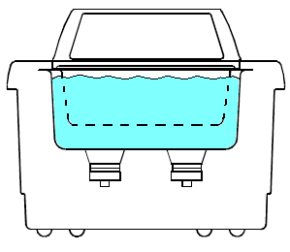

Insert Tray

1. Inspect the condition of the water in the cleaner. Make sure the water is clear of debris. If the water appears contaminated, it must be replaced.

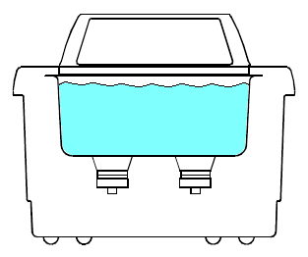

Water

1. Place the insert tray back in the unit.
2. Press the On/Standby key (A) to turn on the unit.

**C**

**H**

**G**

**D**

**A**

**F**

**E**

**B**



1. Press the Up/Down keys (**D**) and set timer to 10 minutes**.**
2. Gently place the parts into a stainless steel or glass Beaker/Container.
3. Put on gloves.
4. Add EZ-Klean to the Beaker/Container to cover all the parts.
5. Place the Beaker/Container into the insert tray in the ultrasonic cleaner. Add metal weights or additional EZ-Klean to the Beaker/Container if the Beaker/Container floats in the water.

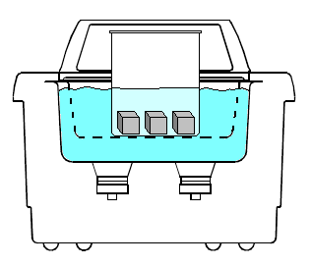

EZ-Klean

Parts

Beaker/Container

NOTE: The water level should be equal to the parts level.

1. Check the water level. Adjust until the water level is at the operating level line.
2. Press the Sonics key (**E**) to activate ultrasonics. Run parts until the entire cycle is complete.
3. Put on gloves.
4. Lift the Beaker/Container out of the insert tray.
5. Remove parts from the Beaker/Container and rinse thoroughly with deionized or distilled water over a waste container.
6. Press the **Fn** button (**B**) until the Set Temperature icon (**G**) flashes.
7. Press Up/Down keys (**D**) and set temperature to 35°C.
8. Press the Heat key (**F)** to activate heat.
9. Gently place parts into Beaker/Container. Insure units with delicate components are appropriately spaced to avoid damage. Use fixtures as specified in the documentation.
10. Add IPA to the Beaker/Container to cover all the parts.
11. Place the Beaker/Container into the insert tray in the ultrasonic cleaner. Add metal weights or additional IPA to the Beaker/Container if the Beaker/Container floats in the water.

**

IPA

Parts

Beaker/Container

1. Check the water level. Adjust until the water level is at the operating level line.
2. Verify that the water temperature reads between 32°C and 35°C by viewing the temperature value at icon (H). If water temperature is >35° C, add cool tap water until temperature falls within proper operating range. If water temperature is <32° C, allow time for water to heat up to within proper operating range.
3. Press the Up/Down keys (**D**) and set timer to 20 minutes.
4. Press the Sonics key (**E** ) to activate ultrasonics. Run parts until the entire cycle is complete.
5. Check the water temperature. If the temperature is >48°C, notify supervisor to remove cleaner from service.
6. Put on gloves or finger cots.
7. Lift the Beaker/Container out of the insert tray.
8. Remove parts from the Beaker/Container and dry with pressurized air.
9. Visually inspect parts for contamination under scope with **3X** magnification.
10. Repeat process if contamination still present.

**Process I – Automated Vapor and Ultrasonic Cleaning with Aerotron**

**Guidelines:**

Use this process to clean:

* + Machined parts, fixtures and tooling

Note: Metal (i.e. acceptable - Aluminum, Stainless Steel, Titanium, Tungsten, Inconel). Other metals check with Engineering.

Note: AeroTron will affect certain types of plastics and can contaminate the cleaner (i.e. acceptable - Acetal [Delrin] and Polytetrafluoroethylene [Teflon]). Other plastics check with Engineering.

* Sensor Assemblies (i.e acceptable – EP937, 353ND, H20E, EC281, 104) other epoxies check with Engineering.

Note: No amplifiers with Sylgard

* Microelectronics Department (WIP)
* PC Boards

**NOTE: See TA1276 for instructions**

**Appendix A - Process FMEA Information**

|  |  |  |  |  |  |  |  |  |  |  |  |  |  |  |  |  |  |  |  |  |  |  |
| --- | --- | --- | --- | --- | --- | --- | --- | --- | --- | --- | --- | --- | --- | --- | --- | --- | --- | --- | --- | --- | --- | --- |
|  | | | | | | | | | | | | | | | | | | | | | | |
|  | | |  |  | | | | |  |  | |  | |  | FMEA Original Date: | | | | | 3/19/2021 | | |
|  | | | | | | | | | | | | | | | FMEA Revised Date: | | | | | N/A | | |
| **Item or Process Step** | **Potential Failure Mode** | **Potential Effect(s) of Failure** | | | **S\*** | **Potential Cause(s)** | **O\*** | **Current Controls** | | | **D\*** | **R\*** | **RecommAction** | | | **Responsand Target Date** | **“After” Action Taken** | **S\*** | **O\*** | | **D\*** | **R\*** |
| Process A – Brush Clean w/ Lenium | Residual flux | Could cause weld issues or shorting | | | 5 | Debris lodged in brush or loose brush hairs | 4 | Brushes changed at set frequency. In-between changes brushes cleaned per TA1061-Process D | | | 4 | 80 |  | | |  |  |  |  | |  |  |
|  | Residual flux | Could cause weld issues or shorting | | | 5 | Insufficient cleaning | 6 | Parts inspected at 10X magnification for FOD | | | 3 | 90 |  | | |  |  |  |  | |  |  |
|  | Residual flux | Could cause weld issues or shorting | | | 5 | Debris transferred from brush | 4 | Separate brushed used for pre-clean and final clean | | | 4 | 80 |  | | |  |  |  |  | |  |  |
|  | Residual flux or FOD | Could cause weld failure or shorting | | | 5 | Brush cleaning does not remove contaminants | 4 | Excess flux or FOD must be picked free and blown off with air | | | 4 | 80 |  | | |  |  |  |  | |  |  |
| Process B – Brush Clean w/ IPA | FOD | Could cause weld failure or shorting | | | 5 | IPA contaminate | 3 | IPA tested per TA1077 | | | 5 | 75 |  | | |  |  |  |  | |  |  |
|  | Residual flux | Could cause weld issues or shorting | | | 5 | Debris lodged in brush or loose brush hairs | 4 | Brushes changed at set frequency. In-between changes brushes cleaned per TA1061-Process D | | | 4 | 80 |  | | |  |  |  |  | |  |  |
|  | Residual flux | Could cause weld issues or shorting | | | 5 | Insufficient cleaning | 5 | Parts inspected at 10X magnification for FOD | | | 4 | 100 |  | | |  |  |  |  | |  |  |
|  | Residual flux | Could cause weld issues or shorting | | | 5 | Debris transferred from brush | 3 | Separate brushed used for pre-clean and final clean | | | 4 | 60 |  | | |  |  |  |  | |  |  |
|  | Residual flux | Could cause weld issues or shorting | | | 5 | Debris lodged in brush or loose brush hairs | 3 | Brushes changed at set frequency. In-between changes brushes cleaned per TA1061-Process D | | | 4 | 60 |  | | |  |  |  |  | |  |  |
|  | Residual flux | Could cause weld issues or shorting | | | 5 | Insufficient cleaning | 5 | Parts inspected at 10X magnification for FOD | | | 4 | 100 |  | | |  |  |  |  | |  |  |
|  | Residual flux | Could cause weld issues or shorting | | | 5 | Debris transferred from brush | 3 | Separate brushed used for pre-clean and final clean | | | 4 | 60 |  | | |  |  |  |  | |  |  |
| Process C – Stir Plate Cleaning | FOD on memory ring | FOD could enter sensor and cause failure | | | 5 | IPA contaminate | 3 | IPA tested per TA1077 | | | 4 | 60 |  | | |  |  |  |  | |  |  |
|  | Ring shrinks | Ring will not fit in assy. | | | 4 | Rings exposed to heat source | 3 | Warning in procedure to keep rings from heat source | | | 3 | 36 |  | | |  |  |  |  | |  |  |
| Process D – Unheated Ultrasonic Cleaning | FOD | FOD could enter sensor and cause failure | | | 5 | IPA contaminate | 3 | IPA tested per TA1077 | | | 2 | 30 |  | | |  |  |  |  | |  |  |
|  | FOD | FOD could enter sensor and cause failure | | | 5 | Equipment settings not adequate to remove FOD | 3 | Ultrasonic cleaner settings documented in TA1288 | | | 2 | 30 |  | | |  |  |  |  | |  |  |
|  |  |  | | |  |  |  |  | | |  |  |  | | |  |  |  |  | |  |  |
| **Risk Priority Number =** | | | | | | | | | | | |  | “After” Risk Priority Number = | | | | | | | | |  |

*S = Severity, O = Occurrence, D = Detection Key

Scaling is 1-10 based on the rating scale in EN036

Note: RPN > 100 requires action to reduce risk