# Responsibilities:

### The Manufacturing Operations Managers and Service Group Supervisors are responsible for maintaining this procedure. The Service Group Operators are responsible for this procedure being carried out effectively.

# Affected Department / Product Group / Support Group:

### NC Service Group

# Associated Documents:

### ISO 9001, Quality System Manual, Assurance Manual

# Procedure:

## Initial Start Up:

### Turn ON the Filter Mate.

### Check position of key switch on front panel to assure it is in the 0 position.

### Turn the main power switch to the ON position.

### Select Laser from tool bar, select “Info” on the pull down menu to view the operating temperature.

### Do not operate until the temperature stabilizes at 25 deg C. (+ or – 1) Leave information open on screen displayed for reference through out the day.

## Etching Operation

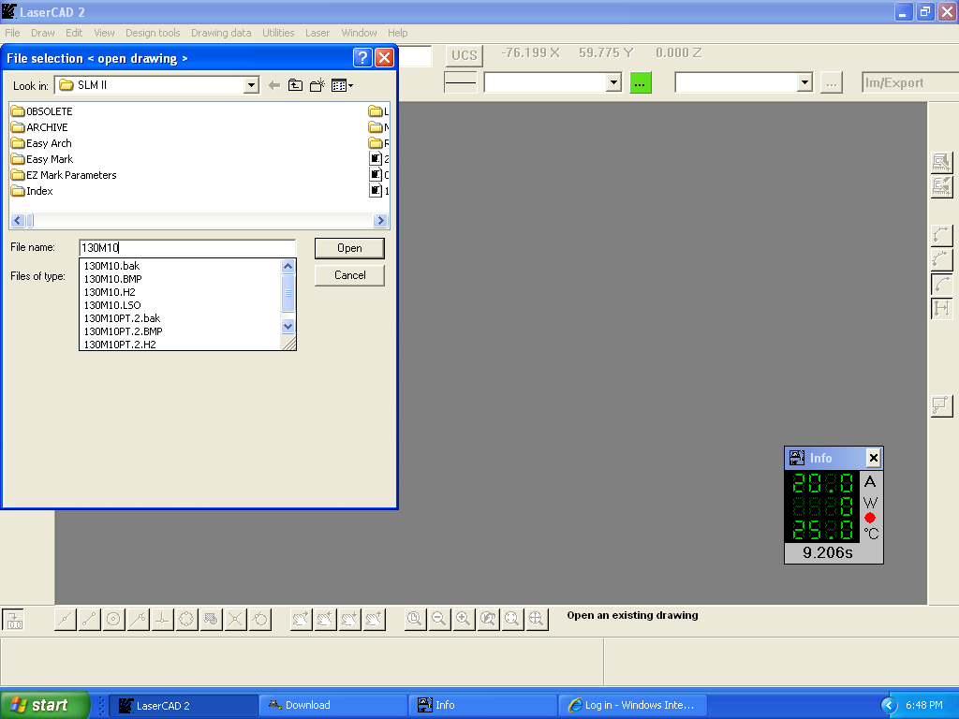

### **Note**: If serial sheet is not available do not etch & Contact Supervisor\*

### Select FILE – OPEN and scan the bar-code at the top left of the serial sheet. (select .H2 prefix)

### Open file.

### Follow the instructions on the screen. If manual opening of the file is required, skip to “The Manual Etching File Operation” section.

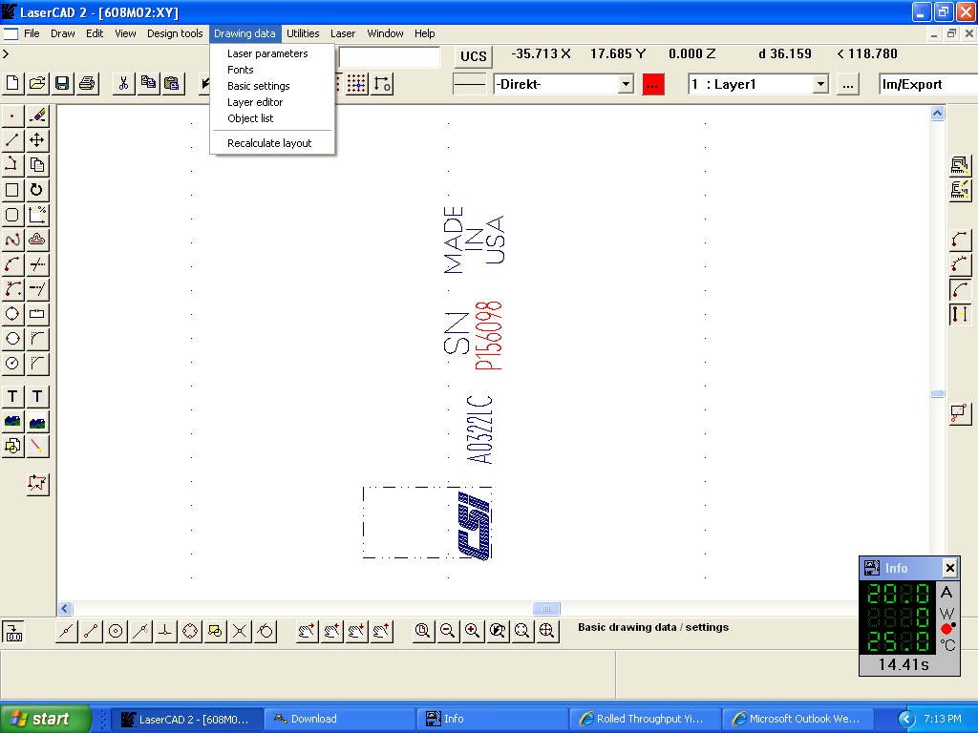

### Etching Pic2On the top tool Bar

#### Select - Drawing Data

#### Select **Basic Settings**

#### BD21298_Select **Comment** (The specific instructions for fixturing, alignment and etching each item is described within comment section).

### Etching Pic7Complete setup and adjustments as described in the **Comment** section.

### Mount the item to be etched as described in the **Comment** Section.

### Close the Comment and Basic Settings windows by selecting **OK**.

### Using the left mouse button, select and update the serial number as needed and select **OK**

### Position the new serial number near the original area on the drawing and select **Enter**.

#### (This will position the serial number correctly and sequence from the starting number)

### Select the “Send the active drawing to the file” icon, located on the right side tool bar.

### Close door and press green button to etch each piece.

### First piece inspection with the microscope at 1X power is required. For the criteria for inspection, refer to visual standard QA107 Visual Inspection Master”. Check for the following criteria:



“Send the active drawing to the file”



#### Centered - lettering is centered in the available space on sensor.

#### Legible – lettering is clear, consistent with no gaps, readable.

#### Accurate – must match the documentation listed on the router.

#### Contrast - lettering is neither to dark or too light to read. If too dark, the sensor may have been etched to deep.

#### Consistant – If multiple side are being etched, each etching must be consistant in appearance and meet the criteria listed above.

### Call any non-conformity to the attention of the supervisor or trainer before proceeding.

### If serial number string is interrupted in sequence it may require repeating steps 9 thru 11.

### \*Check every serial number to assure accuracy.\*

### When the serial numbers are sequential, continue the etching process until the job is finished.

### Use the Microscope at 1X power to inspect accuracy. Contact supervisor or trainer if needed.

## Manual Etching File Operation

### \*Note: If serial sheet is not available do not etch & Contact Supervisor\*

### Select the (Laser Cad) Icon on the windows desktop and select LaserCad folder.

### Select **File**



#### **Open** (the folder that contains the model within the range).

#### **Open** (the model number being etched).

#### **Drawing Data**

#### **Basic Settings**

#### **Comment** (The model specific instructions for fixturing, alignment and etching described in the comment section).

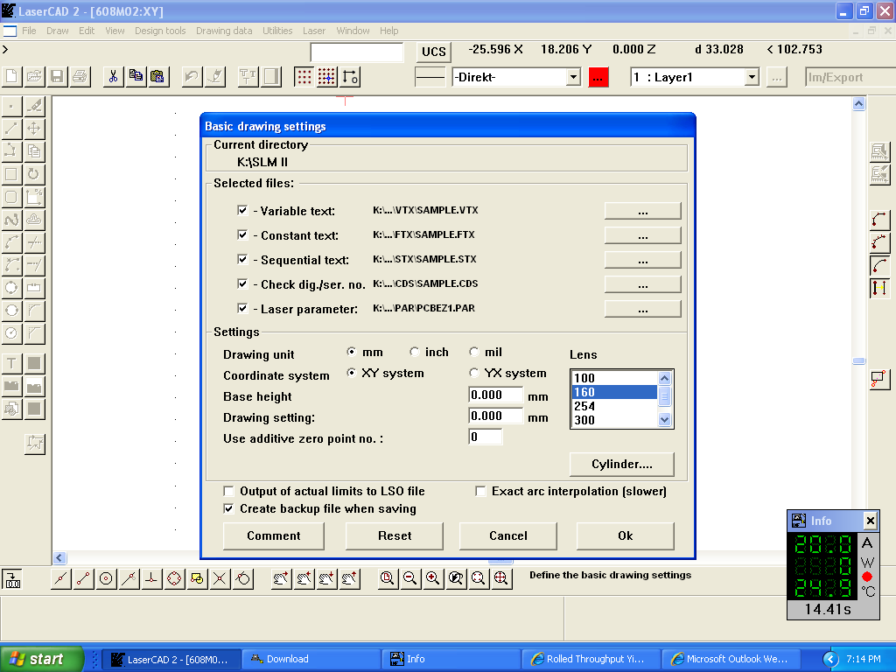

### Mount the item to be etched as described in the **Comment** section.

### Using the left mouse button, select and update the serial number as needed and select **OK**

### Position the new serial number near the original area on the drawing and select **Enter**. (This will position the serial number correctly and sequence from the starting number)

### **Etching Pic7**Select the “**Send the active drawing to the file”** icon, located on the right side tool bar.

### Close door and press green button to etch each piece.

### First piece inspection with the microscope at 1X power is required. For the criteria for inspection, refer to visual standard QA107 Visual Inspection Master”. Check for the following criteria:



“Send the active drawing to the file”



#### Centered - lettering is centered in the available space on sensor.

#### Legible – lettering is clear, consistent with no gaps, readable.

#### Accurate – must match the documentation listed on the router.

#### Contrast - lettering is neither to dark or too light to read. If too dark, the sensor may have been etched to deep.

#### Consistant – If multiple side are being etched, each etching must be consistant in appearance and meet the criteria listed above.

### Call any non-conformity to the attention of the supervisor or trainer before proceeding.

### If serial number string is interrupted in sequence my require repeating steps 5 thru 7.

### Check every serial number to assure accuracy.

### When the serial numbers are sequential, continue the etching process until the job is finished.

### Use the Microscope at 1X power to inspect for non conformities. Contact supervisor or trainer if needed.

## Etching Process for Array:

### Array programs allow multiple pieces of the same item to be etched as a group.

### The Array programs are located in the same file folders as standard etching files, identified with the title of ARRAY.

#### Open the etching file of the model being etched. (Bar-Code or Manual)

#### Open Drawing Data, Basic Settings.

#### Open Comments and follow the setup instructions.

#### Close the comments and basic setting windows.

#### Select Laserfrom the tool bar.

#### Select Controls.

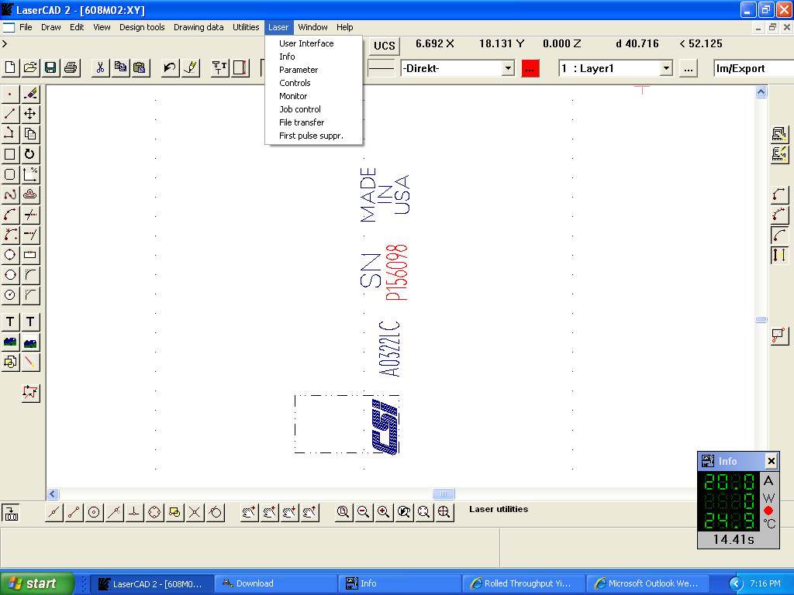

#### Select **Array**.

#### Select Settings.

#### Selectthe program that matches the item(s) to be etched. (e.g. 607) and click OK.

#### Review the Layout Screen (Activate should be “**X”** selected).

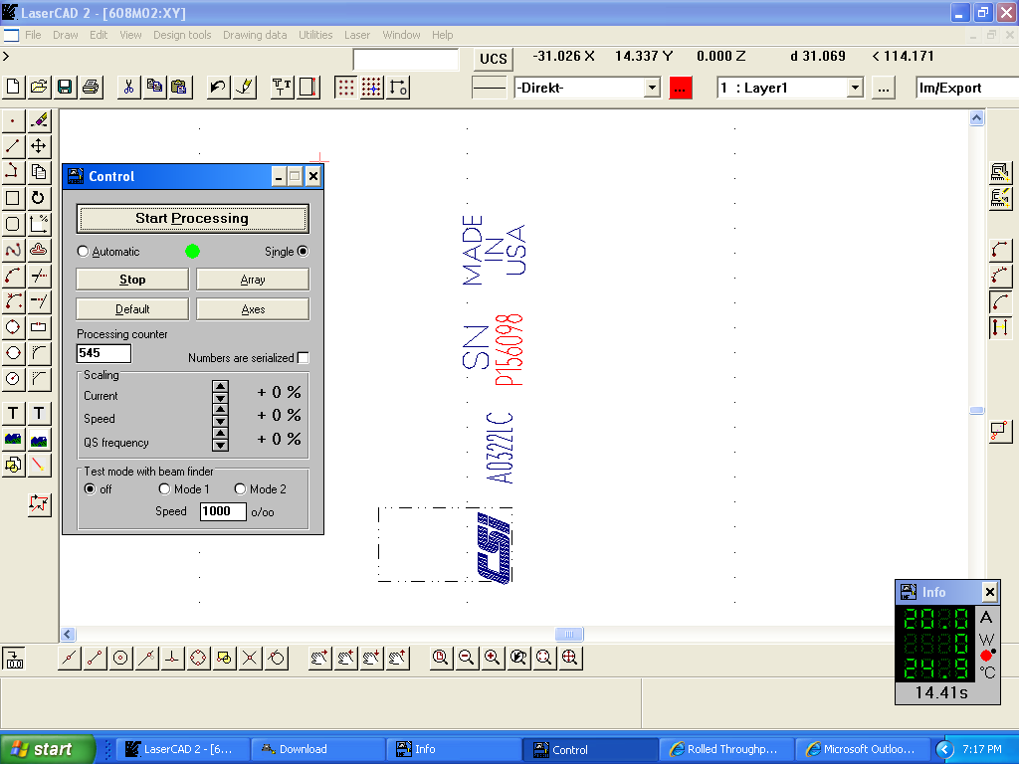

#### Select **Set.**

#### Select **Read**

#### Select **Exit**

#### **Send the Active drawing to the laser** (icon located right side, top of tool bar)

#### When job is complete, Select **Laser** form the tool bar.

#### Select **Controls** from the drop down.

#### Select **Array**.

#### Un-select [X] Activate in the Layout Array Window, Select Set, Read and Exit

#### The laser control is now returned to normal etching mode.

## TA012 Creation and Control

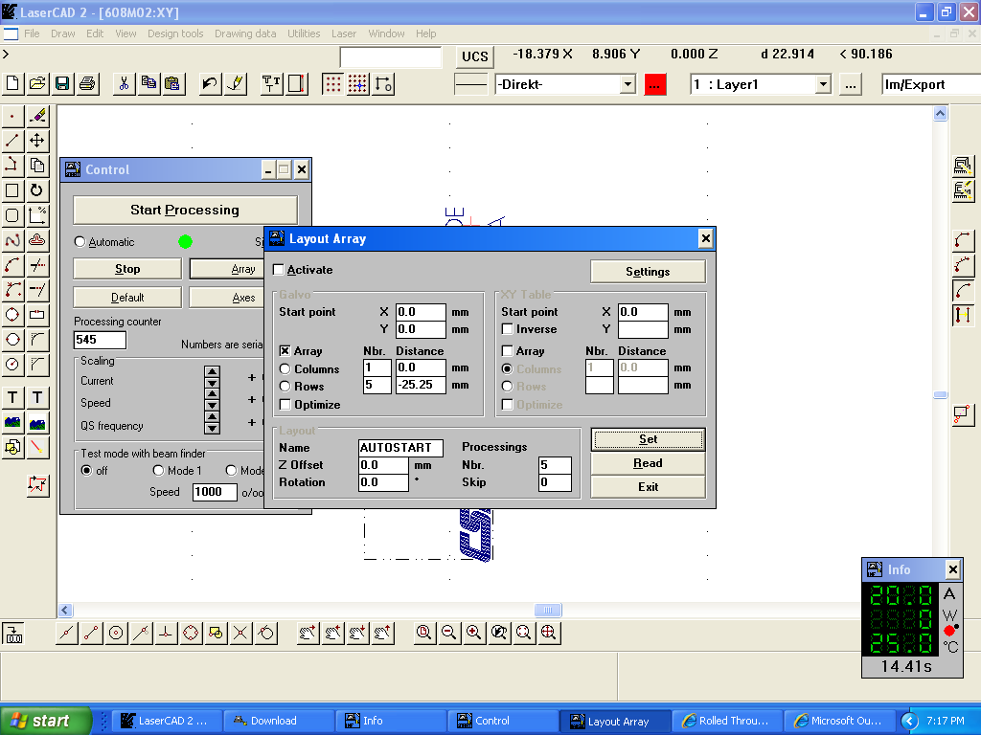

### Sensors that do not have a TA012 and are not listed on the Etching Index require evaluation by the etching supervisor, engineer and/or trainer to determine if a TA012 is required or, if it can be added to the etching index based on similarity to a another model.

### If a TA012 is required an etching program is set up and sample etch created Upon evaluation and approval of the sample by the etching supervisor and engineer, the TA012 is completed per TA012i instructions. The approval authority and etching supervisor(s) and engineers from NY and NC must initial and date the TA012 form to validate that the program has produced the desired etch. The TA012 is then sent to the drafting department to be scanned into the G:\Etchingsfolder.

### When confirmation of the etching file is required, reference the Product Identification Guide Form TA012 that is located in the G:\Etchings folder and listed by model number.

### If a TA012 isn’t found for a specific model, reference the Etching Index as it may have been determined to have similar characteristics to another model that does have an existing TA012.

### The Etching Index.doc is located in the R:\Production\Etching-Welding\Etching folder.

### If the model does not have a TA012 and not listed on the index, Do Not Attempt To Etch. Contact a Supervisor or Trainer for further instructions. The supervisor or trainer may be required to create a new TA012 for this model or determine that it is similar to another model and add it to the index. Reference TA012 Creation and Control in a later section of this procedure.

## Referenced Documents:

### ls, TA012, TA012i, Etching Index

## Unusual Conditions:

### NA