# Table of Contents

Table of Contents 1

1 Special Handling Precautions 1

1.1 Moving Between Workstations 1

2 Dispensing of Solder Paste. 1

2.1 Material and Workstation Preparation 1

2.2 Assembly Operations 2

3 Reflow Oven 2

3.1 Reflow Oven Preparation 2

3.2 Placement of Assemblies 3

3.3 Running a Reflow Program 4

4 Cleaning Assemblies After Reflow 5

4.1 Cleaning Process 5

5 Post Solder Inspection 5

5.1 Inspect for Proper Cleaning 5

5.2 Inspect for Good Soldering 6

6 Troubleshooting 7

6.1 Causes of Unacceptable or Non-conforming conditions 7

# Special Handling Precautions

## Moving Between Workstations

### When transporting assemblies to and from workstations throughout the reflow, cleaning, and inspection process, ensure proper ESD handling precautions are being followed as per QA1008 - Control of Electrostatic Discharge (ESD) Users Guide.

# Dispensing of Solder Paste.

## Material and Workstation Preparation

### Allow the solder paste syringe to reach room temperature before use. Do not accelerate this process. A purple applicator tip (Size: 21 GA .020 x .5 / PCB Part # 100-7014-20) is the recommended tip size. Other tip sizes may chosen depending on the application. When using a pneumatic dispensing system, the initial dispense pressure should be set in the range of 20psi to 40psi. If necessary, the pressure may be adjusted higher or lower to produce the desired solder paste formation. Return syringe to refridgerated storage immediately after use.

## Assembly Operations

### Apply solder paste to substrate in locations as per the assembly documentation.

### Place components into the solder paste and ensure that there is intimate contact between the part, solder paste, and substrate. This interface is essential to ensure a good solder joint. Refer to Figures 2-1, 2-2, and 2-3 for example target dispense amounts.

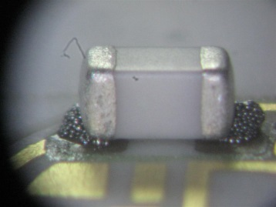

Figure ‑

Too Little Paste

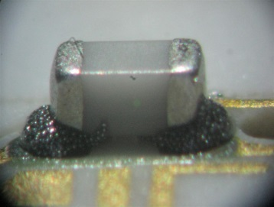

Figure ‑

Ideal Amount of Paste

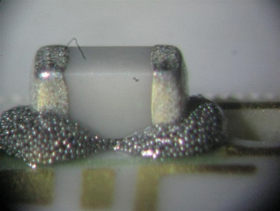

Figure ‑

Too Much Paste

# Reflow Oven

## Reflow Oven Preparation

### The reflow oven in Microelectronics is a Manncorp Model MC-301N. (Figure 3-1).

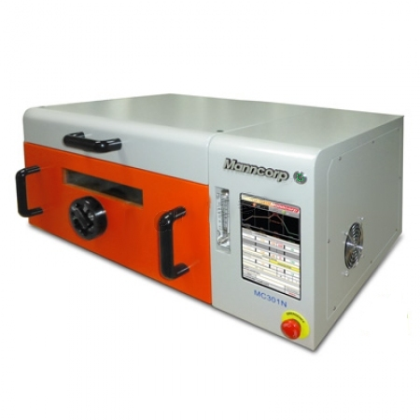

Emergency Stop

Display Screen

Power Button

Figure ‑

### If the oven is not on, use the following sequence to power it up:

#### Press and hold the power button on the upper right of the oven (button with green lit ring around it) until a logo appears on the display screen, then release the button. (Figure 3-2).

#### The panel will boot to an Android lock screen. Using a finger, slide the lock icon to the right to unlock the screen and finish the startup process. (Figure 3-3).



Lock Icon

Figure ‑

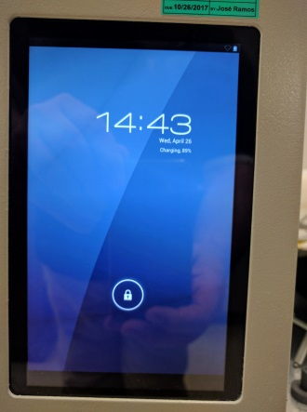

Figure ‑

#### If the reflow work will involve a solder material with no flux, such as Gold-Tin, the process gas flow must be turned on in the utility closet. (Figure 3-4). Turn on both the main valve and the oven valve. Cylinder pressure must be at least 500psi at the start of each reflow, if not, replace gas cylinder. Adjust pressure valve so that output pressure is between 37-42psi at beginning of each reflow. Pressure may drop during reflow, but further adjustment is not needed.

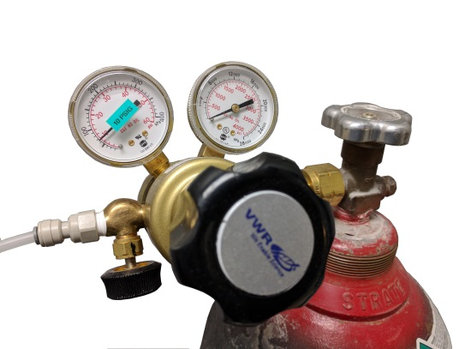

Oven Gas On/Off

Output Pressure

Main Gas On/Off

Cylinder Pressure

Figure ‑

## Placement of Assemblies

### Open the oven and place the assemblies to be reflowed onto the metal table that is attached to the oven door. (Figure 3-5). **Do not run more than 3 jobs at once.**

### Place the assemblies in a group as close to the center of the table as possible. Ensure all parts are within the rectangular target inside the oven.

### Close the door. Lock the door in place by turning the locking knob to the right until it is hand tight.

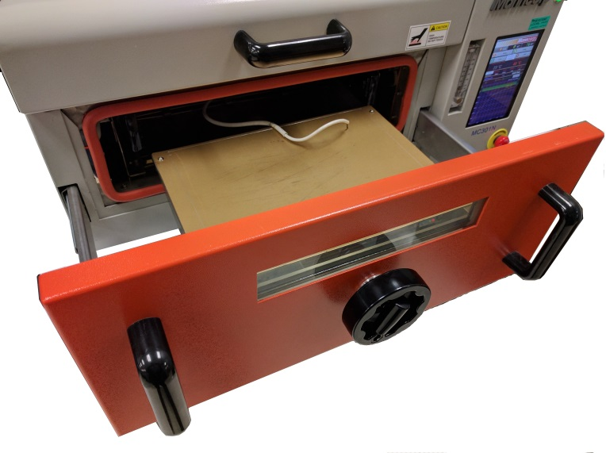

Metal Table

Locking Knob

Figure ‑

## Running a Reflow Program

### At the top of the screen, touch the green gear icon labeled “SET”. This takes you to the program profile page. (Figure 3-6). At the very bottom of this page there is a gray bar in the middle of the screen. This is the program load button. Touch this button to display the list of programs. (Figure 3-7).

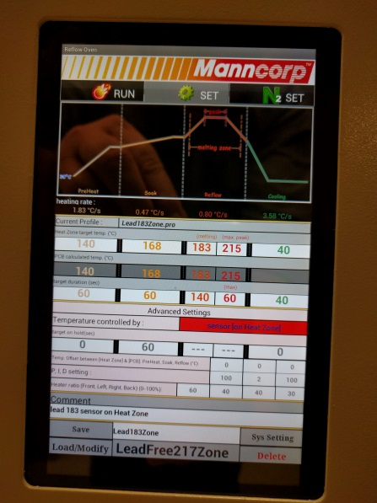

Program Icon

Program Load

Figure ‑

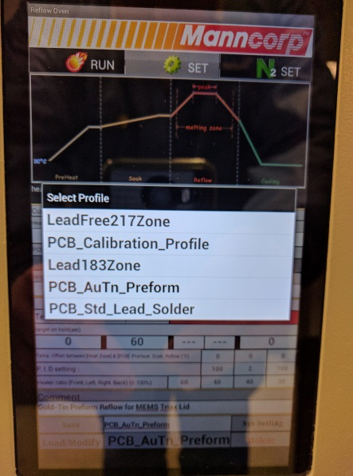

Program List

Figure ‑

### Select the appropriate program for the assemblies being soldered. (Figure 3-7).

In Microelectronics department:

* For attaching capacitors to substrates with standard lead solder, select the ‘MICRO_Cap_Lead_Solder’ program.
* For attaching TEDS chips to substrates, select the ‘MICRO_TEDS’ program.

Elsewhere:

* For standard solder (100-14892-00 or 100-2945-70) select the ‘PCB_Std_Lead_Solder’ program.
* For RoHS solder (100-11059-20), select the ‘PCB_RoHS_Solder’ program.
* For a gold-tin preform (60607-XX), select the ‘PCB_AuTn_Preform’ program.

### At the top of the screen, touch the orange/red flame icon labeled “RUN”. This takes you to the program run page. (Figure 3-6). Touch the ‘Start’ button near the top of the screen to begin the reflow process. (Figure 3-8).

### There will be a pop up that asks the operator to confirm the thermocouple to be used. Touch the ‘Yes’ button. (Figure 3-9). The reflow process will now begin. The temperature of the chamber and the thermocouple will be plotted on the gragh as the process runs.

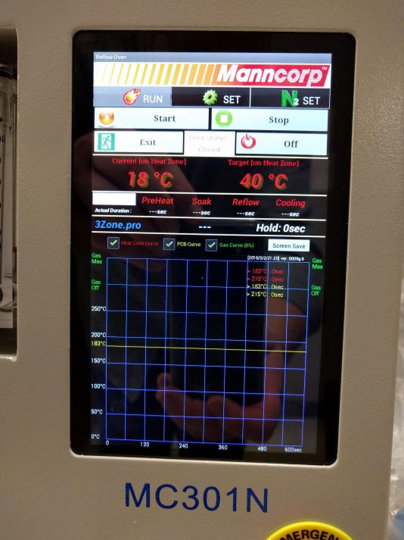

Figure ‑

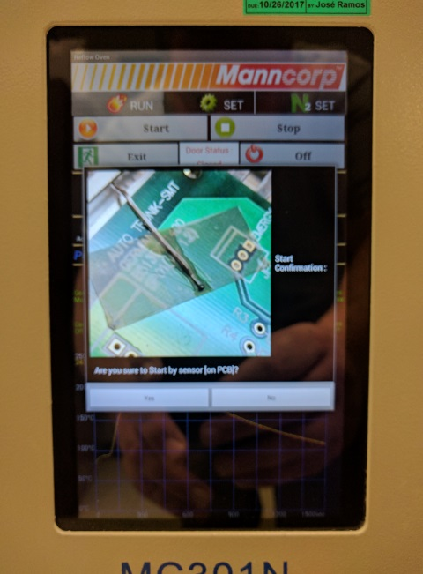

Figure ‑

# Cleaning Assemblies After Reflow

## Cleaning Process

### Clean assemblies referencing TA1276 Vapor Degreaser and the recipe specified in the router.

# Post Solder Inspection

## Inspect for Proper Cleaning

### After cleaning, inspect the assemblies to ensure complete removal of flux, proper seating of all components, and that the solder has sufficiently reflowed. Non-conforming solder joints, solder bridging (shorts) and/or solder balls (beading) may be cause for rework or rejection. Engineering and/or supervision needs to be notified when non-reworkable material is generated during the reflow process.

### Note that flux residue can been seen either as white or translucent.

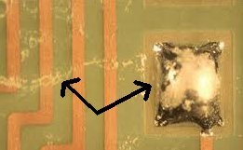

Figure ‑

White Flux Residue

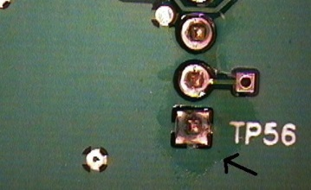

Figure ‑

Translucent Flux

## Inspect for Good Soldering

### Check for acceptable solder fillet range on end terminated components. A solder fillet that is less than minimum or greater than maximum is considered non-conforming. In most cases these non-conforming solder joints can be reworked by hand, using a soldering iron. (Refer to TA1004 Hand Soldering).

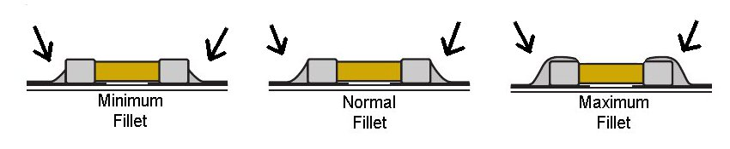

Figure ‑

### Inspect Flip Chips / Ball Grid Arrays. Refer to the photos below for acceptability. This type of connection can not be easily reworked and non-conforming assemblies should be scrapped. An acceptable joint is shown in Figure 5-4. Figure 5-5 shows a joint that was lifted and no longer provides good pad contact. Figure 5-6 shows a joint that had poor wetting to the pad.



Figure ‑

Acceptable

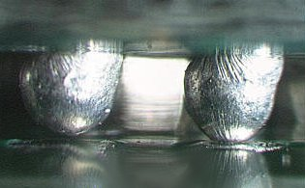

Figure ‑

Non-Conforming

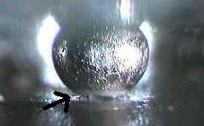

Figure ‑

Non-Conforming

### Inspect for solder bridging and electrical shorts. Solder bridging / shorts occur when the solder connects two adjacent leads/traces/pads that are not supposed to be connected. (Figure 5-7). In most cases these can be reworked by hand, using a soldering iron. (Refer to TA1004 Hand Soldering).

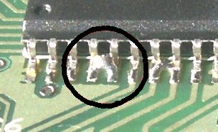

Figure ‑

### Check for solder beading. Solder beading is unacceptable, but can be removed manually. (Figures 5-8 and 5-9). Solder Beads not removed during cleaning must be manually removed.

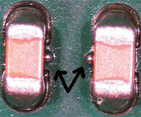

Figure ‑

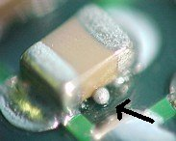

Figure ‑

### Check for proper component placement. Tombstoning (one side is lifting) of components is unacceptable but can be reworked manually. (Figure 5-10). Rotated or shifted components are also unacceptable if more than 25% of the termination is off of the pad. (Figure 5-11). In many cases, manual rework is possible.

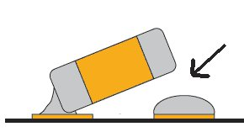

Figure ‑

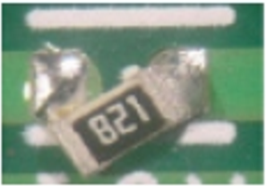

Figure ‑

# Troubleshooting

## Causes of Unacceptable or Non-conforming conditions

### Too much solder paste. Too much solder paste may cause solder to unintentionally adhere to parts of substrate not intended for solder. Excess solder paste may also cause excessive beading, bridging and tombstoning.

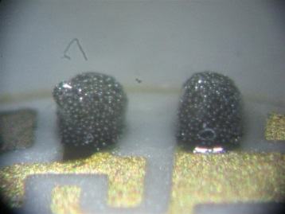

Figure ‑



Figure ‑

### Too little solder paste. To little solder paste may result in gaps, where solder adheres to part and adheres to substrate, but not enough solder for a good connection between the two.

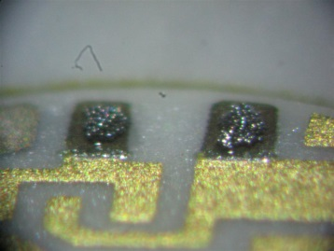

Figure ‑



Figure ‑

### Bad solder paste (too much flux, or not enough flux, in the solder paste mixture).

#### Too much flux in the solder paste mixture may result in not enough solder to adhere the part to the substrate. A gap may occur.

#### Too little flux in the solder paste mixture may result in a bad solder joint. (Note: Flux cleans parts when heat is applied.) To insure a good mixture it may be necessary to remove purple tip (PCB part # 100-7014-20) dispense some solder (checking for a good consistent mixture), and install a new purple tip.

### Parts not pushed down into solder paste. Parts not pushed into the solder paste may cause parts to tombstone. Pushing the parts down into the solder paste ensures intimate contact between part, solder paste, and substrate which helps to ensure a good solder joint.

### Parts not clean or contaminated.

### Reflow oven not setup properly (profile). The correct profile program needs to be selected to get good reflow of the solder. Choosing the wrong program can result in too little or too much heat.