Containment Report:

Step 1: Go to appropriate site in Syteline. Open “PCB Containment Report”

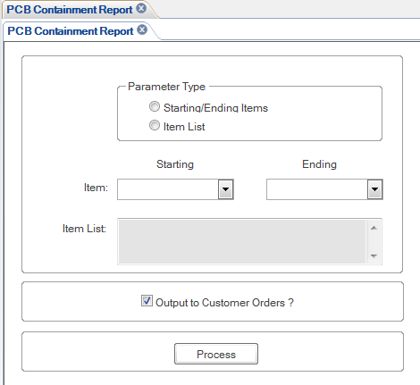

Step 2: You have the option to select by item number or by a range of item numbers. If you choose Item List, you also have the option of selecting multiple items in the Item List field.

If a list of customer orders for the item number(s) is required, check the box labeled “Output to Customer Orders?”

When all information has been filled in, press the “Process” button.

Step 3: Go to R:\Syteline Reports\”User Name” folder to access the report information. The Containment Report will be titled “pcb_ContainmentReport_V2_pcb (or nc) _XXXX.” The Customer Order information (if “Output to Customer Orders” box was checked) will be found in a separate spreadsheet titled, “pcb_ECOReviewOrder List_pcb (or nc) _XXXX”.

Step 4: Run the containment report for multiple sites, if applicable, by signing out and signing back in Syteline for the appropriate site. Cut and paste data to same worksheet. NOTE: NC in for Halifax, North Carolina and “PCB” is for Depew, New York.

Step 5: In the directory “R:\Quality\Containment Sheets” and create a file name as (MDR) xxxx or (MRR) xxxx or (CAR) xxxx and then the “Item No”, Example “MDR 17546 14563-02”. If the MDR/MRR/CAR was initiated by the NC facility, place an “(NC)” after the MDR/MRR/CAR No. and before the Item No. Example “MDR (NC) 17546 14563-02” Make sure you put the MDR/MRR/CAR number, Item No. and a brief description of discrepancy in the header of the containment report.

Step 6: Save the single (one facility) or the combined file in the correct directory. NOTE: If the containment sheet expanded to include addition items/ part no., do not override the existing containment report. Add the new file to the correct folder and add text to the file name indicating its revision or status. Example: “17204 56681-01 – Rev.2” / “17204 56681-01 – Final”. Once the containment is complete, the containment report for each of the affected facilities must be updated and place into the correct folder.

