Purpose: 1

Responsible: Operations Administrator, Manufacturing Engineering, IT 1

Instructions for Creating the Excel Data file: (both Depew and NC) 1

Instructions for Creating the Upload file: (both Depew and NC) 4

Instructions for Creating the Engineering Review file: (both Depew and NC) 5

Instructions for Engineering to Review Items with Shrink Factor Exceptions: (both Depew and NC) 5

Purpose:

To generate Shrink Factor Quarterly review and upload file

# Responsible: Operations Administrator, Manufacturing Engineering, IT

# Instructions for Creating the Excel Data file: (both Depew and NC)

1. Open the Shrink Factor Template R:\Operations\Shrink Factor\Shrink Factor Template.xls
2. Save your R:drive as Template
3. In Syteline, select the site you are creating the file for
4. Open Job Orders Query form-
   1. Go to the Additional Criteria Tab
      1. First set of boxes Status = complete
      2. Add
      3. Last Transaction Date >greater than 1 year prior to today’s date (enter as date format)
      4. Add
      5. Last Transaction date < less than today’s date (enter as date format)
      6. Add

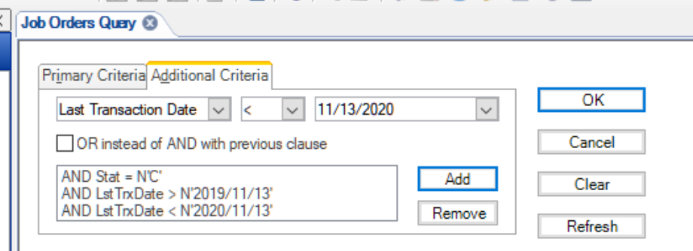

* 1. Refresh
  2. Confirm the search is gathering the info you want (It should hit the output max which is usually 200 lines)

1. Export the Job Orders Query information
   1. Form (on Menu Bar) Export (form – export to file)
   2. Source Collection Job Orders Query
   3. Cap Option Unlimited query
   4. Output File Type Tab Seperated

Output File Name *copy the path of the file you want it in* add \Export.txt

*****note any Excel file creates scientific notation for items******

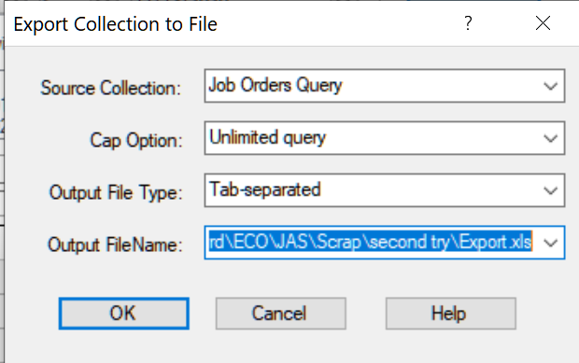

* + 1. It takes a long time up to 15minutes and will look like Syteline is frozen
    2. When it is done when you see this

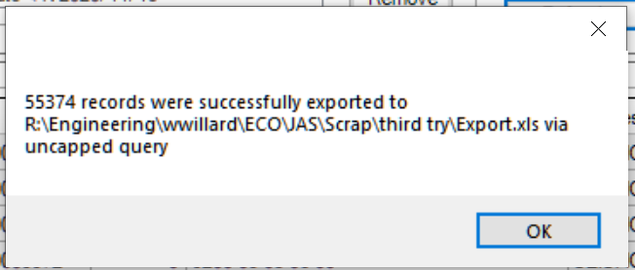

* 1. Open a blank Excel file (ctrl N)
  2. File – Open
     1. Find “Export” in the path file you sent it to (you may have to select all files not just excel files)
  3. Will bring up a wizard
     1. Delimited – Next
     2. Tab Next
     3. Text Finish

1. Copy Export into Template -tab Jobs
   1. The most efficient way is to highlight the first line go to the last line, shift and click that line

(will highlight them all)

* 1. Copy
  2. Paste into the Jobs tab in the template A2

1. Refresh the pivot table tabs
   1. Released tab press ALT and F5 at the same time
   2. Scrapped tab press ALT and F5 at the same time
   3. Count tab press ALT and F5 at the same time
2. Save
3. Close the export file
4. Go to Syteline, open Items
   1. Type Box **<>**O **(**does not equal O for Other)
   2. Source Box Manufactured
   3. Product Code box <>Z* (does not equal Z*)
   4. Under the Controls tab - Material Status <>O (does not equal O for Obsolete)
   5. Under the Planning Tab Production type - Job

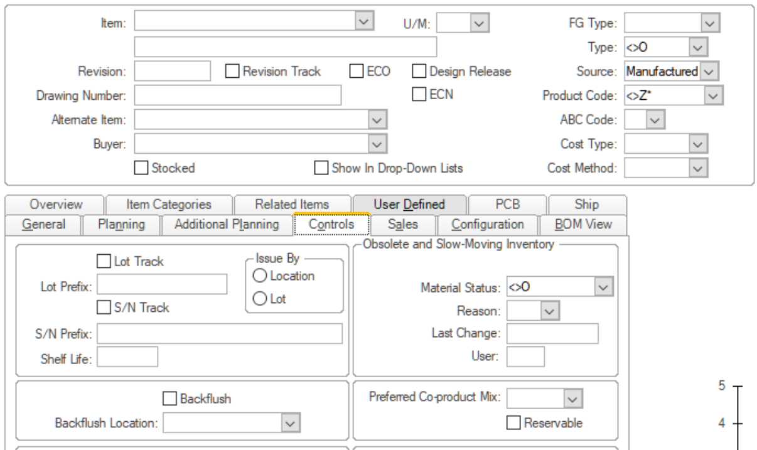

* 1. Press F4
     1. Confirm the search is gathering the info you want (It should hit the output max which is usually 200 lines)
     2. Press F4 again
  2. Form (on Menu Bar) - Export to File
     1. Source Collection Items
     2. Cap Option Unlimited Query
     3. Output File Type Tab seperated
     4. Output File Name *copy the path of the file you are writing in* add \Export.xls

****note can not be xlsx******

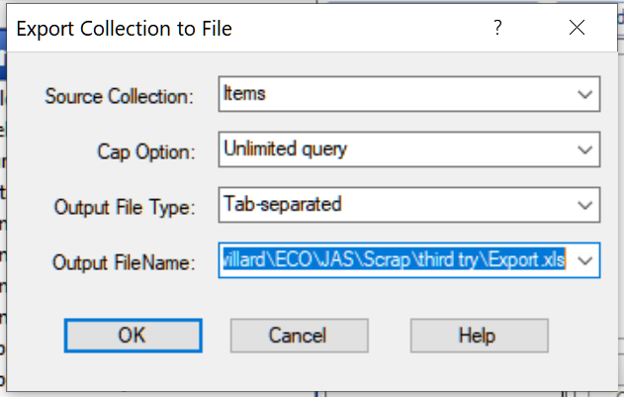

* 1. Press OK

Notes:

This will overwrite the previous table

This exports all manufactured items from the Items form

It takes a long time up to 15minutes and will look like Syteline is frozen

* 1. When complete a box will appear similar to this

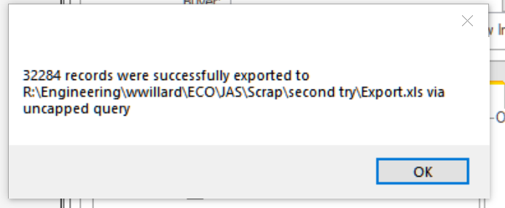

1. Open a new Excel Document (ctrl N)
   1. File – Open
   2. Find “Export” in the path file you sent it to (you may have to select all files not just excel files)
   3. Will bring up a wizard
      1. Delimited – Next
      2. Tab Next
      3. Text Finish
   4. Insert a line at the top
   5. Copy heading rows from Template workbook- Items tab and insert into “Export” line you made
   6. Correct any Overrun (columns that don't add up to Template- Items tab.)
      1. Example : below usually corrects it
      2. Add a row between column D and F
      3. Delete columns FC and FD
2. Copy Export into the Items tab in the template
   1. The most efficient way is to highlight the first line go to the last line, shift and that line will highlight them all
   2. Copy
   3. Paste into the Items tab in the template A3
3. Save
4. Copy from Export, Items Column into the the Data tab.in the template
   1. Highlight A2 go to the last one in column A, hold Shift and click last A - Copy and Paste
5. Copy down all formulas on Data sheet in template
   1. **Be aware it usually opens in the middle of the sheet
   2. Hylight B2 to Q2
   3. Go to bottom and hold down shift hylight last row B to Q in the last populated area
   4. Under home tab, editing, press fill arrow, down
      1. This will fill in the formulas down to your last line.
      2. It takes a moment and don’t panic if it looks like the first line at first, it is working
      3. This takes 3-5 minutes
6. For any items that had no job data during this time, Column M and N will have a #N/A.
   1. Sort Column M
   2. Filter for #N/A
   3. Delete all rows
   4. Sort Column N
   5. Filter for #N/A
   6. Delete all rows
7. Column P and Q should not have any #N/A but if they do proceed with the following.
   1. Sort Column P (If No of jobs less than 5, shrink factor was not recalculated column) in Ascending order.
   2. Filter for #N/A
   3. Replace the #N/A with Not Re-Calculated
   4. Remove filter from Column P
   5. Sort Column Q (If New shrink factor is greater than .5, review column) in Ascending order
   6. Filter for #N/A
   7. Replaced the #N/A with Not Updated
   8. Remove filter on Column Q
8. Resort sheet in Ascending order for Items
9. Format the sheet (Freeze panes under the title row and add gridlines.)
10. Save as “Site” Shrink Factor Data “quarter and year and today’s date”. Example Depew Shrink Factor Data Q1 2013 13Jan04 in your R:drive folder
11. Delete Template and Export Files

# Instructions for Creating the Upload file: (both Depew and NC)

1. Open the Shrink Factor Data File
2. Open a blank workbook.
   1. Copy the Data tab into the new workbook as paste special (values) include headings.
3. Sort Column P (If No of jobs less than 5, shrink factor was not recalculated) in Ascending Order
   1. Filter Not Re-Calculated and delete sheet rows.
   2. Remove the filter on Column P
4. Sort on Column Q (If New shrink factor is greater than .5, review ) in Ascending Order
   1. Filter on anything other than Updated
   2. Delete Sheet Rows
   3. Remove filter on Column Q
5. Delete all columns except Item Column A and New-Shrink Factor Column E.
6. Save as “Site” Shrink Factor Upload “Quarter and Year”. Example Depew Shrink Factor Upload Q1 2013 in folder R:\Operations\Shrink Factor\Upload Files
7. Send e-mail to Help Desk requesting the shrink factors be updated and attach the file, copying PD level 2 team.

# Instructions for Creating the Engineering Review file: (both Depew and NC)

1. Open the Shrink Factor Data File
2. Open a blank workbook.
3. Copy the Data tab into the new workbook as paste special (values and format)
4. Freeze top row.
5. Save as “Site” Shrink Factor “Quarter and Year”. Example Depew Shrink Factor Q1 2013 in folder R:\Operations\Shrink Factor
6. Share the workbook
7. Send e-mail to PD level2 team and attach the Hyperlink with the subject – Quarterly Shrink Factor files are ready for review per TA1235.

# Instructions for Engineering to Review Items with Shrink Factor Exceptions: (both Depew and NC)

Quarterly a report will be generated for Depew and Halifax and saved in the following directory:

R:\Operations\Shrink Factor\Depew Shrink Factor (quarter and year run)

R:\Operations\Shrink Factor\Halifax Shrink Factor (quarter and year run)

For items with greater than 5 jobs released and completed over this 12 month period AND the newly calculated shrink factor based on the past 12 month job transaction is less than 0.500 this file will be sent to IT to update Item Syteline Shrink Factors to the newly calculated value. For all these items a note will appear in the message columns stating; “Calculated” and “Updated”.

This report WILL NOT update the shrink factors if the past 12 month job transactions calculates the shrink factor to be great than 0.500 (yield less than 50%) OR the number of jobs released is less than 5. For all these items a note will appear in the message columns either stating, “Not Re-Calculated” and “Not Updated” if less than 5 jobs were released or “Calculated” and “Review” if the new calculated shrink factor is great than 0.500.

A notification that these quarterly reports were run will be sent to PD Level II team and NC Engineering for review.

Calculated new shrink factor regardless of quantity released

New shrink factor after latest update

Total annual item cost from released jobs.

Shrink factor currently in Syteline after update

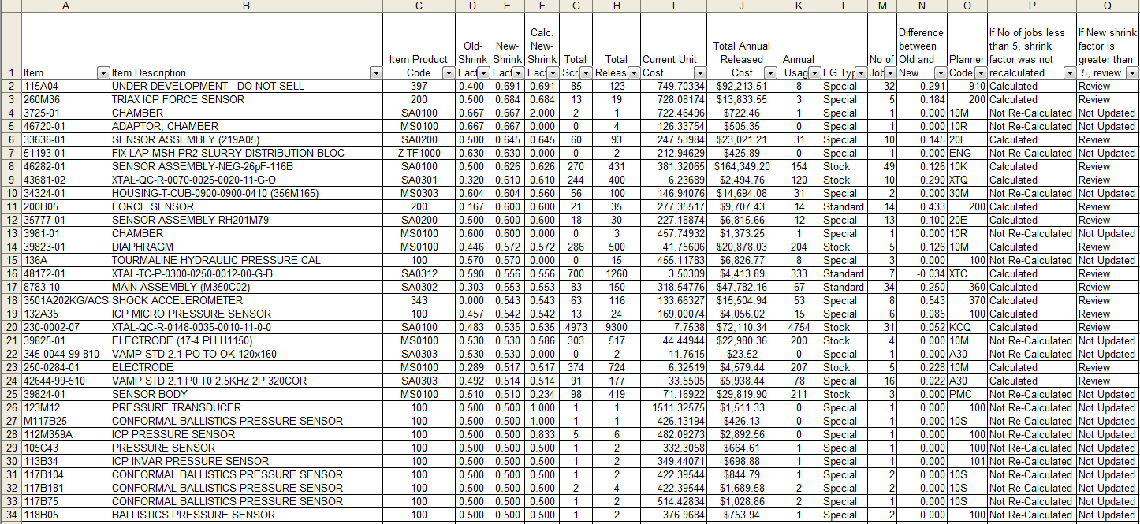

Screen Shot of Quarterly Shrink Factor Report

The following actions must be taken by manufacturing engineering:

1. Review all items assigned to your responsible group where the “Calculated New Shrink Factor is greater than .500.
2. Determine what the Syteline shrink factors should be set to:
3. Update Syteline Shrink Factors found in the Panning Tab in the Items Form accordingly.

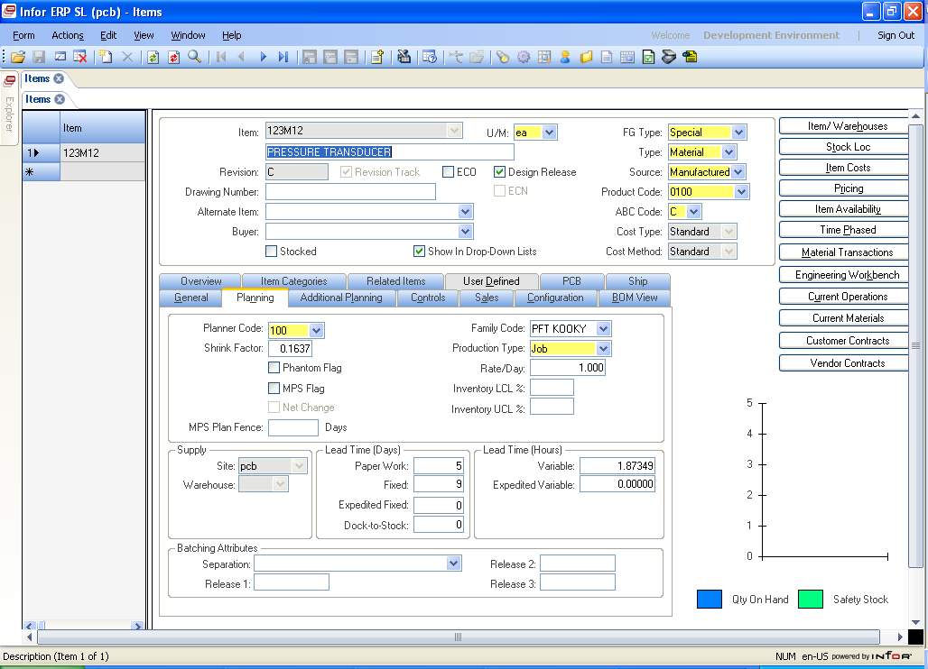

Screen Shot of Shrink Factor in Items Form

* 1. **Note:** Some of these items may have limited data based on annual volume.
  2. **Note:** Use total released annual cost as a guide for potential scrap avoidance when job releases are less than 5.

1. The figure below is an example of on special instance that may require action. In this example, filters were set to select: “Not Re-calculated”, “Not Updated”, and descending order on “Total Annual Release Cost”. This item did not qualify of a shrink factor update because the number of job released was less than 5. The calculated new shrink factor is significantly less than the current shrink factor. This item has a finish good type equal to special, thus has the potential to produce a significant material overrun condition. Engineering might want to consider updating the shrink factor on this item.

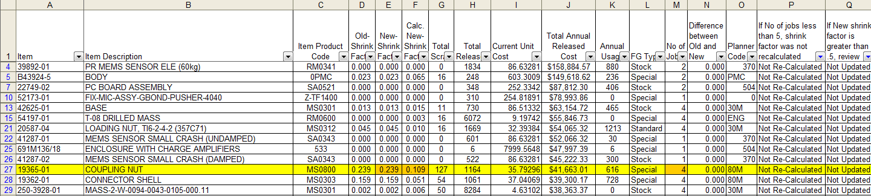

Screen Shot of Quarterly Shrink Factor Report Sorted to look for exceptions.

The following action is recommended to be taken by manufacturing engineering:

1. Review all items with an FG Type = Stock assigned to your responsible group with calculated new shrink factors greater than .300.
2. Determine failure modes and potential CI projects to improve yields.

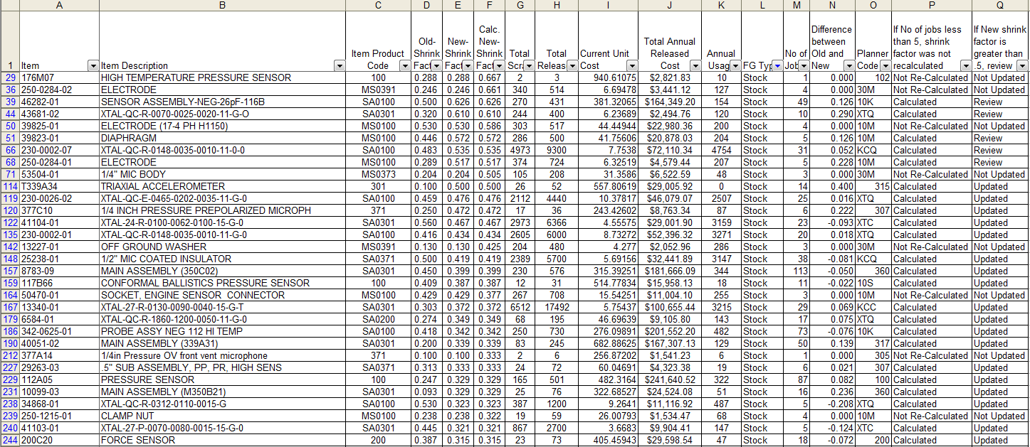

Screen Shot of Quarterly Shrink Factor Report Sorted by FG Types = Stock and New Syteline Shrink Factors Sorted in Descending Order.