Purpose: 1

Related Documents: N/A 1

Responsible: Operations Administrator, Manufacturing Engineering, IT 1

Rules: N/A 1

Instructions for Creating the Excel Data file: (both Depew and NC) 1

Instructions for Creating the Upload file: (both Depew and NC) 2

Instructions for Creating the Engineering Review file: (both Depew and NC) 2

Instructions for Engineering to Review Items with Shrink Factor Exceptions: (both Depew and NC) 3

Purpose:

To generate Shrink Factor Quarterly review and upload file

Related Documents: N/A

# Responsible: Operations Administrator, Manufacturing Engineering, IT

# Rules: N/A

# Instructions for Creating the Excel Data file: (both Depew and NC)

1. Open the Shrink Factor Template R:\Operations\Shrink Factor\Shrink Factor Template.xls
2. Save as “Site” Shrink Factor Data “quarter and year and today’s date”. Example Depew Shrink Factor Data Q1 2013 13Jan04 in folder R:\Operations\Shrink Factor\Data Files\
3. Run job orders query -
   1. Additional Criteria Tab enter Status = complete
   2. Last Transaction date greater than 1 year prior to today’s date (enter as date format)
   3. Last Transaction date less than today’s date (enter as date format)
   4. Refresh
   5. Export (form – export to file)
4. Copy export into Template tab called Jobs
5. Refresh the pivot table tabs
   1. Released
   2. Scrapped
   3. Numbers of Jobs
6. Export all manufactured items from the Items form
   1. Type does not equal O for Other
   2. Source equals Manufactured
   3. Product Code does not equal Z*
   4. Status does not equal O for Obsolete (Controls Tab)
   5. Production type equals Job (Planning Tab)
   6. Export (Form – Export to File)
   7. Correct any line issues with the overrun from Overview
7. Copy Items export into the items tab in the template
8. Copy Item number from the Items export the Data tab.
9. Copy down all formulas
10. For any items that had no job data during this time, Column M and N will have a #N/A.
    1. Sort Column M
    2. Filter for #N/A
    3. Delete all row
11. Column P and Q should not have any #N/A but if they do proceed.
    1. Sort Column P (If No of jobs less than 5, shrink factor was not recalculated) in Ascending order.
    2. Filter for #N/A
    3. Replace the #N/A with Not Re-Calculated
    4. Remove filter from Column P
    5. Sort Column Q (If New shrink factor is greater than .5, review) in Ascending order
    6. Filter for #N/A
    7. Replaced the #N/A with Not Updated
    8. Remove filter on Column Q
12. Resort sheet in Ascending order for Items
13. Format the sheet (Freeze panes under the title row and add gridlines.)
14. Save

# Instructions for Creating the Upload file: (both Depew and NC)

1. Open the Shrink Factor Data File
2. Open a blank workbook.
3. Copy the Data tab into the new workbook as paste special (values).
4. Sort Column P (If No of jobs less than 5, shrink factor was not recalculated) in Ascending Order
5. Filter Not Re-Calculated and delete these rows.
6. Remove the filter on Column P
7. Sort on Column Q (If New shrink factor is greater than .5, review ) in Ascending Order
8. Filter on anything other than Updated
9. Delete Rows
10. Remove filter on Column Q
11. Delete all columns except Item and New-Shrink Factor.
12. Save as “Site” Shrink Factor Upload “Quarter and Year”. Example Depew Shrink Factor Upload Q1 2013 in folder R:\Operations\Shrink Factor\Upload Files
13. Send e-mail to Help Desk requesting the shrink factors be updated and attach the file, copying PD level 2 team.

# Instructions for Creating the Engineering Review file: (both Depew and NC)

1. Open the Shrink Factor Data File
2. Open a blank workbook.
3. Copy the Data tab into the new workbook as paste special (values and format)
4. Put filters on.
5. Freeze panes at B2.
6. Protect the sheet
   1. Tools, Protection, Protect Sheet
   2. In addition to what is already checked, check Sort, Use Filters, Use Pivot Tables.
7. Save as “Site” Shrink Factor “Quarter and Year”. Example Depew Shrink Factor Q1 2013 in folder R:\Operations\Shrink Factor
8. Share the workbook

# Instructions for Engineering to Review Items with Shrink Factor Exceptions: (both Depew and NC)

Quarterly a report will be generated for Depew and Halifax and saved in the following directory:

R:\Operations\Shrink Factor\Depew Shrink Factor (quarter and year run)

R:\Operations\Shrink Factor\Halifax Shrink Factor (quarter and year run)

For items with greater than 5 jobs released and completed over this 12 month period AND the newly calculated shrink factor based on the past 12 month job transaction is less than 0.500 this file will be sent to IT to update Item Syteline Shrink Factors to the newly calculated value. For all these items a note will appear in the message columns stating; “Calculated” and “Updated”.

This report WILL NOT update the shrink factors if the past 12 month job transactions calculates the shrink factor to be great than 0.500 (yield less than 50%) OR the number of jobs released is less than 5. For all these items a note will appear in the message columns either stating, “Not Re-Calculated” and “Not Updated” if less than 5 jobs were released or “Not Re-Calculated” and “Review” if the new calculated shrink factor is great than 0.500.

A notification that these quarterly reports were run will be sent to PD Level II team and NC Engineering for review.

Calculated new shrink factor regardless of quantity released

New shrink factor after latest update

Total annual item cost from released jobs.

Shrink factor currently in Syteline after update

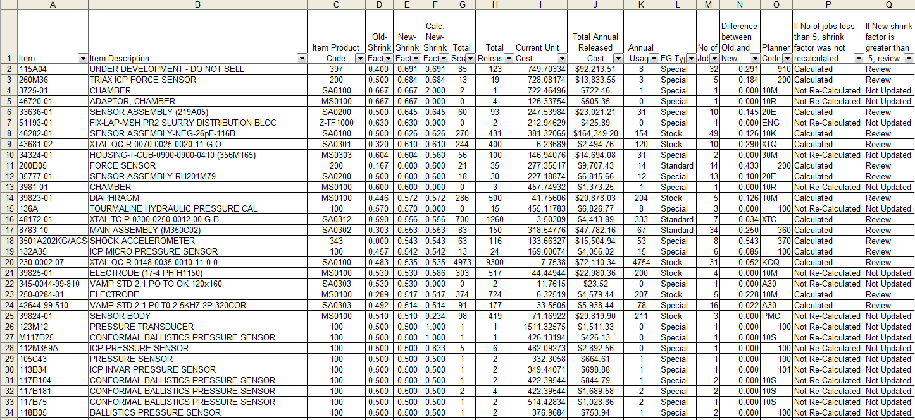

Screen Shot of Quarterly Shrink Factor Report

The following actions must be taken by manufacturing engineering:

1. Review all items assigned to your responsible group where the “Calculated New Shrink Factor is greater than .500.
2. Determine what the Syteline shrink factors should be set to:
3. Update Syteline Shrink Factors found in the Panning Tab in the Items Form accordingly.

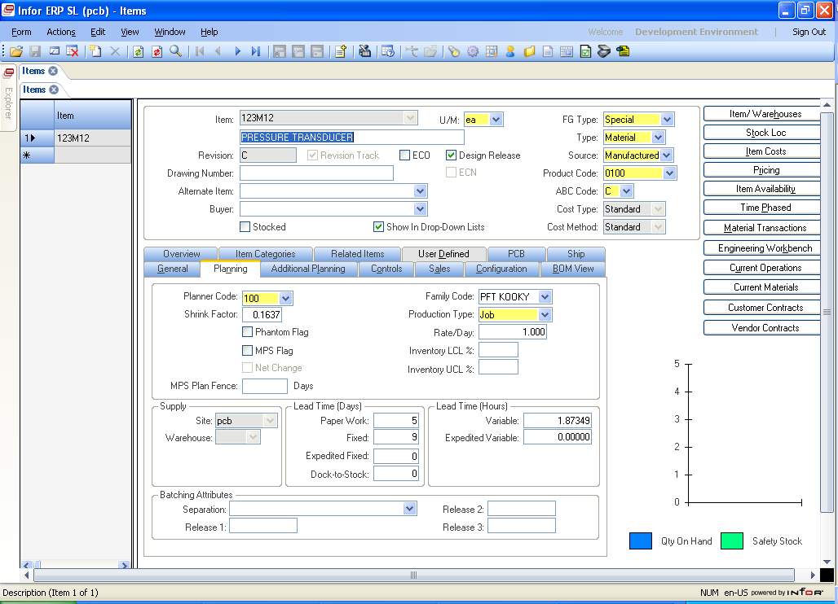

Screen Shot of Shrink Factor in Items Form

* 1. **Note:** Some of these items may have limited data based on annual volume.
  2. **Note:** Use total released annual cost as a guide for potential scrap avoidance when job releases are less than 5.

1. The figure below is an example of on special instance that may require action. In this example, filters were set to select: “Not Re-calculated”, “Not Updated”, and descending order on “Total Annual Release Cost”. This item did not qualify of a shrink factor update because the number of job released was less than 5. The calculated new shrink factor is significantly less than the current shrink factor. This item has a finish good type equal to special, thus has the potential to produce a significant material overrun condition. Engineering might want to consider updating the shrink factor on this item.

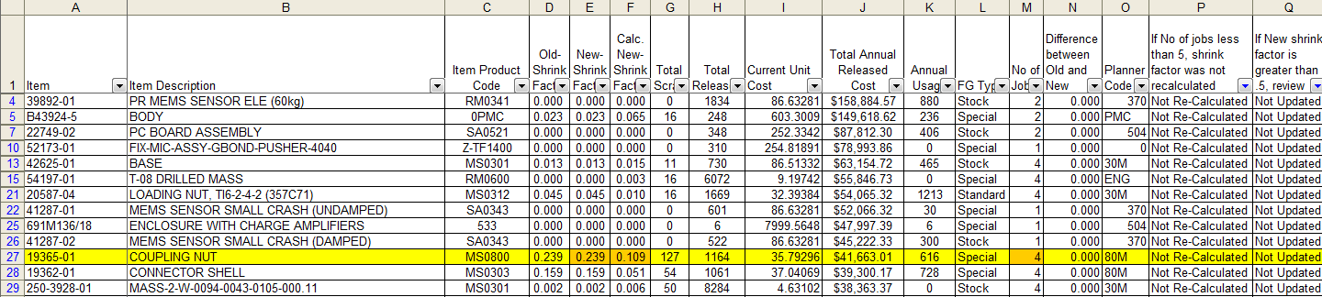

Screen Shot of Quarterly Shrink Factor Report Sorted to look for exceptions.

The following action is recommended to be taken by manufacturing engineering:

1. Review all items with an FG Type = Stock assigned to your responsible group with calculated new shrink factors greater than .300.
2. Determine failure modes and potential CI projects to improve yields.

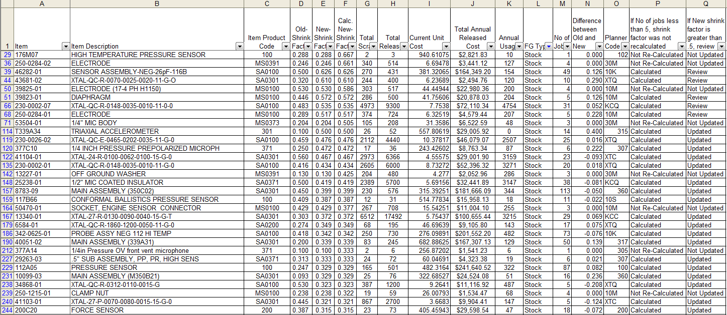

Screen Shot of Quarterly Shrink Factor Report Sorted by FG Types = Stock and New Syteline Shrink Factors Sorted in Descending Order.