The following guidelines are used by PCB Technicians working in the cable assembly departments as a framework to coil, spool and final package cabling. This user guide provides a framework for packaging finished spooled cable, is by no means all inclusive and is superseded by the specific product documentation (i.e. assembly procedure, router, etc.). All cables must be fastened together with (at least) TWO ties (ie. twist tie, cable tie, or zip tie) and/or be secured to a coil with shrink-wrap.

## Preparing cable for assembly (Cut and wind)

|  |  |  |  |  |
| --- | --- | --- | --- | --- |
| **BLE** | **LENGTH** | **COILING** | **Fastener** | **SPECIAL REQUIREMENT** |
| ALL CABLES | LENGTH<=2FT | DO NOT COIL | CABLE TIES | NONE |
| CABLES LESS THAN 1/8” OD | 2FT<LENGTH<=150FT | WHEN USING THE SCHLEUNIGER PS9500RS COIL ON HEAD 1 OF THE SCHLEUNIGER CC2000 OR COIL TO AN INSIDE DIAMETER OF 4.88”+/-1” | CABLE TIES | NONE |
| CABLES LESS THAN 1/8” OD | LENGTH>=150FT | PLACE ON SPOOL | SHRINK WRAP | NONE |
| 018 | LENGTH>=2FT | COIL TO FIT INSIDE OF QUALITY BOX / SMALL-STAMPED (700-0992-90). MUST BE COILED BY HAND. | TWIST TIES | DO NOT COIL THROUGH THE SCHLEUNIGER PS9500RS |
| 030/031 | LENGTH>=2FT | COIL TO FIT INSIDE OF QUALITY BOX / SMALL-STAMPED (700-0992-90). MUST BE COILED BY HAND. | CABLE TIES | DO NOT COIL THROUGH THE SCHLEUNIGER PS9500RS |
| ALL IMI CABLES, AND CABLES GREATER THAN 1/8” OD | 2FT<LENGTH<=200FT | WHEN USING THE SCHLEUNIGER PS9500RS COIL ON HEAD 2 OF THE SCLEUNIGER CC2000 OR COIL TO AN INSIDE DIAMETER OF 6.33”+/-1” | CABLE TIES | ARMORED CABLES MUST BE SHIPPED WITH ZIP TIE |
| ALL IMI CABLES, AND CABLES GREATER THAN 1/8” OD | LENGTH>=200FT | PLACE ON SPOOL | SHRINK WRAP | NONE |

|  |  |  |  |  |
| --- | --- | --- | --- | --- |
| **BLE** | **LENGTH** | **COILING** | **Fastener** | **SPECIAL REQUIREMENT** |
| 046/049 | 2FT<LENGTH<50FT | COIL TO AN INSIDE DIAMETER OF 7.5”+/-1” | CABLE TIES | DO NOT RUN THROUGH THE SCHLEUNIGER PS9500RS |
| 046/049 | LENGTH>=50FT | PLACE ON SPOOL | SHRINK WRAP | DO NOT RUN THROUGH THE SCHLEUNIGER PS9500RS |
| 641 ARMOR CABLE | 2FT<LENGTH<100FT | WIND BY HAND | CABLE TIES | ARMORED CABLES MUST BE SHIPPED WITH ZIP TIE |
| 005/006 CABLE | ANY LENGTH | WIND BY HAND | CABLE TIES | PLACE CABLE INTO HEAT SHRINK TUBE USING THE METHOD DESCRIBED BELOW (Currently, this method is only being used at the NC Facility). |

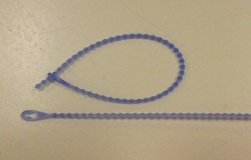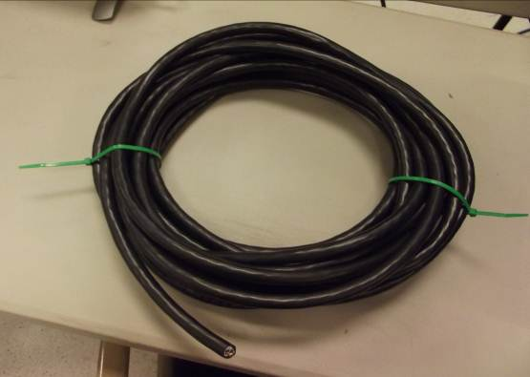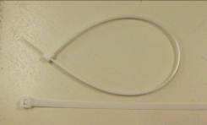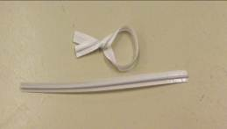

Cable Ties

Zip Ties

Twist Ties

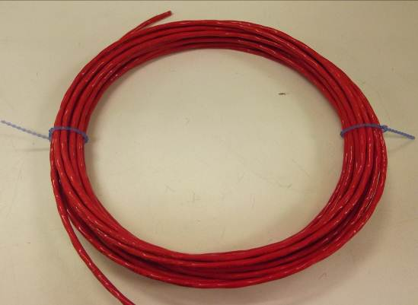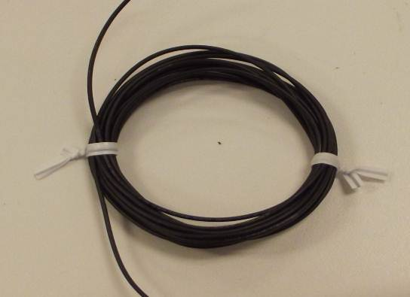

When winding cable onto spools, it is very important to keep both ends of the cable within the spool wheels:

* Tape may be used to hold the starting-end of the cable to the inner wall of the spool (see figure 1)
* Tape may also be used to hold the second end of the cable to the inner wall of the spool after spooling (See figure 2)
* Tape is removed to facilitate final assembly of the cable ends.
* Shrink wrap may be used to hold both of the completed ends (ends with connectors, pigtails or blunt cuts) onto the inner spool (see figure 3)

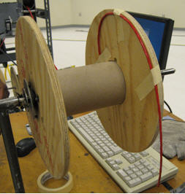 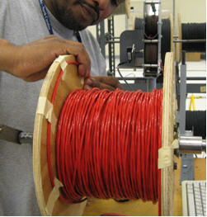 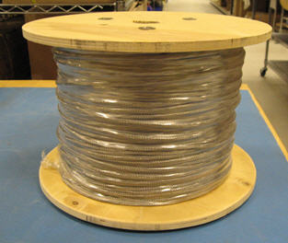

Figure 1 Figure 2 Figure 3

### http://www.caulfieldindustrial.com/product_images/caulfieldindustrial.com/2-121B_L.jpgCut and Wind Equipment:

Figure 1. Schleuniger PS9500RS with CC2000   
*(Currently, this winding machine is only at the NC Facility).*

**Figure 1**

### Notes:

* In the event the machine misfeeds the wire, experiences an error condition, or finishes the production run, any wire that has entered the machine past the placards shown in Figure 2 must be scrapped immediately.
* Any wire removed from the spool and not cycled through the machine must immediately be marked with a part number for identification or placed back on the spool (spool must be marked with part number).

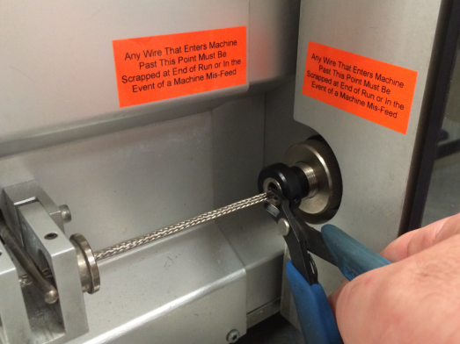

**Figure 2**

Pulling the 005/006-cable through the Heat Shrink Tube

Attach the air hose and push the fish line down through the clear tube.

Attach the fish line to one   
end of the cable.

Begin turning the reel to   
take in the fish line

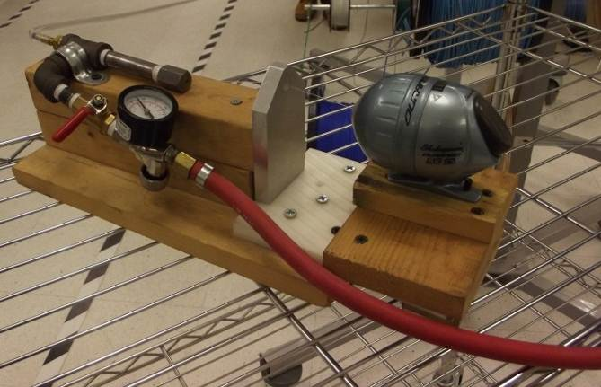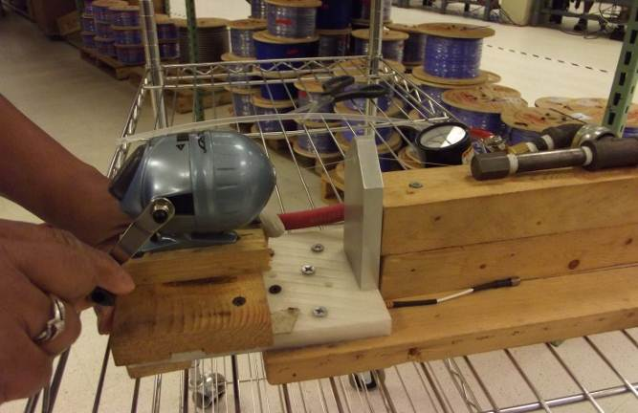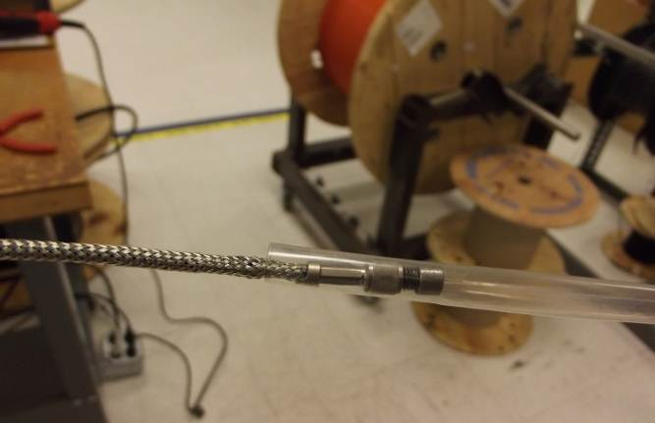

Support the heat shrink tube so it does not   
touch the floor

At the same time unwinding the cable from the cable winder.

Pull the cable through  
 the heat shrink tube

