1.0 Purpose 1

2.0 Responsibilities 1

3.0 Associated Documents 1

4.0 Cryogenic Argon Dewars 1

4.1. General Description and Practice — Cryogenics 1

4.1.1. Cryogenic Gasses — Cryogenic Liquids 2

4.1.2. Cryogenic Containers 2

4.1.3. Pressure Relief Devices 3

4.1.4. Pressure Building Circuit 3

4.1.5. Liquid-to-Gas Conversion 4

4.2. Safety 4

4.2.1. Emergencies 4

4.2.2. Handling & Storage: Cryogenic Dewars 4

4.2.3. PPE and Prudent Work Practices 5

4.3. Argon 5

4.4. Replacing Argon Dewars 5

4.5. Resolving Common Dewar Problems 8

5.0 Concoa IntelliSwitch™ 9

5.1. IntelliSwitch Troubleshooting 11

# Purpose

The purpose of this user guide is to provide information for safe handling of cryogenic Argon by authorized personnel at PCB Piezotronics, Inc. (PCB). In order to maintain a safe work environment for all employees and visitors of PCB, all handling of cryogenic Argon on PCB premises must be done by authorized personnel only, using the proper Personal Protective Equipment (PPE) and following the information listed in this user guide.

# Responsibilities

Welding Department engineering/management is responsible for maintaining this procedure. Authorized Welding Department technicians are responsible for carrying out this procedure.

Affected Department / Product Group / Support Group:

Welding Department

# Associated Documents

ISO 9001, QAM, QSM, AS9100

# Cryogenic Argon Dewars

## General Description and Practice — Cryogenics

The Argon used for laser welding at PCB is used only in gas form, however, the Argon is stored as a cryogenic liquid. The word “Cryogenics” is derived from two Greek words: Kryos, which means cold or freezing, and Genes, meaning born or generated. To maintain the pressures and temperatures required for cryogenic storage, the liquefied Argon is stored in specialized cryogenic containers. See Cryogenic Containers.

### Cryogenic Gasses — Cryogenic Liquids

When gasses are converted to liquid form they become cryogenic liquids. Cryogenic liquids are liquefied gases that have a normal boiling point below -238° F (-150° C). The temperature difference between the product and the surrounding environment is substantial. Keeping this surrounding heat from the product requires special equipment to store and handle cryogenic liquids.

The cryogenic tank is constructed like a vacuum bottle. It is designed to keep heat away from the liquid that is contained in the inner vessel.

### Cryogenic Containers

Cryogenic liquid cylinders are insulated, vacuum-jacketed pressure vessels. The type of container in use is the dewar, named after Sir James Dewar, who invented cryogenic liquid cylinders in 1892.

Because the dewar is constantly absorbing heat from the surrounding environment, vaporization takes place continuously. Rates of vaporization vary depending on the design of the container and the volume of stored product. The product may be withdrawn as a gas under its own vapor pressure or by passing the liquid through an internal vaporizer known as a pressure building circuit.

The containers used operate at pressures up to 350 psig. Above that pressure, the pressure relief valve will open up and reduce the pressure back into its operating range. If for some reason the pressure relief valve should fail, the dewar also has a rupture disk. The rupture disk allows for a semi-controlled release of product and prevents a catastrophic explosion of the dewar. See the example liquid cryogenic cylinders in the figure below.



The product may be withdrawn as a gas by passing liquid through an internal vaporizer or as a liquid under its own vapor pressure.

Liquid cylinders designed to dispense gaseous argon have valves equipped with standard Compressed Gas Association (CGA) outlets. Suitable pressure regulating equipment may be attached. Insulated flexible or rigid lines are used to withdraw product from storage tanks. The connections on the lines and tanks vary by manufacturer.

Liquid cylinders should always be stored and used in areas with appropriate natural or mechanical ventilation. Never adjust, block, plug or attempt to repair anything on a liquid cylinder. Maintenance and repairs must be performed only by authorized personnel.

### Pressure Relief Devices

The liquid-to-gas conversion rate is about 2.3% per day under perfect conditions, so the actual vaporization rate experienced can vary. If gas product is not used, pressure will build until it is released by a control valve. Hearing a periodic loud hiss from a liquid cylinder is usually the normal operation of its pressure relief device. Note that this is a high pressure container, with the valve marked for 350 psig, as shown in the figure below.



Pressure relief devices are designed to relieve head pressure, which occurs as the cryogenic liquid boils into a gas. Normally, the pressure relief valve will periodically release this pressure. Never plug, tamper with or remove the pressure relief valve. If the pressure relief valve malfunctions, a backup disk will rupture and relieve the pressure. The rupture of the backup disk will produce a loud sound and may release a large quantity of liquid and gas. If that happens, immediate evacuation of the area is required to prevent asphyxiation.

The pressure relief valve should not be constantly leaking gas. If there is a constant leak of gas, the pressure relief valve is defective and the supplier of the dewar should be notified.

### Pressure Building Circuit

As a bank of dewars is used, the pressure that these dewars can provide will decrease. The pressure building circuit, as shown below, can build additional pressure in the dewar. This extra pressure is helpful because it provides a reservoir of gas for use during high need periods (i.e when the glovebox is purging). When the bank of dewars gets down to 200-220 psi, crack open the pressure building valve on both dewars. Allow the dewar some time to build pressure. Continue slowly opening the pressure building valve to maintain a supply pressure between 200- 330 psi. It is normal for ice to form around the bottom of the dewar when the pressure building valve is open.

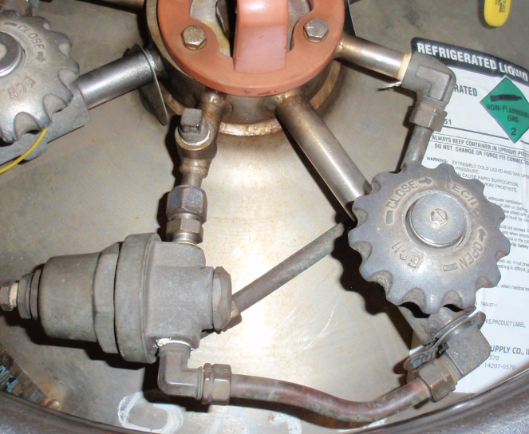

### Liquid-to-Gas Conversion

Because liquid is converted to gas at about 2.3% per day, even under ideal container conditions, if the liquid is not used regularly, the vessel will be empty in a certain amount of time. For the most part, PCB’s argon usage is relatively level. Under normal conditions, it is recommended to order new dewars for the spare bank when you open the pressure building valve on the bank being used.

The exception to this is when the glovebox is purging for a long period of time, like after a glovebox cleanout. Under these conditions, it is recommended to have full dewars on the spare bank regardless of the condition of the dewars on the bank being used. It is important to accurately estimate your use so we do not run out of gas.

## Safety

### Emergencies

* If there is a large spill or rupture of a container:
  + Immediately call 911!
  + Warn others in building
  + Evacuate!! There will be an oxygen deficiency in the area of the spill!!
* If there is injury to the body from liquid Argon, seek immediate medical assistance:
  + If liquid is splashed in the eyes, flush with **warm** water for at least 15 minutes. Seek immediate medical attention—Call 911!!
  + Skin contact with liquid argon will cause severe frostbite and burns. Soak affected part in warm water and seek medical attention—Call 911immediately!! Lack of prompt medical attention may result in amputation!!!
  + Do not use hot water or rub the affected area.

### Handling & Storage: Cryogenic Dewars

* Store and use cryogenics with adequate ventilation.
* Do not store cryogenic containers in a confined space.
* Cryogenic containers are equipped with pressure relief devices to control internal pressure. Under normal conditions, these containers will periodically vent product. Do not plug, remove, or tamper with any pressure relief device.
* Never allow any unprotected part of the body to come in contact with un-insulated pipes or equipment that contains cryogenic product. The extremely cold metal will cause the flesh to stick to the surface and may tear when one attempts to withdraw from it. Use a suitable hand truck for container movement.
* Containers should be handled and stored in an upright position.
* Do not drop, tip, or roll containers on their sides.
* Do not remove or interchange connections.
* Contact the vendor if you experience any difficulty operating the container valve or with the container connections. Discontinue use. Use the proper connection. DO NOT USE ANY TOOLS TO OPEN OR CLOSE THE VALVES.

### PPE and Prudent Work Practices

One must be thoroughly familiar with the properties and safety considerations before handling a cryogenic liquid and its associated equipment. At PCB, cryogenic liquids are to be handled by authorized persons only. PCB personnel should not handle cryogenics unless they are appropriately trained and supervised.

The eyes are the most sensitive body part to the extreme cold of the liquid and vapors of cryogenic liquids. The recommended personal protective equipment for handling cryogens is a full face shield. In emergency situations, self-contained breathing apparatus (SCBA) may be required.

Steel toed shoes are required any time you are moving or transporting a dewar.

## Argon

Argon is derived from the Greek word **αργον** meaning lazy or inactive. This refers to the fact that Argon is chemically inactive and thus makes a good shield gas for welding.

Liquid argon has a boiling point of -302.6° F (-185.9° C). Extensive tissue damage or burns can result from exposure to liquid argon or cold argon vapors.

Although Argon is nontoxic, it can act as a simple asphyxiant by displacing the oxygen in air to levels below that required to support life. Argon is odorless, so the only way to determine the amount of argon in the air is to use a calibrated oxygen meter. If there is a non-emergency concern about argon displacing the oxygen, evacuate the area immediately and call maintenance. Maintenance will use a hand held oxygen meter to determine if there is a problem and get the appropriate help as needed. Inhalation of argon in excessive amounts can cause dizziness, nausea, vomiting, loss of consciousness, and death. At low oxygen concentrations, unconsciousness and death may occur in seconds and without warning.

There is an oxygen alarm in the welding room. If the alarm goes off during the work day, immediately check the oxygen level reading displayed on the alarm. If the reading is less than 19.5% oxygen, immediately evacuate the welding room and call for maintenance. If the alarm is sounding first thing in the morning, do not enter the welding room; instead, call maintenance. If there is a concern about a failed sensor, get a hand held oxygen meter before entering the room.

## Replacing Argon Dewars

When replacing Argon dewars, follow the safe handling guidelines and use appropriate PPE as described above.

NOTE: When changing dewars, change an entire side at once.

1. Close the bank shutoff valve as shown below. (Note: the valve in line with the piping (as shown) is open. The valve perpendicular to the piping is closed.)

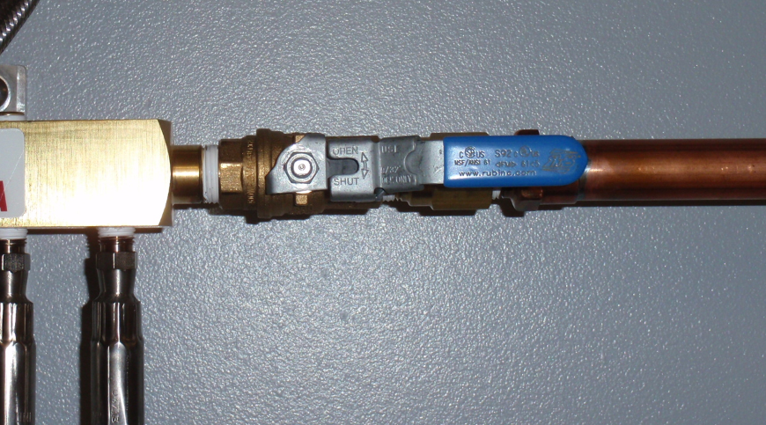

1. Close the gas supply valve on each dewar. This valve may be labeled “Gas Use” or just “Use” as shown below.

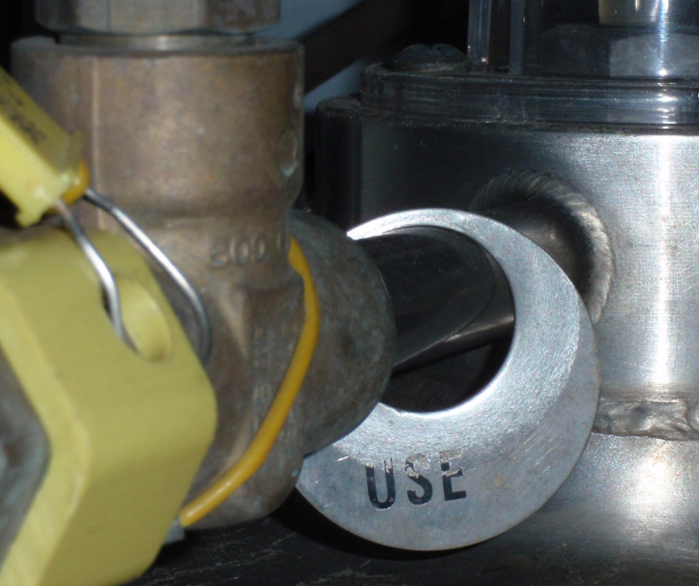 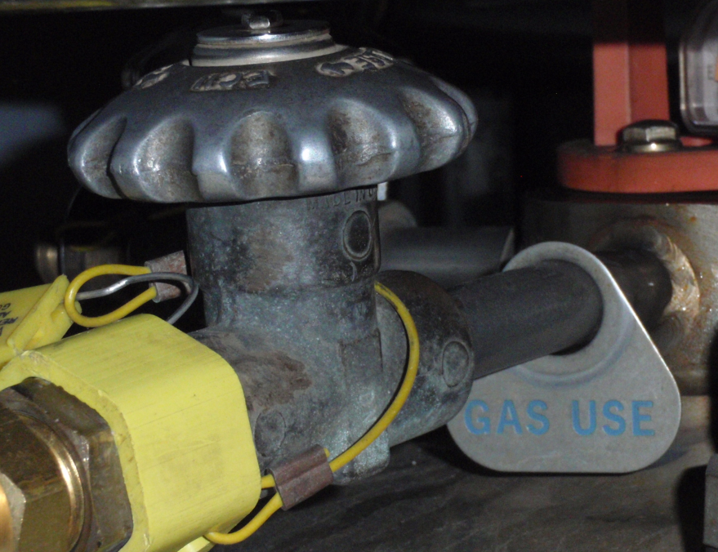

1. Close the vent valve on each dewar.

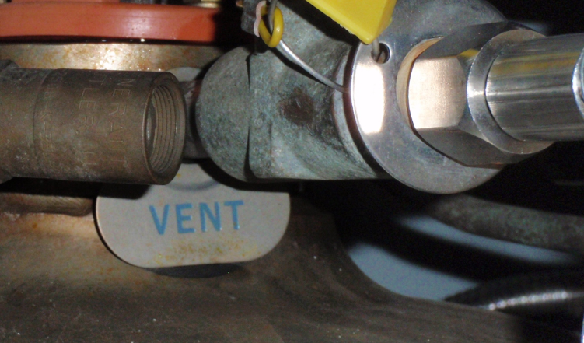

1. Close the valve for the pressure building circuit.
2. Disconnect the gas feed line and the vent line from each dewar.
3. Remove the empty dewars.
4. Put new dewars into position on the rubber floor matting with the liquid port facing the wall.
5. Connect the gas feed line and the vent line to each dewar.
6. Open the vent valve on each dewar.
7. Open the gas supply valve on each dewar.
8. Open the bleed valve on the vent manifold to purge the air out of the vent lines. Keep it open for approx. 45 seconds and then close the bleed valve.

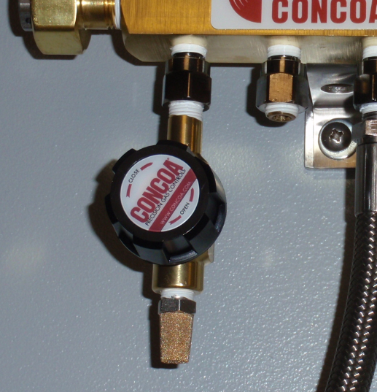

1. Open the bank shutoff valve.

## Resolving Common Dewar Problems

| **Issue** | **Possible Cause** | **Recommended Action** |
| --- | --- | --- |
| Gas vents intermittently through safety relief valve | -Probably normal operation  -Gas generated due to heat leak into cylinder causes head pressure to build | -Ensure inactive containers are stored in well-ventilated area.  -Rotate inventory.  -Obtain “Just the right amount, at just the right time.” |
| Gas vents continuously through safety valve | Possible relief valve failure or excessive heat leak | -Remove container or vent the exhaust to a well-ventilated area.  -Relieve product through vent valve.  -Check to see if safety relief valve is frozen open.  -Contact supervisor or supplier for assistance.  -Call vendor for inspection and/or replacement. |
| Gas vents during use through safety relief valve | Set point on regulators exceeds safety relief valve setting | -Reduce set point on pressure building regulator.  -Contact supervisor or supplier for assistance, maintenance, and/or repair. |
| Pressure in the container is low | Pressure building regulator not set high enough | Adjust to increase pressure— contact supervisor or supplier. |
| Pressure building valve is open | -Close the valve if frost is visible on the pressure building vaporizer near the bottom of the tank.  -Contact supervisor or supplier. |
| Pressure in the container is too high | Leaking or improper setting of pressure building regulator | -Reduce regulator setting to achieve desired pressure level.  -Contact supervisor or supplier. |
| Vacuum integrity failing | If container walls are covered with frost, contact supervisor or supplier. |
| Container top covered with frost | High product use | Normal operation |
| Container surface is uniformly covered with frost | Vacuum integrity compromised | If accompanied by a high rate of product venting through the safety relief valve, or high rate of pressure increase, call supplier. |

# Concoa IntelliSwitch™

The Concoa IntelliSwitch is used to make sure that argon is continuously supplied to the welders and to minimize the loss of argon due to boiling off. The intent of the IntelliSwitch is to empty one bank of cylinders at a time. However, if the IntelliSwitch senses that the other bank is close to venting, it will start using that bank until the pressure is reduced to approx. 300 psig and then will automatically switch back to the original bank.

When a bank gets down to 130 psi, the IntelliSwitch will automatically switch to the other bank. It will periodically check the pressure of the original bank of dewars several times to see if it has built any more pressure before it declares the first bank as empty. At this point, the red “replace” indicator will light and remain lit until the “reset” button is pressed. Allow the almost empty dewars to sit for 24 hours. Press the reset button and then the bank select button to use the remaining gas in these dewars. This will provide another 1-2 hours of argon (depending on usage). This may be repeated 1-2 times until no more pressure builds in the empty dewars.

If the dewars in a given bank are near empty, they will not be able to maintain pressure with the glovebox purging. This will create a false “replace” light to come on. When the purging of the glovebox is complete and that bank of dewars has regained pressure, press the reset button and the bank select button to use the remaining gas in the dewars.

The picture on the next page illustrates the proper setup of the Concoa IntelliSwitch and use of the control buttons.

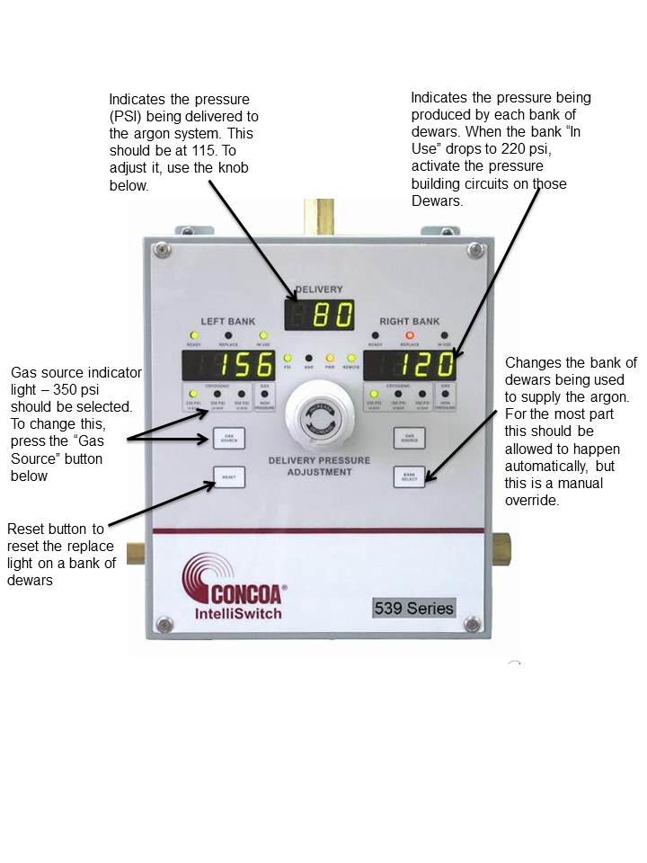

## IntelliSwitch Troubleshooting

If problems occur with the operation of the IntelliSwitch, refer to the following table to troubleshoot them.

|  |  |  |
| --- | --- | --- |
| **Issue** | Possible Cause | **Recommended Action** |
| No display or status lights ON. | -No power to the system.  -Check that power source is live.  -Check the system fuse. | -Restore power.  -Replace fuse.  -Replace electronic control board. |
| System will not switch from one side to the other automatically. | Check that the pressure on the destination side is greater than the switchover pressure setting. | -Restore pressure to proper operating level.  -Check that the switchover pressure setting is correct for the cylinder size and inlet pressures required. |
| There are pressure readings on both inlet displays but no delivery pressure. | -Air supply is off or its pressure is too low. | -Restore pressure. |
|  | -Internal regulator for the valve system is plugged or faulty | -Clean or replace internal regulator. |
| There is a pressure reading on the left inlet display and no pressure on the right inlet display or outlet display. | In a system using delivery process gas activation, the right side must be pressurized for gas delivery. | Restore a minimum of 80 PSI pressure to the right side. |
| Remote alarm does not work with the system. | -Remote alarm is not powered.  -Wiring between the IntelliSwitch and the alarm is incorrect. | -Check the remote alarm LED on IntelliSwitch front panel.  -Check alarm is powered and on.  -Check wiring between alarm and IntelliSwitch. |
| Outlet pressure from the system drops below the adjusted value. | -Flow demands on the system are greater than the cylinders can supply.  -Cylinder pressures are too low.  -Switchover pressure set too low for the application. | -Replace or resize cylinders.  -Change switchover pressure on IntelliSwitch.  -Replace check valve. |
| Gas from one side appears to be flowing to the other. | Dirty or bad check valve. | Replace burst disk. |
| Gas escaping from side of regulator block. | Failed burst disk. | Reduce pressure to the inlet to maximum allowable. |
| Inlet display shows “Err2”. | Inlet pressure greater than maximum inlet operating pressure. | Replace outlet regulator. |
| Outlet display shows “Err2”. | Outlet regulator failure. | Change cylinder size by pressing the SOURCE SELECT button. |
| Any display shows “Err3”. | Switchover pressure value is greater than the cylinder size selected. | Change switchover pressure setting. |