1.0 Purpose 1

2.0 Responsibilities 1

3.0 Associated Documents 1

4.0 Procedure 1

4.1. Autoclose Exception Errors – Operation not Complete 1

4.2. Correcting Errors in Time Reporting 6

4.2.1. Forgot to Punch Out Error 6

4.2.2. Other Time Reporting Errors 7

# Purpose

This user guide provides procedures for identifying and fixing the most common Shop-Trak errors in the Business System Database (BSD).

# Responsibilities

Operations management is responsible for maintaining this procedure. Authorized Supervisors or Lead Technicians are responsible for carrying out this procedure.

**Affected Department / Product Group / Support Group**

All Depew Production Departments.

# Associated Documents

ISO 9001 Quality System Manual, Quality Assurance Manual

# Procedure

The following sections describe how to rectify the two most common Shop-Trak errors.

## Autoclose Exception Errors – Operation not Complete

NOTE: You need to have the affected job number available in order to correct an Autoclose exception error.

1. Open “Job Operations” form in Syteline.
2. Enter the Job number in upper left corner of the form.
3. Select “Filter in Place” icon (magnifying glass icon) from Syteline toolbar.
4. Press “Ctrl-2” keys to display the job detail grid.

NOTE: “Ctrl-1” and “Ctrl-2” allow you to toggle between the original job operations screen and the job detail grid screen. See Figure 1 and Figure 2.

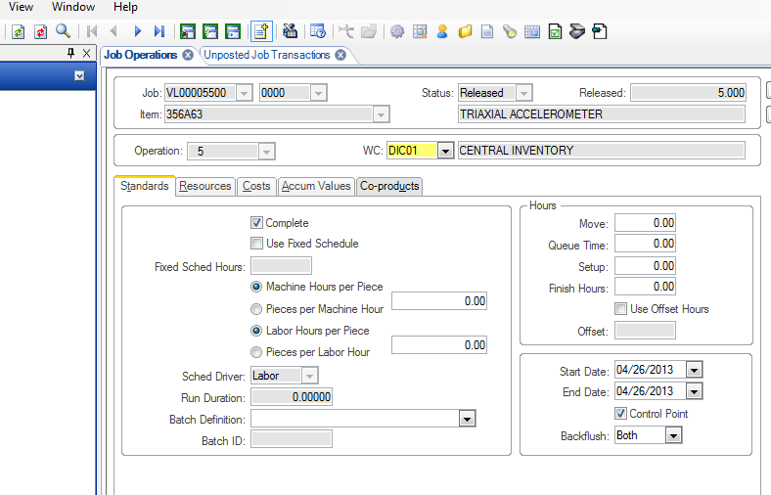

Figure 1 “Ctrl-1” – Original Job Operations Screen

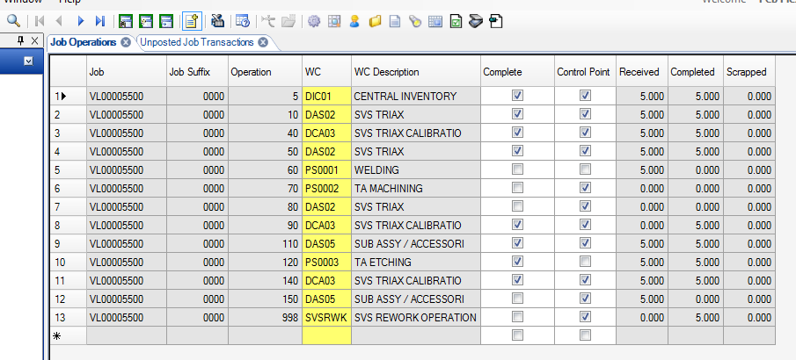

Figure 2 “Ctrl-2” – Job Detail Grid Screen

1. Move cursor to blank area below the job detail grid on the job detail grid screen.
2. Right-click and select “Edit Grid Columns” to open the Edit Grid Column Visibility and Order dialog box. See Figure 3.
3. Click the hide all button. Place a check in the boxes in the visible column for the following Captions: Job/ Job Suffix / Operation/ WC/ WC Description/ Complete/ Control Point/ Received/ Completed/ Scrapped and remove the checks for all other rows.

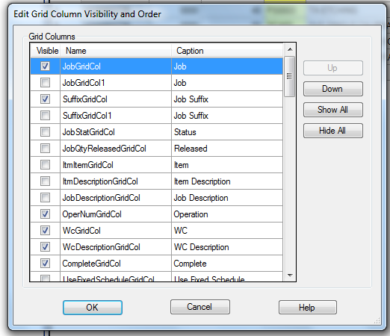

Figure Edit Grid Column Visibility and Order Dialog Box

1. Click “OK”. Unchecked columns will be removed from the job detail grid screen. See Figure 4.

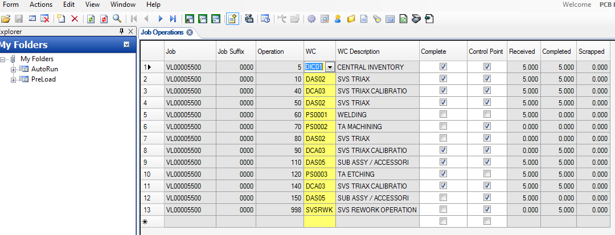

Figure 4 Updated Job Detail Grid Screen

1. Identify the control point operations that need to be corrected. The quantity completed plus quantity scrapped should equal the quantity received. If the quantity received at operation is incorrect, look to the previous control point for the transaction error. The operation complete quantity and the operation move quantity should always be equal and the quantity received at an operation should never exceed the job quantity. To identify the root cause of transaction errors, the Job Transaction Report can be run for the specific job. Click the show detail on the form prior to running the report.

NOTE: If the operation to be corrected has a checkmark in the box in the “Complete” column, then uncheck the box. See Figure 5. Click on the “Save” icon in the Syteline toolbar.



Figure 5 “Complete” Column on Job Detail Grid Screen

1. Open “Unposted Job Transactions” form in Syteline. See Figure 6.
2. Click on “Filter in Place” icon (Magnifying glass).
3. Select “Move” for Transaction Type (dropdown arrow).
4. Enter the Job number and suffix.

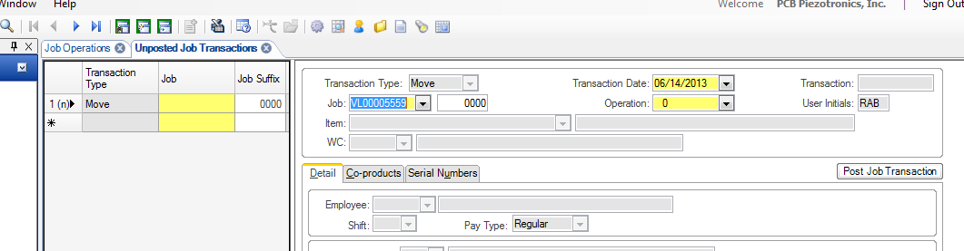

Figure 6 Unposted Job Transactions Form

1. Verify that a new record was created by looking for the (n) designation. See Figure 7.



Figure (n) Designation for Transaction Type

1. If a new record was not created, select “Create New Object in Current Collection” icon from the toolbar (upper left). See Figure 8.

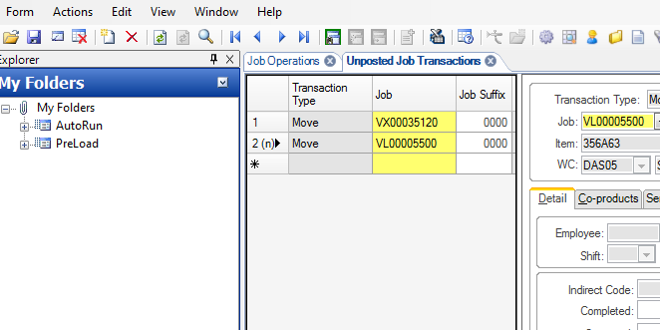

Figure 8 Create New Object in Current Collection Icon

1. See Figure 9. Enter the Operation number [A] and Quantity Completed [B].
2. Place a check in the “Oper Complete” box [C].
3. Confirm the next operation [D] is correct. Change it if it is not correct. If this is not correct, it will result it can result in a quantity received at an operation that exceeds the job quantity.

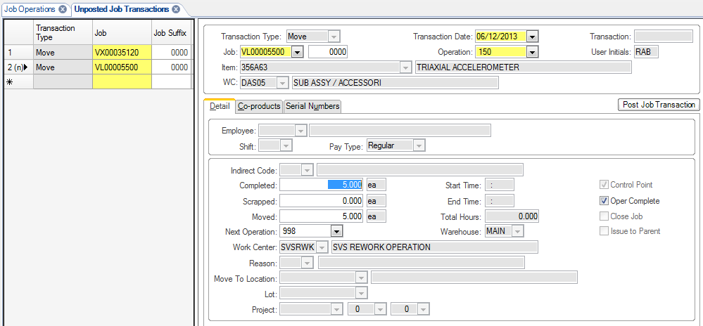

**[D]**

**[B]**

**[C]**

**[A]**

Figure 9 Data Entry Points in Updated Job Transactions Form

1. Click on the “Save” icon in the Syteline toolbar.
2. To review the change, click the “Refresh” icon in the toolbar, then switch to the Job Operations job detail grid screen.

## Correcting Errors in Time Reporting

Examples of errors that may need to be corrected are forgetting to punch out for breaks or lunch, forgetting to punch back in after lunch or breaks and charging incorrectly to jobs or indirect codes.

### Forgot to Punch Out Error

The “Forgot to Punch Out” report will be distributed daily or can be run manually from the “Shop-Trak Time Attendance/Delinquency Report” form.

1. Log on with st + username, enter the password, then click OK. Open the Shop-Trak Edit Transactions form in Syteline.
2. Filter on < Today’s Date.
3. Find record by employee.
4. Press the “Lock” button. [A] Note: If there is already a lock on the transactions, the button on the form “Shop-Trak Unlock Locked Employees” will unlock.
5. Edit “Daily End Time” or “Daily Start Time” as required. (Be sure to use military time format.) [B] Note: If multiple transactions exist for the employee for the same workday, the start and end times must be adjusted to not overlap and so no gaps occur.
6. Uncheck “Forgot to Punch Out” box. [C]
7. Click on the “Save” icon in the Syteline toolbar.
8. Press the “Unlock” button. [D]

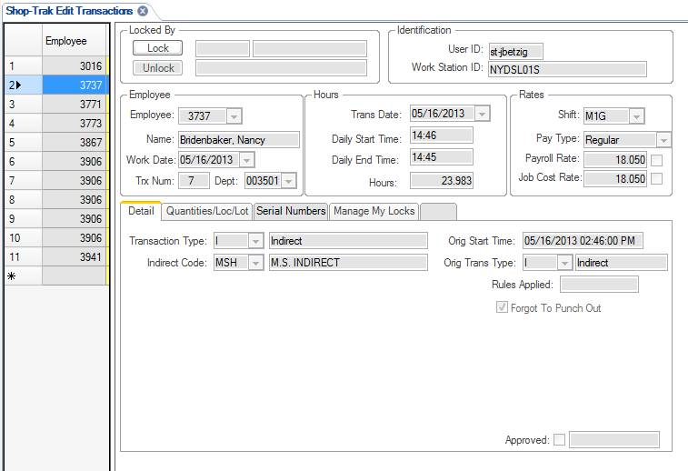

**[C]**

**[B]**

**[A]**

**[D]**

Figure 10 Shop-Trak Edit Transactions Form

### Other Time Reporting Errors

Supervisors or leads should run the “Break/Lunch Report” from the “Shop-Trak Time Sheet Display Report” form filtered by supervisor daily to confirm that employees have punched out and in properly for breaks and lunches. The “Prior Day Timesheet Report” will be distributed daily. The Prior week timesheet will be distributed every Monday morning. If any of these reports indicate an inaccuracy in charging of 15 minutes or more, the transaction(s) must be corrected. These corrections must be made by Monday at 11am for the prior week.

When correcting a person’s time it is important that there is no overlaps or gaps in their time and the total time accounted for in Shop-Trak does not exceed their paid hours.

1. Run the “Shop-Trak Time Sheet Display Report” filtered on the employee number and the date with the error.
2. Determine which transactions are in error.
3. Make the necessary corrections using the “Unposted Job Transactions” form. Post the transactions.
4. Re-run the “Shop-Trak Time Sheet Display Report” filtered on the employee number and the date with the error to verify the corrections.

Note: For most transaction errors other than forgetting to punch out there will likely be two offsetting transactions required; One to remove time from an existing transaction and one to add to another. The example given is removing a half hour of Run time from a job and adding the half hour to indirect time.

For Run transactions, the Transaction Type, Transaction Date, Job, Operation, Employee and Total Hours fields must be populated.

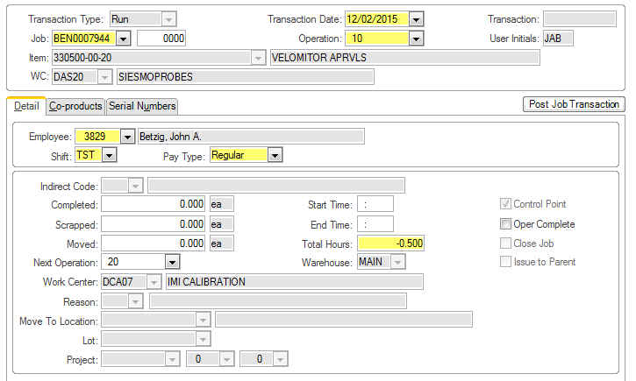

For Indirect transactions, the Transaction Type, Transaction Date, Employee, Indirect Code and Total Hours must be populated.

