Table of Contents

I. Purpose: 2
II. Responsibilities: 2
III. Associated Documents: 2
IV. Safety Considerations: 2
V. Machine Start-Up 2
VI. Selecting a weld program 5
VII. Inspection/Leak test 7
VIII. Machine Shutdown 7
IX. Referenced Documents 7
A. TA1003- Laser Welding Procedure 7
B. TA1012- Leak Testing 7
C. TA1039- General Workmanship for TA 7
D. TA33- Laser Welding Process Map 7

Purpose:

To provide instructions for Service Operators in the process and procedures necessary for operating the JK745.

Responsibilities:

The Welding Supervisor and Manufacturing Engineers are responsible for maintaining this procedure. The Welding Supervisor and Weld Technicians are responsible for adhering to and effectively carrying out this procedure.

Associated Documents:

ISO 9001, Quality System Manual, Quality Assurance Manual

Model JK745 Series Laser Operating Manual,

Safety Considerations:

Laser welding uses a focused beam of light to achieve very precise welds. The major hazard of this powerful beam is to the eyes, which can be partially blinded when hit with the beam. Special eye protection must be used, and care must be taken with any reflective surfaces since both the original and reflected beam are extremely dangerous.

Machine Start-Up

Press and hold on/off button for 3 to 5 seconds located in the front of the work station. (should illuminate green)

Turn Chiller to the local postion.

Pull the lever on the laser supply to the on postion and press the reset button below the lever. (It should turn blue)

Turn the exahaust fan on located on the left wall. (labeled JK745)

Turn switch under workstation table to on position.

Once computer boots up, press Power On/E-Stop Reset Button

Press power button on Operator Control Panel. “Cooler” light will come on followed by the “Power” light and the “Ready” light. Once all of these lights are on you can press the “Remote” button on the “Laser” tab.

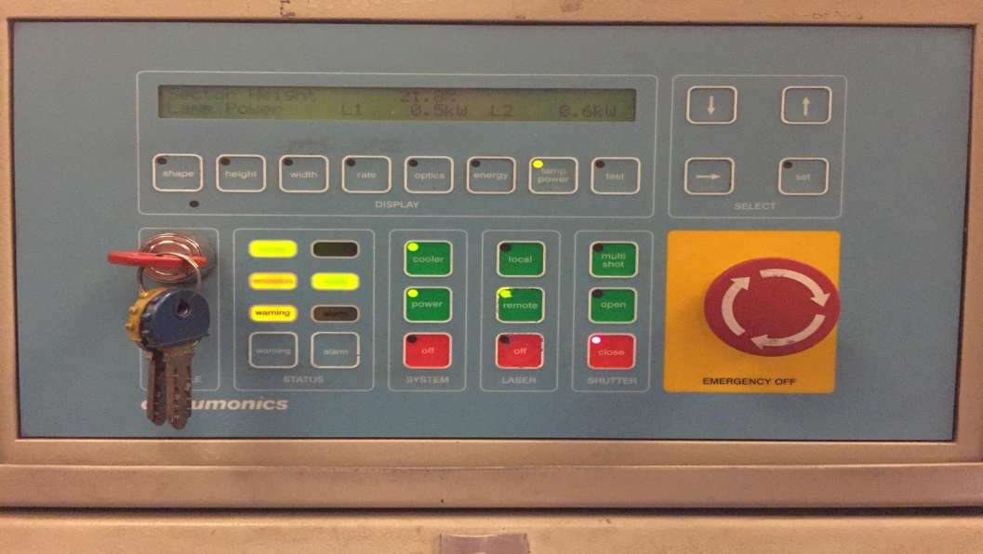

On Control Panel, Laser Emission light will come on and a moment later the Laser Running light will come on.

Open NVIEW/MMI program and Press CNC Run

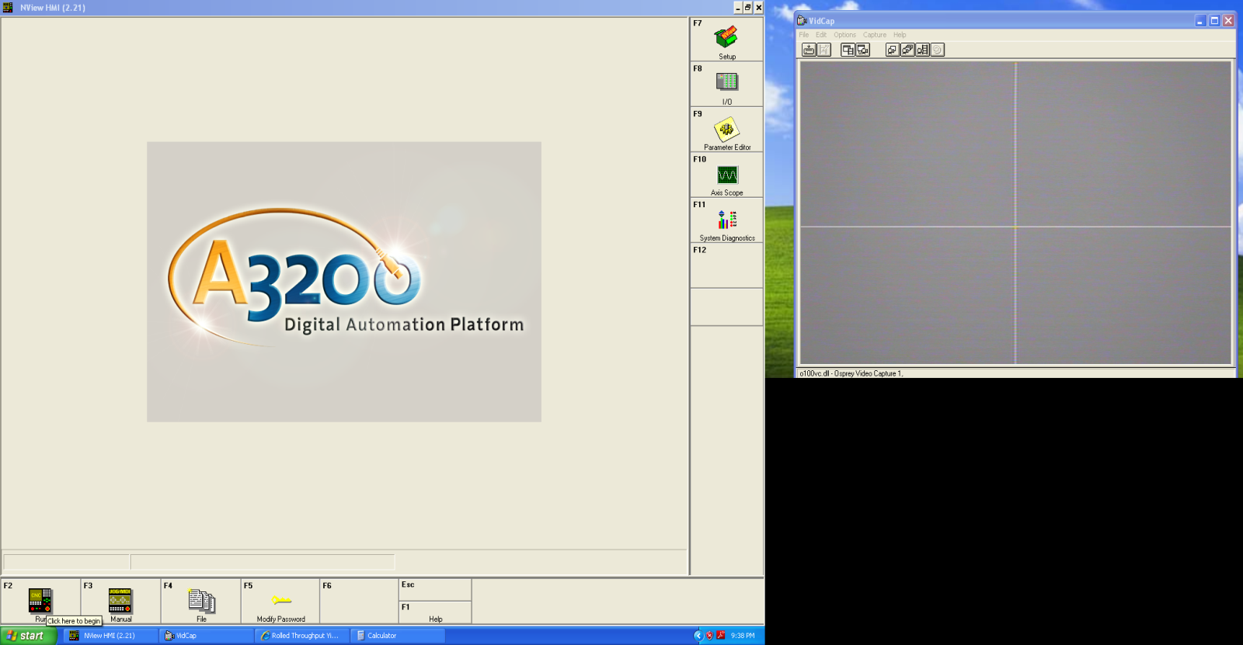

Press Control On and press Home All

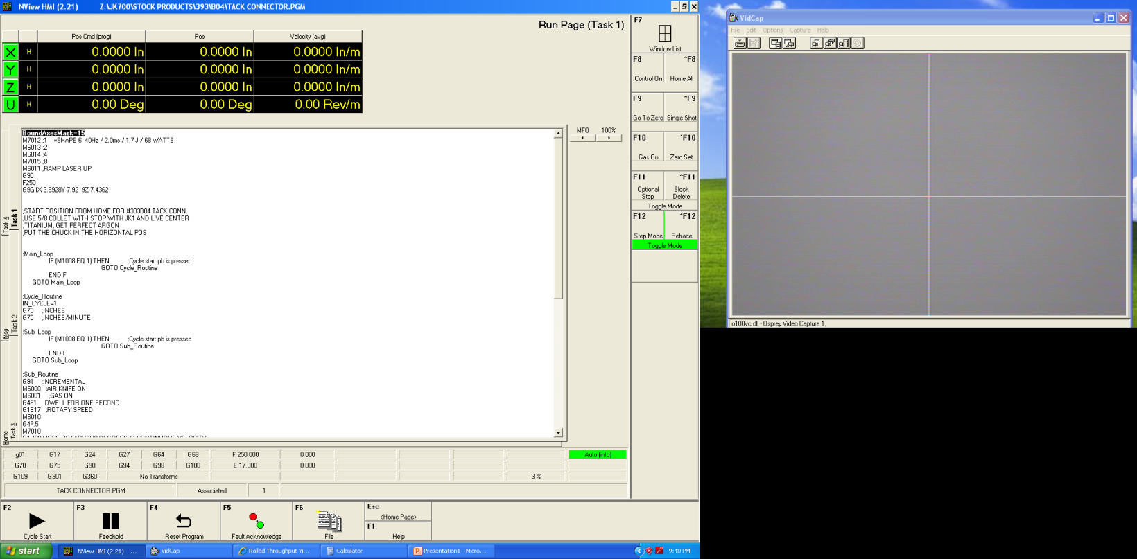

Once all axis are homed go to Windows List(F7) and press JOG/MDI(4)

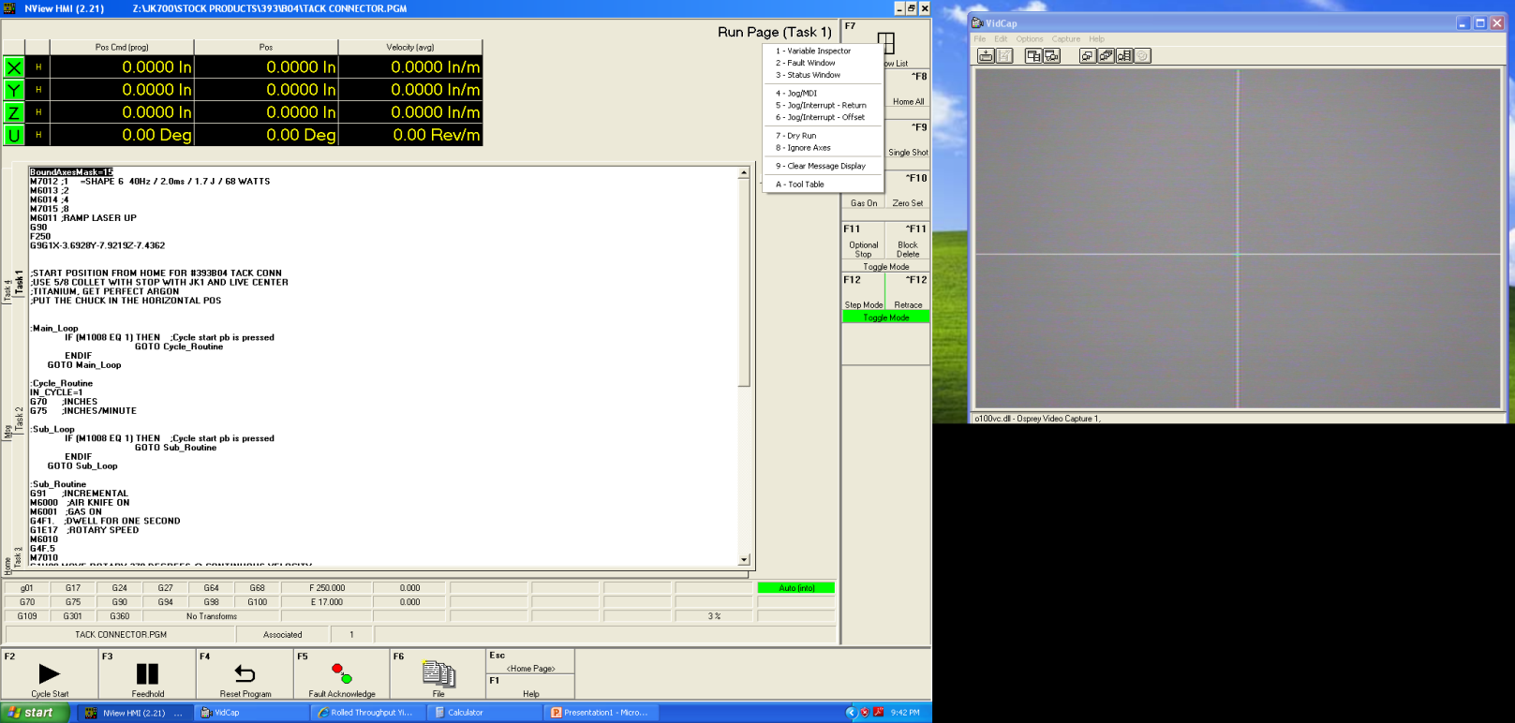

Press button to turn on either Fiber 1(400u) or Fiber 2(600u)

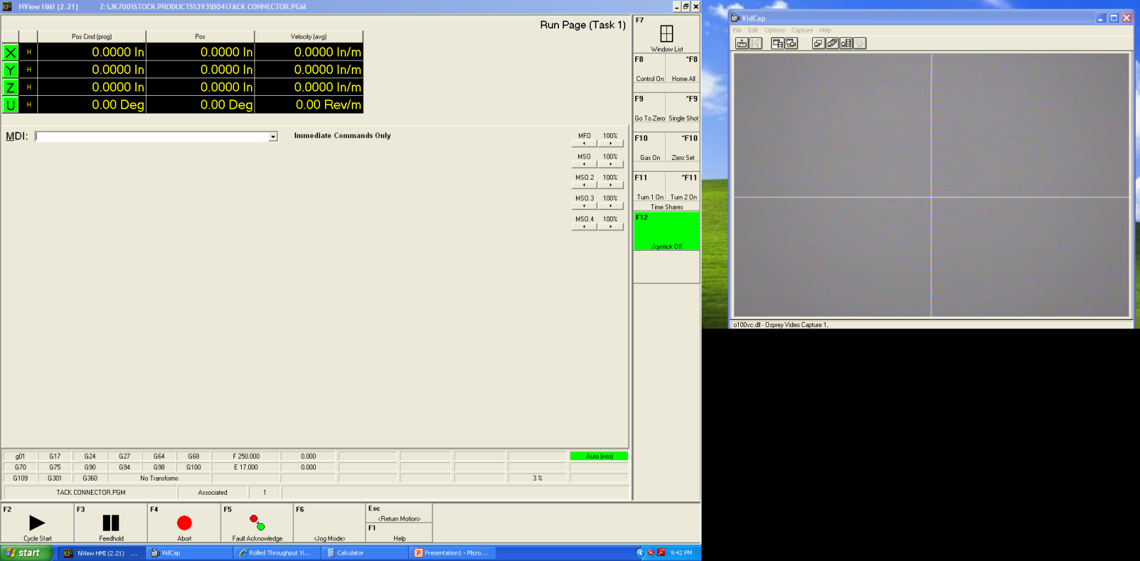

Selecting a weld program

Click “File”(F6)

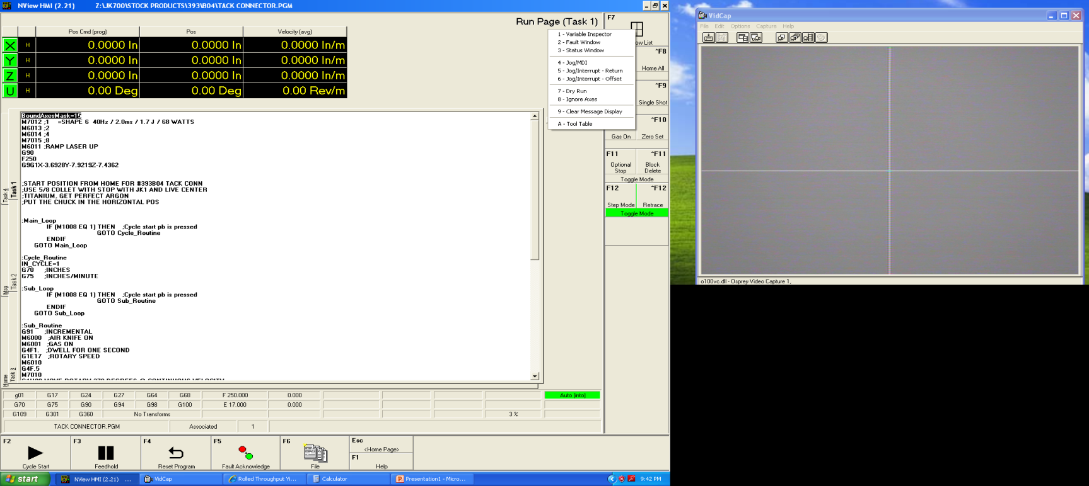

Click “Open”(F8)

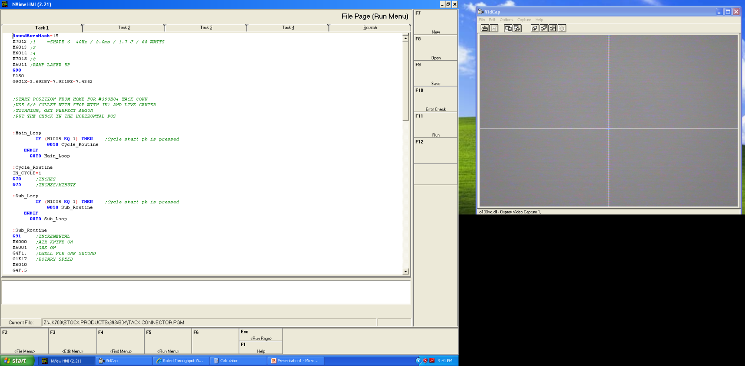

Using the router as a guideline select the appropriate weld program.

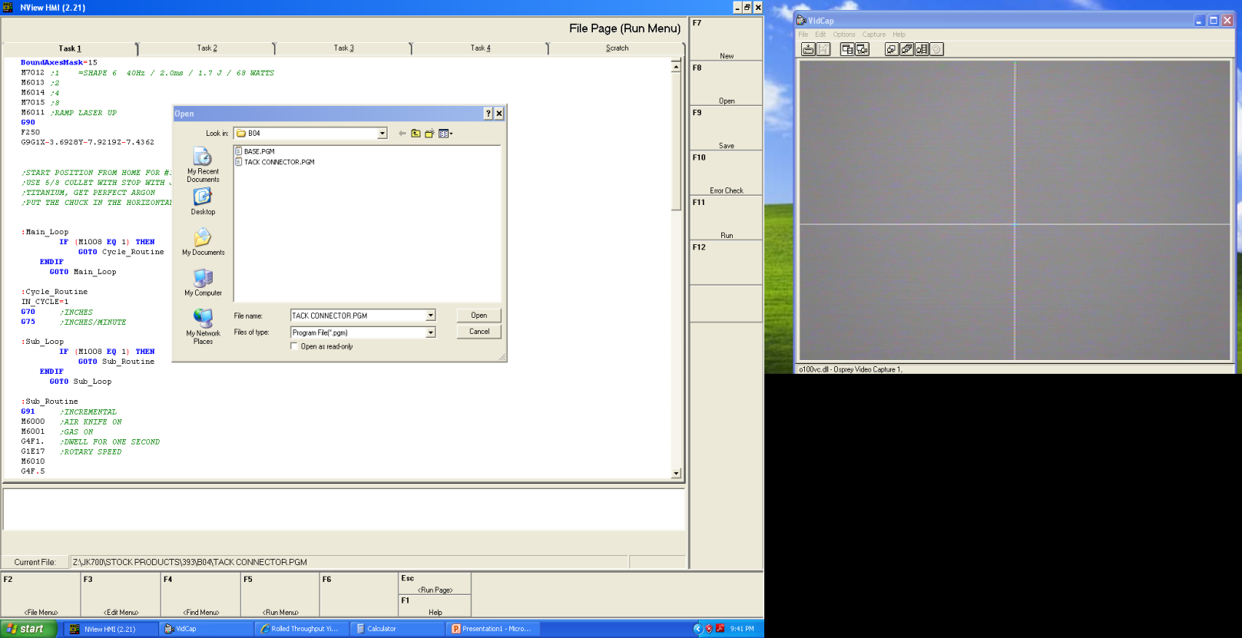

Click “Run”(F11)

Click “Cycle Sart”(F2)

Once the Laser is in position click Windows List(F7), click JOG/MDI(4), then click “Joystick Off”(F12) to turn the joystick on.

Refer to TA33 Laser Welding Process Map and TA1003 Laser Welding Procedure to ensure proper weld procedure is followed.

Inspection/Leak test

Inspect all parts per TA1003.

Perform a Connector Weld Strength Verification test per TA1003 when applicable.

Perform a leak test per TA1012 when applicable.

Complete router per TA1039 and place on outgoing shelf.

Machine Shutdown

Make sure laser head is in the home postion by clicking “Abort”, “Fault Acknowledge” then “Home All.”

Select the “Off” button for the Laser and then the “Off” buttong for the System on the Operator control panel.

Close the NVIEW/MMI program.

Shut down computer.

Pull the laser supply lever to off postion

Turn Exhaust fan off. Note: Only perform this step if all welding stations are shut down.

Turn Chiller off. Note: Only perform this step if all welding stations are shut down.

Referenced Documents

TA1003- Laser Welding Procedure

TA1012- Leak Testing

TA1039- General Workmanship for TA

TA33- Laser Welding Process Map

