Table of Contents

I. Purpose: 2
II. Responsibilities: 2
III. Associated Documents: 2
IV. Safety Considerations: 2
V. Machine Start-Up 2
VI. Inspection/Leak test 5
VII. Machine Shutdown 5
VIII. Referenced Documents 5
A. TA1003- Laser Welding Procedure 5
B. TA1012- Leak Testing 5
C. TA1039- General Workmanship for TA 5
D. TA33- Laser Welding Process Map 5

Purpose:

To provide instructions for Service Operators in the process and procedures necessary for operating the JK450.

Responsibilities:

The Welding Supervisor and Manufacturing Engineers are responsible for maintaining this procedure. The Welding Supervisor and Weld Technicians are responsible for adhering to and effectively carrying out this procedure.

Associated Documents:

ISO 9001, Quality System Manual, Quality Assurance Manual

Model JK450 Series Laser Operating Manual,

Safety Considerations:

Laser welding uses a focused beam of light to achieve very precise welds. The major hazard of this powerful beam is to the eyes, which can be partially blinded when hit with the beam. Special eye protection must be used, and care must be taken with any reflective surfaces since both the original and reflected beam are extremely dangerous.

Machine Start-Up

Press and hold on/off button for 3 to 5 seconds located in the front of the work station. (should illuminate green)

Turn Chiller to the local postion.

Turn the laser supply to the on postion.

Turn the exahaust fan on located on the left wall. (labeled JK450)

Log into computer.

Select HMI Icon on left monitor at work station.

Log into HMI with the username “user’ and the password “admin”.

Select “Control On” icon located in the upper left of screen. (should illuminate green)

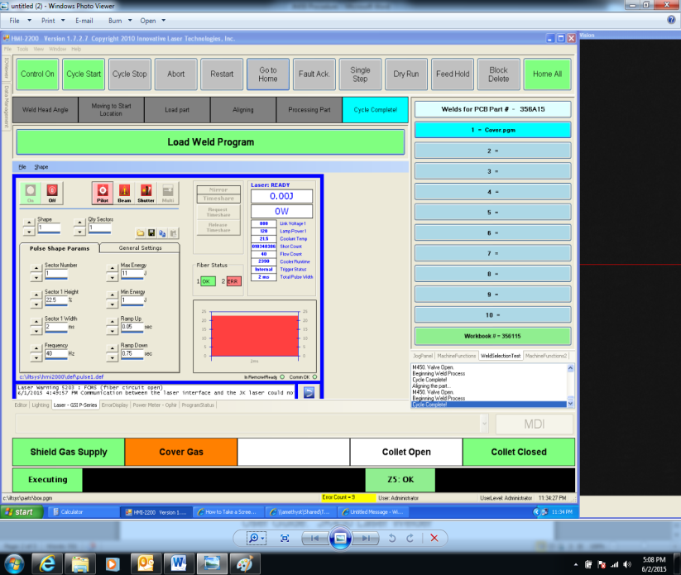

Select “Home All” to home all axes

Select the “Laser – GSI - P Series” tab

Select the “On” icon located in the middle of screen. When the “Pilot”, “Beam” and “Shutter” icons are on the the laser is ready for operation.

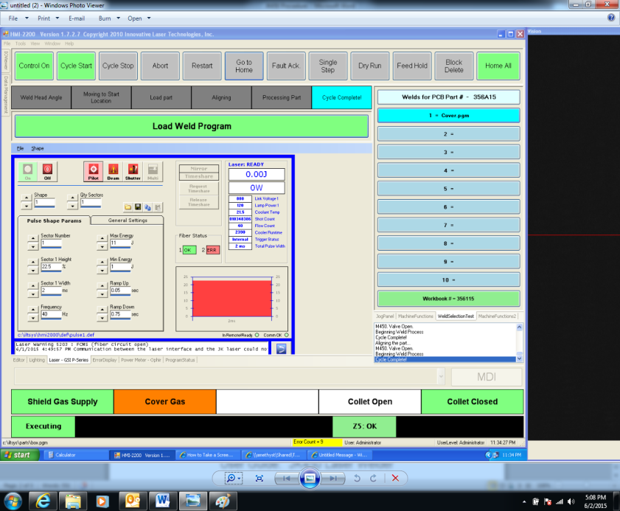

NOTE: Do not proceed to next step until screen matches the picture below

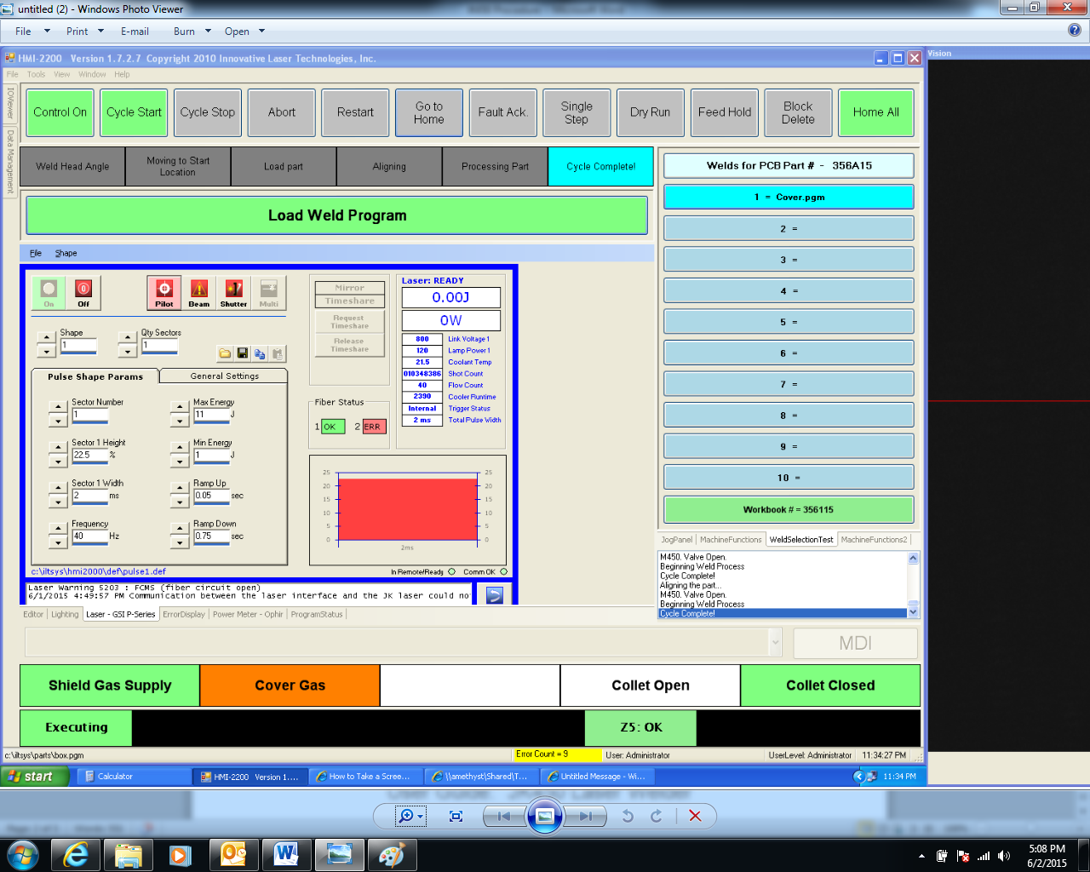

Select “Load Program” and follow on screen instruction.

Refer to TA33 Laser Welding Process Map and TA1003 Laser Welding Procedure to ensure proper weld procedure is followed.

Inspection/Leak test

Inspect all parts per TA1003.

Perform a Connector Weld Strength Verification test per TA1003 when applicable.

Perform a leak test per TA1012 when applicable.

Complete router per TA1039 and place on outgoing shelf.

Machine Shutdown

Make sure laser head is in the home postion by selecting “Cycle Stop, “Abort”, then “Home All.”

Select the “Off” icon. (Should turn grey)

Once the “Pilot”, “Beam” and “Shutter” turn grey you the laser is no longer operable at the work station.

Close the HMI program.

Shut down computer.

Once the light on both of the screens are no longer green press and hold power button located in the fron of the workstation until machine turns off.

Turn laser supply to off postion

Turn Exhaust fan off. Note: Only perform this step if all welding stations are shut down.

Turn Chiller off. Note: Only perform this step if all welding stations are shut down.

Referenced Documents

TA1003- Laser Welding Procedure

TA1012- Leak Testing

TA1039- General Workmanship for TA

TA33- Laser Welding Process Map

