Table of Contents

I. Purpose: 2

II. Responsibilities: 2

III. Associated Documents: 2

IV. Safety Considerations: 2

B. For additional safety related information refer to: 2

V. Procedure 2

A. Computer/Workstation 2

B. Laser turn on 2

VI. Glovebox Operation 2

A. Verify the Pressure, O2 and H2O Readings 2

B. Circulation ON/OFF 3

C. Quick Purge 4

D. Changing the Laser from the Open Air to the glovebox 5

E. Select the program 5

F. Moving parts into and out of the Glovebox from the Antechamber 5

G. Small antechamber operation for sample transferring 5

H. Big-T antechamber Operation 6

I. Removing Parts from Glovebox 6

J. Inspection/Leak Test 6

VII. Regeneration 7

VIII. Referenced Documents 7

A. TA1003- Laser Welding Procedure 7

B. TA1012- Leak Testing 7

C. TA1039- General Workmanship for TA 7

# Purpose:

### To provide instructions for Service Operators in the process and procedures necessary for operating the GloveBox.

# Responsibilities:

### The Welding Supervisor and Manufacturing Engineers are responsible for maintaining this procedure. The Welding Supervisor and Weld Technicians are responsible for adhering to and effectively carrying out this procedure.

# Associated Documents:

### Model JK700 Series Laser Operating Manual

### MBRAUN Glove Box Standard Operating Manual

# Safety Considerations:

### Laser welding uses a focused beam of light to achieve very precise welds.

### The major hazard of this powerful beam is to the eyes, which can be partially blinded when hit with the beam.

### Special eye protection must be used, and care must be taken with any reflective surfaces since both the original and reflected beam are extremely dangerous.

## For additional safety related information refer to:

### Model JK700 Series Laser Operating Manual

### MBRAUN Glove Box Standard Operating Manual

# Procedure

## Computer/Workstation

### The glovebox should remain on in circulation mode at all times

### Turn switch under table to on position

### Once computer boots up, press Power On/E-Stop Reset Button

### Open NVIEW/MMI program and Press CNC Run

### Press Control On and press Home All

### Once all axis are homed go to Windows List and press JOG/MDI

### Go back to Laser Power Supply and press the reset button (it should illuminate blue)

## Laser turn on

### Press power button on Operator Control Panel (Cooler Light will come on and then Power Light will come on. On Control Panel, Laser Emission light will come on and a moment later the Laser Running light will come on.

### System is now ready for operation

# Glovebox Operation

## Verify the Pressure, O2 and H2O Readings

### Readings are found on the screen and must be verified before the glovebox is used. If reading reaches 10 ppm, welding is not permitted.

#### Box pressure ~ 3.5 mbar. Pressure should be adjusted by using the foot pedals.

#### O2 <0.1 ppm. As the O2 level starts to approach 1 ppm a regeneration should be scheduled.

#### H2O ~ 2.3 ppm.

### The Welding Supervisor/Technician must determine cause and make corrections/adjustments. A quick purge may be used to bring the levels down to normal operating level.

### If levels do not come into range after making all possible corrections and adjustments, form QA074 must be completed.

## Circulation ON/OFF

### Turning circulation on

#### On Main screen

#### (1) Touch “Function”

#### (2) Touch “Circulation” (red/off => green/on)

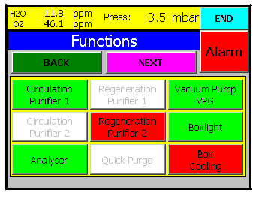

#### **NOTE**: The circulation should always be on during normal operation. Only during system. Maintenance should the circulation be shut down. (Example: glove change, oil change, quick purge, or regeneration, etc.)

### Turning circulation off

#### On Main screen

##### Touch “Function”

##### Touch “Circulation” (green/on => red/off)

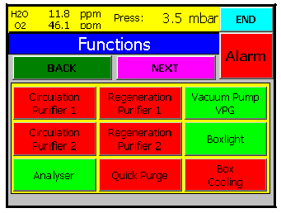

## Quick Purge

#### On Main screen

##### Touch “Function” , then

##### Touch “Circulation Purifier 1”, then

##### Touch “Quick purge” (red/off =>green/on)

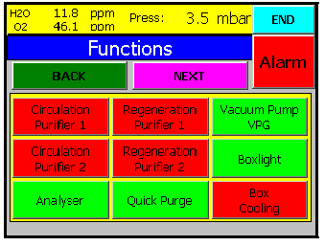

#### NOTE: Main goal: decrease the high O2 level of the glovebox. Normally, it takes at least 20 to 30 minutes to bring O2 back from 15 ppm to 2.3ppm

## Changing the Laser from the Open Air to the glovebox

### Make sure open air welder is homed.

### Select F11 on glove box computer

### Press alarm button on laser control panel so that the alarm sound stops.

### Press reset button on laser

### Select power on system on the laser control when ready light is illuminated.

### Select remote on laser control

## Select the program

### Verify the Fiber required and change the fiber if necessary

### Verify the Power Puck test has been completed per TA1003. If not perform power puck test per TA1003.

### Install the tooling per the instructions in the program.

### Verify the Laser parameters are correct.

## Moving parts into and out of the Glovebox from the Antechamber

### Parts coming out of the oven must be moved to the Antechamber within 10 minutes to allow for cooling.

### Do not weld parts that are still warm to the touch.

## Small antechamber operation for sample transferring

### Check pressure gauge (attached on the top of the small antechamber) The pressure should be always at zero in Hg when the antechamber is not being used.

### Open the outside door. Load the product into the antechamber. Close the door by rotating the door handle until you feel it become tight, then go a quarter turn further. Make sure the locating tabs on the door are rotated from the entrance slots. Note: ONLY go a quarter further. Over tightening of the door may cause damage.

### Turn the valve from the “Close” position to “Evacuate” position. Wait until the pressure gauge reading become -30 in Hg. (at least 3 seconds at pressure - 30 in Hg), then turn the valve from “Evacuate” back to “Close”.

### Turn the valve from the “Close” position to the “Refill” position. Wait until the pressure gauge reading becomes zero. Turn the valve from “Refill” back to “Close”.

### Repeat the previous two steps at least two more times to ensure all O2 is removed.

### After three evacuate/refill cycles, bring the valve back to the close position. (Now the pressure should be zero). Open the inside door. Unload your samples. Close the inside door.

## Big-T antechamber Operation

### Check the pressure gauge (attached on the top of the big antechamber. The pressure should be always at 0 in Hg when the antechamber is not in use.

### Open the big-T antechamber by rotating the door handle counterclockwise and load your sample. Close the big-T antechamber by rotating the door handle clockwise. Note: Do not close the door too tight. Only go another quarter of turn when you rotate and feel the door is tight.

### Touch the blue box on the top right of the touch panel display. The page will change to the operation mode of the big-T antechamber.

### Touch “Evacuate” (red/off, green/on). Wait until the pressure gauge reading becomes -30 in Hg. Touch “Evacuate” (green/on, red/off)

### Touch “Refill” (red/off, green/on). Wait until the pressure gauge reading becomes zero. Touch “Refill” (green/on, red/off)

### Repeat the last two steps at least 4 times to reduce the air/O2 in the big-T antechamber

### Open the side door. Pull tray into the glovebox. Unload product. Close the side door. Note: Do not close the door to tight. Only go another quarter turn when you rotate and feel the door is tight.

## Removing Parts from Glovebox

### Open the side door. Pull tray into the glovebox. Load samples. Close the side door. Note: Do not close the door to tight. Only go another quarter turn when you rotate and feel the door is tight.

### Open the big-T antechamber by rotating the door handle counterclockwise and remove product from tray. Close the big-T antechamber by rotating the door handle clockwise. Note: Do not close the door too tight. Only go another quarter of turn when you rotate and feel the door is tight.

## Inspection/Leak Test

### Inspect all parts per TA1003.

### Perform a Connector Weld Strength Verification test per TA1003 when applicable.

### Perform a leak test per TA1012 when applicable.

### Complete router per TA1039 and place on outgoing shelf.

# Regeneration

### When the O2 levels start to reach close 10 PPM a rengeneration cycle must be scheduled to restore the filter beds to normal operation. This cycle takes 16 hours and can not be stopped even by an interruption in power.

### Connect forming Gas (Mixture of 90% N2:10% H2) to the Glovebox.

### Set the regulator to 5-10 PSI

### Ensure that the exhaust is being vented outside the building

### The O2 reading must be less than 50ppm. Use quick purge to decrease the level. If the level can not be reached a manual purge per the instruction manual must be done. Do not proceed if the level is greater than 50ppm because the filter be will be re-contaminated.

### From the functions screen select “Regeneration” a message will come up on the screen to verify the gas flow. There is an air flow meter in the front of the machine. Adjust the pressure until the float is in the middle. Press okay to continue. Make sure quick purge is off. It maybe used during regeneration if the levels start to rise.

# Referenced Documents

## TA1003- Laser Welding Procedure

## TA1012- Leak Testing

## TA1039- General Workmanship for TA