1.0 Purpose 1

2.0 Responsibilities 1

3.0 Associated Documents 1

4.0 Rofin and Glovebox Machine Startup and Shutdown 1

4.1. Startup of Rofin 1

4.2. Startup of the Attached Glovebox 2

4.3. Shutdown of the Rofin 2

4.4. Glovebox 3

5.0 Startup and shutdown of the JK450 3

5.1. Startup of JK450 3

5.2. Shutdown of JK450 3

6.0 Startup and shutdown of MS800 4

6.1. Startup of the MS800 4

6.2. Shutdown of the MS800 5

7.0 Startup and shutdown of the ILT #1 welder 5

7.1. Startup of the ILT #1 welder 5

7.2. Shutdown of the ILT#1 welder 6

# Purpose

The purpose of this user guide is to provide instructions for Laser Technicians with startup, shutdown and equipment usage instructions for the Depew laser welders and the attached glovebox.

# Responsibilities

Welding Department engineering/management is responsible for maintaining this procedure. Authorized Welding Department technicians are responsible for carrying out this procedure.

Affected Department / Product Group / Support Group:

Etching Department

# Associated Documents

ISO 9001, QAM, QSM, AS9100, TA1003

# Rofin and Glovebox Machine Startup and Shutdown

## Startup of Rofin

1. Turn on main power switch (rotary dial from horizontal {0} position to vertical {|} position).
2. Start chiller unit (located in the machine shop compressor room; turn controller switch to ON, wait for temperature digits to illuminate, start system pump by pressing the ON side of the pump start switch).
3. Turn on computer.
4. Push in green “Control Power” to turn on.
5. Log on Control Alt Delete
6. Open U500 MMI
7. Enable axis X, Y, Z, and U by clicking on them. Home all axes by clicking Home and the desired axis.
8. Energize Rofin Sinar Laser by pressing the ON (green) Main Voltage Switch. Display will read “HV ready” when ready for next step.
9. Make sure that the HV Standby/Simmer key switch is in the unlocked (ON) position.
10. Press and hold (for approx. 3 seconds or until the orange indicator light illuminates) the HV Standby/Simmer ON button.
11. After approx. 20 seconds: the capacitors are charged, the flash lamps are charged and in simmer mode, and the controller terminal display should indicate that the laser is ready to start pulsing (look for the 0W and 0.0J display).
12. Move the shutter control key switch from the MANto the CNC position (if necessary, see the Rofin Sinar Laser Operating Manual, section 4.1.1, for instructions on operating the laser in MANUAL mode).
13. Check that the Fiber Selector Control is set to the correct position (either 400µ or 600µ based on program specs – NOTE: when program requires a 400µ fiber it will be listed, no fiber callout specifies the 600µ).
14. Load desired job instruction program.

## Startup of the Attached Glovebox

1) Confirm that chamber is at 0-10 ppm of oxygen and moisture (if reading reaches 10 ppm, welding is not permitted. The welding supervisor/technician must determine cause and make corrections/adjustments).

a) Verify that chamber doors are fully closed.

b) Run auto purge until oxygen and moisture levels come into range listed in step 1.

c) If levels do not come into range after making all possible corrections and adjustments, QC074 must be filled out.

2) Turn on U511 controller with red button located below keyboard shelf.

3) Set the Fiber Selector Control toggle switch to GLOVE BOX

4) Perform, or confirm prior performance of, 4-13 from the Rofin Sinar Machine Startup procedure listed (above) in this procedure.

## Shutdown of the Rofin

1. Shutdown laser on computer screen, close window, start shutdown, shutdown (refer to section 4.4.2 of the Rofin Sinar Operating Manual)
2. Turn off power supply switch located on the back of the computer.
3. Turn control from CNC to MAN
4. Turn the HV off.
5. Wait for the capacitors to discharge – HV ready will show up on the display.
6. Turn off the main power switch.
7. Shutdown chiller (turn controller switch to OFF)
8. Turn off Rofin Sinar main power switch (rotary dial from the vertical {|} position to horizontal {0} position).

## Glovebox

1. Verify that chamber doors are fully closed.
2. Turn off the U511 controller with red button located below keyboard shelf.

# Startup and shutdown of the JK450

## Startup of JK450

1. Turn on the chiller located in the weld room.
2. Turn the main knob, located on the front panel of the work station, to the on position.
3. Inside the panel, on the side of the work station, open the computer door and turn on the computer.
4. Go to the front of the computer screen and push the power on/e-stop reset, located on the right side of the computer.
5. Go to the front of the power supply and turn the front switch to the on position.
6. Go to the chiller and turn it on by flipping the on/off switch to the on position
7. Once the computer is booted up, open up the laserview icon, and push the standby tab on the top part of the screen
8. Push on button next the standby button once it is highlighted black. When the laser begins pulsing, push the remote button on the top right side of the screen. Minimize laserview.
9. Open up the nview (hmi) icon next. Once it is open, push the run/cnc icon on the lower left of the screen.
10. Once on the run/cnc page, go to the home tab on the left side of the screen and press tab. When on the home screen, press the homing sequence tab. When all axes are homed, press task 1 tab on the left side of the screen, and then minimize nview (hmi).
11. Turn on the monitor on top of the computer control panel.
12. Turn on the exhaust fan located behind the work station and fiber optic light located on the top of the work station.
13. Maximize nview (hmi) and in task 1 you may now call up a program and weld.

## Shutdown of JK450

1. Maximize the laserview window and press the off button on the top left of the screen.
2. Maximize the nview (hmi) window and close out the program.
3. Turn off the monitor above the computer console.
4. Go back to laserview and close out the program (this will have given the lamps enough time to cool before shutting off the laser).
5. Turn off the computer by going under the start tab and pressing shutdown.
6. Turn off the fiber optic light and exhaust fan.
7. Go to the front of the laser power supply and switch the knob to the off position.
8. Go to the front of the chiller and flip the on/off switch to the off position.
9. Go to the front of the work station and switch the front knob to the off position.
10. Turn off the chiller located in the weld room.

# Startup and shutdown of MS800

## Startup of the MS800

1. Start chiller unit (located in the machine shop compressor room; turn controller switch to ON, wait for temperature digits to illuminate, start system pump by pressing the ON side of the pump start switch).
2. Switch on main power at external isolator LP104/CIR 32,34,36
3. Turn the ENABLE key to the right (horizontal) position.
4. Turn on the cooler by pressing the COOLER button (the button should illuminate); press POWER button; you should hear the main relays energize after approx. 5 seconds.
5. Check the following: READY lamp illuminated, clock switch set to INTERNAL, and range switch set to NORMAL.
6. Turn on ionizer.
7. Turn on fiber light.
8. Look up welding parameters in welding database. This will show Rate, Pulse Width, Joules, Seconds Fixture Position and any applicable notes.
9. Set laser parameter repetition rate (RATE %) per database job setup instructions. Be sure to read and comply with all job instructions.
10. Set laser parameter pulse width (WIDTH %) per database job setup instructions. Scaling for pulse width is 5X so for PW=1 set 5, for PW=2 set 10, for PW=3 set 15, for PW=4 set 20 and for PW=5 set 25.
11. Energize laser by pressing the LASER ON – LOCAL button
12. Set the energy monitor range switch to 10J.
13. Set laser parameter lamp current to set joules per database job setup instructions. This will be done by adjusting the rheostat while watching the joule output on the scale.
14. Set laser parameter chuck rotation (speed)**.** Adjust the fine dial on the Electro Craft Rotary Motor to set the rpm using the seconds conversion chart.
15. Check that the SUPPLY lamp is illuminated.
16. Check that shield gas is properly setup to supply 6 liters/min to the welder.

|  |  |
| --- | --- |
| Electro-Craft Rotary Motor  For Laser Welder  Top Scale 0-8 | |
| Sec = per 1 revolution +/- 1/4 Sec. Tol. | |
| 0 = 0 Sec | 4 = 5 1/2 Sec |
| 1 = 26 Sec | 5 = 4 1/2 Sec |
| 1.5 = 16 Sec | 6 = 3 1/2 Sec |
| 2 = 11 1/2 Sec | 7 = 3 Sec |
| 2.5 = 9 1/2 Sec | 8 = 2 3/4 Sec |
| 3 = 7 1/4 Sec |  |

Figure 1

**NOTE:** If chart is updated, update reference chart at Lumonics workstation

## Shutdown of the MS800

1. Shutdown laser by turning off ENABLE key. (Refer to Section 6.3.19 – 6.3.20 of the Model MS800 Series Laser Operating Manual). Turn off lights and ionizer.
2. Turn off isolation power LP104/CIR 32, 34, 36.
3. Shutdown chiller (turn controller switch to OFF)
4. Turn off Rofin Sinar main power switch (rotary dial from the vertical {|} position to horizontal {0} position).

# Startup and shutdown of the ILT #1 welder

## Startup of the ILT #1 welder

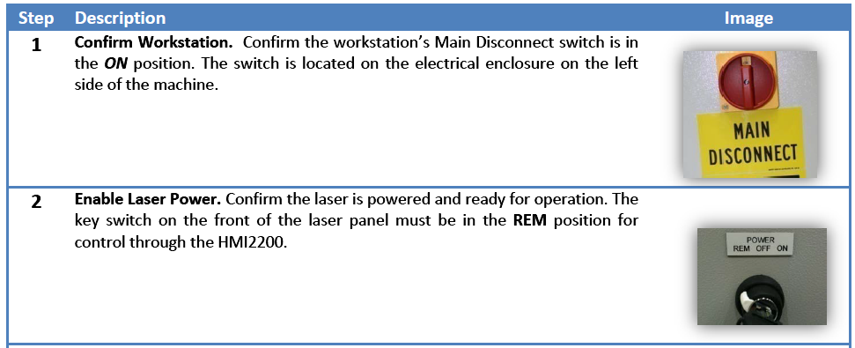

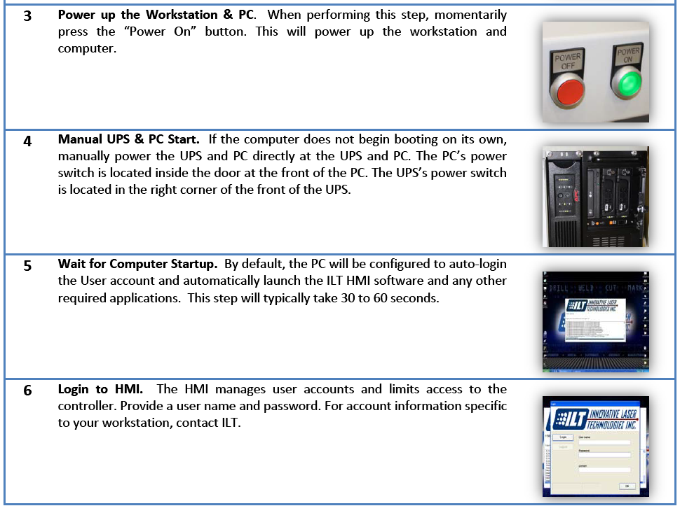

## Shutdown of the ILT#1 welder

