1.0 Purpose 1

2.0 Responsibilities 1

3.0 Associated Documents 1

4.0 Machine Startup 1

4.1. LBI-6000 1

4.2. Starmark 2

5.0 Programs 3

5.1. LBI-6000 Programming **Error! Bookmark not defined.**

5.2. Starmark 3

5.3. Program Backups 3

5.3.1. Because of the obsolesce of the LBI-6000, the programs will no longer be backed up on a regular basis. 3

5.3.2. The Starmark marker will be backed up on the network (Need some details from Dave). 3

6.0 Running the Parts 3

7.0 Starmark Etcher Power Check Instructions 4

8.0 Equipment Shutdown 4

8.1. LBI-6000 4

8.2. Starmark 5

# Purpose

The purpose of this user guide is to provide instructions for Laser Technicians with startup, shutdown and equipment usage instructions.

# Responsibilities

Etching Department engineering/management is responsible for maintaining this procedure. Authorized Etching Department technicians are responsible for carrying out this procedure.

Affected Department / Product Group / Support Group:

Etching Department

# Associated Documents

ISO 9001, QAM, QSM, AS9100, PE04, TA04, TA012, TA1089

# Machine Startup

## LBI-6000

1. Energize the SCU 2080 section.
   1. Turn rotary dial on (clockwise to | symbol).
   2. Press the SYSTEM ON button (green with | symbol).
2. Energize the SSA 3001 section by pressing the POWER button (green).
3. Energize the NFE01 section by pressing the POWER button (green).
4. Energize the SMD-01 section by pressing the POWER button (green).
5. Energize the QSD 27 section by pressing the POWER button (green).
6. Energize the BL 27 section.
   1. Check key switch position (horizontal – turned to fully clockwise position).
   2. Check FREQ (frequency) dial: set to 40 KHZ.
   3. Check the X toggle switch: set to 1.
   4. Check the MODE switch: set to EXT-G.
   5. Press the POWER button (green).
   6. Press and hold lamp start button (white) until lamp current gauge begins to indicate current flowing to the lamp (approx. 5 seconds).
   7. Press SHUTTER button (green, with OPEN label).

## Starmark

1. Turn on the exhaust blower.
2. Turn on main power – round red switch on lower right panel.
3. Press reset button (blue light).
4. Press power on button (green light).
5. Log on to the computer.
6. Turn lamp on by turning key (clockwise full, to LAMP ON position).
7. Home all the axes when prompted
8. Open Lasercad, and SM Info.
9. Open **monitor** icon and the following window will open.

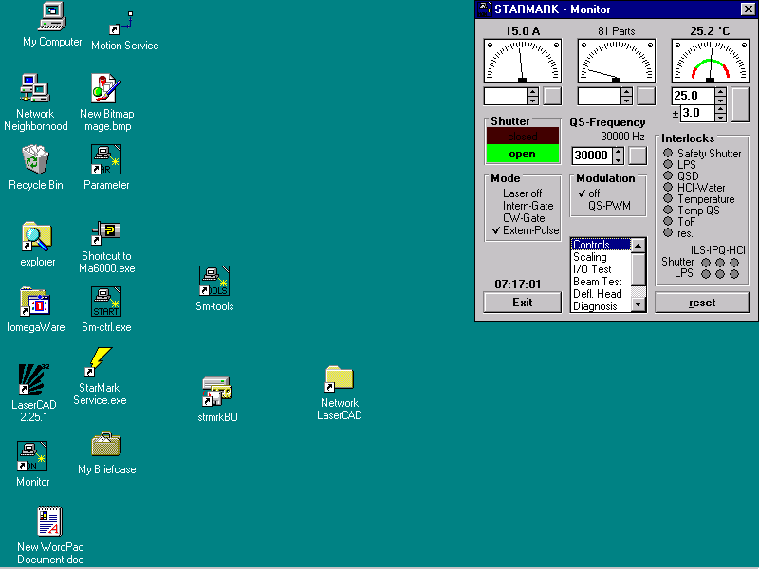

1. Click on **controls** and the following window will open.

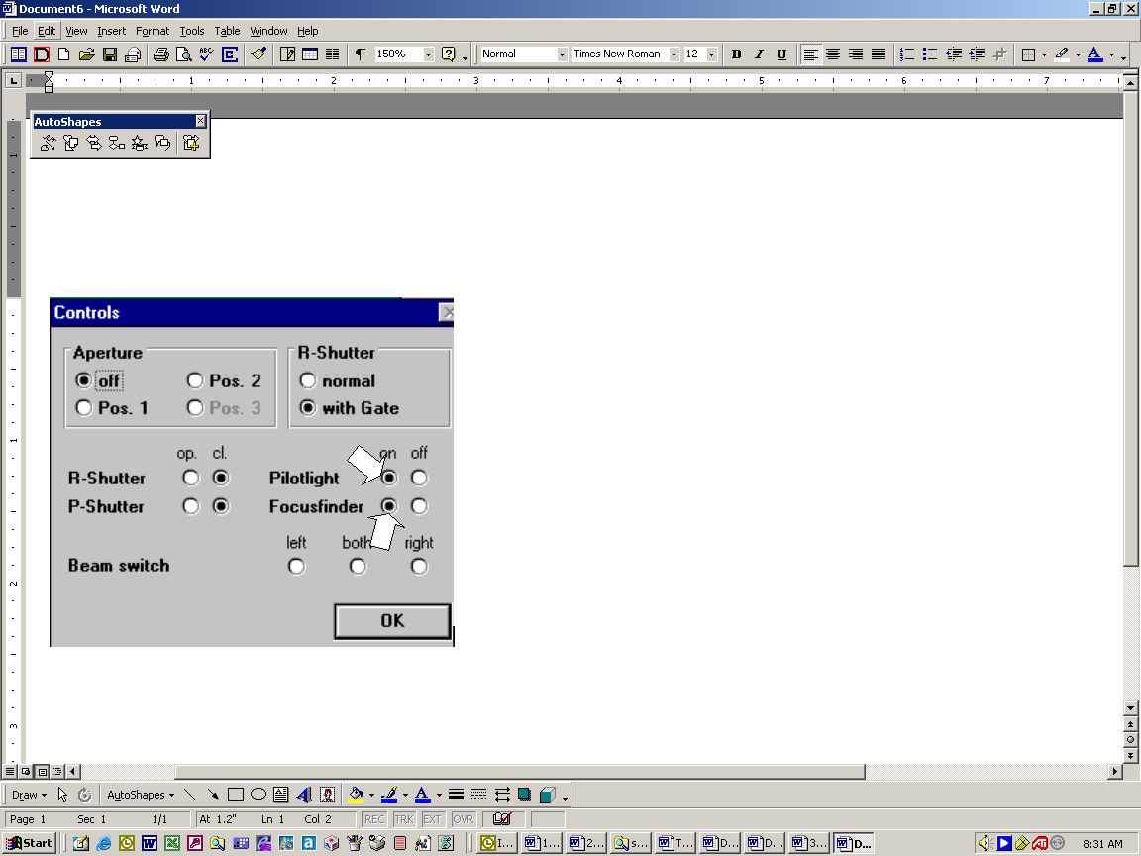

1. Select the **Pilotlight** and **Focusfinder** on option buttons. Click OK.
2. Open the shutter.
3. Open Shop Trak.

# Programs

## Starmark

1. Click on File then select New.
2. Determine proper fixturing, placement and correct axis set-up.
3. Choose cylinder or flat marking.
4. Insert the part diameter for cylinder marking or the height for flat marking.
5. Determine the X and Y Table position.
6. Start drawing.
7. Insert blocks and type in text in appropriate coordinate position and in appropriate scale.
8. Set “tile” position.
9. Set parameters.
10. Etch and verify positioning as well as marking.
11. Save finished drawing.

## Program Backups

### Because of the obsolesce of the LBI-6000, the programs will no longer be backed up on a regular basis.

### The Starmark marker will be backed up on the network.

# Running the Parts

1) Scan the router or manually call up the marking program file name by the model number.

2) Make changes to program if necessary.

3) Load marking program file. Use the serial numbers that are included with the router.

4) Place part in machine.

5) Focus HeNe light beam as shown in form TA012 (not necessary on Starmark).

6) Perform Etch/mark operation.

7) Verify model number and serial number to Calibration Certificate and/or Traveler.

8) Visually inspect etching. Verify that the location of etching on sensors is correct. **NOTE**: if etch is unsatisfactory, take appropriate steps (see group Supervisor if needed) to detail part/sensor (e.g. grind, sand, sand-blast, polish, tumble, etc.) then re-etch.

9) Sign off traveler.

10) Enter the job into ShopTrak.

# Starmark Etcher Power Check Instructions

The Starmark etcher power output must be measured at least once per week. It is strongly recommended that this check should be done at the start of production every Monday. This check will be documented on TA144. The following is the procedure for doing the check:

1. Start StarMark tools.
2. From the start menu, select monitor.
3. Set the mode to CW-gate.
4. Place the power monitor in the rear left hand corner of the table with the monitor sitting so that the display can be viewed through the door’s window.
5. Open the SCM screen and set the axes as needed. Hit the green light to move the laser head over the power probe..
6. Turn on the pilot light to verify that the laser beam is above the center of the power monitor. Adjust laser head position as needed until the pilot light is in the center of the power monitor.
7. Lock the X,Y,Z axes in place.
8. Minimize the SCM screen.
9. Turn off the pilot light.
10. Close the door.
11. In the upper left hand corner of the StarMark tools, enter 23 into the current box.
12. Set the beam test.
13. Turn the beam on.
14. Wait for the power meter to stabilize and read the power output.
15. Turn the beam off.
16. Take the mode plate and insert it on top of the power meter to verify that there is no laser energy bleeding past the shutter.
17. Enter 8.0 into the current box.
18. Remove the power monitor – beware the surface impacted by the laser beam will be hot.
19. Maximize the SCM screen and unlock the axes.

# Equipment Shutdown

## LBI-6000

1. De-energize the BL27 section by pressing the POWER button (green).
2. Let unit cool for 10 minutes.
3. De-energize the QSD 27 section by pressing the POWER button (green).
4. De-energize the SMD-01 section by pressing the POWER button (green).
5. De-energize the NFE01 section by pressing the POWER button (green).
6. De-energize the SSA 3001 section by pressing the POWER button (green).
7. De-energize the SCU 2080 section by pressing the SYSTEM OFF button (red with O symbol), then turn rotary dial off (counter-clockwise to O symbol).
8. If applicable, shut off water (chiller).
9. If applicable, shut off Rofin.

## Starmark

1. Close Lasercad program.
2. Turn lamp off by turning key (counter-clockwise full, to LAMP OFF position).
3. Close Monitor and Motion programs.
4. Close SM tools and the Info. window.
5. Shut down the computer.
6. Wait until monitor indicates that it is safe to turn off computer and then push off button (red light).
7. Turn off main power switch - Red knob on lower right panel.
8. If applicable, shut off water (chiller).
9. If applicable, shut off Rofin.
10. Turn off the exhaust blower.