Use and Set-up of Oxygen-Acetylene Torch
Procedure Number | Rev | Date | Entered by | Description of Change | Change Acct Engineer | ECO
TA1266 | NR | 10/21/14 | EJP | Initial Release

Referenced Documents

Contents
Oxygen-Acetylene Torch Setup 2
Oxygen-Acetylene Torch Storage 5

NOTE: Each assembly operation section (horizontal bars indicate end of sections) contains the assembly steps that apply to all models, plus assembly steps that describe significant variations. Check the router for additional assembly steps and model-specific details before performing the steps in each section. If the assembly procedure steps are different from the steps on the router, perform the steps as specified on the router.

Oxygen-Acetylene Torch Setup  NOTE: Do not wear finger cots when using torch.  - Reference Figure 1  - Secure oxygen-acetylene torch handle into vise.  - Open oxygen valve (green) on torch handle approximately ½ turn counter-clockwise.  - Reference Figure 2  - Open valve on oxygen tank by turning counter-clockwise approximately 1 full turn. | 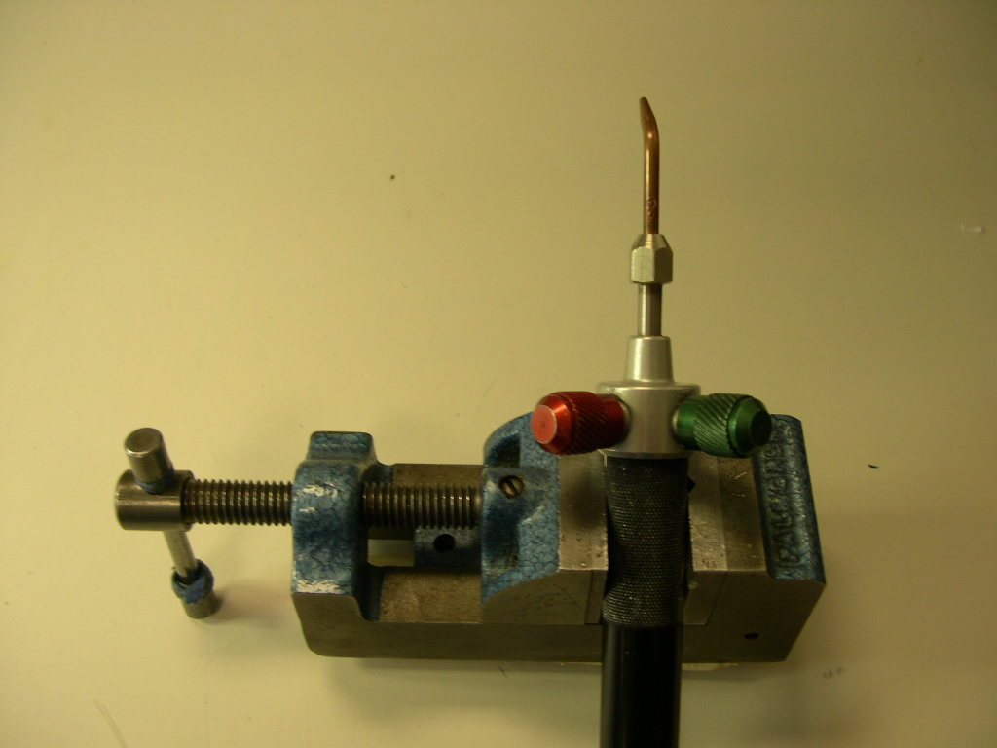  Clockwise to Close Valve  Clockwise to Close Valve  Clockwise to Close Valve  Counter-clockwise to Open Valve  Acetylene Valve  Counter-clockwise to Open Valve  Oxygen Valve  Figure 1
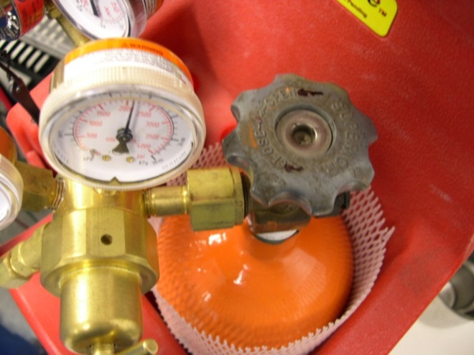
Counter-clockwise to Open Valve
Oxygen Valve
Clockwise to Close Valve
Figure 2

- Reference Figure 3  - Turn regulator valve on oxygen tank clockwise until reading on line pressure gage is 2-4 psi.  - Close oxygen valve (green) on torch handle by turning clockwise.  - Reference Figure 4  - Open acetylene valve (red) on torch handle approximately ½ turn counter-clockwise.  - Open valve on acetylene tank by turning counter-clockwise 1/4-1/2 turn. | 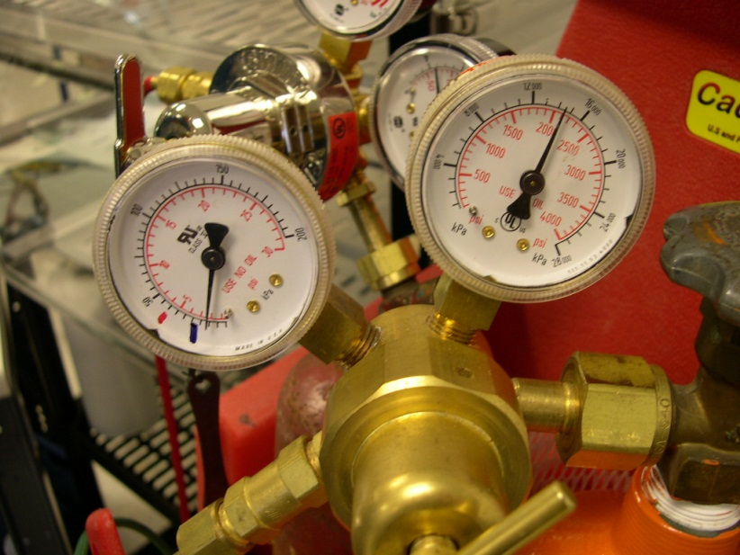  Regulator Valve  Line Pressure  Figure 3
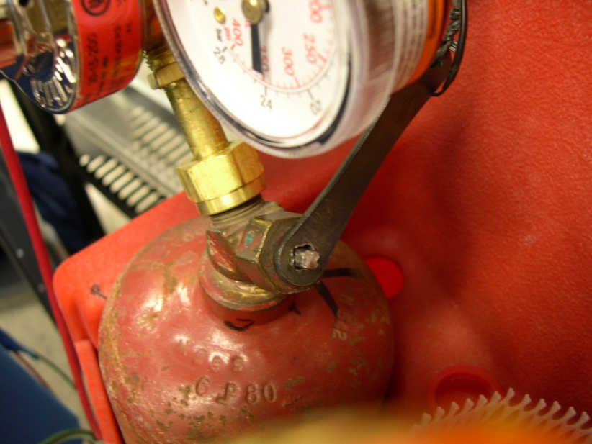
Acetylene Tank Valve
Counter-clockwise to Open Valve
Clockwise to Close Valve
Figure 4

- Reference Figure 5  - Turn regulator valve on acetylene tank clockwise until reading on line pressure gage is 1–3 psi.  - Reference Figure 6  - With acetylene valve still open, light oxygen-acetylene torch using a spark lighter / striker. Be sure the spark lighter is away from the tip and not obstructing the gas flow.  - Open oxygen valve (green) on oxygen-acetylene torch by turning it counter-clockwise and adjust until a bright neutral flame is established (low blue flame).  Oxygen-Acetylene Torch Storage  - Reference Figure 1-5  - Close oxygen valve (green) on torch handle.  - Close acetylene valve (red) on torch handle.  Note: Be careful not to shut off the acetylene valve first; this may create a “pop” type sound. When the “pop” happens it throws carbon soot back into the torch and may in time partially clog gas passages and the flashback arrestors.  - Reference Figure 2 & 4  - Close both cylinder valves.  - Reference Figure 1, 3 & ,5  - Open the oxygen valve (green) on torch and release the pressure from the system. Close the oxygen valve (green) on torch.  - Turn the adjusting screw on the oxygen regulator counterclockwise to release all spring pressure.  - Open acetylene valve (red) on torch and release the pressure from the system. Close the acetylene valve (red) on torch.  - Turn the adjusting screw on the acetylene regulator counterclockwise to release all spring pressure.  - Check the inlet gauges after a few minutes to ensure the cylinder valves are turned off completely and there is no pressure remaining in the system. | 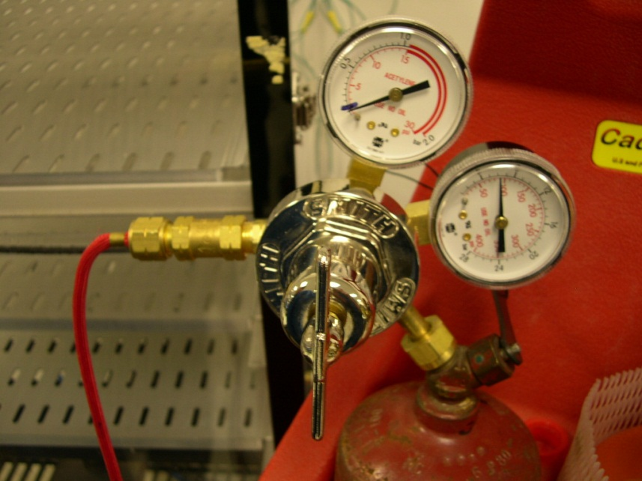  Regulator Valve  Line Pressure Gage  Figure 5
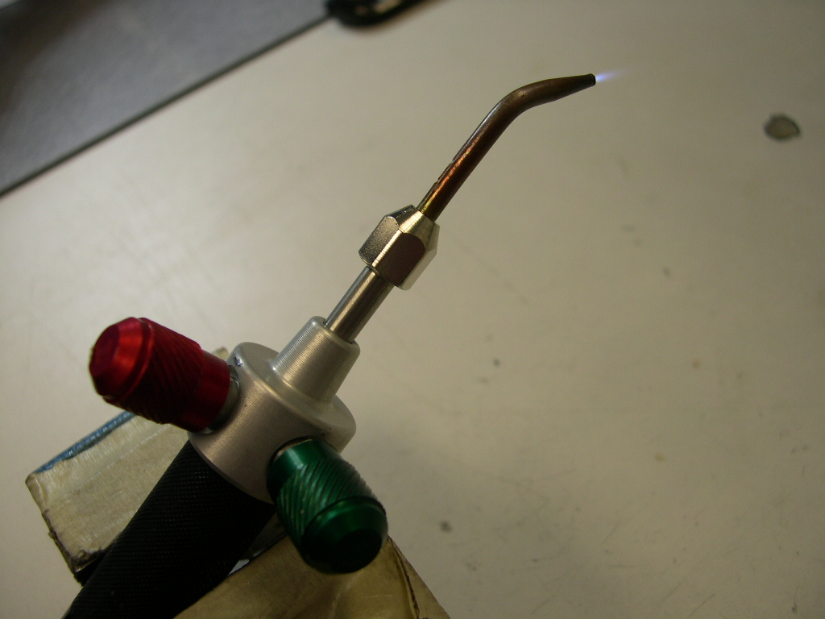
Figure 6

