# Purpose:

This user guide provides an overview of the Polaris Accu-Weld 5200 Projection welder.

# Referenced Documents:

Polaris Accu-Weld 5200 Projection Welder Installation and Operation Manual

# Safety:

The Accu-Weld 5200 Projection welder uses high pressure and high voltage potential to quickly weld two parts. As such, care must be taken to avoid the potential for harm to an operator:

1. At any time in the process, the red emergency stop button on the base of the unit can be pressed to return the press ram to its home position and de-energize the capacitor banks.
2. Care must be taken to avoid the high voltage sources inside the welder cabinet.

# Machine Startup:

1. Turn the chiller on by flipping the switch on the rear of the unit to the on position, see Figure 1.

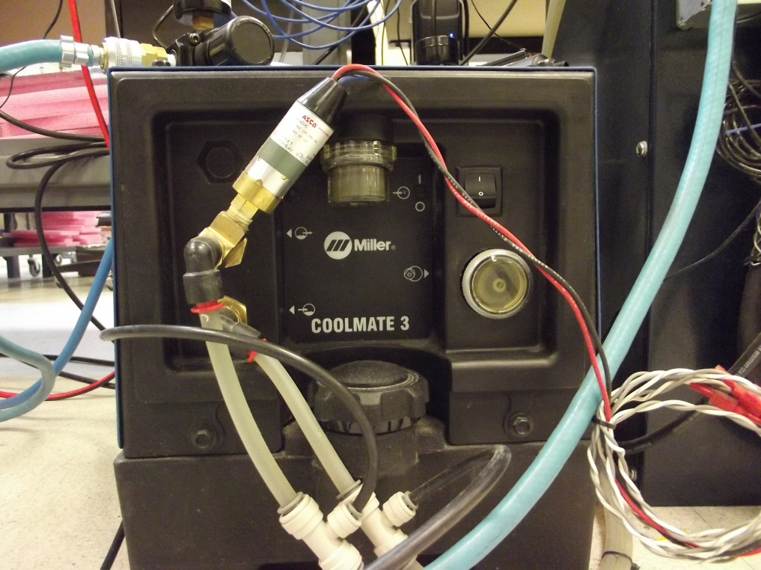

Figure 1. Chiller power switch location.

1. Verify that any regulators or valves are open so that shop air supply is present at the input of the unit, see Figure 2.

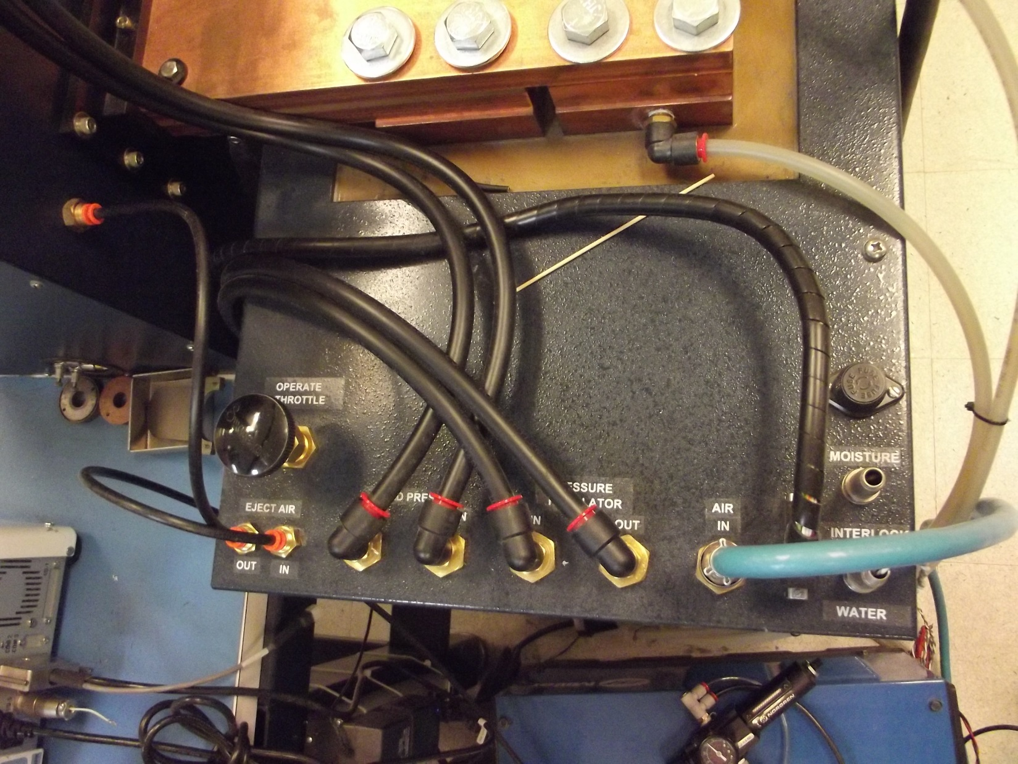

Figure 2. Shop air supply inlet.

1. Check the welder screen for any error codes (Exx).
   1. In case of error, refer to the User manual for error code explanation.

# Changing the electrodes

1. To remove the electrodes:
   1. Unthread the electrode retaining rings.

NOTE: If the retaining ring won’t loosen by hand, use the retaining ring tool stored at the machine.

* 1. Lift the bottom electrode up over the alignment pins.
  2. The top electrode should drop loose.

NOTE: Do not use a hammer or other tool tool to remove the electrodes as these can damage the alignment pin. If an electrode will not come loose, contact engineering.

1. To install the electrodes:
   1. Align the holes in the electrode with the alignment pins.
   2. Slide the retaining ring over the electrode.
   3. Hand tighten the retaining ring.

# Daily Maintenance

1. Inspect the electrode holders, top and bottom
   1. The surfaces should be clean and smooth.
   2. Any solder splash or plating buildup should be cleaned up with alcohol and a lint free wipe.
2. Inspect the electrodes
   1. The surfaces should be clean and smooth.
   2. Any solder splash or plating buildup should be clean up with alcohol and a lint free wipe.
   3. If build up is noted that cannot be cleaned with alcohol and a lint free wipe per the above, the electrode should be routed to the machine shop for a grinding operation.
3. Check the cooling water level and add distilled water as needed.

NOTE: Do not use deionized water.

# Basic Operation

1. Reference the job paperwork to select and install the proper electrodes for the product being welded.
2. Set the air pressure
   1. Adjust the regulator on the front of the welder until the digital air pressure gauge displays the appropriate air pressure.
3. Select a weld schedule

NOTE: Reference Figure 3 for location of front panel buttons.

* 1. Press the “WELD SCHEDULE MEMORY” button
  2. Press the Up and Down arrows to select the appropriate schedule
  3. This sets the Squeeze time, Hold time, and volts, the pressure is set manually at the regulator.

1. Press the “REVIEW SCHEDULE” button and the welder will cycle through all of the settings to verify that they are correct.
2. Press the “NO WELD” button to charge the capacitors.

NOTE: If no welds are performed in a specific timeframe, as determined by the welder manufacturer, the welder has a built in shut off to automatically discharge the capacitors. In case of this happening just repeat steps 4 thru 5 above.

1. Load the part into the electrodes
2. Press the two black buttons on the base of the machine to operate the weld cycle.

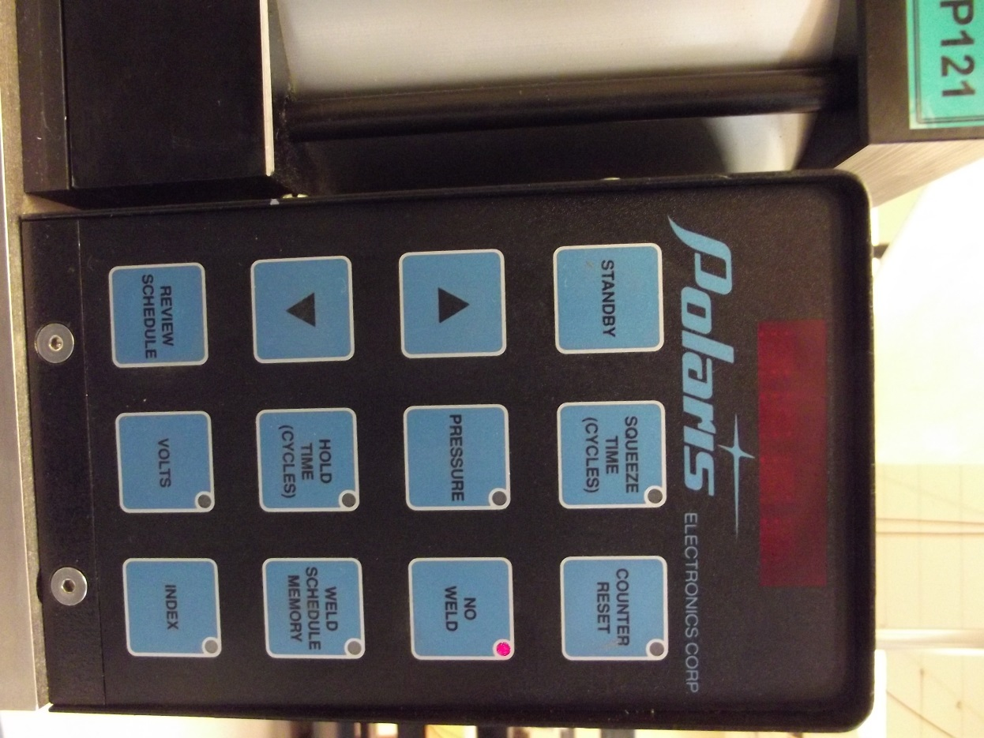

Figure 3. Welder front panel.

# Refinishing Electrodes

1. If the weld surface is pitted, deformed, or has large deposits of material that cannot be cleaned by hand they must be ground using a surface grinder.
2. Parallelism must be maintained with .0002”
3. Place the electrodes on the surface grinder.
4. Place the steel retaining ring over the electrode to hold them in place.
5. Grind until all surface deposits have been removed.
6. After grinding the electrode, place a sheet of 400 or 600 grit sandpaper on a known flat surface. Using light pressure, move the electrode surface in figure 8 patterns on the sandpaper.
7. Remove any burrs from the electrode cavity and alignment holes using a sharp knife.

NOTE:A deburring tool may be used but care must be taken so as not to round off or counter sink the electrode cavity.

1. Inspect the electrode height. A minimum of 0.200 inches is required for operation of the welder.

# Weld Pressure Calibration

The weld pressure setting is calibrated yearly using a back to back calibration method. The calibration gauge is connected in parallel with the welder gauge and the pressure is adjusted to be within range of the parameters in the Met/Track system.

# Weld Voltage Calibration

The weld voltage parameter is indirectly calibrated by measuring the current flow in the main bus bar.

1. Wrap the pickup coil around one of the main bus bars (large copper bar in the top of the welder cabinet).
2. Set the Polaris Current Meter to the 200KA (Pulse) setting.
3. Take three readings at each voltage level requested by the Met/Track system.
4. Readings should be within specification.

Note: The weld voltage and measured current are dependent on the quality of the electrodes. If the readings are out of tolerance, the first step should be to swap out the electrodes with a refinished set of electrodes and check the readings again. If the failures still occur contact engineering.