Procedure Layout:
- Creating / Printing Labels
- Existing Part and Variation
- Existing Parts w/ New Variation

- Applying Labels
- Cables 2 Feet Long or Shorter
- Cables Longer Than 2 Feet

Procedure:
NOTE: All pictures shown below are for reference only.

Creating/Printing Labels
Use LabelMark6 Professional software for creating and printing labels.
- Refer to Section A: Existing Part and Variation if the exact part number and variation have already been created.
- Refer to Section B: Existing Part w/ New Variation if the part number has been created before but not the exact variation needed.

Existing Part and Variation
- Load a previously created label.
- Click the top left blue house  to return to the home screen.
- Select ‘Open’ then click ‘File’.
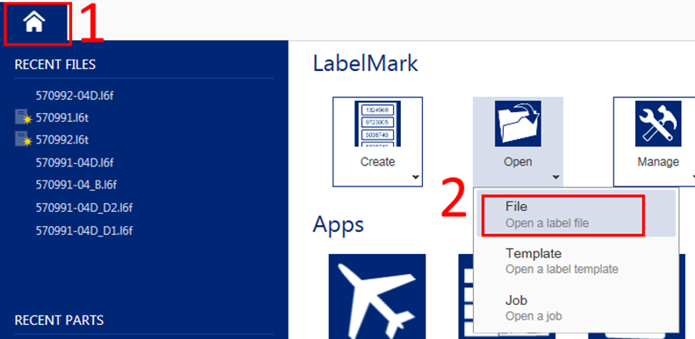
Figure 1 – Open a Label File

- Select your part number from the list.
Note: If your specific variation (dash number) does not show up, then it must be created. Refer to Section B: Existing Part w/ New Variation.

- Update label data.
- Update the date code (WK/YR) if necessary.
Note: You may use http://www.epochconverter.com/weeknumbers to obtain the current week of the year.
- Update the variation revision letter if necessary.
Note: Reference the cable drawing for current revision - use the variation revision as shown below.
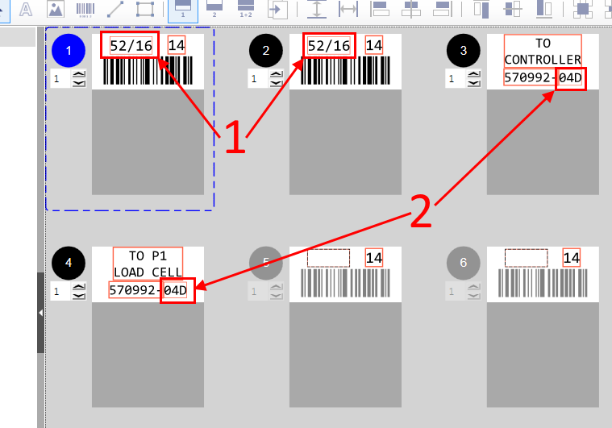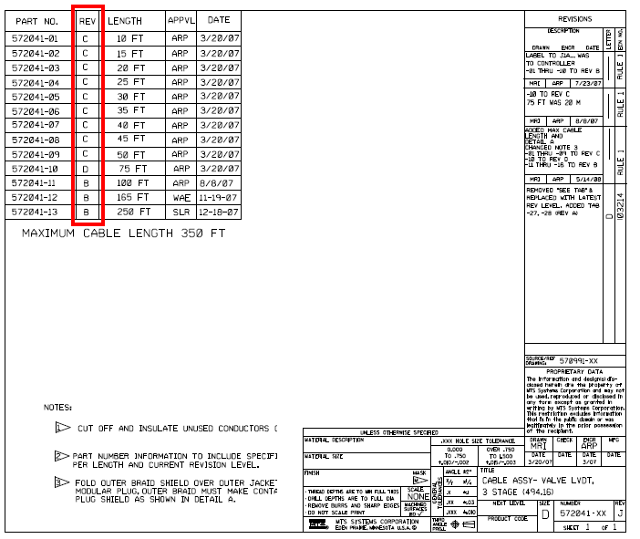
Variation Revision
Figure 2 – Update Date Code (1) and Revision Letter (2) as Needed

Note: After the last label in a set they will repeat. Do not fill out any more than the first set.
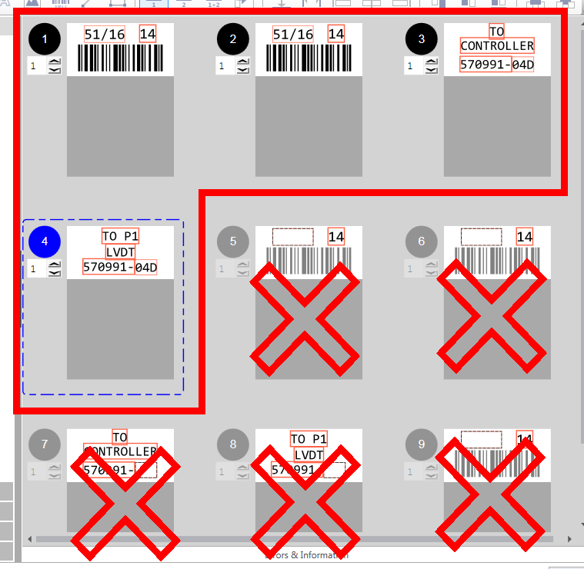
Figure 3 – Do Not Fill Out More Than One Set of Labels
- Save your label.
- Select ‘File’ then click ‘Save’.
- Print the labels.
- Click the ‘Print’ icon at the top left.
- Enter the number of copies needed. This should match the number of cables in the job.
- Set to print ‘Collated’.
- Click ‘Print Preview’ to ensure the correct labels and amount of labels are being printed.
- Click ‘Print’ if everything looks correct.
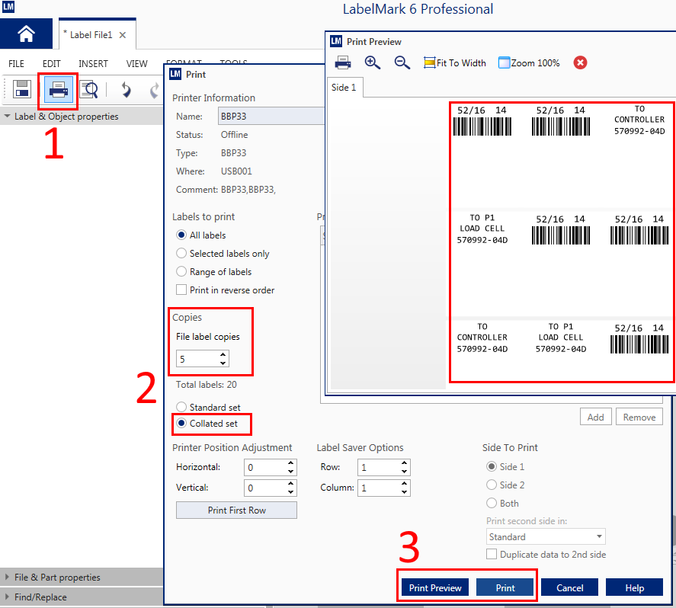
Figure 4 – Set Number of Labels to Print

Existing Part w/ New Variation
- Create a new label using an existing template.
- Click the blue house to return to the home screen.
- Select ‘Create’ then click ‘New Label Using Template’.
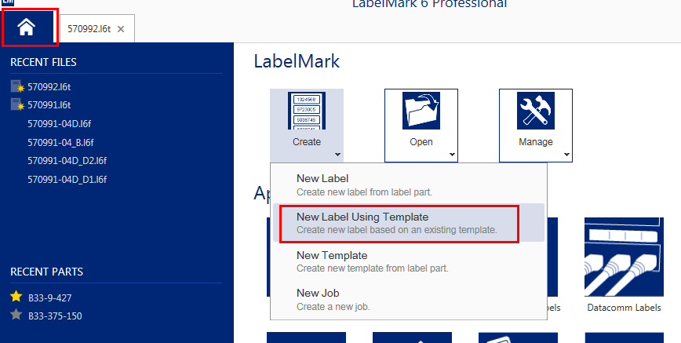
Figure 5 – Create New Label Using Template

- Select the family part number (e.g. a QR57-099-113 will be under the family number QR57-099-1xx).
Note: If the exact base part number does not exist, contact Engineering.
- Click ‘Finish’.
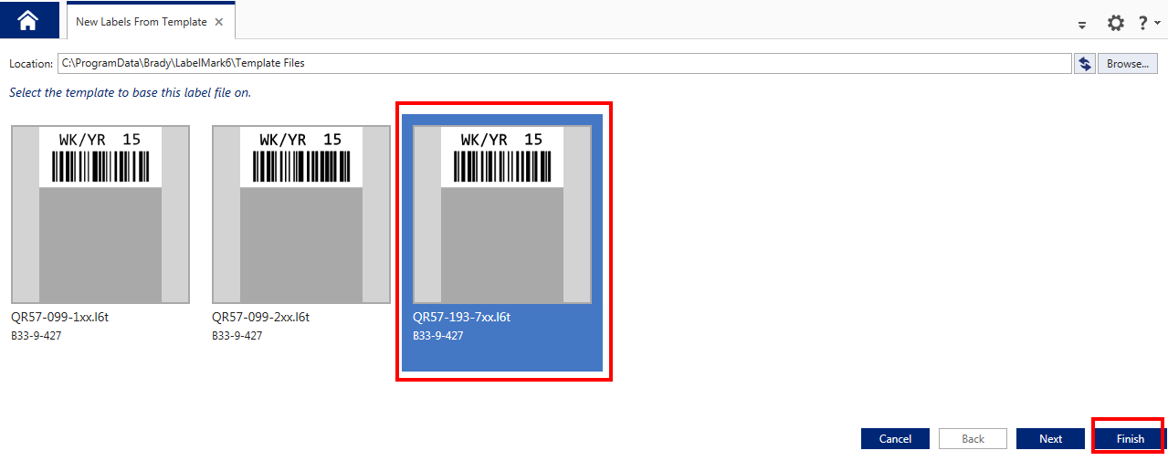
Figure 6 – Choose Family Part Number to Create Variation For

- Enter part variation barcode data.
- Fill out both barcode labels.
  - Select the first barcode and change ‘Value’ to the exact part number needed, excluding the QR and dashes (e.g. QR57-099-201 will be entered as 57099201).
  - Repeat for the second barcode label.
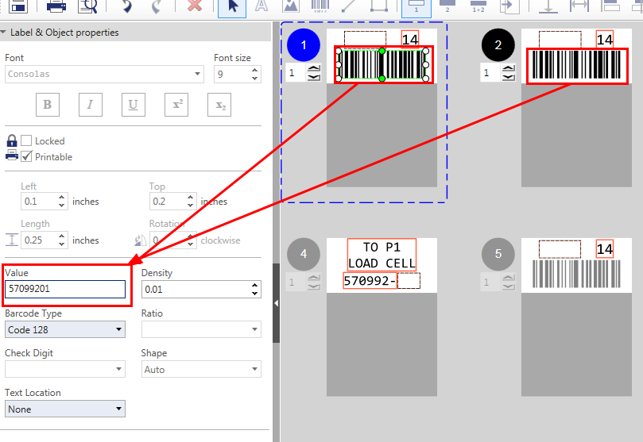
Fill out barcode part number
Figure 7 – Update Both Barcode Numbers

- Fill out the rest of the part variation label data.
- Finish the barcode labels.
- Enter the current week and year in the blank space above each barcode. Use the format “WK/YR” where WK is the current week and YR is the current year (e.g. “03/17” is the 3rd week of 2017).
Note: You may use http://www.epochconverter.com/weeknumbers to obtain the current week of the year.
Note: Both barcode labels MUST be identical.
- Fill out both destination labels.
  - Enter the specific dash number variation of the part followed by the drawing revision letter (e.g. a QR57-099-204 at revision D would have “04D” entered into the box). Both destination labels will have the same part number listed.
Note: The revision letter can be found on the MTS drawing.
- If a RoHS label is required, you must click on the RoHS label to select it (this will highlight it blue).
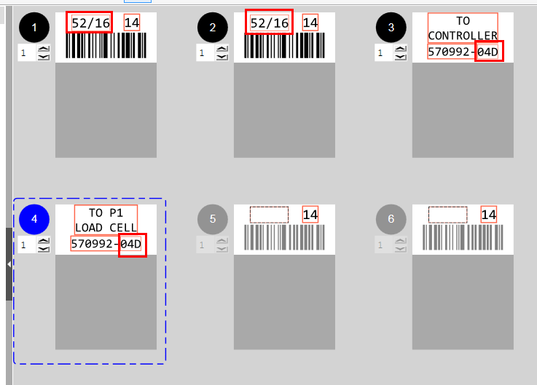
Figure 8 – Update Date Code and Variation/Revision for Destination Labels

- Save your label.
- Select ‘File’ then click ‘Save as…’.
- Use the part number on your router as the file name.
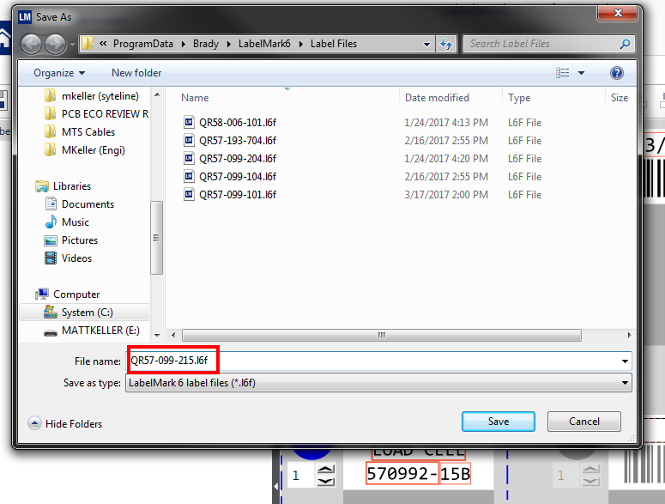
Figure 9 – File Name Includes Variation

- Print the labels.
- Click the ‘Print’ icon () at the top left.
- Enter the number of copies needed. This should match the number of cables in the job.
- Set to print ‘Collated’.
- Click ‘Print Preview’ to ensure the correct labels and amount of labels are being printed.
Note: If RoHS labels do not show up in print preview you must exit the print windows and click on the RoHS label to select it. Then go back to ‘Print’ and ‘Print Preview’.
- Click ‘Print’ if everything looks correct.
Figure 10 – Set Number of Labels to Print

Applying Labels

Cables 2 Feet Long or Shorter
- Carefully peel off a destination label.
- Attach label as close to connector backshell as possible.
Note: Refer to cable assembly procedure to determine correct destination label for connectors.
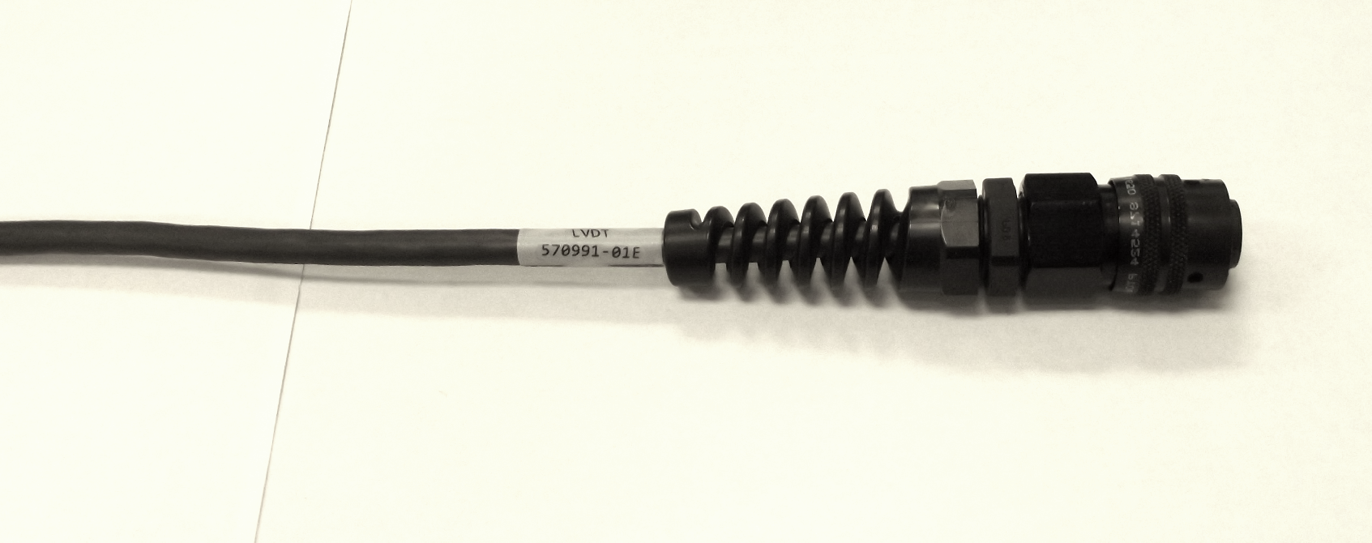
Figure 11 – Destination Label Next to Strain Relief

- Peel off and place any additional destination labels.
- Peel and place the barcode label face down on a flat surface.
- Find the center of the cable and place one barcode label on it.
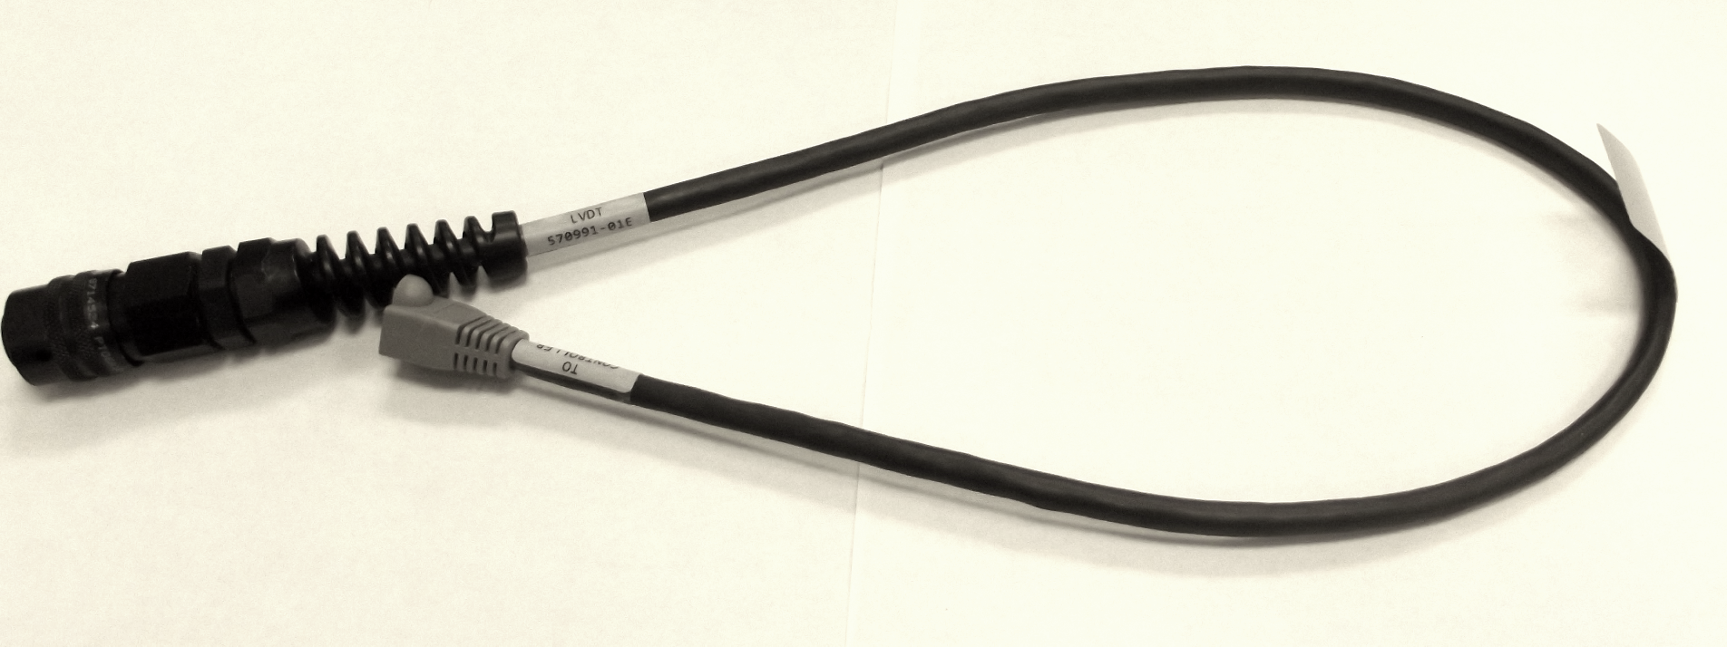
Barcode Label
Figure 12 – Barcode Label Centered on Cable

- Wrap barcode label around cable.
- If applicable, peel and place the RoHS label next to the barcode label at the center of the cable.

Cables Longer Than 2 Feet
- Connect barcode fixture to destination fixture.
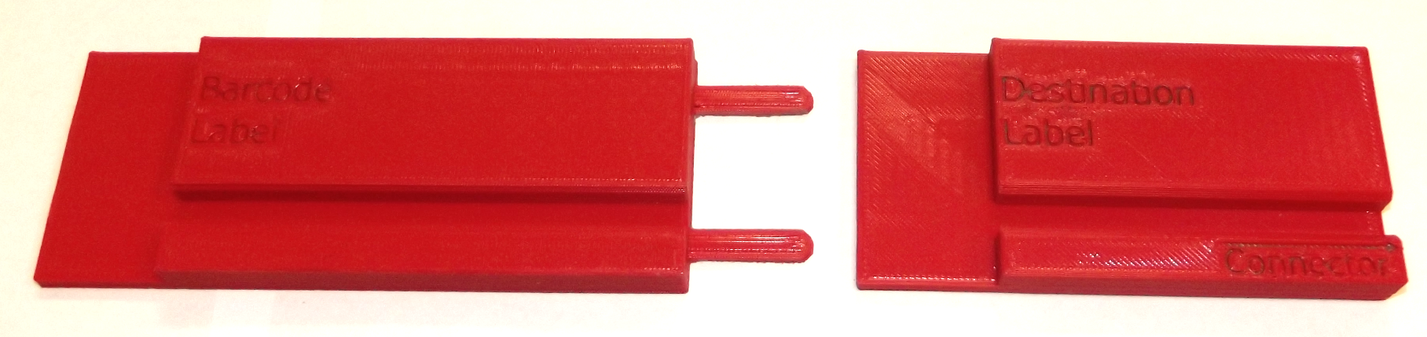
Figure 13 – Attach Barcode Fixture to Destination Fixture

- Peel off destination and barcode labels.
- Note: Refer to cable assembly procedure to determine correct destination label for connectors.
- Place labels face down in corresponding spaces on fixture.
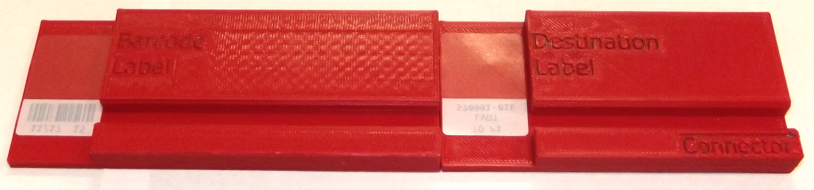
Figure 14 – Place Labels Face Down in Appropriate Space

- Align backshell of connector with end of fixture.
- Lay the cable across the fixture, making contact with the white portion of the label.
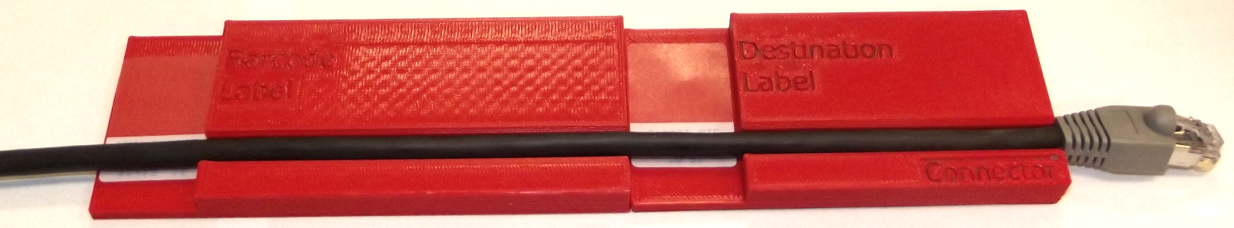
Figure 15 – Place Cable on Fixture

- Wrap the white section of the label around the cable.
- Roll the clear section of the label around the cable evenly. Avoid wrinkling the label.
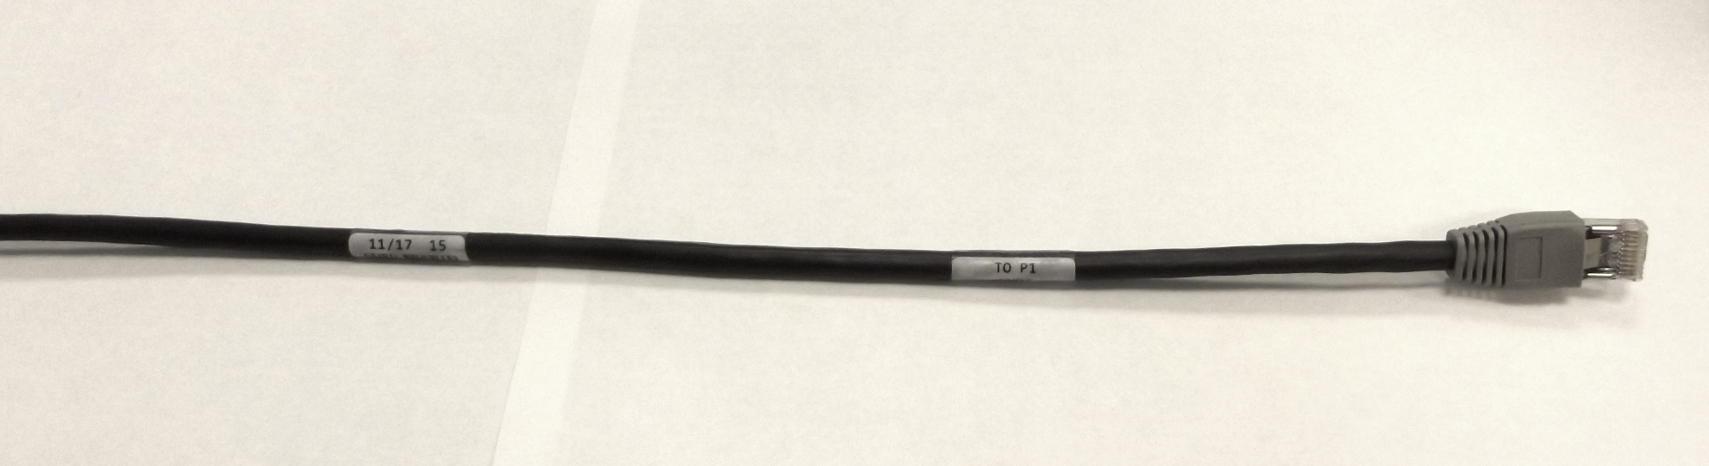
Figure 16 – Labels Attached to Cable

- If applicable, attach the RoHS fixture to the barcode fixture.
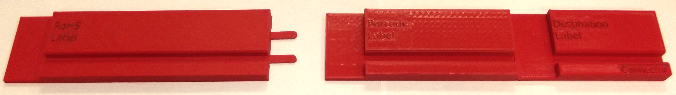
Figure 17 – Assemble RoHS Fixture to Barcode Fixture
Note: Refer to the cable assembly procedure to determine if a RoHS label is needed.
- Peel and place the RoHS label face down in the RoHS label space.

- While keeping the connector backshell even with the end of the fixture, lay the cable in the groove, making contact with the RoHS label.
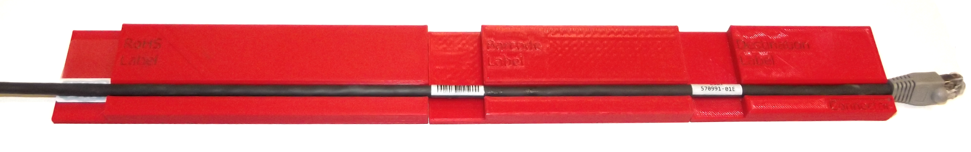
Figure 18 – Attach RoHS Label

- Roll the clear section of the label around the cable evenly. Avoid wrinkling the label.

