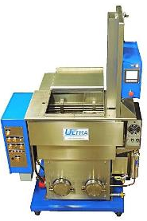

Figure ‑ Reliance Ultra 1212LE Vapor Degreaser

Table of Contents

1 Safety & Precautions 2

1.1 Aerotron Solvent 2

1.2 Other Precautions 2

2 Machine Startup 3

2.1 Start Up Cycle 3

3 Parts Cleaning 4

3.1 System Check 4

3.2 Select Program and Clean Parts 5

4 Machine Shutdown 7

4.1 Idle machine After Production Shift 7

# Safety & Precautions

## Aerotron Solvent

### Aerotron may cause serious irritation if exposed to eyes, respiratory tract or skin. Do not breath in vapors.

### Personal Protective Equipment (PPE): When handling using this equipment, appropriate safety measures must be taken. Wear protective gloves and goggles while utilizing the degreaser.

### Do not allow solvent to come into contact with the body. Solvent above 120°F can cause burns. With prolonged or frequent contact, solvent removes natural oils from the skin.

### Never enter or lean into the degreaser. Solvent vapors will be present even if the degreaser appears empty.

## Other Precautions

### Keep cover closed at all times, except when loading or unloading parts in the lift. Do not reach into vapor degreaser when cleaning is in process. The lift could move at any time and cause serious injury.

### When cleaning amplifiers or assemblies with amplifiers installed, always connect ESD wriststrap to the wriststrap monitor before handling parts.

### The basket handling lift has a total maximum weigth limit of 25 lbs.

# Machine Startup

## Start Up Cycle

### Check the machine for leaks. Walk around the perimeter of the machine and check for moisture around the cleanout door. Verify that all ball valves are closed (4) and do not have evidence of leaking.

### Verify that there aren’t any errors present on the control panel on the left side of the machine. Each controller unit should be showing a temperature number. If “ERR” or any other text is displayed, stop and notify supervisor or engineer. (Figure 2‑1).

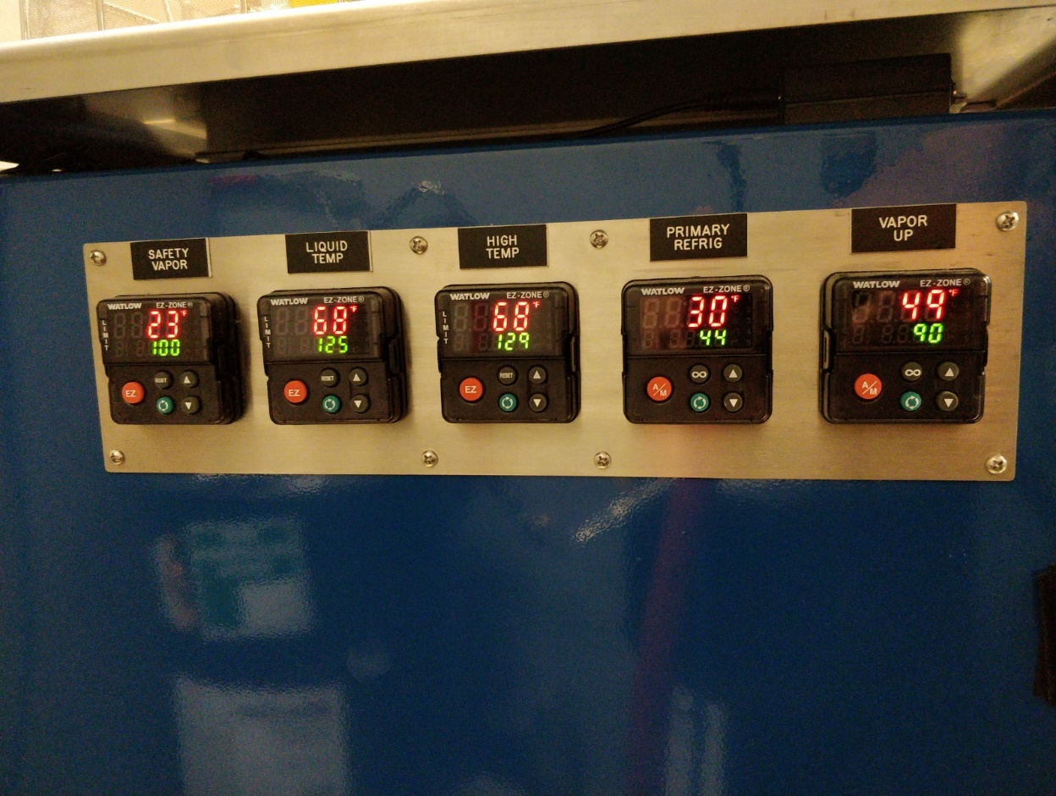

Figure ‑

### Slide back the lid and verify that cooling coils are operational. Verify that solvent level on the immersion side (right side of interior) reaches the top of the middle divider. Verify that the solvent level in the boil side (left side) is at least 50% full. If the solvent is low, stop and notify supervisor or engineer.

### Turn on “HEAT” switch and verify that the switch is illuminated. Verify that the “MAIN”, “PRIMARY REFRIG” and “SUB ZERO” switches are on and illuminated. Turn on “RECIRC PUMP” switch and verify that the switch is illuminated. (Figure 2‑2)

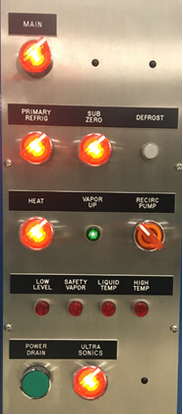

Vapor Up

Warning Lights

Figure ‑

### Equipment is ready to use when the “VAPOR UP” light is illuminated. At this point, turn off the “RECIRC PUMP” switch and verify that it is no longer illuminated. (Figure 2‑2).

# Parts Cleaning

## System Check

### Verify that “VAPOR UP” light is illuminated. Verify that “RECIRC PUMP” knob is in the “Off” position and is not lit.

### Turn on the “ULTRA SONICS” switch and verify that the switch is illuminated. On the right side of the front of the machine, make sure that the “POWER INTENSITY” dial on the ultrasonic power supply is set at the halfway point between MIN and MAX. (Figure 3‑1).

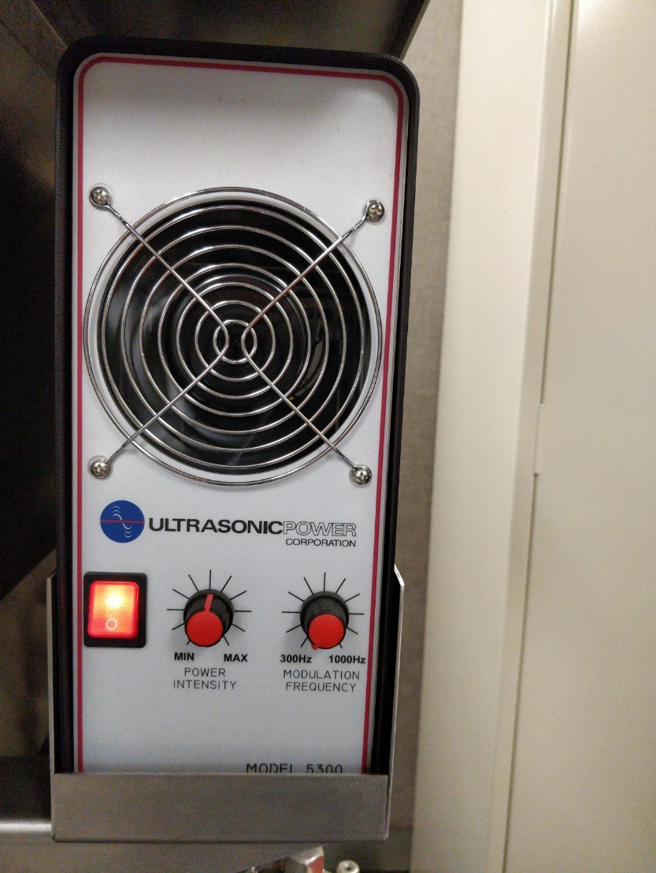

Figure ‑

### Verify that there are no warning lights lit on the main panel (Figure 2‑2). If any of the four warning lights are on, do not use equipment. Notify supervisor or engineer.

## Select Program and Clean Parts

### Slide the lid back and load parts into lift basket. If necessary, use an appropriate jig or fixture to insure that parts do not strike each other and suffer damage during lift movement or submersions in solvent.

### Slide the lid shut.

### On the controller, check the “CURRENT RECIPE” in the lower left hand corner of the touchscreen to determine if the appropriate recipe is loaded. (Figure 3‑2). If a different recipe is required, press the “RECIPES” button and select a recipe from the list, then press the “MAIN” button. (Figure 3‑3). Once back on the main screen, insure that the desired recipe is displayed under “CURRENT RECIPE”. (Figure 3‑2).

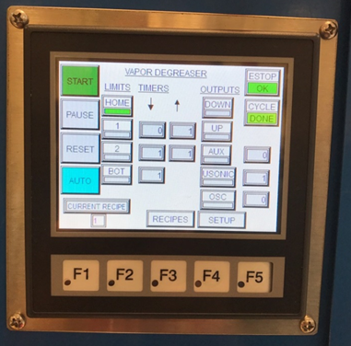

Figure ‑

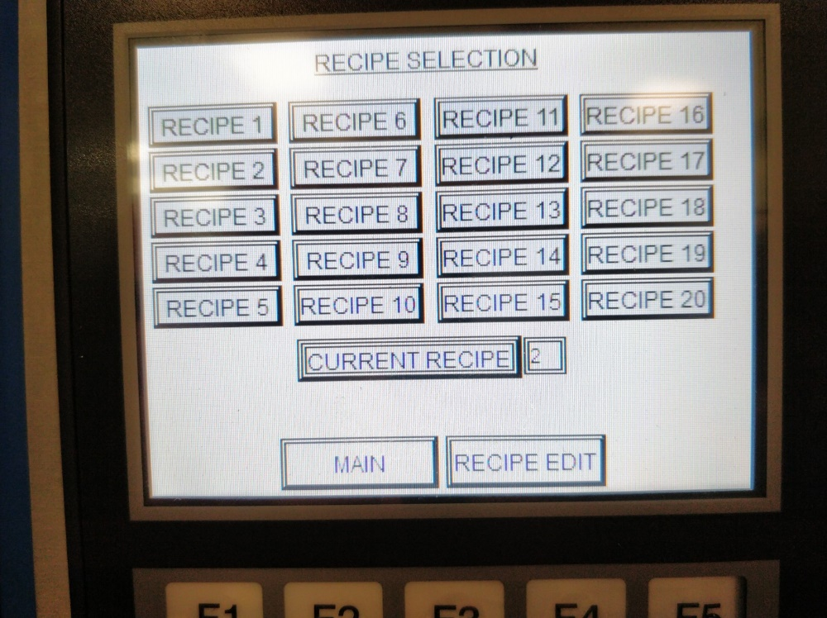

Figure ‑

### Verify the “AUTO” button is selected. The “AUTO” button should be light blue. If it is grey, touch the “AUTO” button to enable it, and it should turn light blue.

### Press the “RESET” button to ensure the basket is in the home position. Press the “START” button. The basket will drop into the initial cleaning position. The basket will automatically move between the different cleaning areas at the appropriate times based on the recipe.

### Once the cycle is complete, the stacklight will illuminate yellow and the parts must be removed from the vapor degreaser. NOTE: Remove cleaned parts from the handling basket within five minutes in order to ensure condensation does not form on the parts.

# Machine Shutdown

## Idle machine After Production Shift

### At the end of a shift, if the machine will not be used on the next shift, the heat system and ultrasonics should be shut off by following the steps below.

### Verify that parts were not left in the lift basket. Confirm that lid is closed.

### Turn off the “HEAT” switch and verify that the switch is no longer illuminated. Turn off the “ULTRA SONICS” switch and verify that the switch is no longer illuminated.

### The “MAIN”, “PRIMARY REFRIG” and “SUB ZERO” switches must remain in the “On” position. The “SUB ZERO” light will be illuminated intermittendly as it is temperature controlled.

### Inspect the temperature controls on the left side of the macine to verify that no errors are present. If there is an error, notify a Production Supervisor or Manufacturing Engineer.

### Wipe down external surfaces with ESD safe cleaner and paper towels. Do not spray the cleaner directly onto the equipment.