Contents

[I. Purpose 2](#_Toc24967874)

[II. Overview 2](#_Toc24967876)

[III. Procedure 4](#_Toc24967880)

[A. Safety 4](#_Toc24967881)

[B. General Operation 4](#_Toc24967883)

[i. Loading Template and S/N 4](#_Toc24967884)

[ii. Applying Label 7](#_Toc24967885)

[iii. Visual Inspection 8](#_Toc24967886)

[iv. When Finished with job 8](#_Toc24967887)

[v. Rework 8](#_Toc24967888)

[C. Creating New Templates 9](#_Toc24967889)

[D. Changing Labels – Refer to Wraptor Manual 9](#_Toc24967890)

[i. Video – Changing Label Material 9](#_Toc24967891)

[E. Changing Print Ribbon – Refer to Wraptor Manual 9](#_Toc24967892)

[i. Video – Changing Print Ribbon 9](#_Toc24967893)

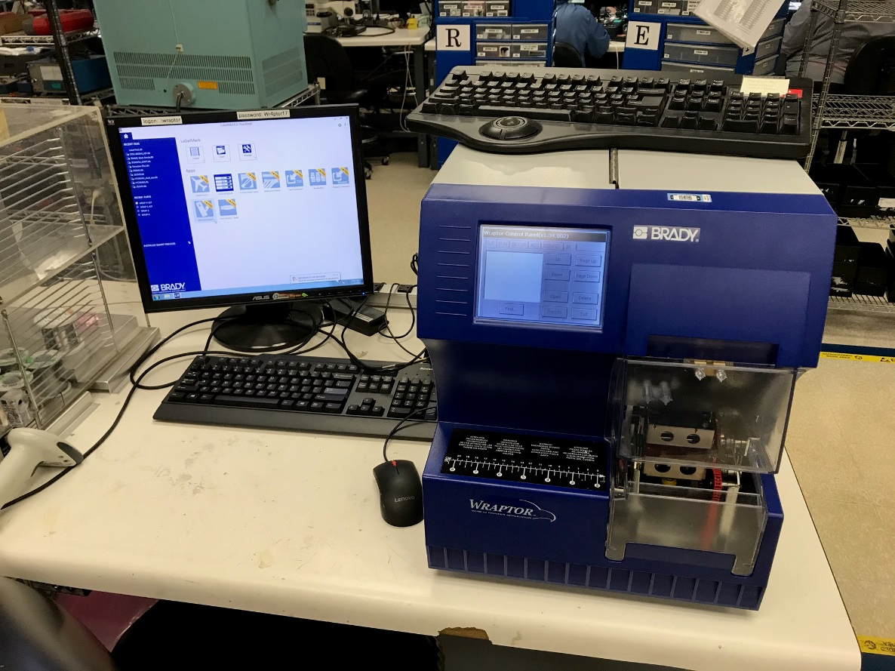

**Wraptor Station Overview**

# Purpose

### The purpose of this user guide is to provide instructions for Assembly Technicians in the process and procedures necessary for operating the Brady Wraptor for the purpose of applying identifying label to integral cable sensors.

# Overview

### Reference Figure 1: Hardware - The Wraptor® Wire ID Printer Applicator is an automated print and apply machine that makes wire and cable identification faster and easier. Please note that the labels may only be applied to wire diameters 0.06-0.6 inches.

## C:\Users\awalkowski\AppData\Local\Microsoft\Windows\Temporary Internet Files\Content.Outlook\8WXDG5CQ\IMG_3732.jpg

Control Panel

Plastic Safety Cover

Warning Labels

Wrapper Jaws

Figure 1 - Wraptor unit

## Control Panel - Reference Figure 2: Pictured below is the Wraptor Control Panel. Ensure that the “Run” tab (pictured below) is displayed on the Wraptor touch screen. Refer to the accompanying table for button functionality.

Figure 2 - Wraptor control panel

|  |  |
| --- | --- |
| **Button** | **Description** |
| > | Goes to the next label. |
| < | Goes to the previous label. |
| >> | Goes to the last label in the file. |
| << | Goes to the first label in the file. |
| Goto… | Prompts for the label number to jump to. |
| Reset | Sets the *Count* (number of labels wrapped) to zero. |
| Queue | Open the job queue dialog. |
| Close | Press this button to close the current label file and then open the next one in the queue |
| Wrap | Shows the operating mode of the printer: Auto or Manual (Notify Manufacturing Engineer or Supervisor if “Manual” is selected). |
| Count | Displays the number of labels wrapped. |
| Label Number | Displays the position in the label file. If the print file only contains one label this field displays SINGLE. |
| File | The currently open label file. |

# Procedure

## Safety

### The wrapper mechanism contains hazardous moving parts. Keep fingers and other body parts away from wrapper jaws.

## General Operation

### Loading Template and S/N

1. 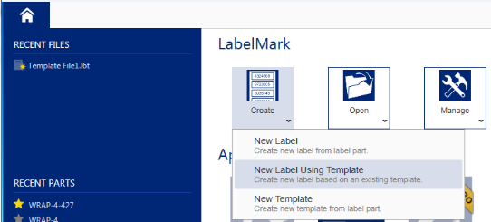Reference Figure 3: Open LabelMark -> Create -> New Label Using Template

Figure 3 - Selecting label file

1. Reference Figure 4: Select Template File That Corresponds with Model Number -> Next

#### *Note: If the model does not have an existing template, do Not Attempt to create a new template. Contact a Supervisor or Trainer for further instructions. .*

Figure 4 - Select template file

1. 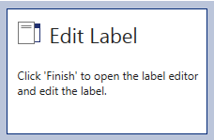Reference Figure 5: Edit Label-> Finish

Figure 5 - Edit label

1. Reference Figure 6: Verify correct model number is displayed in “Label 1” and that the line underneath the model number is outlined with a solid blue rectangle.
2. Scan serial numbers on serialization sheet in numerical order. Continue until each serial number has been scanned.
3. Reference Figures 7 and 8: After all serial numbers have been imported, Select File->Print. The print screen will open. Select “Print” or click the printer icon. Verify “All Lables” is selected on Print options or select the option desired (figure 8).

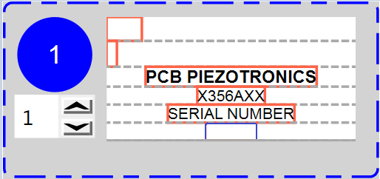

Figure 6 - Model template display

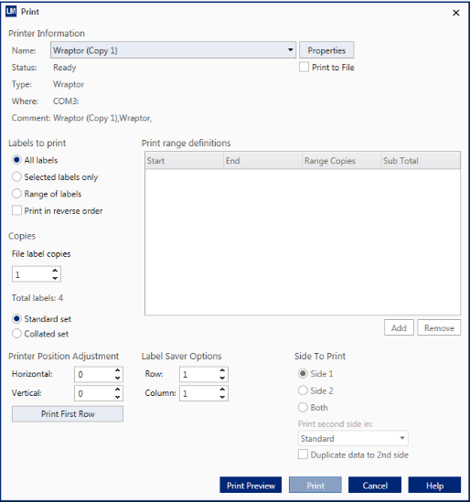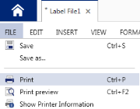

Figure 7 - Printing file

Figure 8 - Printing file

1. 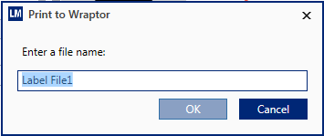Reference Figure 9: A LabelMark window that contains “Print to Wraptor” heading will open. Select “OK”.

Figure 9 - Export to Wraptor

1. 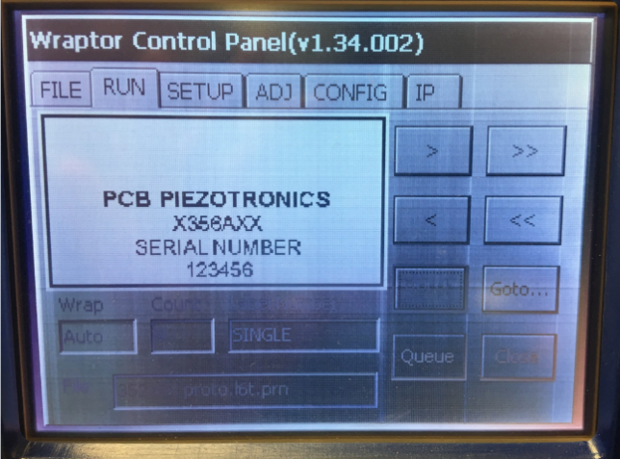The contents of “Label 1” will now be visible on the Wraptor display.

Figure 10 - Wraptor display after exporting file

### **Applying Label**

1. Reference Figure 10: Verify the model and serial number displayed on the screen match the first sensor listed on the job paperwork
2. Reference Figures 12: Ensure the connector is aligned with outer left of safety cover and cable is held straight and taught.
3. Reference Figures 11 and 12: Insert cable into jaws. The placement of the label should be approximately ${\frac{ 2 }{3}}^{rds}$ from the end of heat shrink (see figure 14).
4. Reference Figures 11 and 12 & 13: While holding the cable taught, push the cable against the engagement pins.
5. Hold the cable in place until the wrapper mechanism completely stops.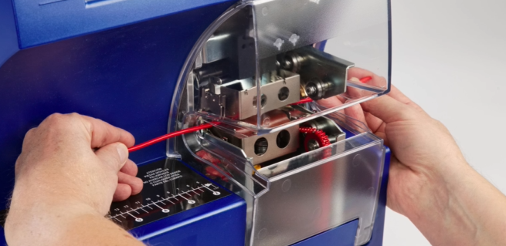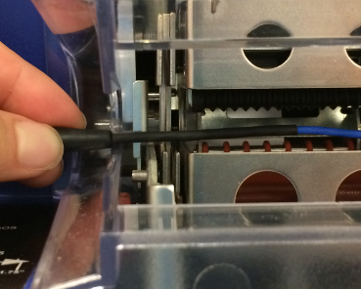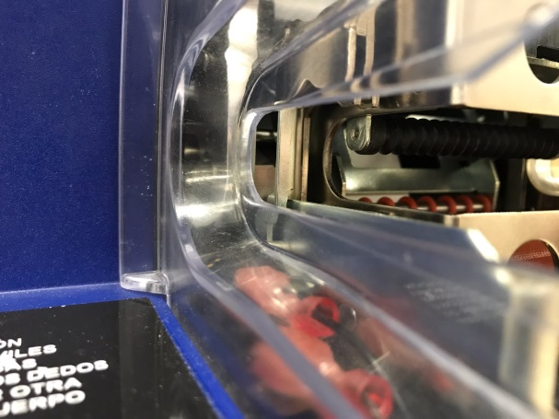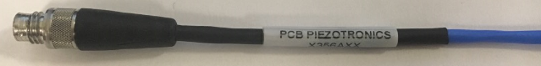

Figure 11 – Location of Engagement Pin

Figure 13 - Cable is held taught and straight when activating engagement pins

Wrapper jaws

Engagement pin

Rear of connector boot aligned with outside of plastic cover

Figure 12 - Connector is aligned with outer cover

Figure 14 - Final product

### **Visual Inspection**

1. Reference Figure 14: Label content matches model and serial numbers on etching and job paperwork. Label should contain the following elements; each centered and on separate lines:
   * Line 1: Company name text: ”PCB PIEZOTRONICS”
   * Line 2: Model number listed on etching and job paperwork
   * Line 3: Text “SERIAL NUMBER”
   * Line 4: Serial number that matches etching
   * Minimal negative space between “line 1” and “line 4”
2. Label is uniformly applied over the heat shrink.
3. Edges are fully adhered (not curling up)
4. Label is legible.
5. Label is not applied past the heat shrink.

### **When Finished with job**

1. When job is compeleted you will recive a warning message on the wraptor, select “YES”, see figure 15. This will delete all currently saved information loaded on the printer that is not needed for next person.

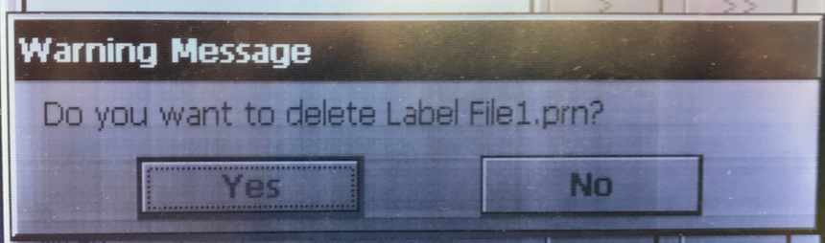

Figure 15 – Warning Message

1. Close program, but Do Not save data when closing program.
2. Do Not Shutdown Computer. There is no need to fully shutdown the station.

**NOTE**: If computer is off, login using credentials state below (also located on workstation). If not type in correctly you will not beable to login.

* USERNAME: **.\wraptor**
* PASSWORD: **Wr4ptor17**

### **Rework**

1. Peel label seam and slowly unroll the wrap until completely removed.
2. Manually select the label that will be reapplied from the Wraptor operating screen using the < and > selections.
3. Follow “Applying Label” procedure for re-labeling.

## Creating New Templates - See Manufacturing Engineer or Supervisor if a sensor template is not available.

## Changing Labels – Refer to Wraptor Manual

### [Video – Changing Label Material](file:///R:\Engineering\LMcGee\Wraptor%20Videos\How%20To%20Change%20Wraptor%20Label%20Material.mp4)

## Changing Print Ribbon – Refer to Wraptor Manual

### [Video – Changing Print Ribbon](file:///R:\Engineering\LMcGee\Wraptor%20Videos\How%20To%20Change%20Wraptor%20Ribbon%20Material.mp4)