**Contents**

1 Introduction 2

1.1 Purpose 2

1.2 Machine Safety and Care 2

2 Machine Basics 2

2.1 Motion Controls 2

2.2 Moving Components Onto Machine 3

2.3 Setting the Z-Stop 3

3 Running The Tests 4

3.1 Starting Software / Loading Applications 4

3.2 Positioning Parts to Test 6

3.3 Running the Test 7

# Introduction

## Purpose

### The purpose of this document is to establish a procedure for using the Zygo Model 8300 in Micro to get data for the 40002-05 assemblies.

## Machine Safety and Care

### The Zygo NewView 8300 has a motorized X/Y/Z/Tilt system to bring samples into focus under the lens. The table is small, and there is appropriate clearance on all sides, but it could still be possible to drive one of the axis in such a way that an injury could be caused by pinching or crushing. Always be aware of the table and head movement. Do not place hands near the table or head when machine is running an automated script. Do not manually move table or head if anyone is too close to the machine.

### The Zygo uses high precision optical components to make measurements. These components, especially the lenses, are VERY fragile. Extreme care must be taken to avoid damaging the machine. The following cautions must be kept in mind at all times:

#### Never let anything touch the lens, especially a finger.

#### Do not attempt to clean the lens. Lens cleaning should only be done by a Zygo service person. If something does leave a mark on the lens, run a machine calibration to zero out the potential error.

#### **Reset the Z-Stop every single time a new application program is loaded**. It is recommended that the Z-Stop be reset each time a technician returns after being away from the machine. **Without a proper Z-Stop, the lens could crash into a part or fixture and be damaged.**

# Machine Basics

## Motion Controls

### All of the motion on the machine is accomplished using the control console. Below in Figure 2-1 is a brief summary of what each control on the console does.

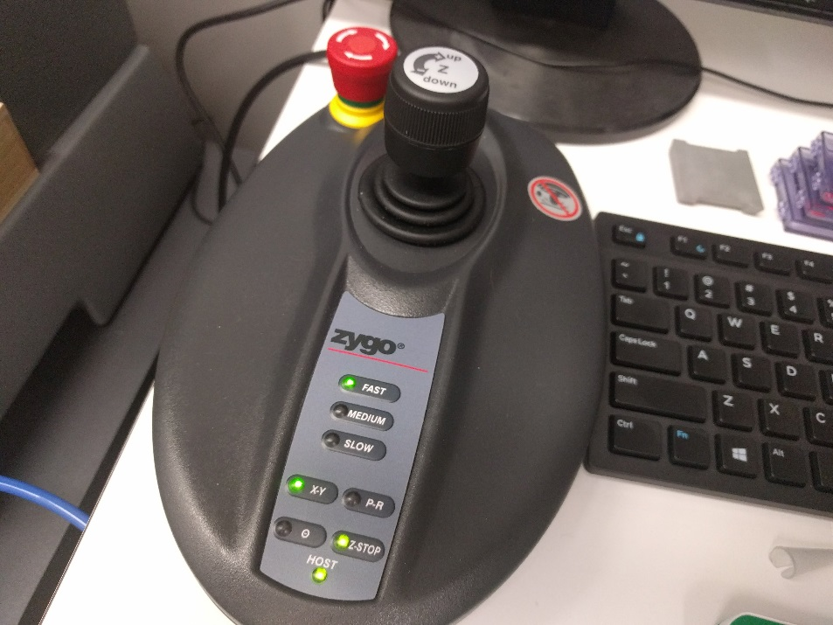

JOYSTICK

Rotate Left: Lower Head

Rotate Right: Raise Head

Move Left: Table moves left

Move Right: Table moves right

Move Up: Table moves up

Move Down: Table moves down

TABLE MOVE SELECT

Left (X-Y) selects X/Y table

Motion. Right (P-R) selects

Table tilting.

MOVEMENT SPEED

Select how fast the

Joystick move the table and

head

EMERGENCY STOP

Press to stop and disable

All table and head movement

Z-STOP BUTTON

Press to set/unset Z-Stop.

Light is green when Z-Stop is set

Light is red when Head is at Z-Stop

Light is flashing red when

Z-Stop is not set

Figure 2‑1

## Moving Components Onto Machine

### To prepare for the first piece, use the joystick on the control module by rotating the joystick clockwise to raise the head unit up and out of the way. See Figure 2-2.



Joystick:

Rotate Right raises Head

Rotate Left lowers Head

Figure 2‑2

### Once the head is out of the way, place the required fixture, with component, onto the workstage. Try to place the fixture such that the component to be tested is in the small area of light being emitted by the head unit lens.

## Setting the Z-Stop

### **Setting the Z-Stop is the most important part of using the machine.** The proper Z-stop setting will prevent the objective lens from being damaged by striking parts or fixtures. The objective lens is extremely expensive and fragile. See section 1.2.2 for more detail.

### Make sure there is enough room under the lens to place the fixture and part under test onto the X-Y table. (See 2.1.1) Use fixture 52925-01 for all Zygo measurements.

### With the fixture and part in place, press the Z-Stop button on the control module (it will turn red). Slowly lower the head unit until the bottom of the lens is about 1-2mm away from the part under test. (A suggestion is to choose medium or slow speed on the control module to avoid moving toward the part too fast).

### When the desired height is reached, press the Z-Stop button again. It will change from flashing red to solid red. Move the head slightly upward, and the Z-Stop light will turn green.

# Running The Tests

## Starting Software / Loading Applications

### Click on the Mx icon on the computer desktop to star the Zygo Mx software. This software is the interface to the Zygo machine. See Figure 3-1.

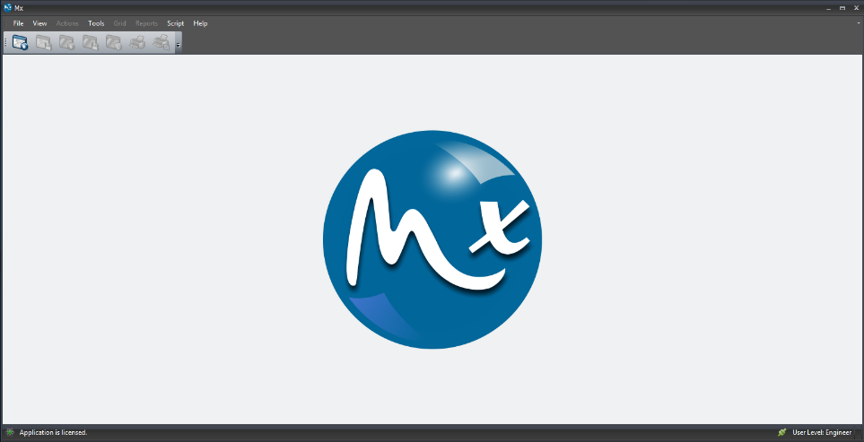

Figure 3‑1

### Once the application is running, click on [File] and then on [Load Application]. See Figure 3-2.

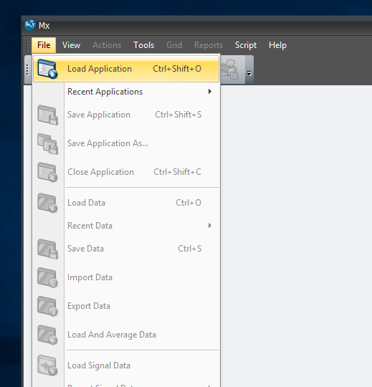

Figure 3‑2

### The Load Application file window will open. From this window, select which of the three applications is needed, Chip Height, Carrier Fixture, or LID TO LID, then click the [OPEN] button. See Figure 3-3.

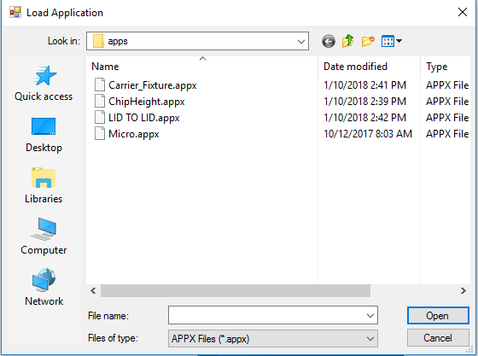

Figure 3‑3

### The software will prompt for the optical controls to be set. (See Figure 3-4). The Micro Zygo machine only uses one setting (F-Stop Open, Filter F1, A-Stop Open). Verify that these controls have not been moved. See Figure 3-5.

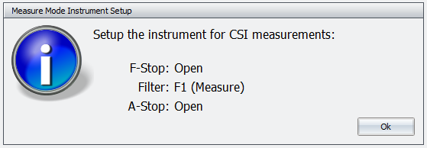

Figure 3‑4

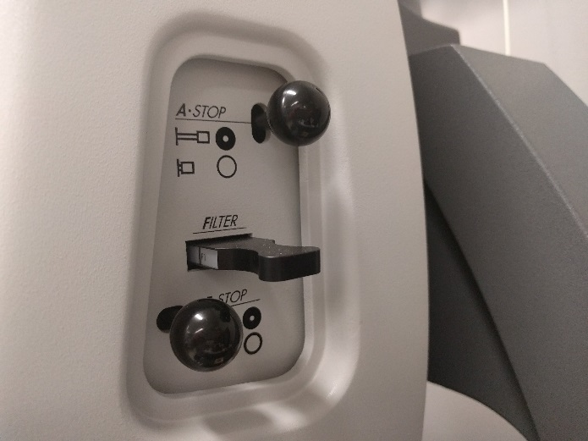

Figure 3‑5

### Once that application opens, there should be windows in both monitors. In the left monitor, there should be a large greyscale camera image. In the right monitor the main application window should be showing. See Figure 3-6. If the left monitor shows a windows desktop, and the right monitor shows a full screen grey image, the camera window will need to be dragged over to the left monitor.

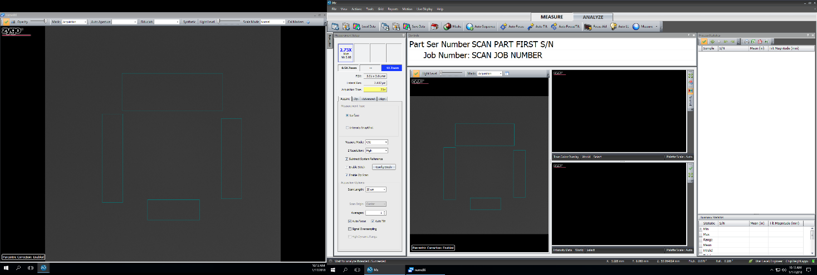

Right Monitor

Left Monitor

Figure 3‑6

## Positioning Parts to Test

### If there is not already a part on the table from setting the Z-Stop, place the part to be tested onto the appropriate fixture on the table. There are Mask lines drawn onto the camera view to help in aligning the parts under the lens. See Figures 3-7 and 3-8.

### If more than one carrier is to be measured at once, make sure that they are all lined up as straight as possible, and that there is a small space between each part. This will make it easy to use the joystick to drive to the next part, and insure that the software can see each part. If this method is chosen, make sure to keep traceability to the serial number of each carrier/chip pair!

### Rotate the parts until the proper features are contained in the mask areas. For the chip, all of the text and PCB logo on the top of the chip must be in the mask area. For the carrier, the gold wire bond pads should overlay the mask areas. See Figures 3-7 and 3-8.

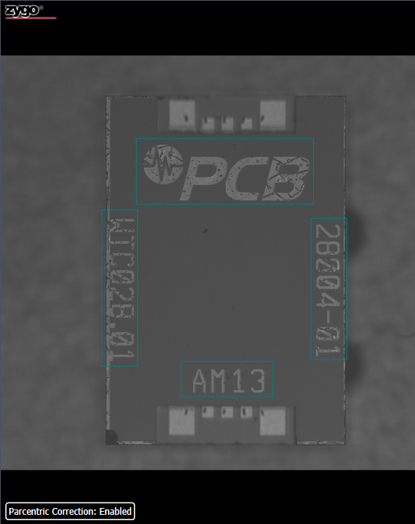

Figure 3‑7

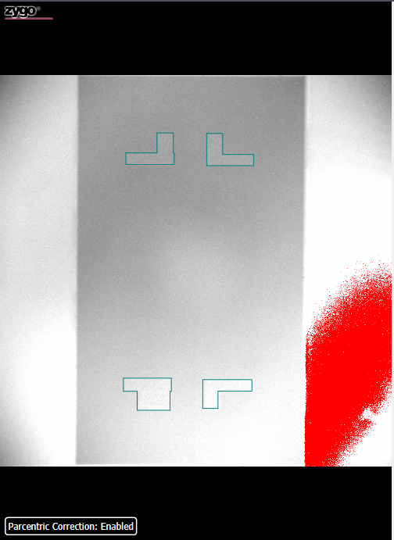

Figure 3‑8

## Running the Test

### Once the part is aligned, click the [Measure] button on the middle menu bar. See Figure 3-9. This will run a script that will perform all the steps necessary to complete the measurement of the part and to store the results.

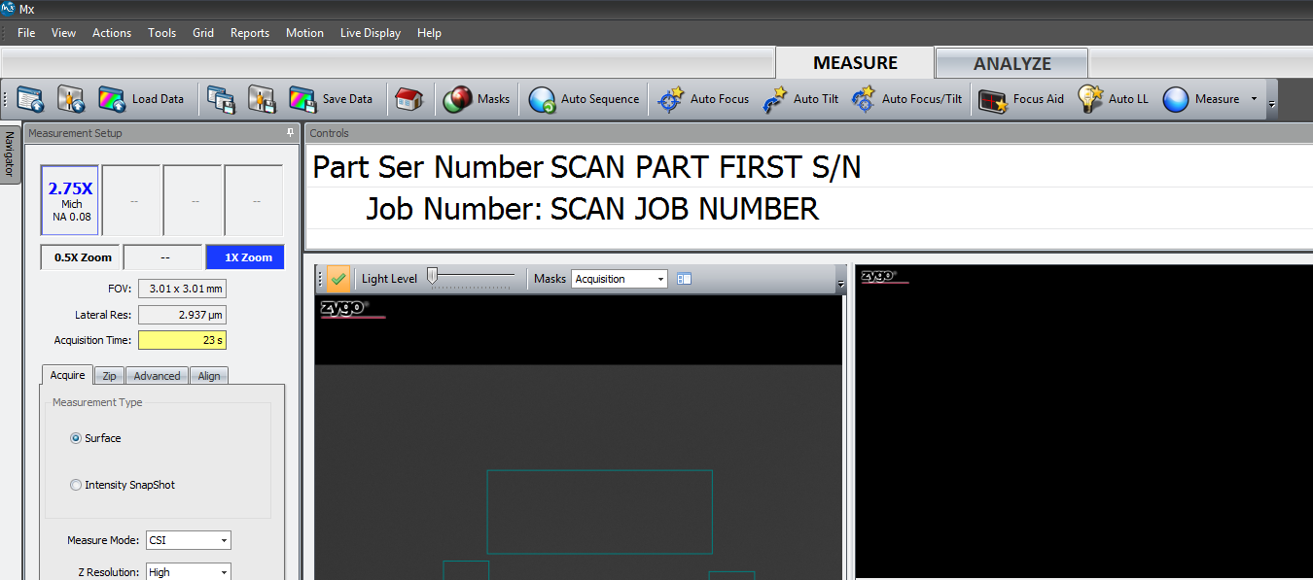

Figure 3‑9

### The script will first ask for the job number and serial number to be scanned. There is some error checking to insure that a valid entry is made. Use care to scan the correct serial number, as this is the number that will be used to save all data. See Figures 3-10 and 3-11.

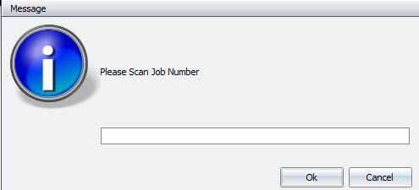

Figure 3‑10

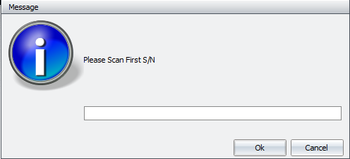

Figure 3‑11

### Once the serial number is scanned, there will be a short delay while the software checks for older data from this job. If some serial numbers were worked on previously, the results will be imported into the Process Statistics window.

### Once old data is imported, the part is measured and the new result is added to the Process Statistics window. A 3D view of the measured surface is also displayed next to it. Once the result is displayed in the process statistics window, it is automatically saved to a file. See Figure 3-12.

### If the part being measured is the ceramic carrier, the ISO flatness of the carrier bottom is displayed, and is highlighted in green or red for pass or fail. If any carrier flatness measurements show up in red, that carrier should be scrapped, and another carrier should be measured and added as a matched pair to the associated chip.

### If the part being measured is the bare MEMS chip or a completed assembly, the Tilt Magnitude will be highlighted in green or red for pass or fail. If any chip or assembly fails for tilt magnitude, there may be debris under the chip/assembly. Try to re-seat the chip/assembly on the fixture, and/or blow off the fixture and bottom surfaces. Re-run the measurement. If the chip/assembly continues to fail, put it aside for further analysis and if it is a chip, get a new chip.

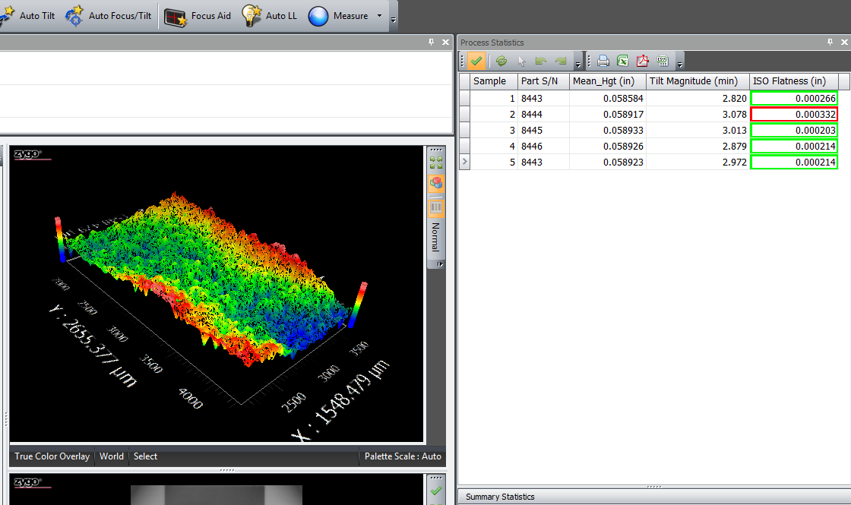

Figure 3‑12