Scope
The purpose of this user guide is to provide information for safe handling of gas cylinders (used to supply the CamCo B-16 Brazing Furnace) by authorized personnel at PCB Piezotronics, Inc. (PCB). In order to maintain a safe work environment for all employees and visitors of PCB, all handling of compressed gas on PCB premises must be done by authorized personnel only, using the proper Personal Protective Equipment (PPE) and following the information listed in this user guide.

Responsibilities
Cables Department engineering/management is responsible for maintaining this procedure.
Authorized Cables Department technicians are responsible for carrying out this procedure.
Affected Department / Product Group / Support Group:
Cables

Safety

Emergencies
- If there is a large spill or rupture of a container:
  - Immediately call 911
  - Warn others in the building
  - Evacuate the area; there will be an oxygen deficiency. Risk of explosion is possible if Hydrogen gas is exposed to a spark.

Handling & Storage
- Discontinue use and contact the vendor if you experience any difficulty operating the container valve or with the container connections. Use the proper connection. DO NOT USE ANY TOOLS TO OPEN OR CLOSE THE VALVES.
- All compressed gas cylinders should be stored in the designated storage location and secured in an upright position to prevent tipping.
- Whenever a cylinder is being moved or transported, the protective cap must be secured to the top.
- Cylinders need to be secured to the wall at all times. When changing cylinders, move the empty cylinder to a proper wall-mount harness and secure with strap.
- Do not drop, tip or roll cylinders on their side.
- Proper cart should be used to transport the cylinders while secured with a chain/ strap.

Personal Protective Equipment (PPE)
- Steel-toed shoes or caps should be worn any time a cylinder is being transported or moved.
- Safety glasses are recommended during tank change.

Proper Transport and Usage Practices

General Instructions
- Make sure the furnace is not actively running a profile. NEVER change the tanks while the furnace is running. Confirm that the furnace is at room temperature and that the controller is idle.
- Do not overtighten hose fittings into cylinder valve openings. A wrench should only be needed to ensure connection is snug or to remove hose fitting from cylinder.
- Never leave any of the gas line fittings open to the air except during tank change. This will prevent unnecessary moisture from entering the system.
- When retrieving a new cylinder of compressed gas from inventory, confirm it has been received into stock with a green sticker on the lot tracking tag noting the Part Number, Lot Number and Expiration Date with a PCB employee stamp.
- Maintain Kanban system for monitoring gas supply. See Purchasing with questions.
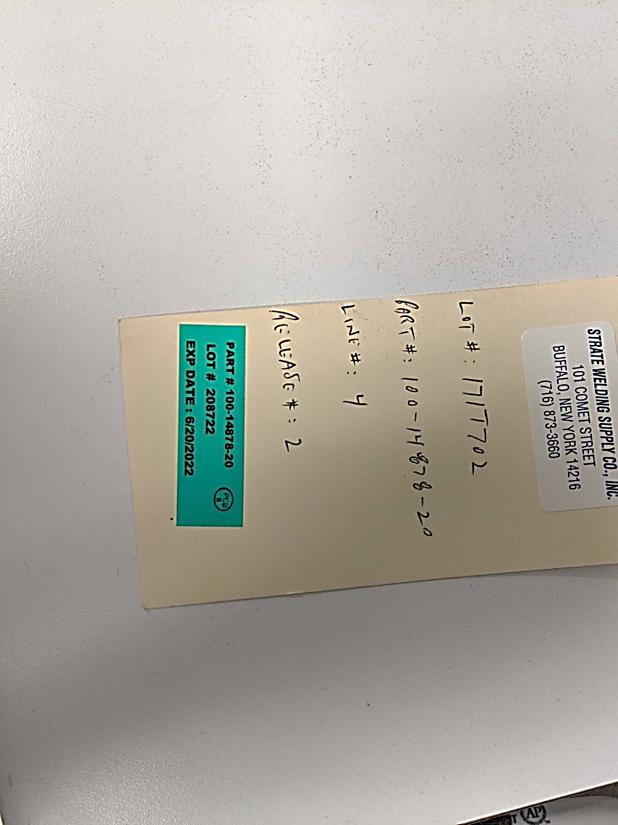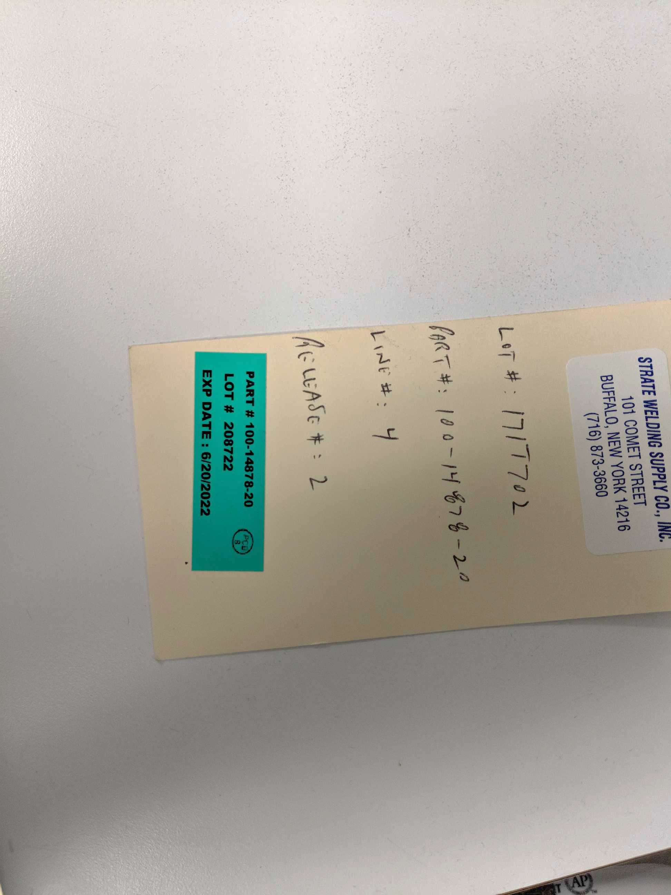
PCB Employee stamp

Compressed Hydrogen
- Acquire gas cylinder from Inventory. Remove chain securing the gas cylinders together and place one on a cart with a chain/ strap.
- Tip cart onto its wheels. Move cart out of the way.
- Place the chain back on the remaining cylinders in Inventory.
- Transport the new cylinder to the Braze Furnace.

Removing Depleted Hydrogen Cylinder
- It is critical to the process to have both a PRIMARY and SECONDARY Hydrogen gas supply. Whenever the Primary cylinder is empty, the Secondary cylinder should be moved to the Primary position and the new tank will fill the Secondary position.
- Turn the valves on top of both of the Hydrogen gas cylinders clockwise until closed.
- Turn the small black knob valves above the regulators clockwise until closed.
NOTE: There is no need to adjust the large black knob on the regulator.
- Remove the hose fitting from around the valve opening on both cylinders. Use of a wrench may be necessary for the initial turn.
NOTE: Hydrogen tanks use external, left-handed threads for hose fittings to go over the valve opening. Turn clockwise to loosen.

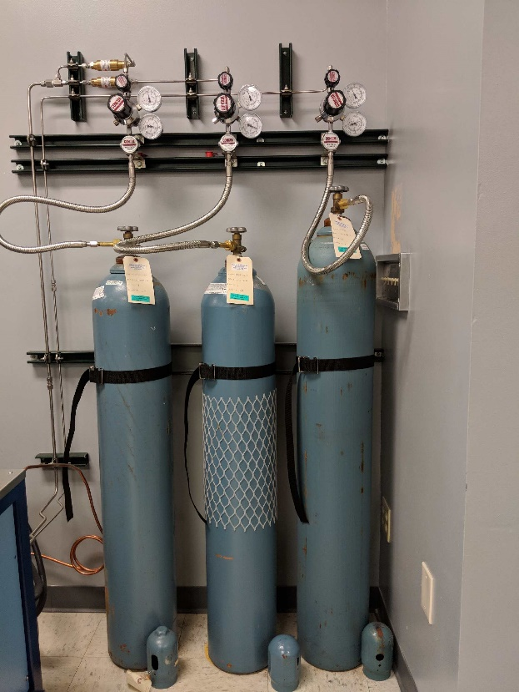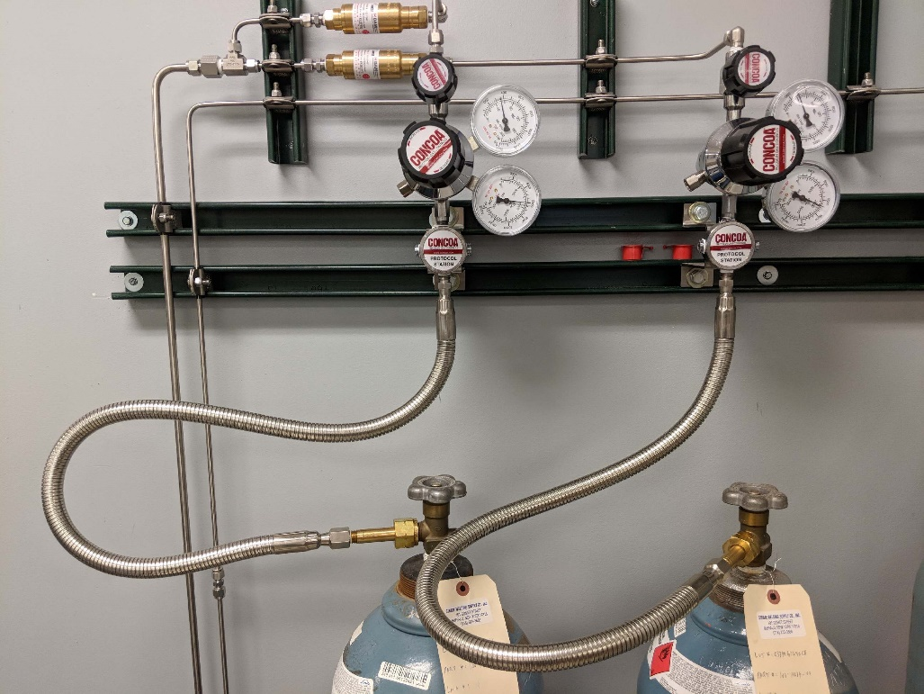
Cylinder Valves
Large knob Regulators:
Do not adjust
Small knob Valves
- Move the lot tracking tag from the Primary cylinder to its protective cap.
- Secure protective cap to Primary cylinder.
- Remove harness from around Primary cylinder.
- Move the empty Primary cylinder to the extra wall-mount harness and secure with strap.

Attaching New Hydrogen Cylinder
- The new cylinder should always be installed as the Secondary Hydrogen gas supply. This requires moving the current Secondary cylinder into the Primary position.
- Remove the lot tracking tag from the Secondary cylinder; momentarily place to the side to be re-attached as soon as cylinder is moved into Primary position.
- Secure protective cap to Secondary cylinder.
- Remove harness from around Secondary cylinder.
- Move the Secondary cylinder to the primary harness. Secure with strap. This cylinder will be referred to as Primary cylinder going forward.
- Remove protective cap from Primary cylinder.
- Move the lot tracking tag onto the cylinder.
- Move cart with new Hydrogen cylinder near the Secondary harness.
- Remove chain from around cylinder. Carefully slide cylinder off cart while holding the cart to prevent it from tipping. Rest cart back on its wheels and move out of the way.
- Move the New cylinder into the Secondary harness. Secure with strap.
- Remove protective cap from cylinder.
- Move the lot tracking tag onto the Secondary cylinder.
- Install hose fitting onto the valve opening on Secondary cylinder. Use of a wrench should only be needed to snug into place.
NOTE: Hydrogen tanks use external, left-handed threads for hose fittings to go over the valve opening. Turn counter-clockwise to tighten.
- Open valves on top of cylinders by turning counter-clockwise.
- Open small black knob valves above the regulators by turning counter-clockwise.
- Attach empty cylinder to cart and secure with chain/ strap.
- Return to proper location in Inventory for Empty Gas.

Compressed Nitrogen
- Acquire gas cylinder from Inventory. Remove chain securing the gas cylinders together and place one on a cart with a chain/ strap.
- Tip cart onto its wheels. Move cart out of the way.
- Place the chain back on the remaining cylinders in Inventory.
- Transport the new cylinder to the Braze Furnace.

Removing Depleted Nitrogen Cylinder

- Turn the valve on top of the Nitrogen gas cylinder clockwise until closed.
- Turn the small black knob valve above the regulator clockwise until closed.
NOTE: There is no need to adjust the large black knob on the regulator.
- Remove the hose fitting from inside the valve opening on cylinder. Use of a wrench may be necessary for the initial turn.
NOTE: Nitrogen tanks use internal, right-handed threads for hose fittings to go into the valve opening. Turn counter-clockwise to loosen.
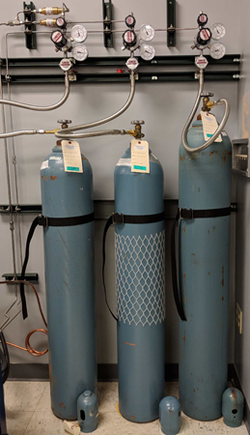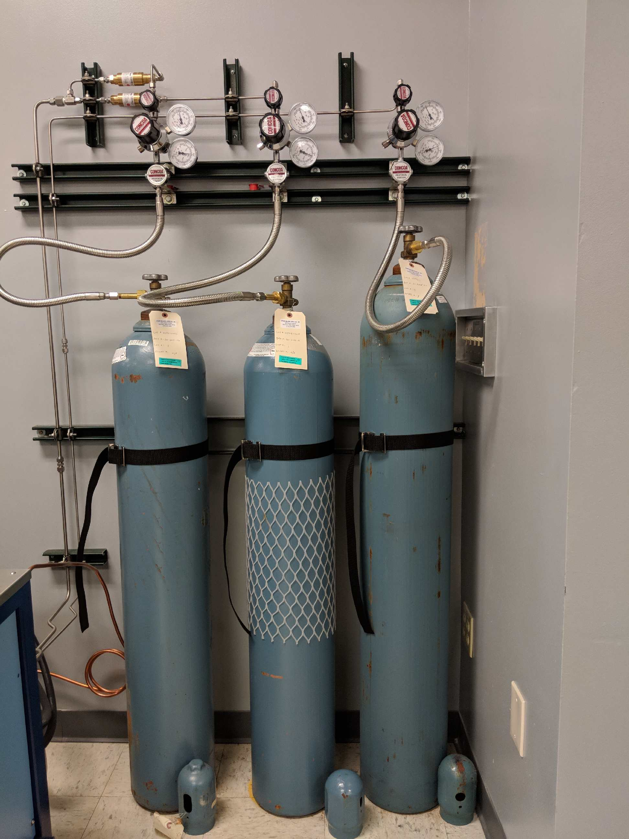
Cylinder Valve
Small knob Valve
- Move the lot tracking tag from the Nitrogen cylinder to its protective cap.
- Secure protective cap to cylinder.
- Remove harness from around cylinder.
- Move the empty cylinder to the extra wall-mount harness and secure with strap.

Attaching New Nitrogen Cylinder
- Move cart with new Nitrogen cylinder near the Nitrogen harness.
- Remove chain from around cylinder. Carefully slide cylinder off cart while holding the cart to prevent it from tipping. Rest cart back on its wheels and move out of the way.
- Move the cylinder into the harness. Secure with strap.
- Remove protective cap from cylinder.
- Move the lot tracking tag onto the cylinder.
- Install hose fitting into the valve opening on cylinder. Use of a wrench should only be needed to snug into place.
NOTE: Hydrogen tanks use internal, right-handed threads for hose fittings to go into the valve opening. Turn clockwise to tighten.
- Open valve on top of cylinder by turning counter-clockwise.
- Open small black knob valve above the regulator by turning counter-clockwise.
- Attach empty cylinder to cart and secure with chain/ strap.
- Return to proper location in Inventory for Empty Gas.

Documenting Change
- Update the furnace log book with a note showing the gas cylinder change including the date, user and gas Lot Number.

