# Scope

The purpose of this user guide is to provide requirements for operating the CamCo B-16 Braze Furnace, along with the equipment settings requirements, to be executed by authorized personnel at PCB Piezotronics, Inc. (PCB). In order to maintain a safe work environment for all employees and visitors of PCB, all operation of the furnace must be done by authorized personnel only following the information listed in this user guide.

# Responsibilities

Cables Department engineering/management is responsible for maintaining this procedure.

Authorized Cables Department technicians are responsible for carrying out this procedure.

Affected Department / Product Group / Support Group:

Cables

# Safety

# Emergencies

* If there is a large spill or rupture of a compressed gas container:
  + Immediately call 911
  + Warn others in the building
  + Evacuate the area; there will be an oxygen deficiency. Risk of explosion is possible if Hydrogen gas is exposed to a spark.
* In the event of an emergency, if the furnace should be turned off immediately or is running in an unsafe mode, disable the furnace by pushing the RED EMERGENCY OFF BUTTON. When pushed, power will no longer go to the elements and the Chamber will automatically purge with purge gas. **Leave the furnace in this state.** No other buttons need to be pressed.
* In case of a Power Outage during a run, push the RED EMERGENCY OFF BUTTON. Product in furnace should be deemed non-conforming unless proper approval is given by Engineer. Determination of when in the process the outage occurred will need to be determined by Engineer.
* In any Emergency situation, contact the Supervisor or Engineer immediately. Record the stoppage on the log.
  + Engineer/ Supervisor:
    - Purge gas will purge until key is turned to release Red Emergency Off button or until tank is empty.
    - Nitrogen alarm will sound if insufficient purge gas is present during restart. Check level before turning key.
    - System will continue from previous step in program
      * To pause program, press RUN/HOLD
      * To reset program, hold PROG and press RUN/HOLD.
* If power is shut off at the breaker, use LEFT arm, face away from breaker and put in ON position.

# Equipment Classification

**4.1** **Qualified Operation Temperature Range**

* 1000°C - 1200°C

**4.2 Furnace Class**

* Class 5

**4.3 Instrumentation Type**

* Type D

# Furnace Operation

# Gas Supply

1. Inspect gas cylinders to verify they are present, secured and all fittings are attached correctly
   1. Process gas will always be Hydrogen (H2) (99.99% pure or higher, unless otherwise specified)
   2. Purge gas will always be Nitrogen (N2) (99.99% pure or higher, unless otherwise specified)
   3. Product BOM should indicate required gas part numbers.
2. Inlet (tank) gages on regulators display remaining pressure inside gas cylinder. Check regulators to verify there is enough gas for a run:
   1. Process gas minimum: Full Secondary tank and partial-fill on Primary tank
   2. Purge gas minimum: 500 psi
3. Completely open all valves on gas cylinders
4. Completely open all small black knob Outlet valves above regulators
5. Adjust regulators while gas is flowing (only as needed for proper Outlet pressure)
6. Ensure proper pressure on all regulators (adjustment should not be required):
   1. Process gas tank required pressure:
      1. Primary tank = 50psi +/- 2psi
      2. Secondary tank = 40psi +/- 2psi
   2. Purge gas tank required pressure:
      1. Main tank = 40psi +/- 2psi

Primary Process Gas

4. Small knob: Outlet Valves

Purge Gas

Secondary Process Gas

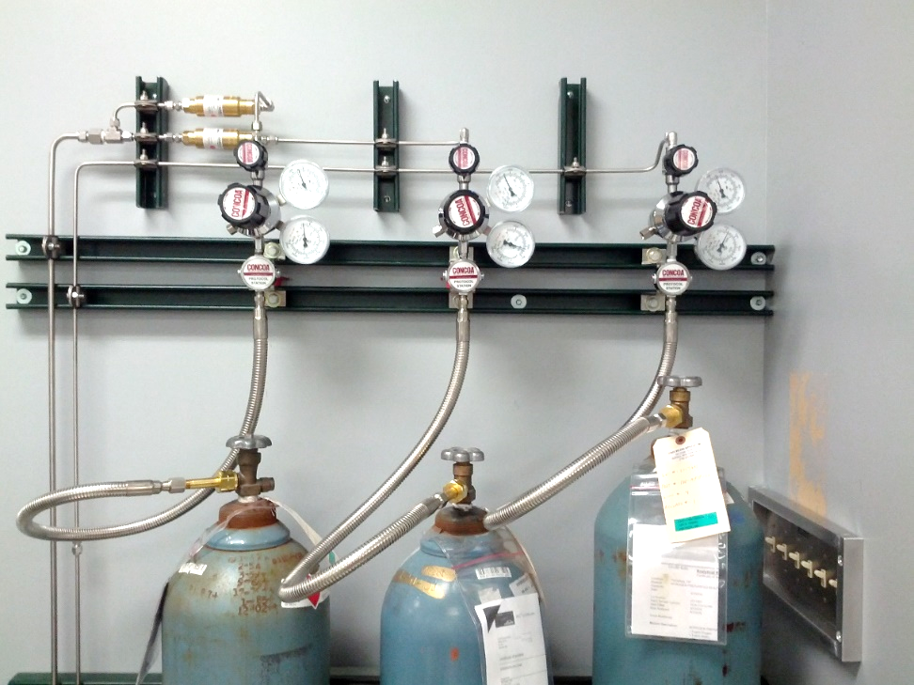

5. Large knob: Regulators

6. Outlet Pressure Gage

2. Inlet (Tank) Pressure Gage

3. Cylinder Valves

# Cooling System

1. Turn on the chiller circulation by pressing the power button on the control panel.
2. Monitor unit for proper operation and to ensure no alarms are triggered. Allow chiller to run for approximately 3 minutes to ensure proper operation.
   1. If Alarm triggers, NOTES button on control panel will repeatedly flash red.
      1. Turn off chiller, wait 10 seconds, turn ON
3. Equipment settings:
   1. Water temperature set point:
      1. 68°F (+3°F /-3°F)
   2. Water flow rate:
      1. 3.0 – 4.0 gpm. Flow meter is located outside chiller near the floor

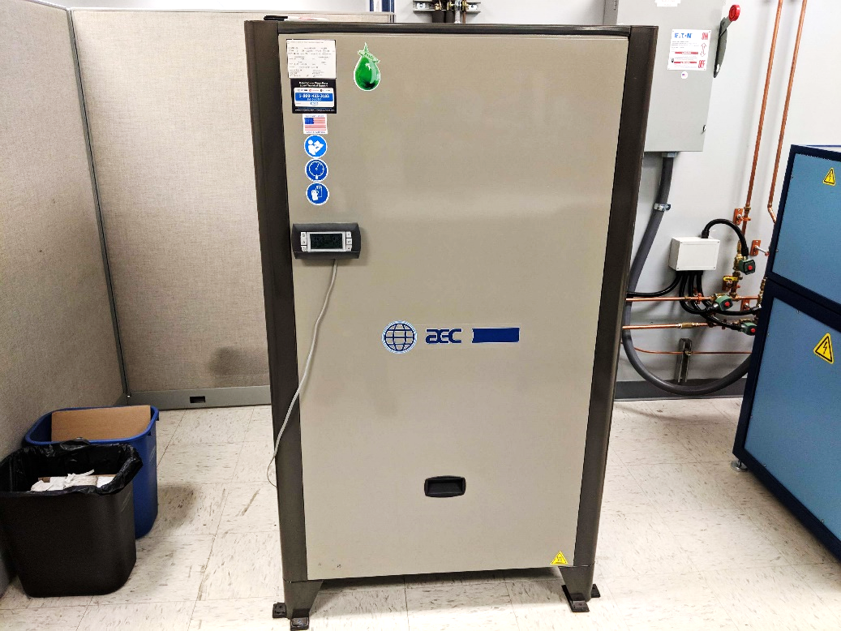

2. Notes

1. Power

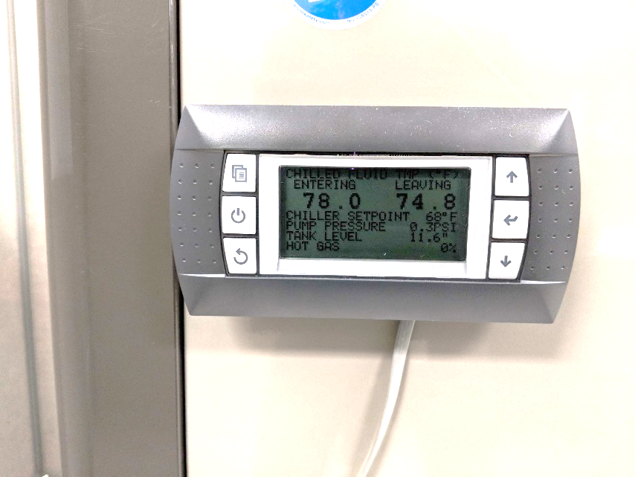

# Over Temperature Controller

1. Top Number is Present Value
2. Bottom Number is Set Point Value
   1. To adjust the Set Point, use arrow keys then press the M-A/ Reset button.
3. Set Point = 100°C over MAX process temperature, unless otherwise specified.  
   CAUTION: Furnace Max Operating Temperature = 1600°C  
   DO NOT SET OVERTEMP OVER 1500°C (Program MAX Temperature = 1400°C)
4. If alarm has been triggered, LIMIT will flash in bottom of display.
   1. System will not function if alarm is not cleared
   2. Press M-A/ Reset to clear alarm

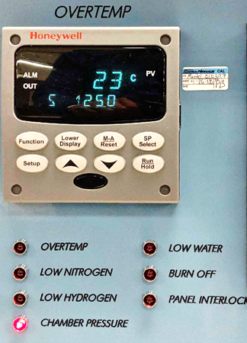

# Program Control

1. Enter program number into the Program Controller
   1. Current program is visible in the top left corner under PROG
   2. Set correct program number (reference job router)
      1. To adjust program, press the PROG key to change the number
2. Current program segment (step) is visible in middle display under SEG
3. Use DISPLAY button to change which output the 2 numerical LEDs on the right are displaying
4. Top right display shows Present Value of temperature (in example below)
5. Bottom right display shows Time Remaining in segment (in example below)
   1. LEDs in Profile display current step (left) and next step (right)
      1. Pointing upward indicates ramping up temperature
      2. Pointing downward indicates ramping down temperature
      3. Flat indicates holding temperature

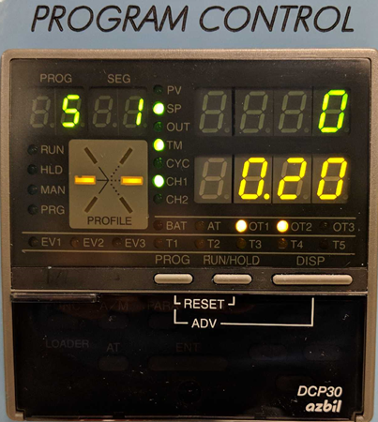

# Start-Up

1. To maintain cleanliness of parts and fixtures, all handling shall be done with clean nitrile (or equivalent) gloves on.
2. Open furnace door
   1. While pressing the door-lock release button, pull handle towards you then up. Fully open the door to the furnace; it will rest on its hinges.
3. Remove heat shield
   1. Grasp the top heat shield with both hands and carefully lift out of chamber.
   2. Flip heat shield over and with the handles turned downward, set the heat shield down on its handles.  
      NOTE: Be sure nothing makes contact with the heat shield plates to avoid damage.
4. Load parts
   1. Parts should be properly placed onto designated fixture before loading into furnace.
   2. Jewelry and loose garments shall be removed to prevent catching on internal furnace components (as necessary).
   3. For high temperature burn-out of furnace, no parts or fixtures will be loaded into furnace.
5. Position Thermocouple(s)
   1. Requirements should be given in the process procedure if a LOAD thermocouple is needed
   2. Position load thermocouple in line with the highest parts being brazed, near in height to the point of brazing (ex. in a braze adaptor near the braze ring groove)
6. Replace heat shield
   1. Grasp the top heat shield with both hands and carefully lower onto chamber.
7. Close furnace door
   1. While pressing the door-lock release button, pull handle towards you then press down.
8. Turn B-16 Main Power on
   1. Main Breaker in ON position
   2. Emergency Stop button pulled out (key required if pressed in)
9. Begin logging on Yokogawa recorder
   1. Open control panel on bottom of Yokogawa recorder.
   2. Ensure SD Memory card is inserted.
   3. Press green Start button to begin logging.
10. Select program on Program Control panel (displayed in top left of Program Control panel). Proper program is based on several factors and shall be determined by Engineering. Take into consideration:
    1. Material of parts
    2. Material of braze alloy
    3. Process gas
    4. Ramp rates
    5. Hold times
11. Press Run/Hold on Program Control panel.
    1. System will begin to run
    2. Green IN USE light will illuminate
    3. Door lock light will turn off forbidding the door from opening
12. Fill out the B-16 Furnace Run Log
    1. Record run number from the counter on the bottom left of the control panel.
    2. Record if the run is being done for [P]roduction, [E]ngineering or [Q]uality testing.
    3. Record the job number.
    4. Record the item number.
    5. Record the job quantity.
    6. Record the date and time.
    7. Record any pertinent details, such as:
       1. Calibration Run, System Accuracy Test, or Temperature Uniformity Survey.
       2. Test of a new fixture design or a new thermal profile.
       3. Qualification run of new part or batch of braze rings.
       4. Failures or observations about the furnace behavior during the run.
13. After Temperature ramp-up begins (within 5 minutes of furnace beginning temperature ramp-up):
    1. Monitor the dew point
       1. Dew point must be -32°C or below.
    2. Adjust Process gas flow rate
       1. Flow rate must be 25 scfh +/- 2 scfh; use sight glass on flow meter.
       2. Do not adjust Process gas again during run. As temperature rises in furnace, flow rate may appear to fluctuate due to internal pressure changes. No action is required.
14. After completion of run
    1. Green IN USE light will turn off
    2. Door lock light will illuminate allowing door to be opened
    3. Allow sufficient time for internal components and parts to cool before removing from furnace
       1. If door is difficult to open, hold PRESS TO VENT button to vent purge gas into chamber to equalize pressure
15. Open furnace door
    1. While pressing the door-lock release button, pull handle towards you then up. Fully open the door to the furnace; it will rest on its hinges.
16. Remove heat shield
    1. Grasp the top heat shield with both hands and carefully lift out of chamber.
    2. Flip heat shield over and with the handles turned downward, set the heat shield down on its handles.  
       NOTE: Be sure nothing makes contact with the heat shield plates to avoid damage.
17. Remove Load Thermocouple (if applicable)
18. Remove fixture with parts from chamber
19. Wipe inside of door with IPA to remove residues from processing
20. Replace heat shield
    1. Grasp the top heat shield with both hands and carefully lower onto chamber.
21. Close furnace door
    1. While pressing the door-lock release button, pull handle towards you then press down.

# Programs

# Program #5

