User Guide: Multi-Cal Programming System for PGA308

- Calibrated Equipment:
The equipment listed below is used during this test and is calibrated per ISO10012-1 and former MIL-STD-45662A and the calibration records are on file.
- Keysight 34401A Digital Multi Meter (or equivalent)
- Fluke 8370a, 6270a or equivalent

- Non-Calibrated Equipment:
The equipment listed below is used during this test and no calibration is required.
- PCB Multi-Cal Box, which contains,
- Texas Instruments Multi-Cal System
- Texas Instruments Multi-Cal-Salve expansion board
- PCB 67554-01 Power Supply
- MeanWell PLC-30-9 power supply
- PCB 488B14/NC Power supply
- Required cables
- Computer

- System Connection:
- Connect Multi-cal box power cord to outlet. Reference Figure 1.
- Connect a cable from either the ‘DMM’ USB, or GPIB port on the back of the multi-cal box to a computer with ‘Multi_Cal_PGA308’ software installed. Reference Figure 1.
- Connect a cable from the ‘DAQ’ USB port on the back of the multi-cal box to the same computer as step above. Reference Figure 1.

***Power must be on before the ‘DAQ’ USB can be connected, or the software will error***

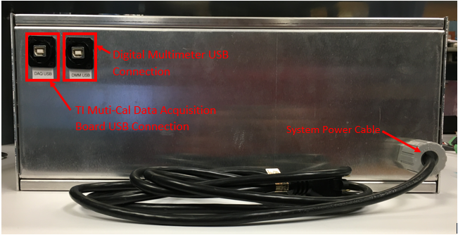
Figure 1

- On the front of the digital multi meter, verify that the on/off switch is set to on. Reference Figure 2 below.
- On the front of the digital multi meter, verify that the front/rear switch is set to rear. Reference Figure 2 below.
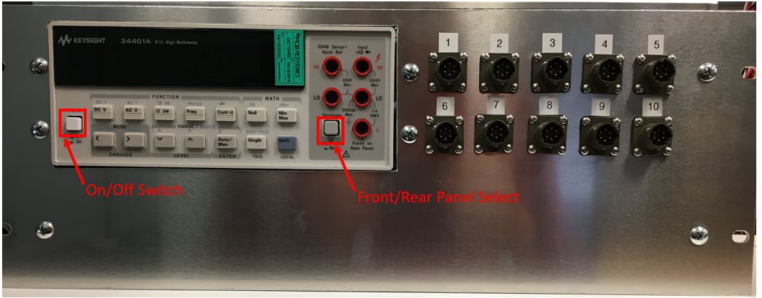
Figure 2

- Connect sensors to pressure source using fixtures and mounting dictated by model.
- Connect calibration cable from front panel to each sensor being tested in ascending order of serial number (ex. If testing s/n’s 1001 and 1002, 1001 should be connected to channel 1, and 1002 should be connected to channel 2). This is to ensure the chip is programmed with the correct serial number.

- Software Setup:
- Open ‘Multi_Cal_PGA308 software.
- Click ‘Config Cal’ tab, and verify the proper sensor model is loaded as shown in Figure 3.
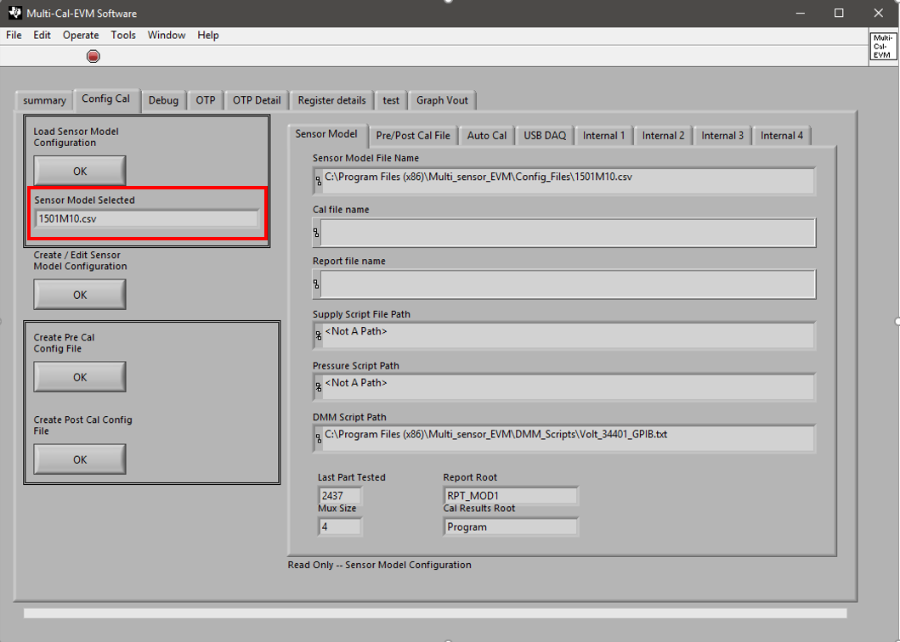
Figure 3
- Return to ‘Summary’ tab and click, the ‘OK’ button under ‘Do Calibration’ as shown in figure 4.
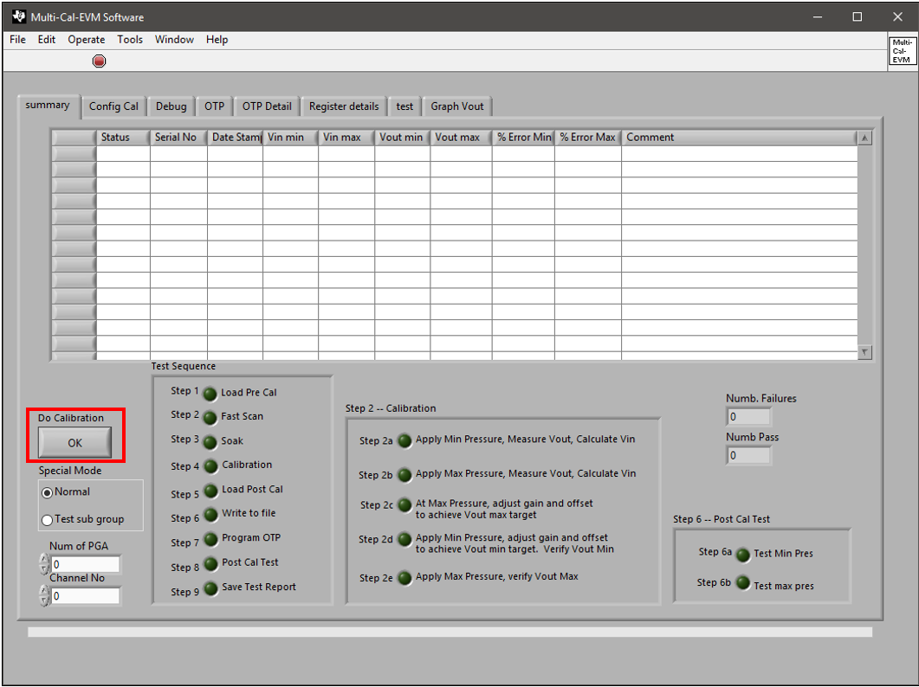
Figure 4

- The ‘Start calibration window will open.
- In the box “Is first Serial number ok?’ click ‘no’ and enter the first serial number in the job in the prompt box that appears.
- Click ‘Yes” to all other questions in the box shown in figure 5. The default information that populates will be acceptable.
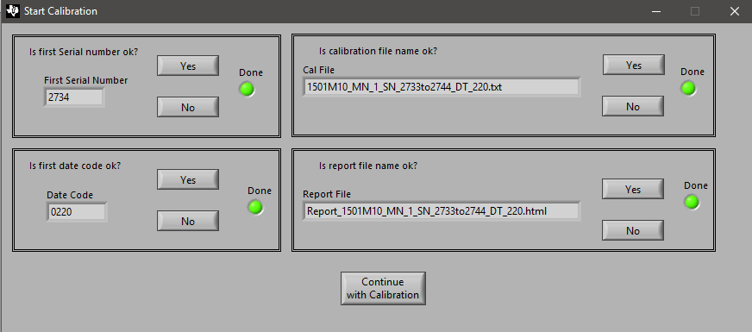
Figure 5

- Select ‘Continue with calibration
- When the prompt appears that says ‘Apply minimum stimulus to the sensor’ verify that the pressure is set to the minimum measurement range, and then hit ‘OK’
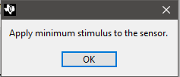
Figure 6

- When the prompt appears that says ‘Apply maximum stimulus to the sensor’ pressurize the sensor to its maximum measurement range.
- After the pressure stabilizes at the correct value, select ‘OK’
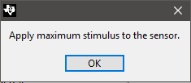
Figure 7

- When the prompt to ‘Apply minimum stimulus to the sensor’ appears, set pressure to the minimum measurement range again.
- After pressure stabilizes at the correct value, select ‘OK’
- When the prompt appears that says ‘Apply maximum stimulus to the sensor’ pressurize the sensor to its maximum measurement range again.
- After pressure stabilizes at the correct value, select ‘OK’
- The software will then program OTP on each sensor
- When a prompt appears that says ‘Done cal!!!!’ select ‘OK’
- The sensors are now programmed and can be disconnected from the system.

- Troubleshooting:
- If upon opening the program, the following error message appears,
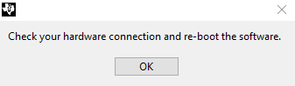
Figure 8

- Verify power is connected and the DAQ board USB is connected. If both are connected, unplug the DAQ USB from the computer, wait a couple of seconds, and then plug back in. Then close the ‘Multi_Cal_PGA308’ program, and then reopen.

- If the issue continues, disconnect all connections and power, and close the program. Then be sure to connect power first, then connect USB, and then open the program.

- If issues still persist, contact engineering

- If during calibration, the following error message appears,
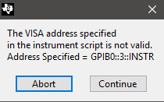
Figure 9

- Verify that the Keysight digital multi meter is turned on.
- If issues persist, contact engineering

- If on the first point on the calibration fails as shown below,
Figure 10

- Verify that the switch on the front panel is set to ‘rear’
- Verify that the DMM USB, or GPIB cable is connected properly
- If issues persist, contact engineering.

