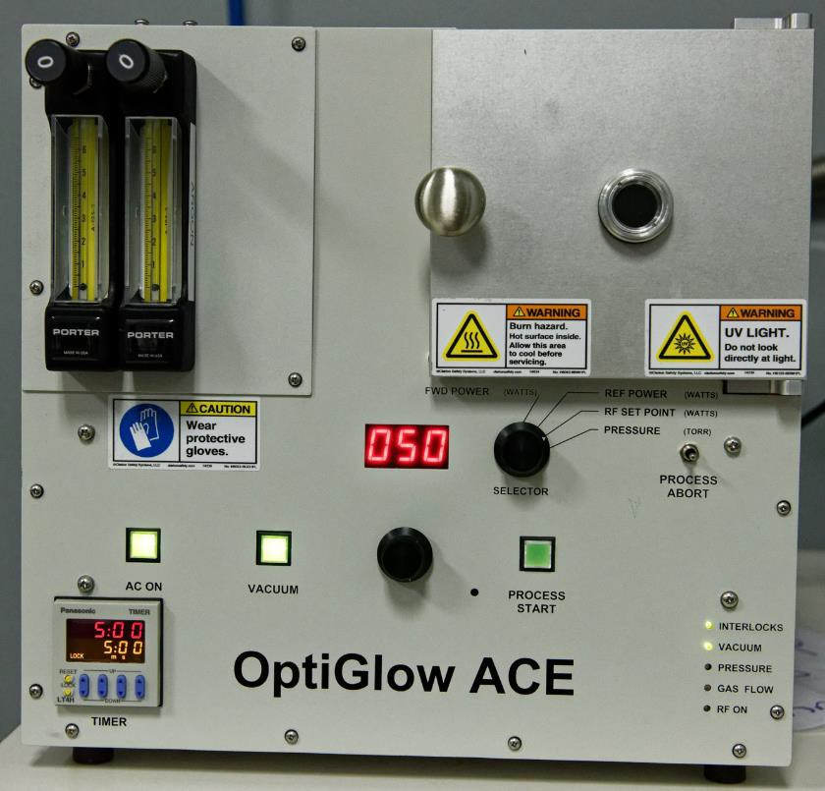

Process Summary
Step | Ar Flow (sccm) | Vacuum | Process Start | Pressure | Time (M:SS) | Vent
Vacuum Valve Open | 0 | On | Off | < Atmosphere | NA | Off
≤ 450 mTorr pressure | 0 | On | Enabled | ≤ 450 mTorr | 0:08 | Off
Process Start | 24 | On | Yes | ≤ 450 mTorr | NA | Off
Etch 5:00 | 24 | On | On | ~290 mTorr | 5:00 | Off
Process End | 0 | On | Off | ≤ 290 mTorr | NA | Off
Vacuum Off | 0 | Off | Off | Venting | NA | On
Backfill | 0 | Off | Off | ≥ 1.58 Torr | 0:45 | On
Atmosphere | 0 | Off | Off | Atmosphere | NA | On

DAILY OPERATIONAL PREFLIGHT/SETUP

- If necessary, plug in the vacuum pump and/or the etcher. If the argon bottle is closed, open by turning the stem valve counterclockwise. Ensure the outlet pressure is 10 ± 2 PSIG (Figure 1). Notify engineering if the bottle pressure is below 250 PSIG.
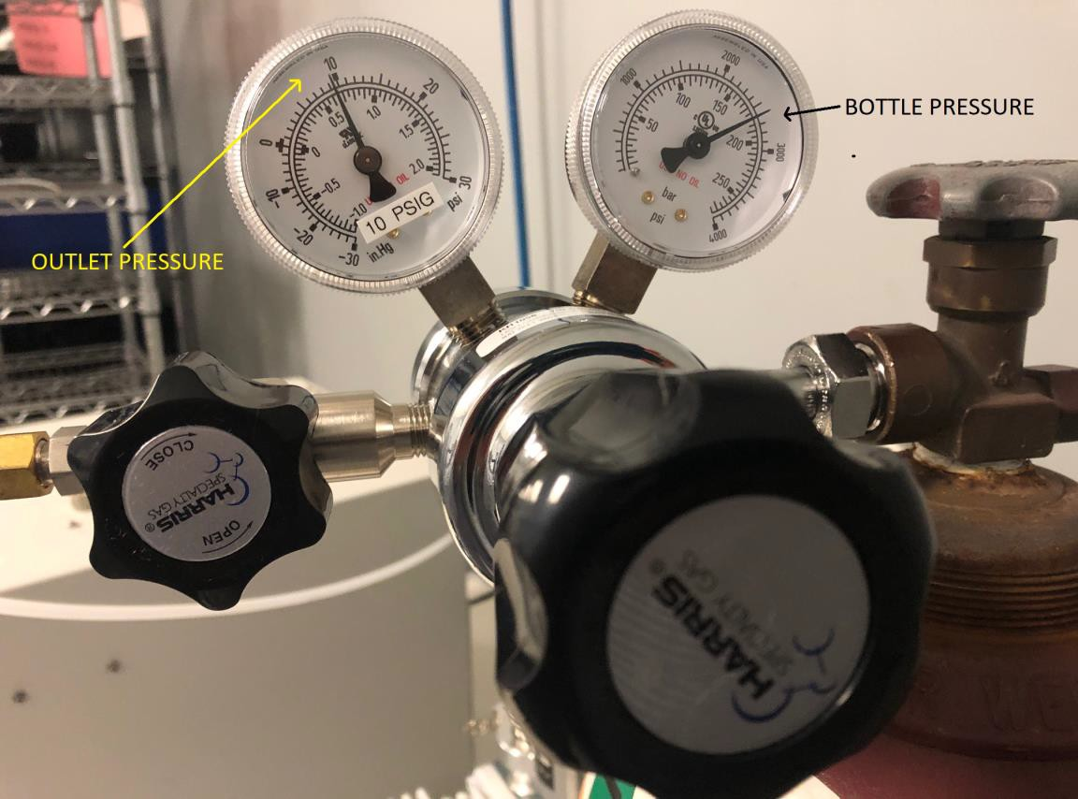

Figure 1: Argon bottle regulator

- Open the door and verify the sample carrier is as far into the chamber as it can go. If the sample carrier is missing and cannot be found, notify engineering. Do not run the system without the sample carrier.

- Power up the etcher by pressing “AC ON”. Rotate the selector to “PRESSURE” (Figure 2). The indicator shows the chamber pressure in Torr.

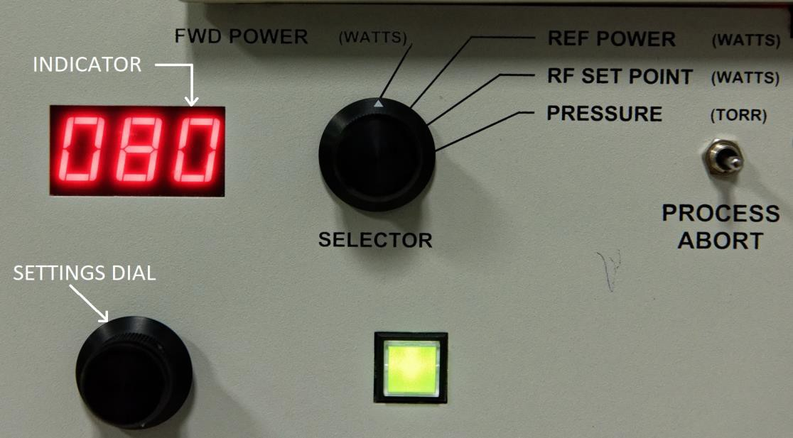

Figure 2: Selector, settings dial, and indicator

- If the button is not already lit, hold the door closed and press “VACUUM”. That button lights, and the door will be pulled shut by the pressure.

- Press “PROCESS START” once the pressure is below 0.50 Torr.

- Rotate the selector to “REF POWER” (Reflected power; see Figure 2).

- The indicator now shows the reflected power in Watts. After 10 seconds, it should be 2.0 or less. If it is greater than
4.0 and remains that way, stop processing and notify engineering.

- Once the plasma is stable, verify the right flowmeter is set to 4.5; adjust if needed (Figure 3). The left flowmeter should not be flowing. Clockwise decreases flow and counterclockwise increases flow. Rotate the selector to “PRESSURE”; it should read 0.29 ± 0.05 Torr.
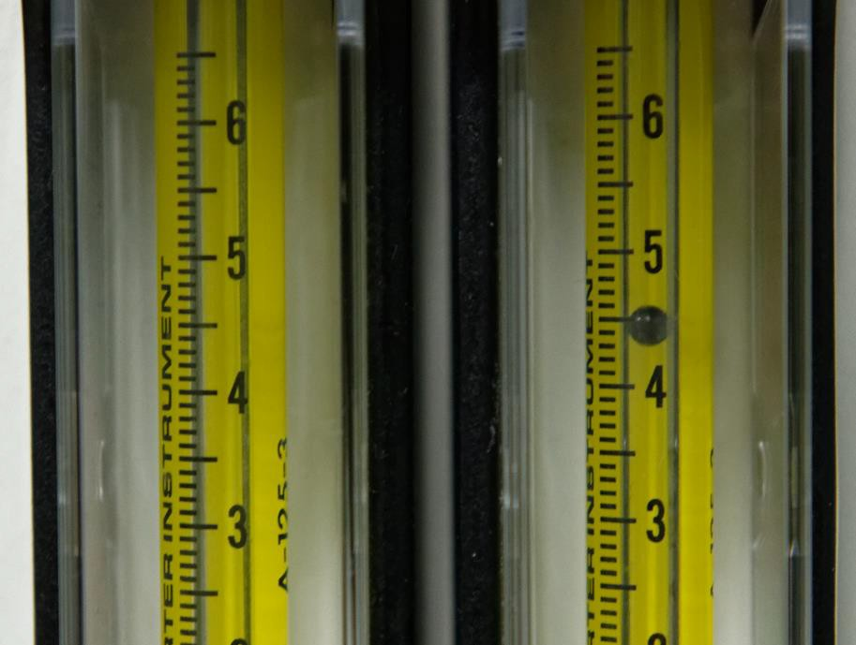

Figure 3: Flowmeters; Argon is on right

- After 20 seconds, the plasma should have a pale violet color. (Figure 4, left). A steady orange-yellow color (Figure 4, right) is caused by an air leak. Notify engineering.
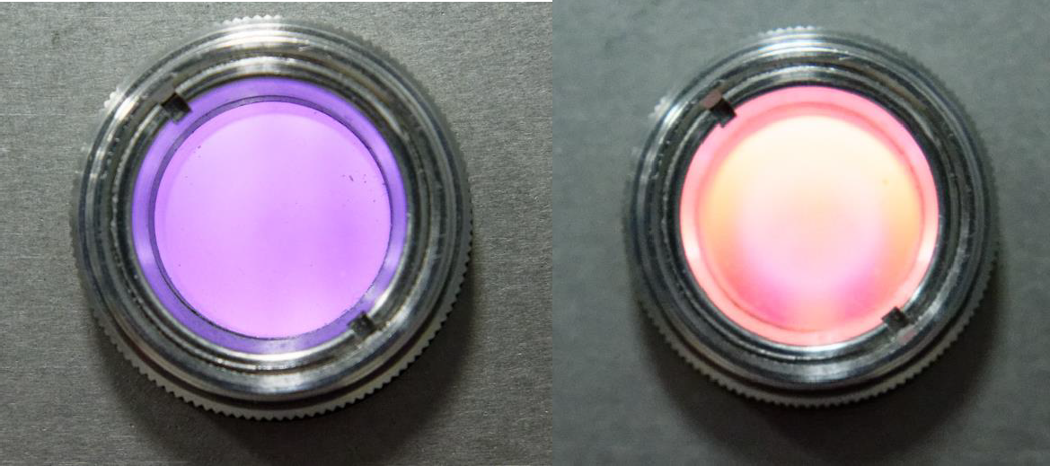

Figure 4: Argon plasma (left); airleak with argon plasma (right)

- Rotate the selector to “RF SET POINT” (Figure 2). The indicator will display the power set point in Watts. If needed, set the RF power to 75 Watts.

- The process will take five minutes to run, starting when the plasma strikes. The timer on the lower left will count down the time (Figure 5, below)
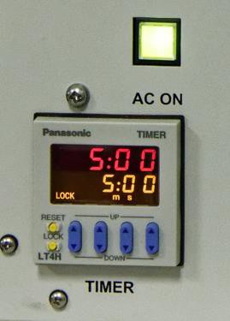
Figure 5: Process timer

- After the run has finished, update the etcher log. Leave the system as-is (under vacuum). The system is now ready for production.

DAILY OPERATIONAL PREFLIGHT/SETUP

- If the etcher is powered off, follow the DAILY OPERATIONAL PREFLIGHT/SETUP (Page 2) then return to Step 2, below.

- Open the plasma chamber by pressing the lit VACUUM button. Wait for the chamber to vent (approximately 45 seconds), then load product/fixtures onto the part shelf (Figure 6).
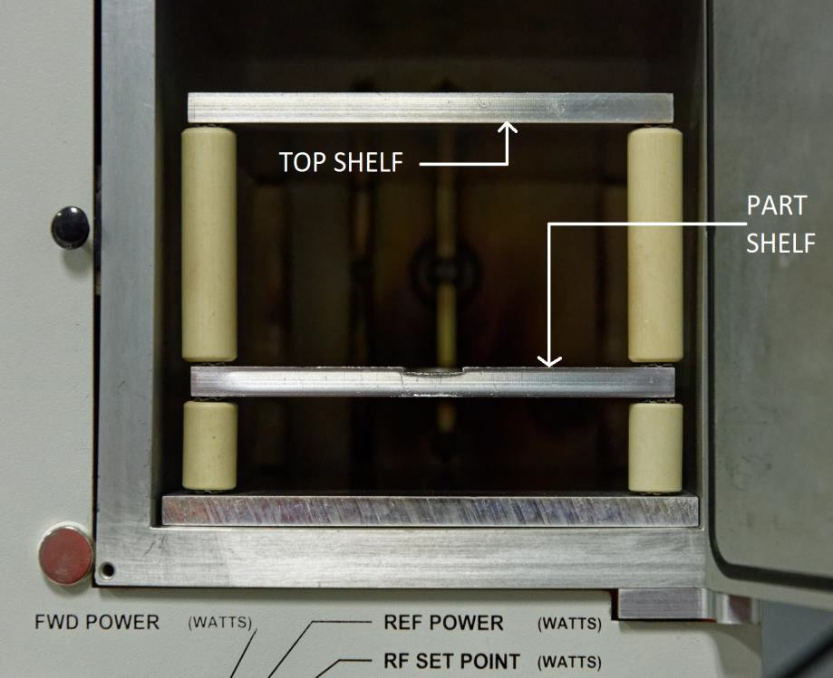

Figure 6: Sample holder and shelves

- Take care to ensure no fixtures/parts are touching each other, the chamber walls, or the shelf supports.

- Rotate the selector to “RF SETPOINT” (Figure 2). The power setting is displayed; adjust to 75W using the settings dial.

- Rotate the selector to “PRESSURE” (Figure 2). The indicator will display chamber pressure in Torr.

- Hold the door closed and press “VACUUM”. That button will light, and the door will be sealed against the chamber.

- Press “PROCESS START” after the pressure reads 0.50 Torr or less.

- Rotate the selector to “REF POWER” (Reflected power; see Figure 2).

- The reflected power should be 2.00 Watts or less.

- The process runs for 5 minutes once the plasma strikes. The process timer on the lower left will count this down.

- After 20 seconds, the plasma should be a pale violet color (Figure 4).

- Press the lit “VACUUM” button once the process is finished to vent the chamber. Once the chamber is vented (approximately 45 seconds), the door can be opened.

- After cleaning, the interior of the chamber, parts/fixtures, and shelves will be hot. After a single run, the part shelf is typically 40-45°C, and the top shelf is 60-65°C. This will increase with repeated runs. Wear thermal gloves and be careful while removing product.

- After the product is removed, close the chamber door.

- Hold the door closed and press “VACUUM”. That button will light, and the door will be sealed against the chamber.

- This has idled the system. Leave it in this condition (under vacuum) during business hours.

EQUIPMENT SAFETY

- See Figure 7 for the safety labels on the system. These illustrate the potential hazards while the system is in operation

- There are five safety interlocks that will prevent RF energy from being delivered into the chamber unless it is safe to do so.

- Both the chamber, sample holder, and product are hot after processing. Wear thermal gloves when removing anything from a hot chamber.

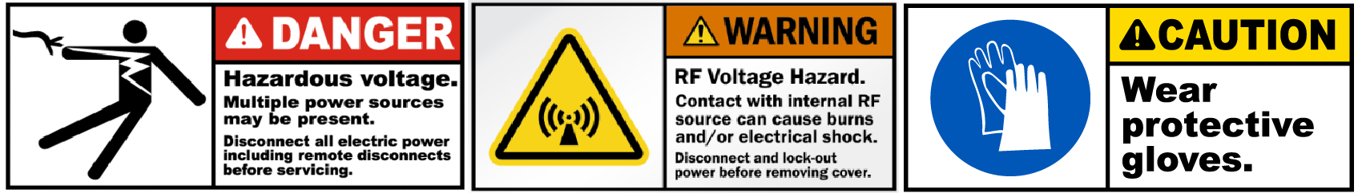

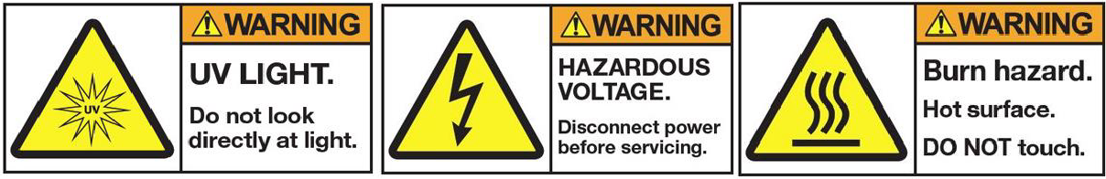
Figure 7: Plasma etcher hazards

