WEEKLY MAINTENANCE

- Unplug the etcher.

- Clean the door gasket and the chamber flange with an IPA-soaked cleanroom wipe.

- Remove the sample carrier, clean the chamber walls and electrodes with an IPA-soaked cleanroom wipe.

- Clean the sample carrier with an IPA-soaked cleanroom wipe.

- Reinstall the sample carrier, power up the system, and run the plasma for twenty minutes to remove residual alcohol and water vapor. See TA1294 for etcher operating instructions.

- View the plasma and check for arcing. The most likely place to see arcing is somewhere along the plasma fringes (Figure 1, below). Arcing will show as a flickering bright arc, like lightning. Should arcing be observed, clean the sample holder as described in the quarterly maintenance, line 3.
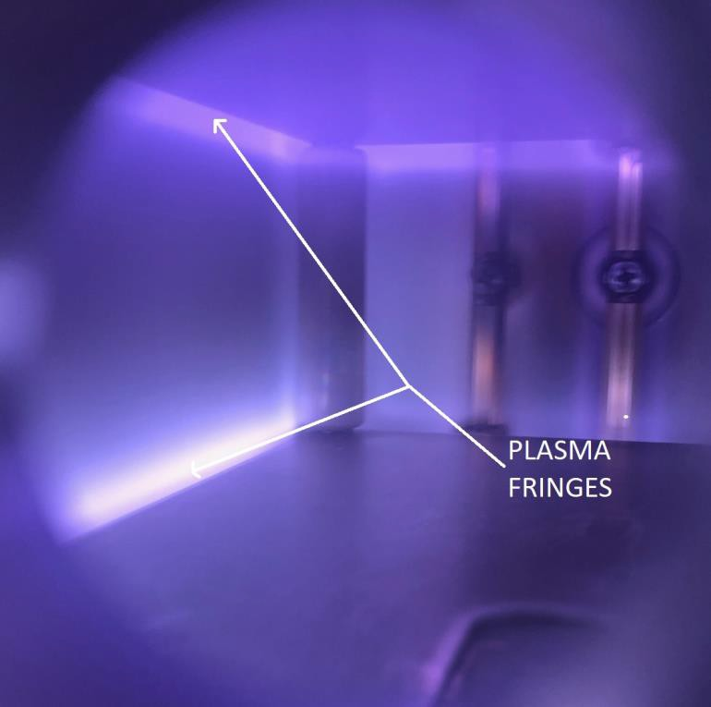
Figure 1: Plasma fringes

- Check the bottle pressure (Figure 2) on the argon regulator- when it falls below 250 PSIG, replace the bottle as soon as possible.
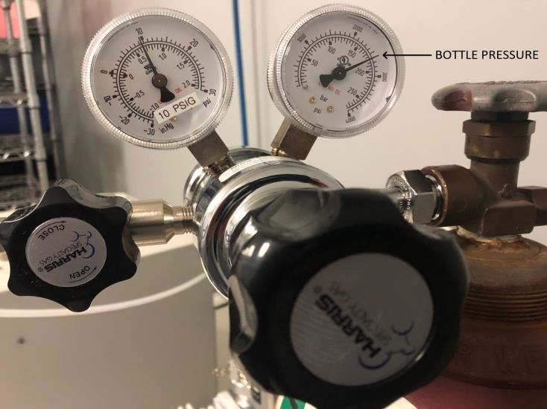

Figure 2: Argon bottle pressure

- Unplug the pump, then check the sight glass on the now-warm vacuum pump. Do not check oil level while the pump is cold, or when it is running. This is a C2-series pump. If the oil is low (Figure 3), top the oil off.
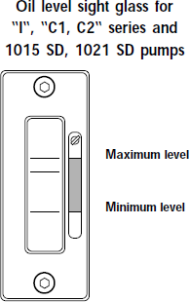

Figure 3: Pump oil sightglass
- If the oil has visible contamination, change the oil. If the oil has a cloudy or milky appearance, there is water condensate in the pump.

  - Manual control of gas ballast is disabled in C2 series pumps.
  - See page 26, “Adixen SDPump Service Manual” for information on installing a gas ballast line.

QUARTERLY MAINTENANCE
- Verify safety interlocks are functional.
- Check for vacuum leaks, by running a leak rate test:
  - Press “VACUUM” and wait until the system reaches base pressure, approximately 0.02 (20 mTorr) or lower.
  - Unplug the vacuum pump and record the chamber pressure every ten seconds, for a total of two minutes. Plot the data.
  - The chart in Figure 4 (below) shows pressure vs. time. Note how the pressure starts to roll off after 20-40 seconds. If this rate increases in a linear manner (red dashed line), there is a vacuum leak.
Leakrate Test- 10 JAN 20
0.42

0.37

0.32

0.27

0.22

0.17

0.12

0.07

0.02
0
20
40
60
Elapsed Time (sec)
80
100
120
Pressure (Torr)

Typical Leaky Chamber

Actual Measured Pressure

Figure 4: Leakrate test, 10 JAN 20

- Clean the sample holder contact clips
  - Turn off and unplug the etcher. Loosen the cap screws with a 3/32” hex key until the assembly is removed from the sample holder. (Figure 5, below)
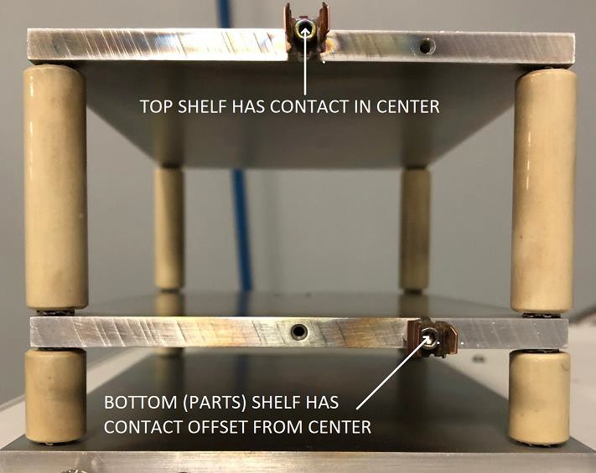
Figure 5: Sample holder contact clips
  - Back out the coupling nuts so the star washers and contact flanges are completely exposed. (Figure 6)

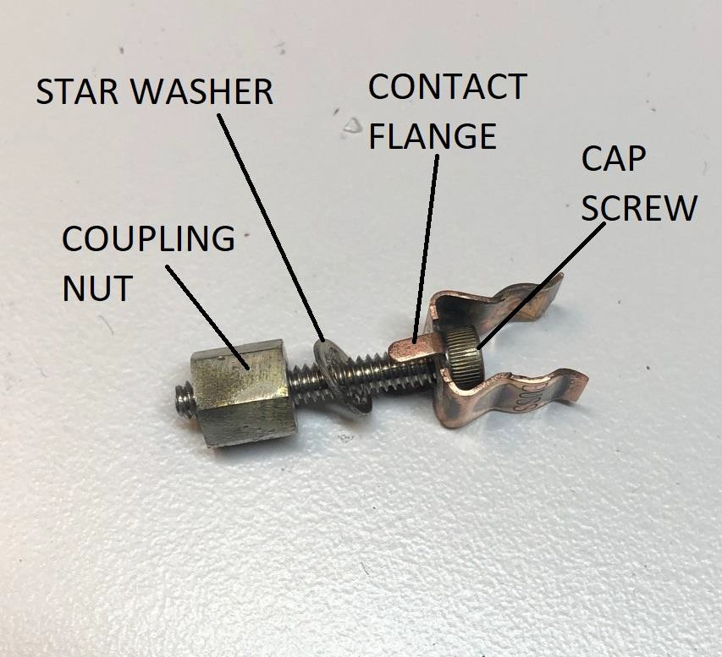

Figure 6: Contact clips, expanded

  - Sonicate the clips using fresh Lenium at 55°C for 60 minutes. While you’re doing that, scrub the edges of the sample holder shelves with scotch-brite. Wipe away all debris with an IPA-soaked cleanroom wipe.
  - Reinstall the clips into the same locations. The clips must be vertical (parallel to the chamber electrodes). Do not overtighten.
  - Reinstall the sample holder into the etcher. Run the plasma for 20 minutes, and verify there is no longer any sign of arcing (See Weekly Maintenance, line 6).

ANNUAL MAINTENANCE
- Change pump oil; use Inland Vacuum GemineYe 25 PFPE pump oil or equivalent (only!). Send out the used oil for reclaim.
  - Use a spill tray or similar to catch any spilled oil.
  - Wear PPE during pump servicing.
- Should the pump require service, the oil must be drained before shipping. Send out the used oil for reclaim.
- Replace door O-rings.

REPLACING THE ARGON BOTTLE
- Turn off and unplug the etcher.
- Close the bottle by turning the stem valve fully clockwise (Figure 7).
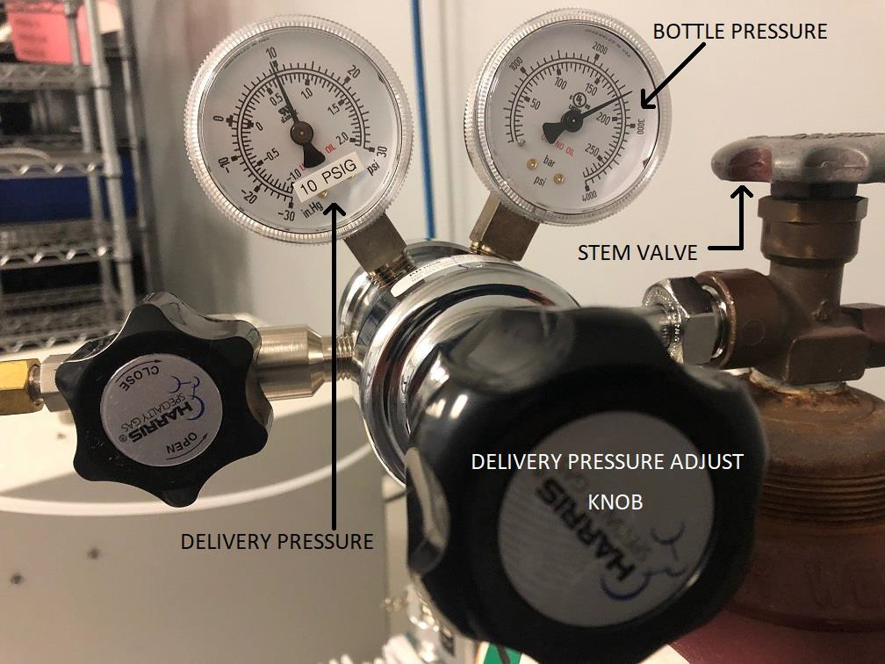

Figure 7: Argon bottle regulator

- Remove the regulator from the bottle using an open-ended wrench.
- Following TA1283, replace the empty argon bottle with a full bottle.
- Install the regulator on the full bottle.
- Cautiously open the new bottle by turning the valve counterclockwise. Listen for leaks; if you hear (or see!) any, close the bottle and reinstall the regulator.
- Adjust the delivery pressure (large black knob) to a flow of 10 ± 2 PSIG.
- Power up the etcher. Press “VACUUM” and wait until the system reaches base pressure, approximately 0.02 (20 mTorr) or lower.
- Press “PROCESS START”, and turn the selector knob to PRESSURE.
- Adjust the flowmeter to 4.5 (Figure 8, below)
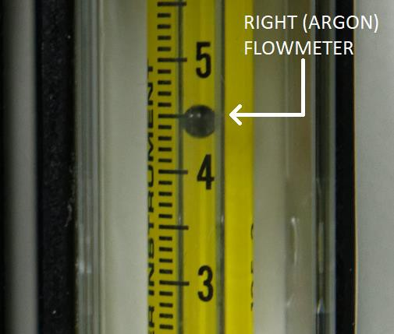

Figure 8: Argon flowmeter
- Adjust the delivery pressure so that the chamber pressure reads 0.29 ± 0.03 (290 ± 30 mTorr)
- Readjust the flowmeter to 4.5 if necessary.

NOTE: This is a two-stage regulator, which delivers a constant pressure as the bottle pressure decreases. Do not use a single-stage regulator with this system.

PROCESSING NOTES
- The purpose of the argon plasma clean is to remove wafer processing residues and contamination, including carbon, fluorine, and other inorganic ions. The plasma-cleaned surface has a much higher surface energy, with better uniformity, than other cleans such as wet solvents, hydrogen flame, or high temperature/inert atmosphere.

- This process removes monolayers of contamination, resulting in an ‘atomically clean’ surface. This system is incapable of removing contaminates thicker than 1-2 thousandths of a millimeter.

- While plasma etching effectively cleans plastics and fluoropolymers, long-term exposure to the plasma’s UV energy will eventually crack/craze these materials. Do not use plastic or fluoropolymers on fixtures, or as replacement parts for the sample carrier.

- The only way to verify the process directly is to measure the surface energy (Ɣ) of a cleaned part. Generally speaking, the higher the surface energy, the cleaner the surface. The process transferred in TA1295 consistently provides a post-clean Ɣ ≥ 70 dynes/cm, after contaminating the surface with a thin coating of spindle oil (Ɣ ≤ 30 dynes/cm). The discussion of the testing methodology is beyond the scope of this document. Consult PCB R&D should questions arise.

- This system is set up so that the product/fixtures are cleaned on the electrically grounded shelf. This provides a less energetic clean than the powered shelf, with less exposure to heat. This should not have an effect on crystal polling. At the time the process in TA1294 was developed, there was no way to verify whether the cleaning would have an effect on crystal polling.

- Within the domain of plasma physics, this argon-based plasma clean works by ion bombardment or ‘sputter etch’. A reactive gas such as an oxygen plasma would be called a ‘reactive ion etch’ or ‘RIE’.

- Should the etch chemistry need to change, the vacuum pump used on this etcher is already rated for oxygen/corrosive service. Those pumps use a perfluoropolyether (PFPE) pump fluid, and can pump reactive/corrosive gases such as oxygen. This oil is expensive, and used oil should be sent out for reclaim. This is much less expensive than new PFPE fluid.

- PFPE pump oil is not compatible with any hydrocarbon-based pump oils. Do not use hydrocarbon-based oils with the 2021 C2 pump.

EQUIPMENT SAFETY
- ALWAYS turn off and unplug the etcher before working on it.
- Figure 9 shows the hazard labels for the etcher.

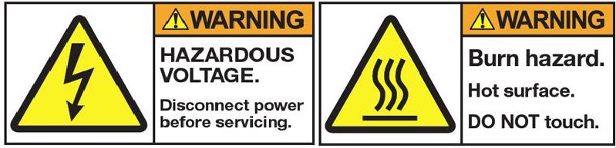



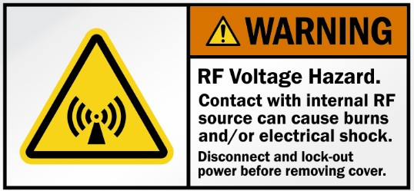
Figure 9, Plasma etcher hazard labels

- The chamber, product, and sample holder become hot after processing. Wear thermal gloves when removing anything from a hot chamber.
- There are two electrical hazards; 110VAC @ 10A, and RF @ 150W.
- There are five safety interlocks that will prevent the distribution of electrical energy.
  - Four are mechanical switches; they sense the door closure and system cover panels.
  - The fifth is a valve switch that allows RF power once the chamber pressure is below 0.50.
- There is a 10A breaker on the rear of the etcher, located directly above the power plug. Cycle this breaker to reset the system.
- Wear appropriate PPE when servicing the vacuum pump. PFPE oil is inert, slippery, and extremely difficult to wash away after contact.

