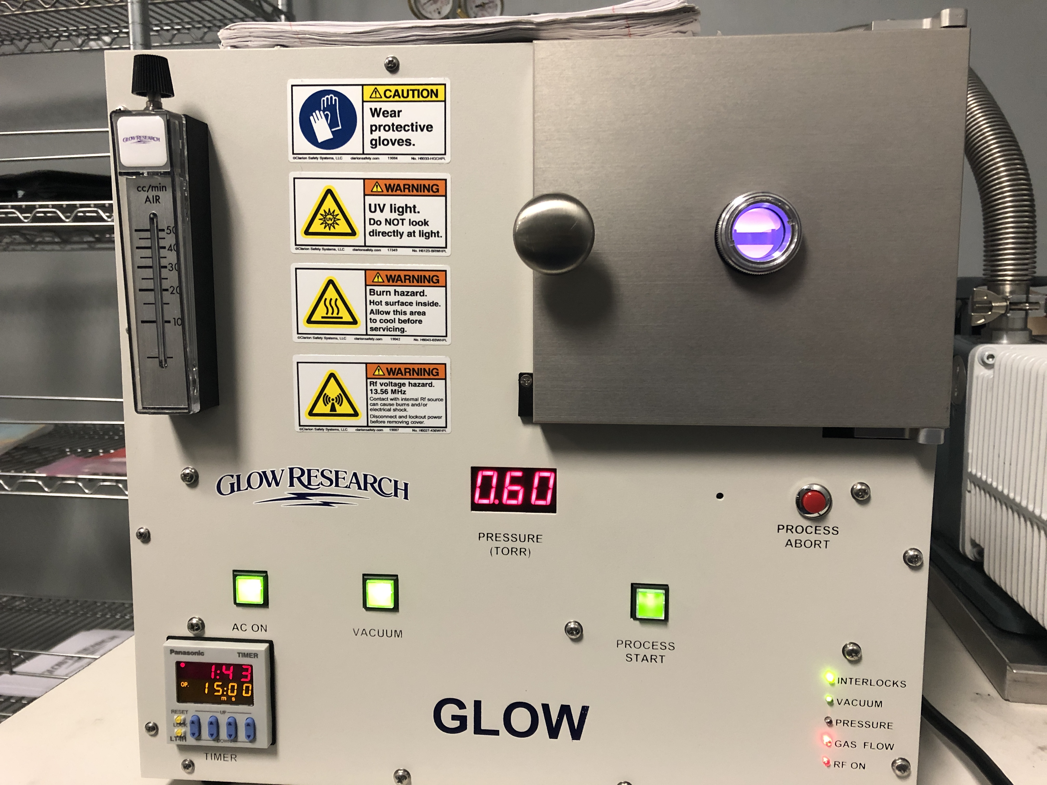

|  |  |  |  |  |  |  |
| --- | --- | --- | --- | --- | --- | --- |
| **Process Summary** | | | | | | |
| **Step** | **Ar Flow (sccm)** | **Vacuum** | **Process Start** | **End Pressure (Torr)** | **Time (M:SS)** | **Vent** |
| Load/Unload | 0 | Off | Off | Atmosphere (760) | NA | Off |
| Vacuum on (pumpdown) | 0 | On | Enabled | ≤ 0.30 | 0:25 | Off |
| Process Start | 50+ | On | Yes | 0.55- 0.65 | NA | Off |
| Etch 10:00 | 50+ | On | On | 0.55- 0.65 | 10:00 | Off |
| Process End | 0 | On | Off | ≤ 0.55-0.65 | NA | Off |
| Vacuum Off | 0 | Off | Off | ≤ 0.55-0.65 | NA | On |
| Backfill (vent) | 0 | Off | Off | ≥ 1.90 | 0:45 | On |
| Idle | 0 | On | Off | ≤ 0.30 | NA | Off |

# DAILY OPERATIONAL PREFLIGHT/SETUP

1. If necessary, plug in the vacuum pump and/or the etcher. If the argon bottle is closed, open by turning the stem valve counterclockwise. Ensure the supply pressure is 10 ± 0.5 PSIG (Figure 1). Notify engineering if the bottle pressure is below 500 PSIG.

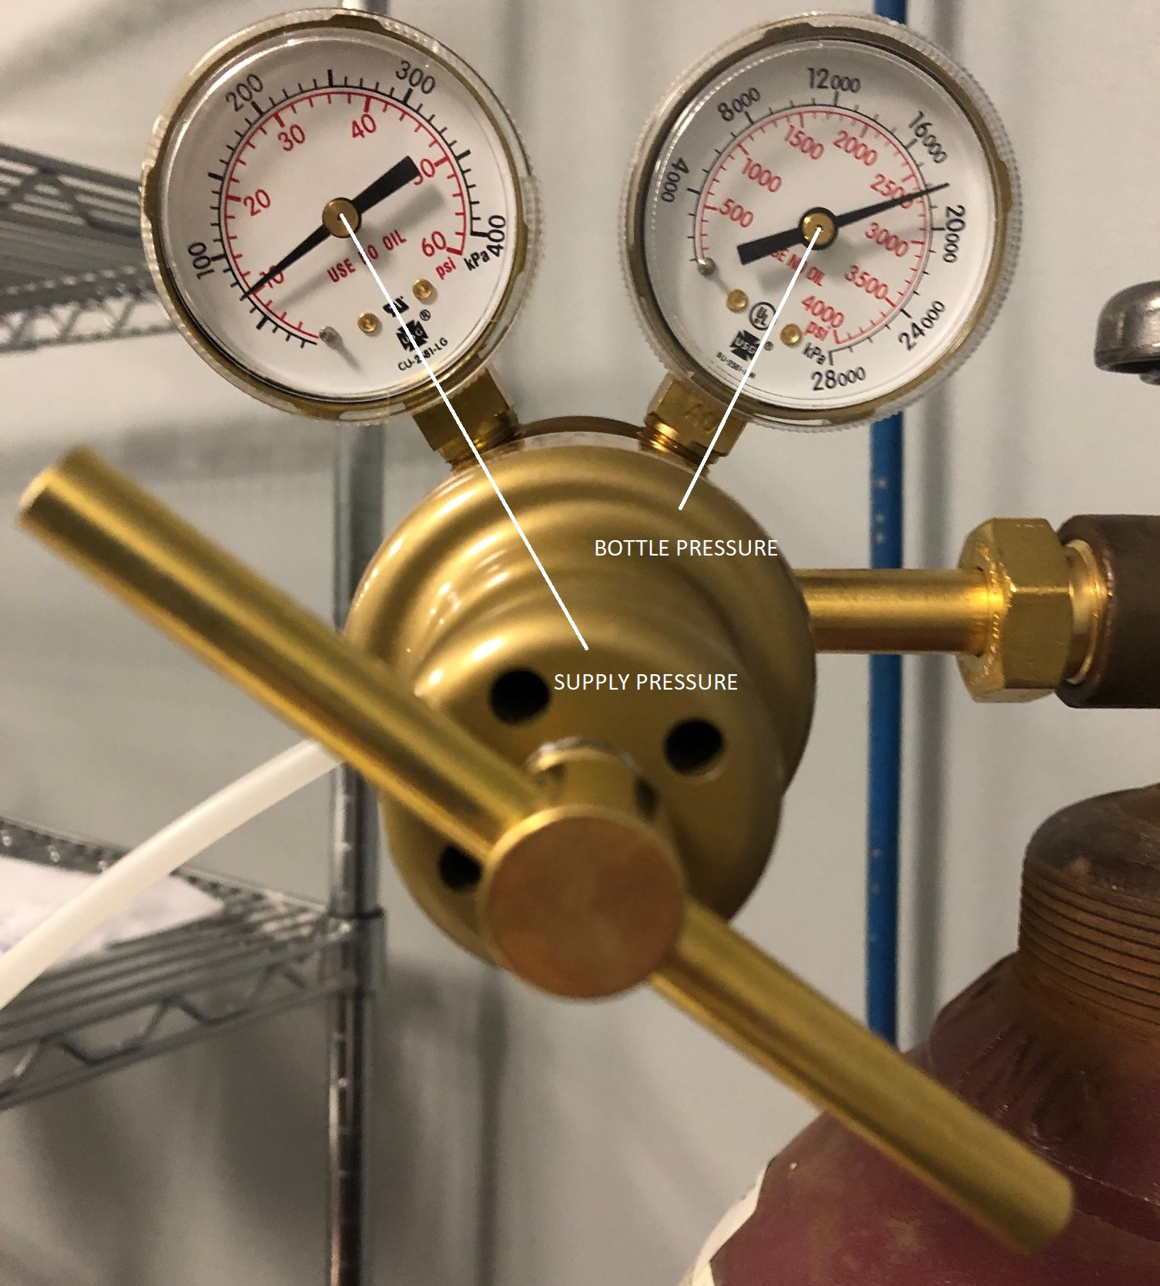

# Figure 1: Argon bottle regulator

1. Open the door and verify the sample carrier is as far into the chamber as it can go. If the sample carrier is missing and cannot be found, notify engineering. Do not run the system without the sample carrier.
2. Power up the etcher by pressing “AC ON”.
3. If the button is not already lit, hold the door closed and press “VACUUM”. That button lights, and the door will be pulled shut by the vacuum.
4. Press “PROCESS START” once the pressure is at or below 0.30 Torr.
5. Once the plasma is stable, verify the flowmeter ball is at the top; adjust if needed (Figure 2). The flowmeter is extremely sensitive- small changes in the dial make big changes in the pressure. Check the pressure; it should read 0.55-0.65 Torr. Adjust the flowmeter if necessary.

# Figure 2: Flowmeter

1. After 20 seconds, the plasma should have a pale violet color. (Figure 3, left). A steady orange-yellow color (Figure 3, right) is caused by an air leak. Notify engineering.

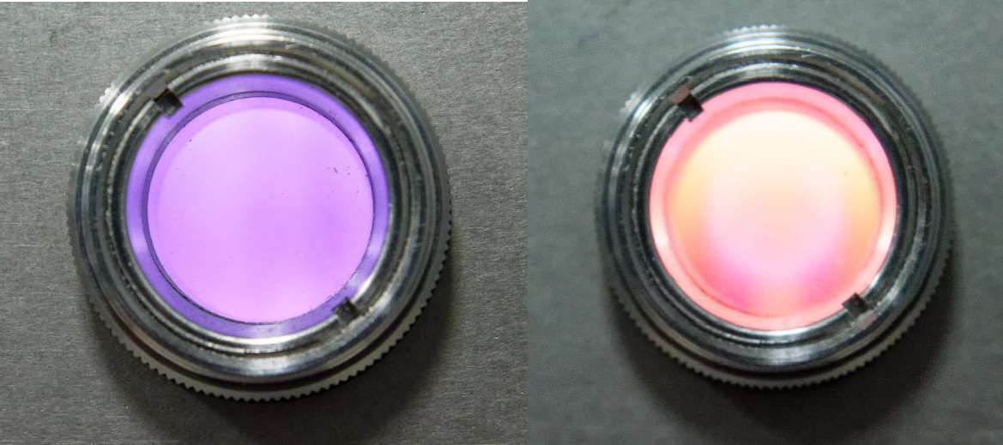

# Figure 3: Argon plasma (left); air leak in argon plasma (right)

1. The process will take ten minutes to run, starting when the plasma strikes.
2. The timer on the lower left will count down the time (Figure 4, below). The elapsed time is red.

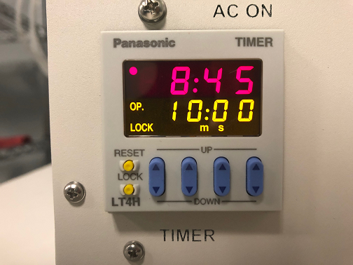

# Figure 4: Process timer

1. After the run has finished, update the etcher log. Leave the system as-is (under vacuum). The system is now ready for production.  
     
   **CLEANING PRODUCT**
2. If the etcher is powered off, follow the DAILY OPERATIONAL PREFLIGHT/SETUP (Page 2) then return to Step 2, below.
3. Open the plasma chamber by pressing the lit VACUUM button. Wait for the chamber to vent (approximately 45 seconds), then load product/fixtures onto the bottom (part) shelf (Figure 5).

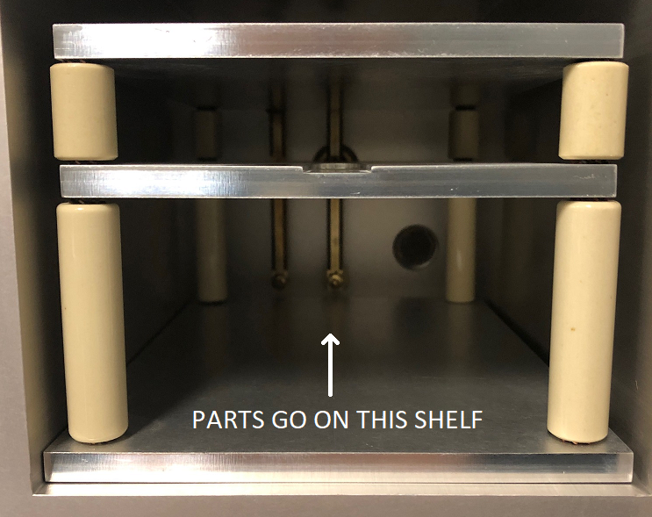

# Figure 5: Sample holder and shelves

1. Take care to ensure no fixtures/parts are touching each other, the chamber walls, or the shelf supports.
2. Hold the door closed and press “VACUUM”. That button will light, and the door will seal itself against the chamber.
3. It takes about 25 seconds to reach a pressure of 0.30 Torr or less. Press “PROCESS START” once it’s below that pressure.
4. The process runs for 10 minutes once the plasma strikes. The process timer on the lower left will count this down.
5. Press the lit “VACUUM” button once the process is finished to vent the chamber. Once the chamber is vented (approximately 45 seconds), the door can be opened.
6. After cleaning, the interior of the chamber, parts/fixtures, and shelves will be hot. After a single run, the part shelf is typically 40-45°C, and the top shelf is 60-65°C. This will increase with repeated runs. Wear thermal gloves and be careful while removing product.
7. After the product is removed, close the chamber door.
8. Hold the door closed and press “VACUUM”. That button will light, and the door will seal against the chamber.
9. This has idled the system. Leave it in this condition (under vacuum) during business hours.

# EQUIPMENT SAFETY

1. See Figure 6 for the safety labels on the system. These document the potential hazards while the system is in operation
2. There are five interlocks that block RF energy from being delivered into the chamber, unless it is safe to do so.
3. Both the chamber, sample holder, and product are hot after processing. Wear thermal gloves when removing anything from a hot chamber.

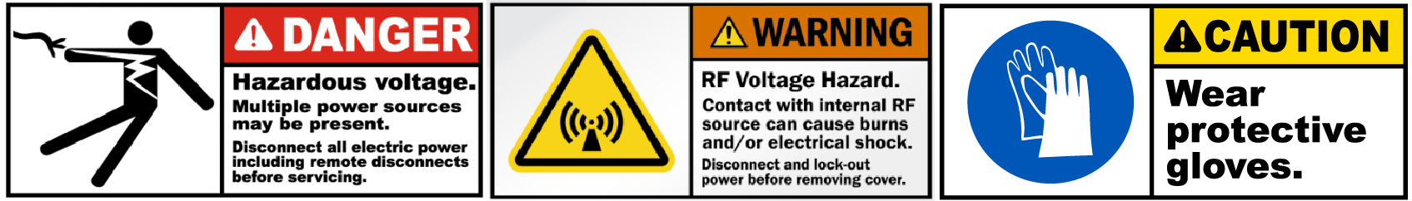

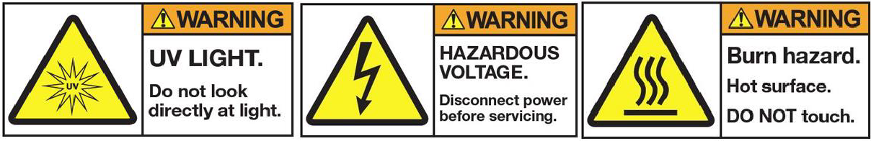

# Figure 6: Plasma etcher hazards