# WEEKLY MAINTENANCE

1. Unplug the etcher.
2. Clean the door gasket and the chamber flange with an IPA-soaked cleanroom wipe.
3. Remove the sample carrier, clean the chamber walls and electrodes with an IPA-soaked cleanroom wipe.
4. Clean the sample carrier with an IPA-soaked cleanroom wipe.
5. Reinstall the sample carrier, power up the system, and run the plasma for twenty minutes to remove residual alcohol and water vapor. See TA1297 for etcher operating instructions.
6. After ten minutes have passed, view the plasma and check for arcing. The most likely place to see arcing is somewhere along the plasma fringes (Figure 1, below). Arcing will show as a flickering bright arc, like lightning. Should arcing be observed, clean the sample holder as described in the quarterly maintenance, line 3.

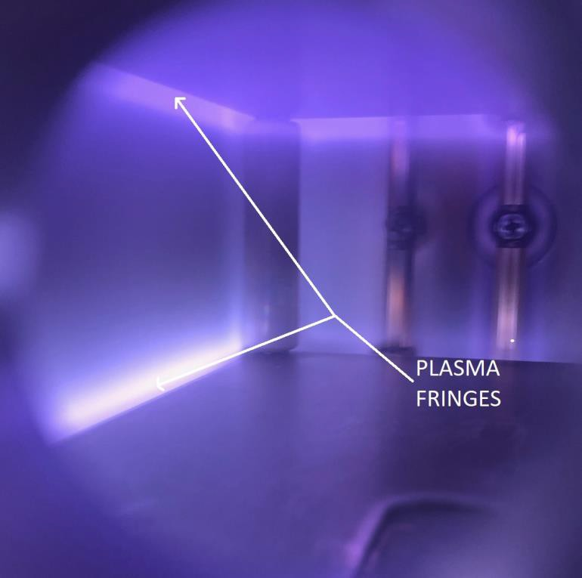

# Figure 1: Plasma fringes

1. Check the bottle pressure (Figure 2) on the argon regulator- when it falls below 500 PSIG, replace the bottle as soon as possible.

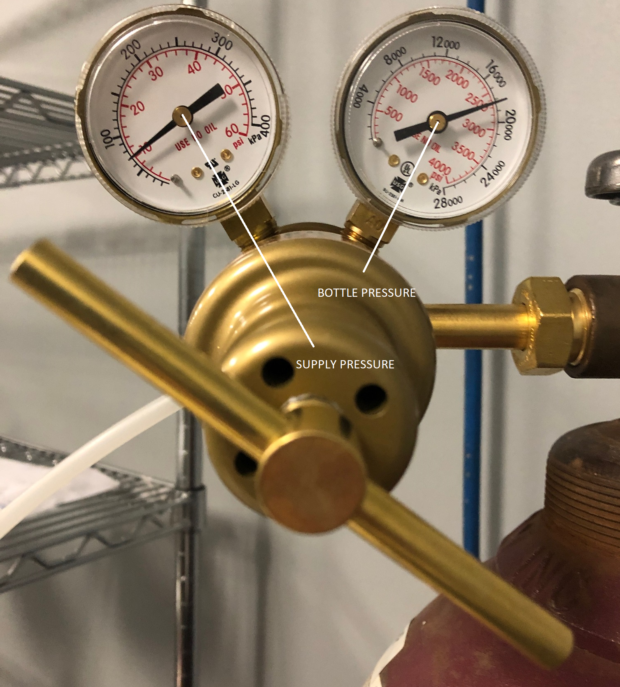

# Figure 2: Argon bottle pressure

1. Unplug the pump, then check the sight glass on the now-warm vacuum pump. Do not check oil level while the pump is cold, or when it is running. If the oil is low (Figure 3), top the oil off.

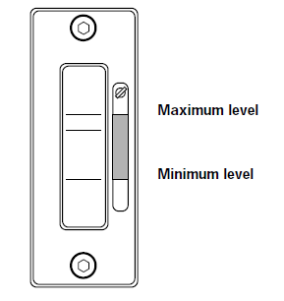  
**Figure 3: Pump oil sightglass**

1. If the oil has visible contamination, let the pump cool, then change the oil. If the oil has a cloudy or milky appearance, there is water condensed in the pump. The ballast valve should be opened to “cook out” the water during pump operation. Air is an acceptable ballast, but after the pump has warmed up to operating temperature, the ballast valve should be closed. The sound of the pump will change noticeably when the ballast valve is open.

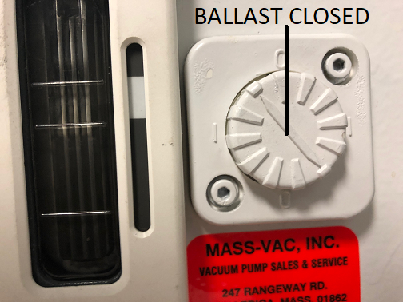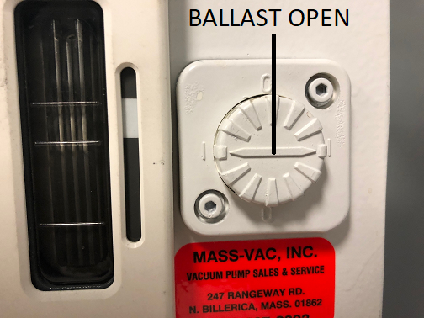  
**Figure 4: Ballast valve positions**

# QUARTERLY MAINTENANCE

1. Verify safety interlocks are functional.
2. Check for vacuum leaks, by running a leak rate test:
   1. Press “VACUUM” and time until the system reaches base pressure, approximately 0.04 (40 mTorr) or lower. If this takes too long, run a clean first to remove adsorbed water vapor. Make certain the ballast valve on the pump is closed (see Fig. 4) once it’s at base pressure.
   2. Unplug the vacuum pump and record the chamber pressure every 15 seconds, for a total of four minutes. Plot the data.
   3. The chart in Figure 4 (below) shows pressure vs. time. Note how the pressure starts to level off after 60-80 seconds. If this rate increases in a linear manner (red dashed line), there is a vacuum leak.

# Figure 4: Leakrate test, 23 MAR 20

1. Clean the sample holder contact clips
   1. Turn off and unplug the etcher. Loosen the cap screws with a 3/32” hex key until the assembly is removed from the sample holder. (Figure 5, below)

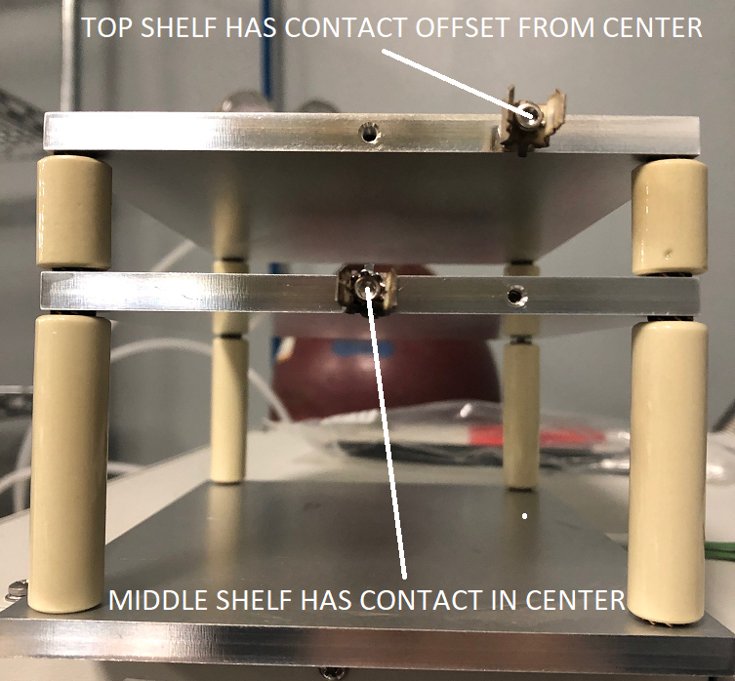

# Figure 5: Sample holder contact clips

* 1. Back out the coupling nuts so the star washers and contact flanges are completely exposed. (Figure 6)

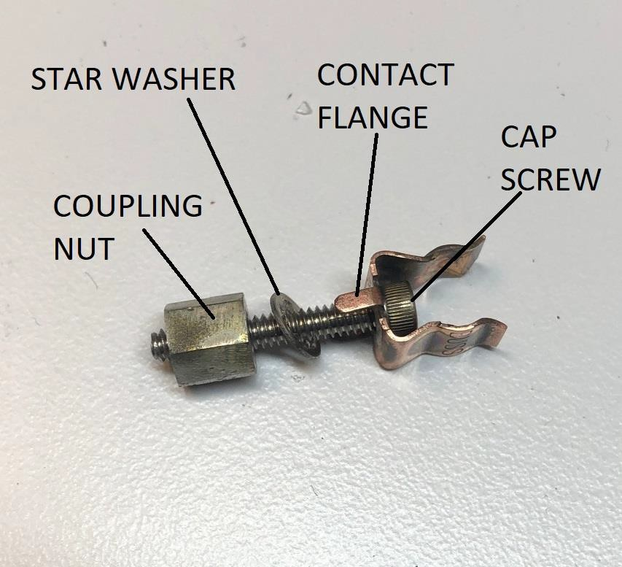

# Figure 6: Contact clips, expanded

* 1. Sonicate the clips using fresh Lenium at 55°C for 60 minutes. While you’re doing that, scrub the edges of the sample holder shelves with scotch-brite. Wipe away all scrub-debris with an IPA-soaked cleanroom wipe.
  2. Reinstall the clips into the same locations. The clips must be vertical (parallel to the chamber electrodes). Do not overtighten.
  3. Reinstall the sample holder into the etcher. Run the plasma for 20 minutes, and verify there is no longer any sign of arcing (See Weekly Maintenance, line 6).

# ANNUAL MAINTENANCE

1. Change pump oil; use Inland Vacuum GemineYe 25 PFPE pump oil or equivalent (only!). Send out the used oil for reclaim.
   1. Use a spill tray or similar to catch any spilled oil.
   2. Wear PPE during pump servicing.
2. Should the pump require service, the oil must be drained before shipping. Send out the used oil for reclaim.
3. Replace door O-ring.

# REPLACING THE ARGON BOTTLE

NOTE: This is a two-stage regulator, which delivers a constant pressure as the bottle pressure decreases. Do not use a single-stage regulator with this system.

1. Turn off and unplug the etcher.
2. Close the bottle by turning the stem (bottle) valve fully clockwise.
3. Remove the regulator from the bottle using an open-ended wrench.
4. Following TA1283, replace the empty argon bottle with a full bottle.
5. Install the regulator on the full bottle.
6. Cautiously open the new bottle by turning the stem (bottle) valve counterclockwise. Listen for leaks; if you hear (or see!) any, close the bottle and reinstall the regulator.
7. If necessary, adjust the delivery pressure (t-handle on regulator) to a flow of 10 ± 2 PSIG.
8. Power up the etcher. Press “VACUUM” and wait until the system reaches base pressure, approximately 0.04 (40 mTorr) or lower.
9. Press “PROCESS START” and observe the chamber PRESSURE once the plasma has run for 30 seconds.
10. Adjust the delivery pressure so that the chamber pressure reads 0.60 ± 0.02 (600 ± 20 mTorr)
11. Readjust the flowmeter if necessary.

# PROCESSING NOTES

1. The purpose of the argon plasma clean is to remove wafer processing residues and contamination, including carbon, fluorine, and other inorganic ions. The plasma-cleaned surface has a much higher surface energy, with better uniformity, than other cleans such as wet solvents, hydrogen flame, or high temperature/inert atmosphere.
2. This process removes monolayers of contamination, resulting in an ‘atomically clean’ surface. This system is incapable of removing contamination thicker than 1-2 thousandths of a millimeter.
3. While plasma etching effectively cleans plastics and fluoropolymers, long-term exposure to the plasma’s UV energy will eventually crack/craze these materials. Do not use plastic or fluoropolymers with fixtures, or as replacement parts for the sample carrier.
4. The only way to verify the process directly is to measure the surface energy (Ɣ) of a cleaned part. Generally speaking, the higher the surface energy, the cleaner the surface. The process in TA1297 consistently provides a post-clean Ɣ ≥ 70 dynes/cm, after contaminating the surface with a thin coating of spindle oil (Ɣ ≤ 30 dynes/cm). The discussion of the testing methodology is beyond the scope of this document. Consult PCB R&D should questions arise.
5. This system is set up so that the product/fixtures are cleaned on the bottom shelf. This provides a less energetic clean than the powered shelf, with less exposure to heat. This should not have an effect on crystal polling, but could not be verified during process development.
6. Within the domain of plasma physics, this argon-based plasma clean works by ion bombardment or ‘sputter etch’. A reactive gas such as an oxygen plasma would be called a ‘reactive ion etch’ or ‘RIE’.
7. Should the etch chemistry need to change, the vacuum pump used on this etcher is rated for oxygen/corrosive service. Those pumps use a perfluoropolyether (PFPE) pump fluid, and can pump reactive/corrosive gases such as oxygen. This oil is expensive, and used oil should be sent out for reclaim. This is much less expensive than new PFPE fluid.
8. PFPE pump oil is not compatible with any hydrocarbon-based pump oils. Do not use hydrocarbon-based oils with the vacuum pump.

# EQUIPMENT SAFETY

1. ALWAYS turn off and unplug the etcher before working on it.
2. Figure 9 shows the hazard labels for the etcher.

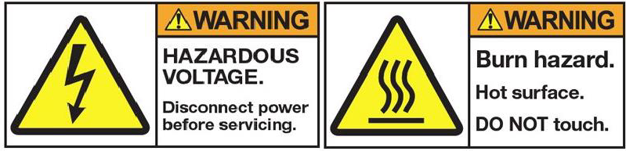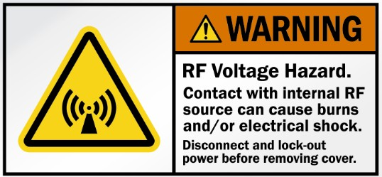

# Figure 9, Plasma etcher hazard labels

1. The chamber, product, and sample holder become hot after processing. Wear thermal gloves when removing anything from a hot chamber.
2. There are two electrical hazards; 110VAC @ 10A, and RF @ 50W.
3. There are five safety interlocks that will prevent the distribution of electrical energy.
   1. Four are mechanical switches; they sense the door closure and system cover panels.
   2. The fifth is a valve switch that allows RF power once the chamber pressure is below 0.50.
4. There is a 10A breaker on the rear of the etcher, located directly above the power plug. Cycle this breaker to reset the system.
5. Wear appropriate PPE when servicing the vacuum pump. PFPE oil is inert, slippery, and extremely difficult to wash away after contact.