**Contents**

1. Overview 2

1.1. Safety and Precautions 2

1.2. Introduction 3

1.3. Particle Extractor 3

2. Procedure for Etching or Ablating Parts 4

3. Preventative Maintenance 7

4. Appendix A: Laser Ablating Crystal # 58639 8

# 



## Overview

## Safety and Precautions

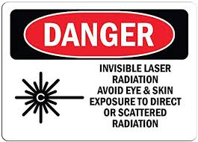

* + 1. The Trumpf Trumark 5000 utilizes a class IV Laser which can be very dangerous when used improperly or carelessly. It is crucially important to avoid any possible eye or skin exposure to either direct or scattered radiation.
    2. It is important to recognize that the most dangerous type of radiation emitted from this equipment is invisible to the human eye. For this reason, it is critical at all times to ensure safe use of the machine.
    3. The Trumpf Trumark 5000 features a protective housing that will not allow the marking laser to run while the automatic door is open.

#### The laser etcher is a Class I workstation that does not allow access to hazardous levels of laser light during operation. Never disable or defeat the door safety switch or remove any of the guarding when the laser is running production.

* + - 1. There is a second ‘Trace’ laser that is used to trace the outline of the etch that can be run when the door is open. This trace laser is not dangerous and is commonly used while the door is open to ensure proper sizing and orientation of etching programs.
      2. Upon starting a program, the door will close and the laser head will move into position to etch. At this time, the laser will begin running. Although the door is closed and the safety glass serves as a safety barrier between the operator and the laser, it is not recommended to ‘stare’ at the laser while it is marking for long periods of time. Periodic glances to ensure proper marking is acceptable. Dangerous radiation (to eyes or skin) is NOT transmitted through the safety glass.

#### Hazardous gasses may be produced from the burning of plastics or metal coatings. In the case of deep etching/light engraving, hazardous metal vapors will be produced. For protection, the etcher is equipped with an automatic ventilation unit that turns on any time a part is being etched

## Introduction

* + 1. This Trumpf TruMark 5000 laser etcher can be used to ablate or laser mark various materials and parts. Ablation is typically used to remove layers of materials in specific and precise geometries for a variety of reasons. Laser marking is typically used to permanently display information and logos on parts. This specific machine is largely automated, which makes the user experience relatively simple and straight-forward. Future appendices will be added to this procedure as machine use is expanded.
    2. Equipment Overview:

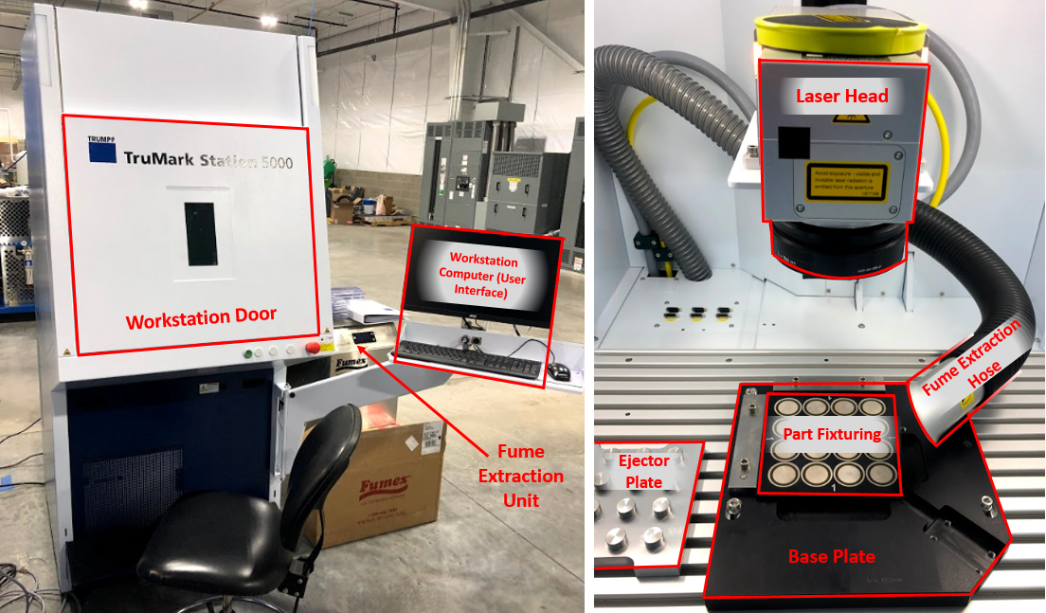

**Figure 1:** Equipment Overview with Essential Parts Labeled

## Particle Extractor

* + 1. The particle extractor located next to the etching machine will be used at all times when crystals are being ablated. During the etching process, the laser will create dust which can build up and obstruct proper etching and also become airborne. This particle extractor has a hose located near the side of the etching field that is designed to remove the particles from the etching field and machine enclosure. This hose and attachment are properly positioned, mounted and move with the laser head. It should never be re-located or removed.
    2. The particle extractor is programmed to automatically power on when the laser is running, and automatically power off when the laser is off for at least 15 seconds. For this reason, user interaction with the particle extractor (power on/off) is not needed.
    3. If the particle extractor begins beeping or flashing on screen, it will need to have the filters replaced. Contact maintenance if this occurs and the filters will be replaced.

## Procedure for Etching or Ablating Parts

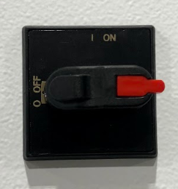

**Step 1:** **Power up Machine**

Power on the etcher by turning the switch located on the right-hand side of the machine to the ‘On’ position. After switching the machine on, a series of pre-programmed startup processes will occur. This is fully automatic and takes approximately 1 minute:

* The machine will power on and the interior lights will turn on.
* The computer will automatically power on.
* TruTops Mark Program (the user interface) will open automatically on the computer screen.
* After TruTops Mark is open, the workstation door will automatically open.

**Figure 2:** Machine On/Off

There is no warm-up time required for this machine. After the machine goes through the startup procedure above, it is ready to run parts.

**Step 2: Load Parts to be Etched in Fixture or Corner**

**\*IMPORTANT\*** Wear gloves at all times when loading and unloading or otherwise handling any parts.

Depending on the type of parts being etched or ablated, load the parts into the machine appropriately. Refer to part specific appendices for more detail regarding unique fixturing methods.

**Step 3:** **Scan Program of Part Being Etched or Ablated**

After scanning, ensure that the correct part number is in the “Marking File” field of TruTops.

**Step 4: Etch Parts using TruTops Software**

TruTops is the user interface which will be used to control the machine throughout the entirety of the etching process. The program opens automatically as part of machine start-up. No other software is needed to run parts on this machine.

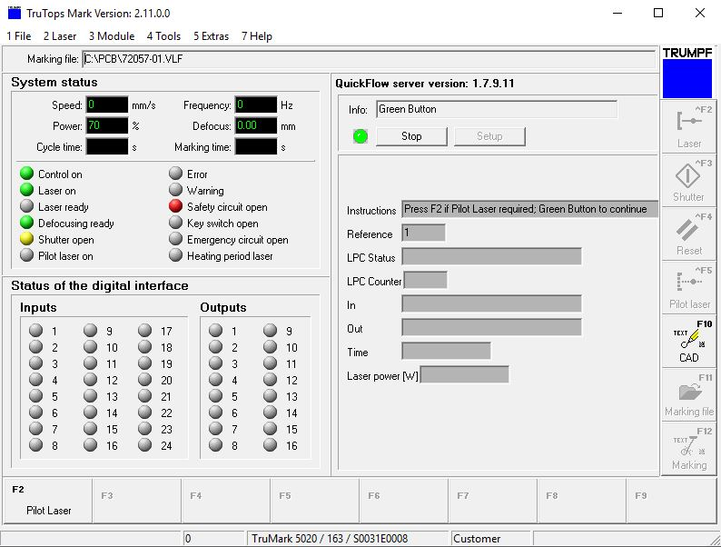

C:\PCB\58639.VLF

**Figure 3:** TruTops Software – machine user interface

After parts are loaded, refer to instructions on-screen circled in red above.

Press the green button on the front of the machine once to bypass the alignment pilot laser. The next instruction will appear as follows:



**Figure 4**: Instructions to etch parts

Check to make sure the parts are loaded correctly and press the green button again to begin etching. The door will close automatically upon approving this instruction.

**Step 5: Unload Parts**

**\*IMPORTANT\*** Wear gloves at all times when loading and unloading or otherwise handling any parts.

Unload the parts from the fixture or corner. Refer to part specific appendices for more detail regarding unique fixtures.

**Step 6:** **Repeat steps 2 through 4** for the remaining parts or jobs to be etched

**Step 7:** **Power Down Machine**

Power off machine after completion of all jobs.

1. Exit out of TruTops software by clicking the ‘X’ in the upper corner of the program.
2. Shut down the computer from the start menu.
3. Switch off the machine using the same switch that was used to power it on (Figure 2).
4. Manually close the door of the machine with your hand by sliding it to the down position.

The machine is now powered down.

## Preventative Maintenance

**NOTE:** For additional information regarding routine maintenance procedures, refer to the TMS5000 Maintenance PDF saved on the desktop of the machine.

The Trumpf TruMark 5000 workstation requires very little maintenance due to the fact that it uses a fiber laser which doesn’t require air or fluid to operate. Cleaning and filter replacements are the main preventative maintenance measures that will be required.

1. **Cleaning protective viewing window:** Clean the glass viewing window on both sides on an as-needed basis using a cotton cleaning cloth and soapy water. Dry the protective filter after cleaning with a paper towel.
2. **Lubricating the linear axes:** The guide rails and spindles of the linear z-axis must be cleaned as required and lubricated every 600 operating hours. Use PCB Part Number 100-9169-60 Shell GADUS S2 V220.

To grease the z-axis, remove the rear cover of the machine following the instructions beginning on page 7 of the TMS5000 Maintenance PDF. Apply grease to the spindle nuts and grease nipple shown in Figure 8 below.

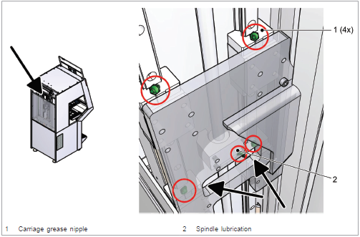

**Figure 5:** Location of grease application on z-axis of machine.

1. **Particle Extractor Filter:** Replace particle extractor filter when the monitoring system indicates a replacement filter is required.
2. **Marking Field:** Clean as needed when the marking field appears dirty with dust from etching. Can either be wiped off or vacuumed

## Appendix A: Laser Ablating Crystal # 58639-01

**Step 1: Power on Machine**

Power on machine following startup instructions in the general procedure in Section 2 above

**Step 2: Load Parts into Array Fixture**

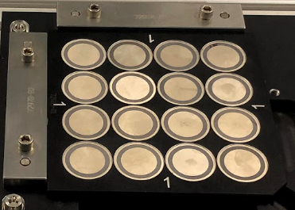

**\*IMPORTANT\*** Wear gloves at all times when loading and unloading or otherwise handling any crystals.

Load the parts in the array as shown in Figure 6 to the right. The parts will sit flush in the fixture if positioned correctly. Orientation of the part within each pocket is not critical.

The notch on the corner of the array fixture should be oriented towards the bottom right of the base plate as shown.

Ensure that the array is cornered completely on the base plate. This is critical to ensuring proper etch positioning.

**Figure 6:** Parts loaded in array fixture. Live parts will be unetched. Etched parts are shown here as an example only.

If ablating a job that is less than 16 pieces, fill the remaining slots with reusable scrap parts so that the fixture remains unmarked.

**Step 3:** **Ensure Proper Program is Selected**

Program 58639 will automatically open when TruTops software opens. If etching only 58639 parts, no program selection is required.

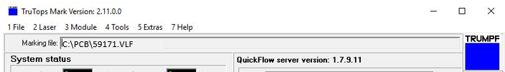  
**Figure 7:** Marking file selected in TruTops

C:\PCB\58639.VLF

After parts are loaded, refer to the on-screen TruTops instructions. Press the green button on the front of the machine once to bypass the alignment pilot laser. The next instruction will appear as follows:



**Figure 8**: Instructions to etch parts

Check to make sure the parts are loaded correctly (sitting flat) and press the green button again to begin ablating. The door will close automatically upon approving this instruction (all 16 pieces in the array will be etched).

**Step 4: Unload Etched Crystals using Ejector Plate**

Remove the array from the base plate and place it directly on top of the ejector plate shown in Figure 9. The 16 pins on the plate will push the crystals up slightly allowing the user to easily remove the crystals as shown in Figure 10.

Place the crystals back in the tray with their associated job.

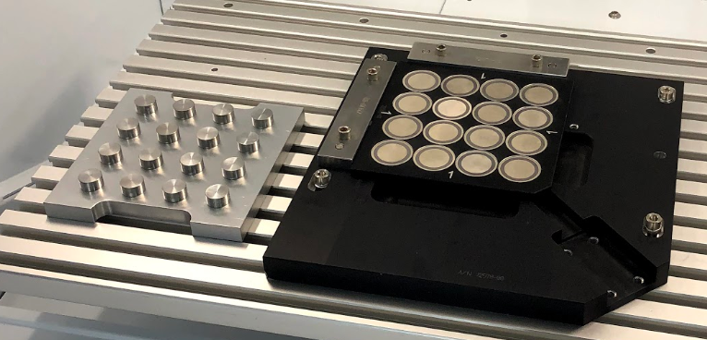

**Figure 9:** Etched array of crystals on base plate with ejector plate on the left.

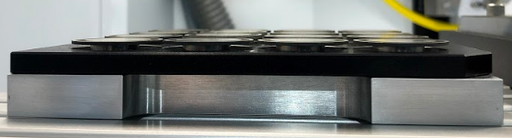

**Figure 10:** Array on ejector plate, showing that the crystals are now raised and can be removed.

**Step 5:** Repeat steps 3 and 4 for the remaining crystals being etched.

**Step 6:** Power down machine following instructions in Section 2 Step 7 of the general procedure above.