# TABLE OF CONTENTS

TABLE OF CONTENTS 1

1. PRINCIPLES OF ULTRASONIC BONDING 1

2. APPLICABLE DOCUMENTS 2

3. MATERIALS 3

4. EQUIPMENT 3

5. CLEANLINESS 7

6. BASIC BONDER OPERATION 8

7. VISUAL INSPECTION 13

8. REWORK 19

9. PULL TEST 20

10. BONDING MACHINE CERTIFICATION 22

11. BOND SCHEDULE GENERATION 25

# PRINCIPLES OF ULTRASONIC BONDING

## Ultrasonic wire bonding is a metal-to-metal welding process which is particularly suited to aluminum and gold wire. Ultrasonic vibrations are transmitted to the wire through the bonding tool. These ultrasonic vibrations scrub the wire into the pad making a bond or weld.

## For the wirebonding defined in this document, aluminum wire will utilize the wedge bonding process (wedge tool and non-heated workstage). Gold wire will utilize the ball bonding process (capillary and heated workstage).

## Bare aluminum picks up a thin oxide film within 20 seconds after being manufactured and oxides do not weld. The ultrasonic (vibration) scrubbing of the aluminum wire to aluminum pads on the substrate will scrub right through the oxide on both aluminum surfaces and a bond (weld) results. A similar action occurs when welding aluminum lead wire to the copper traces on a printed circuit board (PCB). The ultrasonic scrubbing will fuse the aluminum and the copper metal.

## The scrubbing action cannot remove dust, dirt, and oils from human skin that has contaminated the bonding materials. Use precaution as necessary (i.e. wearing gloves or finger cots) to avoid touching the wire or bonding surfaces with bare skin.

## When the aluminum wire bonds during wedge bonding, it does not bond evenly over the whole "footprint" (the interface between wire and the bond surface), that is most of the bond takes place at the edges/sides (none in the center) of the footprint. For this reason, it is important that you position the tool on the pad so that the sides of the footprint do not hang over the pad (as the aluminum wire will not weld to the silicon). If anything has to hang over the pad, let it be the tail.

## Figure 1 shows wirebond features of Wedge Bonding and Figure 2 shows wirebond features of Ball Bonding.

## 

Figure 1

## 

Figure 2

# APPLICABLE DOCUMENTS

## This specification establishes the requirements for ultrasonic wire bonding. It covers certification and qualification of bonding machines, defines weld schedule development, inspection criteria, and outlines manufacturing procedures.

## The following documents form a part of this specification:

* + - * WestBond Manual Wire Bonder: Model 7440D
      * WestBond Manual Wire Bonder: Model 747677D-79
      * WestBond Manual Wire Bonder: Model 7KE
      * TA215 WestBond Wirebonder Parameter Matrix
      * TA1305 WestBond Wirebond Pull Testing Userguide
      * TA216 WestBond Wirebond Pull Test Log
      * MIL-STD-883 Test Method Standard Microcircuits

# MATERIALS

## Only those materials described by PCB drawings and/or BOMs shall be used in making of ultrasonic bonded connections.

## Bonding Wire

### Annealed aluminum wire used by PCB (P/N EDVEW677) has the following properties:

* + - * 0.002” diameter +/- .0001”
      * 99% aluminum, 1% silicon
      * 5-8% elongation

#### The aluminum wire is annealed before use in production per Endevco SPS313. The amount of time the aluminum wire is annealed is dependent on the initial elongation property of the wire. A softer wire (higher elongation will require less time in the furnace. The annealing process makes the wire more pliable for the stress relief bends and wire routing.

### Gold wire used by PCB (EDV30123) for Endevco product while using Westbond manual wirebonders has the following properties:

* + - * 0.001” diameter +/- 15%
      * 99.97% gold
      * Cold Drawn
      * 22,000 psi minimum Tensile Strength

## Substrates, Metallized

### A substrate is a solid (usually planar) substance onto which a layer of another substance typically metal (gold) is applied and to which that second substance adheres (HTCC’s, PCB, LCC’s, etc.).

### Substrates can be made from fiberglass, polyimide, or ceramic and the metal traces and/or pads are often copper, gold, aluminum, or platinum gold.

# EQUIPMENT

## Wire Bonding Machine

### Wire bonding machines used by PCB are as follows:

* + - * WestBond 7KE (S/N 21425) (Depew) – used for bonding aluminum or gold wire to aluminum bond pads (i.e. diodes and gage assemblies) and to gold bond pads (i.e. substrates and LCC’s).
      * WestBond 7KE (S/N 22946) (Depew) – used for bonding aluminum or gold wire to aluminum bond pads (i.e. diodes and gage assemblies) and to gold bond pads (i.e. substrates and LCC’s).
      * WestBond 747677E-79 (S/N 19772) (Depew) – used for bonding aluminum or gold wire to aluminum bond pads (i.e. diodes and gage assemblies) and to gold bond pads (i.e. substrates and LCC’s).
      * WestBond 7440D-79 (S/N 22819) (Depew) – used for tacking of aluminum flying leads only.
      * WestBond 7KE (S/N 21430) (NC) – used for bonding aluminum or gold wire to aluminum bond pads (i.e. diodes and gage assemblies) and to gold bond pads (i.e. substrates and LCC’s).
      * WestBond 7KE (S/N 22818) (NC) – used for bonding aluminum or gold wire to aluminum bond pads (i.e. diodes and gage assemblies) and to gold bond pads (i.e. substrates and LCC’s).

### Wire bonding machines shall be operated and maintained according to the manufacturer’s recommendations.

### The wire bond machines are periodically calibrated per PCB standards. If the machine requires repairs, a calibration is required after the repair is completed.

### Preventive Maintenance (PM) Scheduled Pull Testing shall be completed at a minimum of once every 7 days for each machine that is in service. Bond Schedule Validation and Bond Machine Certification Pull Testing shall be completed as needed. The test results shall be captured on form TA216 WestBond Wirebond Pull Test Log and stored with the machine until scanned to the network in R:\Production\Endevco\Wirebonding\Pull-Testing.

## Bonding Tool

### The wirebond machines shall be configured with the following wedge tools unless otherwise noted:

* + - * WestBond 7KE (S/N 21425) (Depew) – DeWeyl Tool P/N CASOX-1/16-750-45-GW-3540-MP-A1-A9, PCB P/N 100-17211-00
      * WestBond 7KE (S/N 22946) (Depew) – DeWeyl Tool P/N CASOX-1/16-750-45-GW-3540-MP-A1-A9, PCB P/N 100-17211-00
      * WestBond 747677E-79 (S/N 19772) (Depew) – Wedge: DeWeyl Tool P/N CASOX-1/16-750-45-GW-3540-MP-A1-A9, PCB P/N 100-17211-00 / Ball: SPT Capillary P/N UTS-43HH-AZM-1/16-16MM 15MTA, PCB P/N 100-17357-40
      * WestBond 7440D-79 (S/N 22819) (Depew) – DeWeyl Tool P/N MASOX-1/16-750-45-GW-3540-M-A1-A3-A9 Narrow Wedge Tool (preferred for bonding in tight spaces), PCB P/N 100-17226-80 (Alternatively, PCB P/N 100-17211-00 may be used if PCB P/N 100-17226-80 is unavailable but note that tool clearance will be limited).
      * WestBond 7KE (S/N 21430) (NC) – SPT Capillary P/N UTS-43HH-AZM-1/16-16MM 15MTA, PCB P/N 100-17357-40
      * WestBond 7KE (S/N 22818) (NC) – SPT Capillary P/N UTS-43HH-AZM-1/16-16MM 15MTA, PCB P/N 100-17357-40

### The bonding tools must be inspected during each Preventive Maintenance (PM) Scheduled Pull Test or after 10000 bonds whichever comes first (see Figure 3). If the tip is loaded up with metal from the wire or the performance (pull test results or visual inspection) of the bonding has decreased below acceptable levels, the tool must be replaced.

## 

Figure 3

### Installation of a wedge bonding tool must be such that it sits flush with the top of the transducer cone at the back of the tool. Install a new setscrew (WestBond P/N 51714 Screw, Flat Point, 4-40x3/32, PCB P/N 100-17214-10 (for the 7440D) or WestBond P/N 51065 Screw, Socket Set, Flat Pt, 2-56 x 3/32, PCB P/N 100-17357-60 (for the 747677-79 & 7KE) with each new wedge tool and tighten it to 20 in-oz (14.1 ncm) with a calibrated torque tool (Figure 4).

## 

Figure 4

### The gold ball capillary is installed similarly to that of the wedge bonding tool, but uses a 0-80 cap screw from the side of the transducer instead of the 2-56 set screw from the front. Install the bond using a 0.050” allen key and torque the 0-80 cap screw to 24 in-oz (16.9 ncm).

### After each installation of a new bonding tool, a bonding machine certification must be performed as per section 10.

#### The Bond Counter shall be reset to zero in the Machine Setup (7KE & 747677-79). For WestBond Model 7440D, the counter reset button is on the front of the bond counter display.

## Pull Test Machine

### Pull Test machines used by PCB are as follows:

* + - * WestBond 70PTx
      * Dage Pull and Shear Tester (Alternative to the WestBond 70PTx - Microelectronics - Depew only)

### The bond (weld) test machines shall be operated and maintained according to the manufacturer’s recommendations.

### The bond (weld) test machine is periodically calibrated per PCB standards. If the machine requires repairs, a calibration is required after the repair is completed.

### The WestBond 70PT machine is designed for pull testing of wire bonds. Detailed operating instructions for this pull test machine are provided in TA1305 WestBond Wirebond Pull Testing Userguide. The tester has a hook mounted on a sensor arm. The operator/technician maneuvers the hook under the loop of wire to be tested, and then actuates a button for the machine to perform a destructive pull test. The pull test results are recorded on TA216 WestBond Wirebond Pull Test Log.

## Workholder

### To support the assembly during wire bonding, each assembly requires an adequate workholder. The workholder must be rigid and provide support during the ultrasonic bond process.

### If a specific workholder is not specified, the standard non-heated workholder shall be used (WestBond P/N 3600.247 or equivalent). When using this fixture, adjust the repositionable clamping slide such that the assembly being wirebonded is being rigidly held flush against the workholder surface. Pre-load on the clamping lever shall not allow the assembly to lift or move laterally during the wirebonding process.

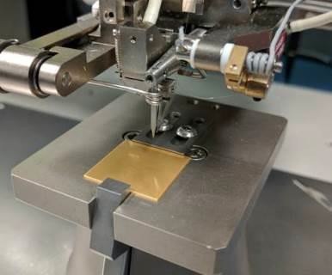

Figure 5

## Work Platform (Height)

### The height adjustment of the work platform is critical for quality wire bonding. If the work platform is not adjusted properly, the operator may lose some measure of control over the bond wedge. To check for proper work height elevation, simply compare the lowest elevation requiring bonding to the position of the bond tool while holding the micromanipulator in its maximum down position. When properly positioned, the lowest required bonding elevation should be approximately 20 – 30 mils (635-762μm) above the tip of the bonding tool, and the operator’s wrist and forearm are lying flat on the desktop surface.

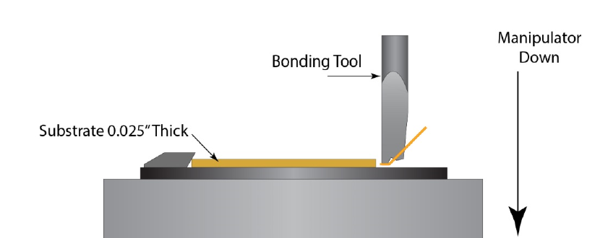

Figure 6

# CLEANLINESS

## The bonding wire and parts being bonded, must be kept clean at all times. Note that some forms of contamination cannot be removed once they are allowed to contact the parts (bonding wire and/or bonding surfaces).

## **Operators and inspectors must wear gloves or finger cots when directly handling the parts** to prevent skin oil contamination on the bonding surfaces. The ultrasonic scrubbing action of the bonding process cannot remove dust, dirt, and skin oil contamination from the bonding surface.

## The surfaces where the bonds will be made are the most critical. Parts that have these surfaces include silicon dies, metallized substrates, printed circuit boards, headers, etc. Special care must be taken to protect the bonding surfaces from contamination.

## Parts shall be cleaned as specified in the Job Traveler (JT), assembly procedure, or userguide for the assembly being built.

## If using compressed air or nitrogen gas to remove particulate contaminates during the wirebonding process, avoid using high pressures or direct blasts on or around any part features that can be easily damaged such as gage elements, balance resistors, silicon flexures,etc.

## If required by the JT traveler (JT) or userguide before wirebonding, assemblies may be plasma cleaned per TA1297 (GLOW Plasma Etcher Processing User Guide).

## Use dedicated clean containers (trays, petri dish, ESD bag, etc.) to transport the parts. These containers are only to be used for transporting clean parts and assemblies. Transport containers must be cleaned as needed after exposure to contaminants.

## Assemblies/parts that have incomplete wire bonding shall be stored in a nitrogen purged desiccator or an ESD safe airtight bag unless they are in WIP. WIP assemblies/parts shall be handled such that there is limited exposure to contamination.

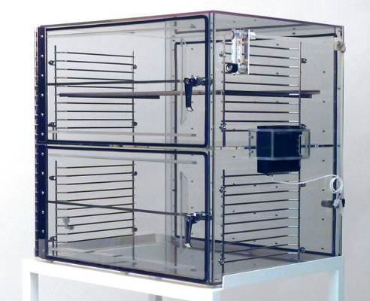

Figure 7

## Keep the work areas free of oils and greases. Hand lotion, and other contaminants must be kept off the benches used for these assemblies.

## 

Figure 8

## 

# BASIC BONDER OPERATION

## Machine Setup

### The wire bond machine shall be powered on for a minimum of 15 minutes prior to performing a wire bond. Erratic and inconsistent wire bonds may result when the machine is not warmed up.

### Confirm that a there has been a passing Preventive Maintenance (PM) Scheduled Pull Test and/or Bond Machine Certification completed within the last 7 days by reviewing the dry erase pull test history placard at the wirebonder and/or by reviewing the pull test logs stored with the machine. If there is no evidence of a passing pull test in the last 7 days, stop and notify the manufacturing engineer and/or supervisor.

### Select Bond Schedule/Buffer

#### The bond schedule/buffer selected will be specified in the WestBond Wirebonder Parameter Matrix (TA215) based on the process required (surfaces being bonded to). If an appropriate bond schedule/buffer is not listed or is not performing as expected, stop and notify manufacturing engineering and/or supervisor.

#### For WestBond model 7440D-79, there can only be one schedule/buffer configured on the machine at a time by manually updating the ultrasonic power, time, and force. For all other models, the schedule/buffer shall be selected by toggling the buffer switch (Figure 9) from the front panel.

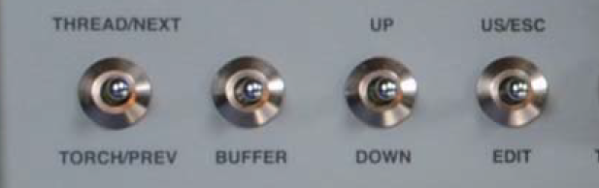

Figure 9

### Make sure the adjustable height table is clean and height is set appropriately.

### Place the workholder on the table and place the substrate or die into the chuck.

### Adjust the microscope to your eyes.

### Lift up on the micromanipulator handle while positioning part in the workholder to be in the center of view in the microscope.

## **Tack bonding** (bonding the end of an existing flying lead / no additional wire is added) (typically aluminum):

### Verify that no wire is loaded in the wire feed path of the machine (See Figure 10).

### Use the handle to align the bonding wedge over the wire and over the pad/substrate to be bonded.

### Verify that the wire to be bonded is centered under and parallel with the front to back groove in the bond tool. Rotate the workholder to adjust as needed.

### Press down on the handle, the machine will bond and an audible “beep” will be emitted if enabled.

### After the bond is complete (which is over almost instantly), manually lift the handle to clear the bond area.

### If the integrity of the bond is in question or a redundant bond is desired, a second bond may be added to a flying lead if there is sufficient bonding area and wire. This second bond shall not overlap the first and shall be placed on the wire between the first bond and the device where the flying lead originated.

### The sequence is now complete and is ready for visual inspection or subsequent bonding.

## **Flying leads** (bonding a length of wire with a single ended bond / wire is added) (typically aluminum):

### Wire installation and routing (if not already configured)

#### While wearing gloves and not touching any turns of wire, load a spool of wire on the spool holder such that the end of the wire when released will feed off the top of the spool. Again, without touching any turns of wire, release the wire from the end of the spool and draw it towards the wire guide tube in the transducer being careful not to let go of it as the wire could roll off the side of the spool. Straighten the end of the wire (approximately 1 inch) and feed it through the wire guide tube in the transducer shank.

#### Open the clamps by selecting (THREAD/NEXT) (Figure 9) from the front panel of the wire bonder. Draw an inch or two of wire from the bottom of the wire guide tube and straighten the end as done in the previous step. Feed the wire through the wire path of the clamps as shown in Figure 10 making sure that the wire is on the inside of the ledge. This ledge keeps the wire from dropping in the clamps. The wire should now be exiting the front of the clamps.

#### Pull approximately 1.5 inches of wire through the open clamps and past the wedge tool. Once again, straighten the end of the wire and rotate it 360 degrees to the backside of the open clamps and facing the back of the wedge tool. While doing so, do not let the wire fall out of the clamps. While holding the wire at a 45 degree angle simulating the natural wire path, lift the end of the wire into the open clamps. Sliding the end of the wire down the back side of the wedge tool will feed the wire into the guide hole in the back of the wedge tool. Once started in the guide hole and without letting the tweezer touch the tip of the wedge tool, grasp the wire and guide the excess wire loop through the hole and clamps.

#### Draw out any sections of wire that may have excessive kinks or tweezer pinches. Close the clamps by selecting (TORCH/PREV) (Figure 9) from the front panel and trim off any excess wire from the front of the tool or bond off the excess on a sacrificial surface.

Wire feed path through Wire Guide Tube and Clamps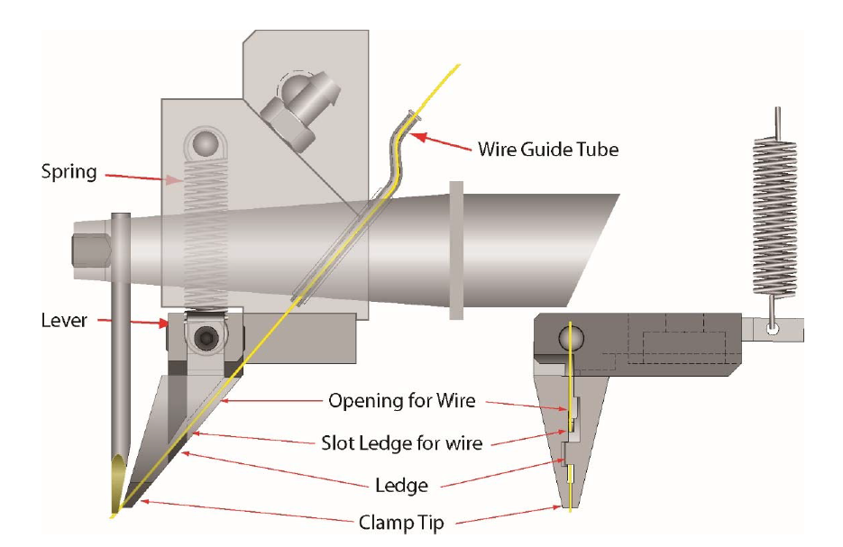

Figure 10

Wire Feed Path through Wedge Tool

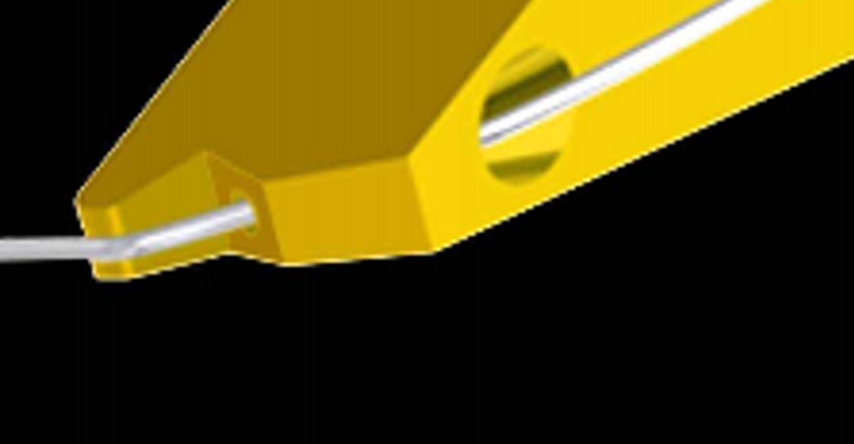

Figure 11

### Use the handle to align the bonding wedge over the wire and over the pad/substrate to be bonded.

### Feed a length of wire from the end of the bond tool equal to the length of wire required to make the complete wirebond including enough to create the loop with strain relief and enough for the second bond (tack bond) by pulsing (TORCH/PREV) (Figure 9). If the wire does not feed, repeat the steps from section 6.3.1 as necessary.

### Rotate the workholder such that the fed wire is in the correct orientation with regard to the target bond pad.

### While targeting the center of the bond pad, press down the handle, the machine will bond, and an audible “beep” will be emitted if enabled.

### After the bond is complete (which is over almost instantly), manually lift the handle to clear the bond area.

### The sequence is now complete and is ready for visual inspection or subsequent bonding.

## **Double bonds** (bonding first and second bond sequentially / wire is added) (aluminum or gold):

### Wire installation and routing (if not already configured)

#### For aluminum wedge bonding, verify wire installation and routing per section 6.3.1.

#### For gold ball bonding, verify wire installation and routing per Figure 12. Note that for gold ball bonding, after the wire guide tube, the wire is routed through the 90° clamps, and then through the center hole of the capillary.

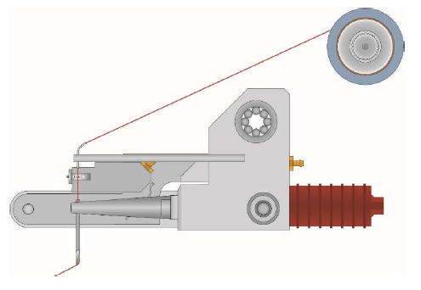

Figure 12

### Use the handle to align the bonding tool over the wire and over the pad/substrate to be bonded.

### Rotate the workholder such that the bonding tool is in the correct orientation with regard to the target first bond pad.

### While targeting the center of the first bond pad, press down the handle, the machine will bond, and an audible “beep” will be emitted if enabled.

#### For wedge bonding, the 1st bond profile will be like that shown in Figure 14.

#### For gold ball bonding, the 1st bond profile will be like that shown in Figure 13.

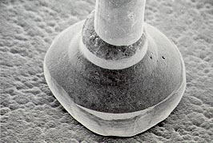

Figure 13

### After the firstbond is complete (which is over almost instantly), slowly lift the handle to clear the first bond area and carefully move the workholder while drawing wire out of the tool such that the bonding tool is now over the second bond pad target area.

#### The necessary loop height with proper strain relief is formed by controlling the tool lift and workholder movement between first and second bonds and will vary depending on work surface heights and distance between first and second bonds.

### While targeting the center of the second bond pad, press down the handle, the machine will bond, and an audible “beep” will be emitted if enabled.

#### For wedge bonding, the 2nd bond profile will be like that shown in Figure 14.

#### For gold ball bonding, the 2nd bond profile will have a crescent shaped bond profile like shown in Figure 24.

### After this second bond, the wire will tear from the bond leaving a tail for the next bond.

### If wedge bonding, this sequence is now complete and is ready for visual inspection or subsequent bonding.

### If gold ball bonding, one more step in the bonding sequence will occur and that is the formation of a gold ball on the end of the wire for the next bond.

#### This process is referred to as Negative Electronic Flame Off (NEFO). When the manipulator arm is lifted after the second bond, an electrode (torch) drops below the capillary and an arc occurs between the electrode and the tail of wire. The temperature of the plasma from this arc is sufficient to melt the tail of wire into a gold ball.

#### 

#### CAUTION! Due to the High Voltage of the NEFO, keep hands and loose wire away from the torch assembly when it is activated.

### The sequence is now complete and is ready for visual inspection or subsequent bonding.

# VISUAL INSPECTION

## Aluminum Wedge Bonds (based on MIL-STD-883K w/CHANGE 1)



Figure 14

### Wedge bonds must have a clear visual indication of the bond tool on the wire either across the full wire diameter or evidence of contact on both sides of the wire.

### Bonds with a width less than 1.0 times the wire diameter for aluminum wires 2.0 mils or greater in diameter shall be rejected.

### Devices containing bonds where less than 50% of the bond is within the bonding pad area shall be rejected.

### Devices with bond tails longer than 3 times the wire diameter shall be rejected.

### Devices with bonds in the fillet area of the bonding pad that reduce the distance between the bond area and the fillet to less than ½ the narrowest design width of the interconnecting metallization shall be rejected (See Figure 16).

## 

Figure

### Devices with the bonds placed so that the separation between bonds or the bonds and adjacent metallization is less than 0.5 mils shall be rejected. (See Figure 16)

### Re-bonds shall not be placed directly over material remaining from previous bond attempts.

### Bonds that are missing material: reject if the bond is not at least ¾ of its design (smashed) size (see Figure 16).

## 

Figure

### The appearance of the bond shall be such that when viewed with magnification from 30X to 50X, there shall be none of the following defects:

* + - * Nick, cuts, crimps or scoring on the wire that reduce the diameter by 25%.
      * Neckdown of the bond wire caused by excessive tension or bond force
      * Leads closer than 2 mils to each other (unless the wires are connected to the same bond pad)

### Visually inspect the first bonds of the double bonds. Deformation shall be uniform and tail lengths shall be straight. Bonded wires shall not show any heavy black markings. A thin dark perimeter is acceptable. See Figure 17 below.

Figure

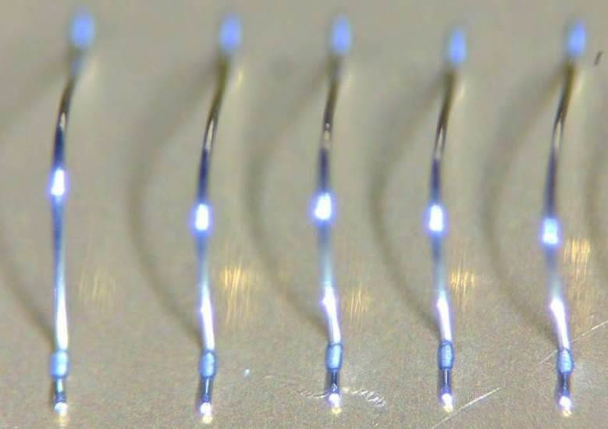

### Visually inspect the second bonds on the double bonds. Deformation shall be uniform. Bonded wires shall not show any heavy black markings. A thin dark perimeter is acceptable. See Figure 18 below.

Figure

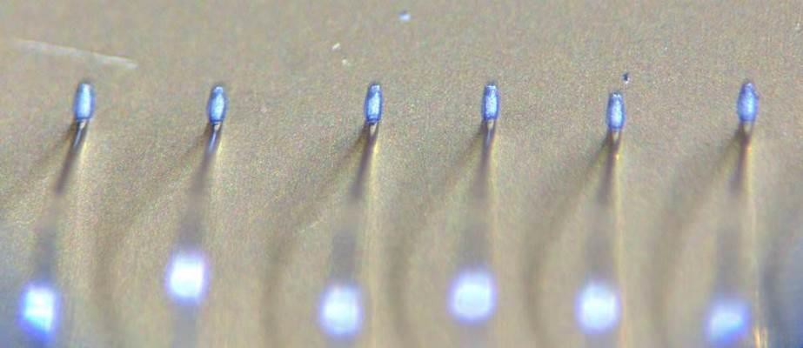

### Wire bonds shall not be burnt (crystallized) from too much ultrasonic time during bonding (Figure 19).

## 

Figure 19

### Wire bonds shall not contain cracks in the heel of the wire bond.

## 

Figure

Figure

## Gold Ball Bonds (based on MIL-STD-883K w/CHANGE 1)

### No device shall be acceptable that exhibits:

#### Ball bond diameter less than 2.0 times or greater than 5.0 times the wire diameter.

#### Bond intermetallics extending radially more than 0.1 mil beyond the bond periphery in any direction.

#### Ball bonds where the wire exit is not completely within the periphery of the ball (Figure 22).

#### 

Figure 22

#### Ball bonds where the wire center exit is not within the boundaries of the bonding site (Figure 23).



Figure 23

#### Tailless bonds (Stitch Bonds) that are less than 1.2 times or greater than 5.0 times the wire diameter in width (Figure 24).



Figure 24

## 

# REWORK

## Wires that are detached during assembly or test may be re-bonded if the following criteria are met:

### If tacking, existing wire is long enough to allow wire bonding without placing the wire in tension.

### Re-bonds will not be placed directly over material remaining from previous bond attempts.

### Bonding area is not contaminated with epoxy, RTV, Parylene coating, etc.

### Assembly can be properly supported/installed in workholder for wire bonding.

## Carefully detach excess bonded wire from surface using a blade or tweezer.

## If tacking, using a tweezer or equivalent, reposition the end of the wire to an area that has not been previously bonded and is free of contaminants.

## Re-bond using steps from section 6.

## Inspect reworked wire bond per section 7.

## 

# PULL TEST

## The method used for Preventive Maintenance (PM) Scheduled Pull Testing, Bond Schedule Validation, and Bond Machine Certification is a destructive pull test.

## Due to the destructive nature of these tests, non-conforming, dedicated pull test sub-assemblies, and/or coupons representative of production parts may be used.

## The Hook Pull Test Method is used in combination with the Double Bond bonding method described in section 6 to validate the integrity of the materials and wire bond process unless otherwise directed.

## To perform a pull test, there must be sufficient height in the loop of the wire to allow a pull test hook to be inserted under the middle of the loops created (Figure 25).

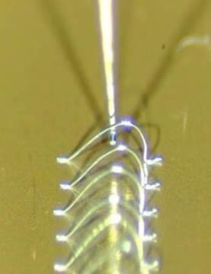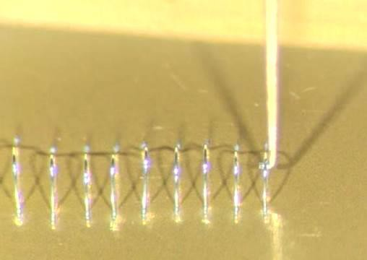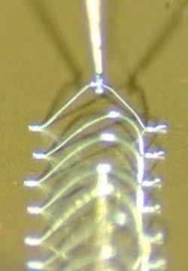

Figure 25

Figure

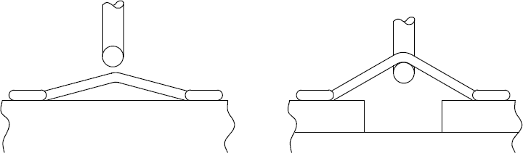

Angle

## Some test geometries will give results that are not indicative of the actual wire and bond strength. For hook pull testing using samples bonded on a flat surface, the loop of the test wire must be high enough so that when the wire is pull tested it has at least a 30° angle to the coupon surface (Figure 26).

## Pull Testing for Tack bond only processes shall be validated by adding an additional tack behind the second bond (between first and second bond) on an existing double bond. Only failures at the wedge or heel of the tack bonds being evaluated shall be considered.

## Single bond / flying lead schedule validation will also follow this method but will require additional preparation. In this case, tack down the flying end of the lead and/or secure it in place with epoxy before pull testing without adding stress to the heel. Failures of the flying end shall not be considered for validation.

## Preparing Sample

### Verify the machine is has been powered on for more than 15 minutes (warm-up time) before performing first wire bond/weld.

### Select the buffer/wire bond schedule used for machine certification and verify the settings matches the information recorded on the WestBond Wirebonder Parameter Matrix (TA215) for the machine serial number.

### Install test coupon (WestBond thin film substrate (test coupon WestBond P/N 50836 - PCB P/N 100-17218-30) into the wirebonder workholder.

### Bond at least 25 wires using the double-ended bonds. See example picture shown in Figure 27. The distance from the first bond to second bond should be approximately 0.070”. The loop height of the wires should be approximately 0.035”. This will provide the optimum angle for the wires during pull testing with the hook.

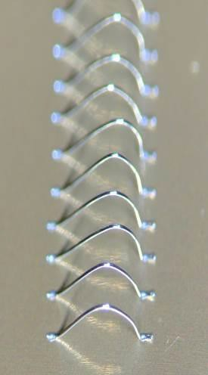

Figure 27

#### It is important to be consistent in the loop shaping because low loops can cause poor pull test results. Skip low loop shapes during pull testing.

### Perform visual inspection on each bond as per section 7.

### Move test sample to the bond test machine.

### Pull Testing 20 wires is required to provide a sufficient sample size for statistical analysis.

### Insert the test sample to be pull tested in the workholder and maneuver the hook under the wire loop.

## Perform the pull test

### Complete a TA216 WestBond Wirebond Pull Test Log for each pull test.

### Perform a pull test for each wire per TA1305 WestBond Wirebond Pull Testing Userguide

### Record the breaking force in grams.

### Under the machine microscope, identify the break point.

### Record the number corresponding to the break category.

### Repeat steps for all wires to be tested.

## **Pass/Fail Criteria:**

### If any pull tests do not meet these minimum requirements, stop and notify manufacturing engineering and/or supervisor.

* + - * No lifted bonds
      * No broken wires (cracks) at the wire bond neck
      * Pull test minimum value:

**≥20 grams-force for .002” aluminum wires**

**≥5 grams-force for .001” gold wires**

* + - * Wire breaking above neck of bond during pull testing is not considered a failure of the wire bond.

## The completed TA216 WestBond Wirebond Pull Test Log shall remain with the machine being validated or certified.

## The dry erase pull test history placard at the wirebonder shall be updated with the testing technician’s initials and the expiration date of the pull test which is 7 day beyond the date of the passing pull test.

# BONDING MACHINE CERTIFICATION

## The ultrasonic bonding equipment used in PCB manufacturing processes must be certified to meet the intent of this specification and the equipment manufacturer's specifications.

## Machine certification must be performed for the following:

* + - * after each new bonding tool is installed
      * after each new spool of bonding wire is installed
      * during machine calibration
      * machine has been moved to another location
      * machine repair
      * machine malfunction

## Material

### WestBond thin film substrate (test coupon WestBond P/N 50836 - PCB P/N 100-17218-30)

### The wire to intended for production assemblies shall be used for certification of the wire-bonding machine.

## Certification Bond Schedule/Buffer

### Each WestBond machine has a dedicated machine Certification Bond Schedule/Buffer that shall be used to bond wires to the test coupon. The Bond Schedule/Buffer settings from each machine are recorded in the WestBond Wirebonder Parameter Matrix (TA215) and a printed copy is kept with the associated machine.

* + - * WestBond 7KE (S/N 21425) (Depew) – Schedule/Buffer 30
      * WestBond 747677E-79 (S/N 19772) (Depew) – Schedule/Buffer 30
      * WestBond 7440D-79 (S/N 22819) (Depew) – Schedule/Buffer 1
      * WestBond 7KE (S/N 22946) (Depew) – Schedule/Buffer 30
      * WestBond 7KE (S/N 21430) (NC) – Schedule/Buffer 30
      * WestBond 7KE (S/N 22818) (NC) – Schedule/Buffer 30

## Bonding Force Test/Verification

### The bonding force setting shall be verified using a calibrated gram tension gauge.

#### The tension gauge shall be operated and maintained according to the manufacturer’s recommendations.

#### The tension gauge shall calibrated per PCB standards.

### Low Bonding Force

#### Use the “Edit” toggle switch to navigate to the “Machine Setup: CALIBRATE LOW FORCE”.

## 

Figure 28

#### Reset the maximum indicator on the gram tension gauge to zero.

#### Place the measurement arm of the gram tension gauge under the transducer cone just in front of the bonding tool.

## 

Figure 29

#### Slowly lift the transducer cone with the gram tension gauge until an audible “beep” is produced on the wire bonder.

#### Verify the maximum reading on the gram tension gauge is +/- 5 grams of the low force listed on the WestBond Wirebonder Parameter Matrix (TA215).

#### **Note: If force reading exceeds limit, contact manufacturing engineer to adjust wire bonder settings to meet force requirements.**

### High Bonding Force

#### Use the “Edit” toggle switch to navigate to the “Machine Setup: CALIBRATE HIGH FORCE”.

## 

Figure 30

#### Reset the maximum indicator on the gram tension gauge to zero.

#### Place the measurement arm of the gram tension gauge under the transducer cone just in front of the bonding tool.

## 

Figure 31

#### Slowly lift the transducer cone with the gram tension gauge until an audible “beep” is produced on the wire bonder.

#### Verify the maximum reading on the gram tension gauge is +/- 5 grams of the high force listed on the WestBond Wirebonder Parameter Matrix (TA215).

#### **Note: If force reading exceeds limit, contact manufacturing engineer to adjust wire bonder settings to meet force requirements.**

## Perform Pull Test as per section 9.

# BOND SCHEDULE GENERATION

## There are 3 main variables in ultrasonic bonding schedules and they all interact.

* + - * **Force** establishes amount of pressure the bonding tool pushes down on the wire. A good weld is not deformed (smashed) flat.
      * **Time** in general for thin films such as the aluminum pads on piezoresistive (PR) die or gold pads on substrates should be set to a minimum.
      * **Power** - should always be higher than time.

### Increasing any of the 3 settings described above will “increase" the amount of welding/bonding. If required, for small variations in pads on die, metallization on substrates, and plating on pins, adjust the “power” setting. If adjustment of the “power” setting does not provide a good bond result, adjust the force and time settings.

## The quality of bond samples used in schedule development shall be determined by visual inspection as defined in section 7and pull test results.

## Each Bond Schedule is applicable for a specific process and a specific bonding machine S/N.

## Establishing a new Bond Schedule for a production assembly is a complex and iterative process and shall be done under manufacturing engineering supervision. Many variables affect the process, machines variables settings, tooling, etc.

## Bond Schedule Establishing

### Verify the machine has been powered on for more than 15 minutes (warm-up time) before performing first wire bond/weld.

### Setup the machine variables (power, time, force) settings to be assessed.

### Install the bonding tool to be assessed.

### Place material (metallized substrate, header, die, gage assembly, etc...) into the workholder.

### Perform wire bonding on Destructive Test Sample as per section 6

### Bond at least 10 wires per settings configuration

### Perform visual inspection on each bond as per section 7

### Perform Pull Test as per section 9

### Repeat steps 2 to 8 with different settings (power, time, force) until optimum settings that give the maximum pull strengths are found.

## Bond Schedule Validation

### Install the bonding tool to be validated.

### Select the buffer that contains wire bond schedule/settings to be validated.

### Place material (metallized substrate, header, die, gage assembly, etc...) into workholder.

### Perform wire bonding on Destructive Test Sample as per section 6.

### Bond a minimum of 20 wires.

### Perform Visual Inspection on each bond as per section 7

### Perform Pull Test on 20 wires as per section 9

## The definitive bond schedule settings shall be chosen by the manufacturing engineer or designee.

## After completing all the validation requirements, record the settings from the wire bond schedule in the live version of the WestBond Wirebonder Parameter Matrix (TA215) stored at R:\Production\Endevco\Wirebonding and then place a printed copy for the wirebonder at the wirebonder workstation.

## Approval field shall reflect the approving manufacturing engineer or designee.

## A record of the approved bond schedule must be available at the bonding machine when production parts are being processed.