# Table of Contents

Table of Contents 1

1.0 PURPOSE 1

2.0 REFERENCE DOCUMENTS AND FORMS 1

3.0 EQUIPMENT, TOOLS, & FIXTURES 1

4.0 WIREBOND PULL TEST MACHINE SETUP 1

5.0 WIREBOND PULL TESTING 4

6.0 APPENDIX 6

# PURPOSE

* 1. The purpose of this userguide is to qualify aluminum and gold wirebonders by testing the wirebond tensile strength of wirebond samples destructively relative to required specs.
  2. The WestBond Pull Tester provides a convenient method to place a hook under the arch of a bonded wire and then pull the wire under microprocessor control to measure tensile strength either destructively or non-destructively. We will be using only destructive test mode for all our qualifications.

# REFERENCE DOCUMENTS AND FORMS

* TA1303 WestBond Wirebonding Userguide (Depew & Halifax)
* TA216 WestBond Wirebonder Pull Test Log
* WestBond Manual Wire Bonder: 7000x (70PTx)

# EQUIPMENT, TOOLS, & FIXTURES

* 1. WestBond Semiautomatic Pull Tester 70PTx
  2. Hook, .004" Wire Dia, w/ .010" pull extension (Westbond 3958.005 or equivalent)
  3. Work holder (WestBond P/N 3600.247 or equivalent)
  4. Dage Pull and Shear Tester (Alternative to the WestBond 70PTx - Microelectronics - Depew only)

# WIREBOND PULL TEST MACHINE SETUP

* 1. This system needs a couple of initial checks before the samples can be tested.
  2. Turn on the power to the system. The system will recalibrate itself on the startup and the screen will light. Read the displayed message as shown in and verify the readout as below:

**(Destruct Test: Chip #1 wire #1)**

**(Pull Stroke = 50 mils)**

**(Pull rate = 5)**

**(Set force = 82 +/- 2 g)**

* + 1. If all above settings are displayed properly, move to Step 4.7.

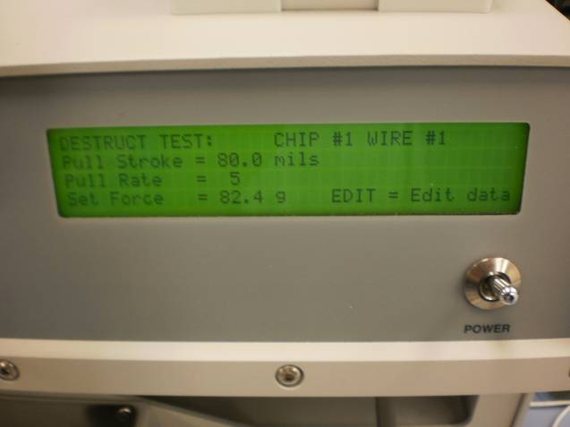 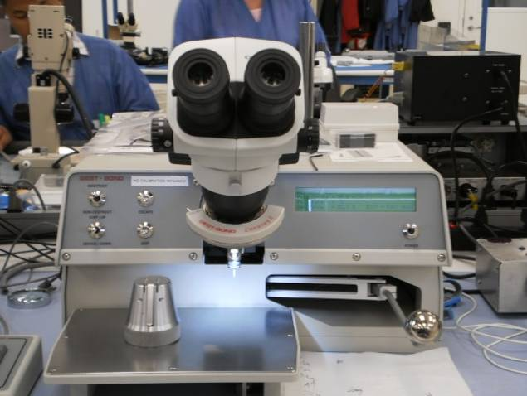

* 1. If the machine is not in Destruct mode, change the switch to select destruct on left side of machine from non-destruct mode.

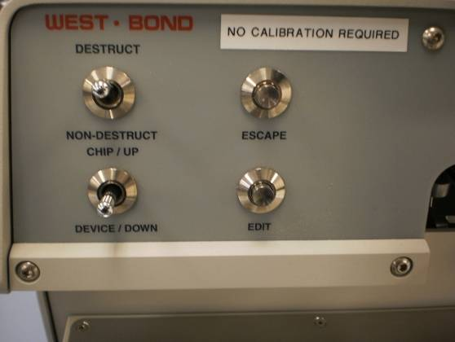 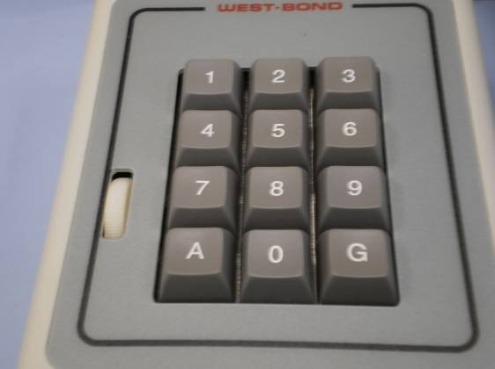

* 1. If pull stroke is not set to 50, press the edit button on the left side and this will allow user to change the pull stroke to 50 mils. Using “Chip Up/Device Down”, change the value to 50. With each switch click, value moves up or down in the increments of 5. Pressing escape will save the data and return you to the main menu. Verify all the values in Step 4.2 are displayed correctly.

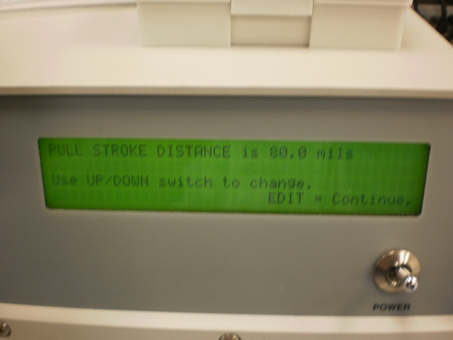 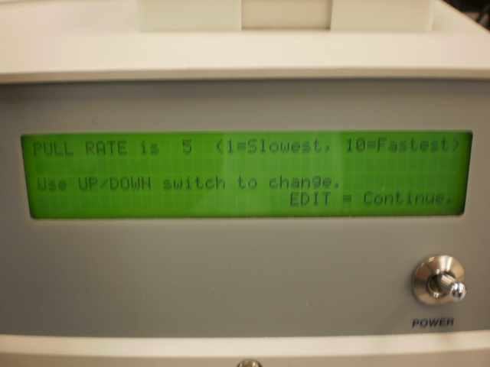

* 1. If pull rate is not set to 5, press the edit button 2 times to change the pull rate. Use “Chip Up/Device Down”, to change the value to 5. Each switch click moves the value up or down by an increment of 1. Pressing escape will save the data and return you to the main menu. Verify all the values in Step 4.2 are displayed correctly.

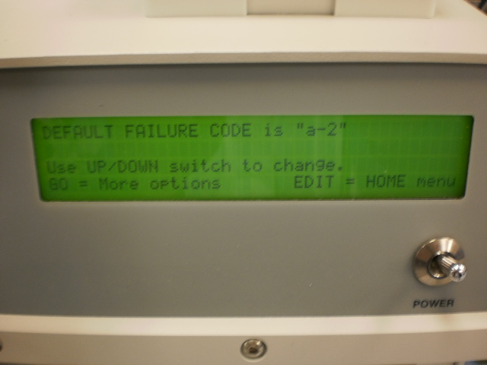 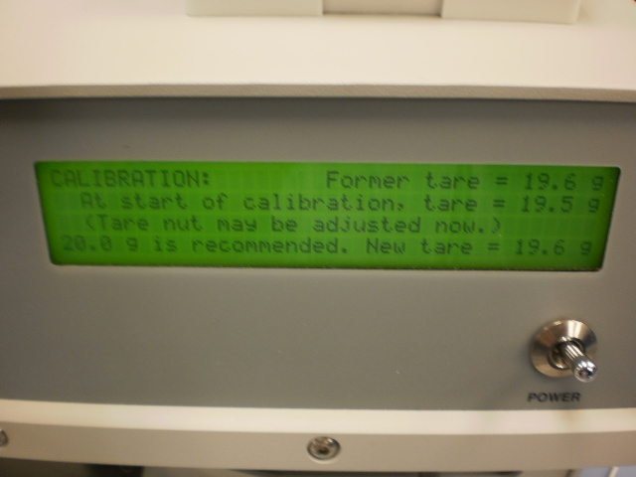

* 1. When we press edit key 3 times we will be able to change most common failure mode. Presently most common failure mode is set to **a-2**. Using “Chip Up/Device Down” operator can change the value of failure mode from a-1 through a-9. We will be using nine failure modes to explain the location at which the wire broke or whole bond lifted. Pressing escape will save the data and come to the main menu. All failure modes will be explained later.
  2. **We always need to check tare value before using, this is very important** in order for the machine to give correct pull strength values while pulling the actual loops. With the workholder out of the way, move the micromanipulator down until it reaches the bottom of its travel and hold it there. Press A on the keypad and you will get a display “Calibration” with the value of the former tare as well as the present value. This present value should be 20 +/-.3. If it is not between 19.7 and 20.3, lift the top lid of the machine and manually rotate the knob clockwise or counter clockwise, as shown in picture below, while doing so monitor the change in the value on the front display and adjust the knob in order to set the value to 20.0. When in range, Press A again to accept the present value and release the micromanipulator. See manufacturing engineering and/or supervisor for assistance if needed.

Knob to be adjusted for Calibration of tare.

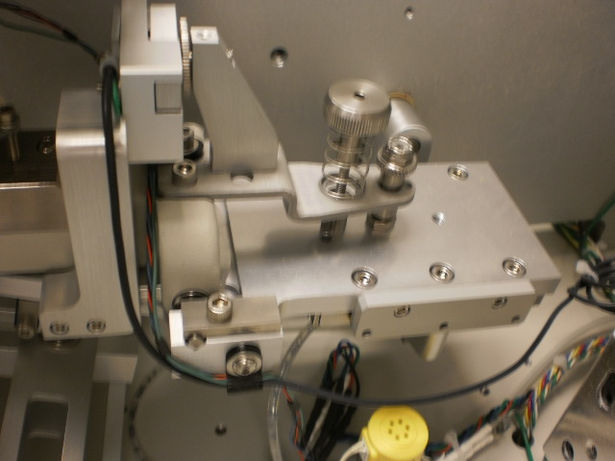

# WIREBOND PULL TESTING

Once you have confirmed that the machine have been setup correctly per the previous section, you can start using the pull tester for the qualification of the wirebonder.

* + 1. The WestBond Test Machine may utilize SPC software to collect and analyze data and/or print the test results to a serial printer. If these features are desired, see the WestBond 70PTx user manual for more details.
    2. If these features are not installed, record all test results on the TA216 WestBond Wirebonder Pull Test Log for each sample set.
  1. Place the sample on the pull tester workholder. You are now ready to perform the pull test.
  2. While looking though the microscope and using the micromanipulator lever on the right side, carefully position the hook under the arch the first wirebond to be tested. If the hook needs rotation, rotate the thumb wheel in the keypad. **Do not release the lever.**

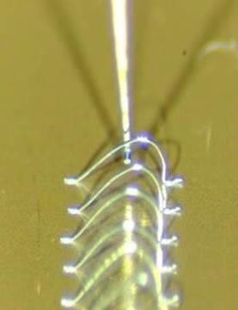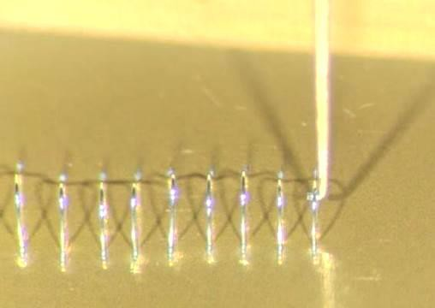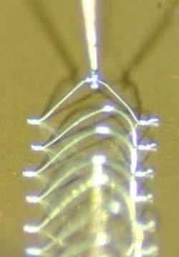

* 1. **While still holding the lever**, press “G” on the keypad and the workstage on which sample workholder rests will slowly move down until the wire breaks. You will see the wire pull test data (in grams) on the screen and the machine will wait for you to enter the failure mode. Failure mode ranges from a-1 to a-9.
     1. Failure modes (Break Category) for Al wire (a-X) (See Appendix Table 1 for more detail):

**1 - Wedge/Ball bond lift (1st bond)**

**2 - Heel/Neck break (1st bond)**

**3 - Wire break (mid-span)**

**4 - Heel/Neck break (2nd bond)**

**5 - Wedge/Stitch bond lift (2nd bond)**

**6 - Double bond lift (1st and 2nd bond)**

**7 - Metallization lift (1st bond) – Notify engineering and/or supervision**

**8 - Metallization lift (2nd bond) - Notify engineering and/or supervision**

**9 - Double metallization lift (1st and 2nd bond) - Notify engineering and/or supervision**

* + 1. If logging the test results (breaking force in grams and break category) on TA216 WestBond Wirebonder Pull Test Log, now is the time to record it as the pull test result will be cleared in the next step.
    2. Enter the correct failure mode by using the keypad and then press “G”. If logging the test results on TA216 WestBond Wirebonder Pull Test Log, it is not necessary to enter the failure mode/break category on the bond test machine. In this case, pressing “G” will reset the bond machine for the next wire.
    3. If the hook slips, the table shakes, or test sample moves during the test and disrupts the test, the reading is not correct. Pressing “0” will discard that reading. You can continue with next wire by pressing “G”.
    4. Repeat sequence until all tests are complete.

# APPENDIX

**PULL TEST CATEGORIES (FOR REFERENCE ONLY)**

|  |  |  |  |
| --- | --- | --- | --- |
| **Category** | **Break Category** | **Category** | **Break Category** |
| **1** | Wedge/Ball bond lift (1st bond) | **2** | Heel/Neck) break (1st bond) |
| **3** | Wire break (mid-span) | **4** | Heel/Neck) break (2nd bond) |
| **5** | Wedge/Stitch bond lift (2nd bond) | **6** | Double bond lift (1st and 2nd bond) |
| **7** | Metallization lift (1st bond) | **8** | Metallization lift (2nd bond) |
| **9** | Double metallization lift (1st and 2nd bond) |  |  |

Table