1. Purpose 1

2. Associated Documents 1

3. General Power Meter Check Instructions 1

4. Machine Specific Power Meter Instructions 2

# Purpose

The purpose of this user guide is to provide laser technicians power meter check instructions for all laser etching/marking equipment.

# Associated Documents TA144, TA1263

# General Power Meter Check Instructions

**Figures 3 & 4:** Power Meter Setup on Starmark Laser

**Figures 1 & 2:** Power Meter Setup on Rofin Laser

**Step 1:** Power on the machine and navigate to the appropriate power meter setup/program based on the machine-specific instructions included in section 4 below.

**Step 2:** With the machine powered on and the appropriate program open, remove the power meter from the storage case and place it in the corner of the base plate as shown above.

*Note* Do not touch the surface of the power meter detection area at any time during testing.

**Step 3:** Power on the power meter by pressing the blue button.

**Step 4:** Press the “play” button on the power meter screen. A series of dots will appear and this means that the power meter is searching for a reading from the laser.

**Step 5:** With the power meter searching for a reading, run the appropriate program on the machine that is being tested (reference machine-specific instructions in Section 4 below for program details).

**Step 6:** Record the power readingon the power verification sheet (TA144) located in the sleeve on the workstation bench. If the recorded range is outside of the acceptable range stated on the sheet, contact a department supervisor or engineer before marking any parts.

**Step 7:** The power meter check is complete.

# Machine Specific Power Meter Instructions

* 1. **Starmark Laser Etcher**

**Step 1:** Power on the machine following the instructions included in TA1263.

**Step 2:** Start StarMark tools.

**Step 3:** From the start menu, select monitor.

**Step 4:** Set the mode to CW-gate.

**Figure 5:** Axes Setup for Starmark Power Meter

**Step 5:** Place the power meter as shown in Figures 3 & 4 above.

**Step 6:** Open the SCM screen and set the axes at **x = 260.36, y = 31.31, z = 200** as shown in Figure 5.

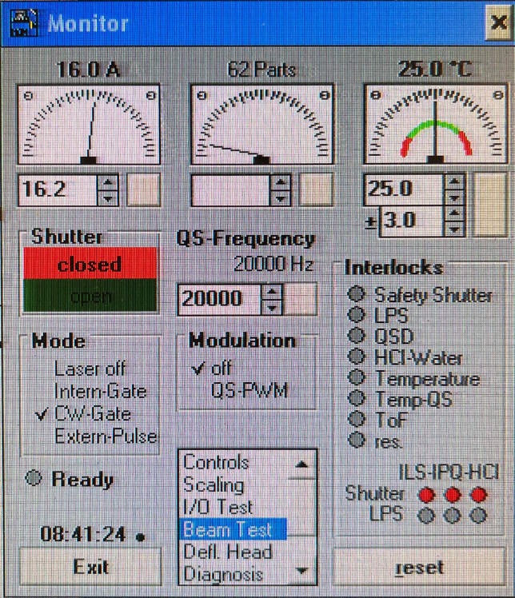**Step 7:** Prepare the power meter for a reading following the general instructions included in Section 3 above. A series of dots will appear on screen when the meter is searching for a reading.

**Step 8:** Minimize the SCM screen, turn off the pilot light and close the etcher door.

**Step 9:** In the upper left hand corner of the StarMark Tools, enter **16.2** into the current box as shown in Figure 6.

**Step 10:** Set the beam test and turn the beam on as shown in Figure 7.

**Step 11:** The power meter will detect laser output and begin a 5 second on-screen countdown. It will then display the power reading.

**Figure 6:** Starmark Tools Current

**Step 12:** Turn the beam off.

**Figure 7:** Beam Test Screen

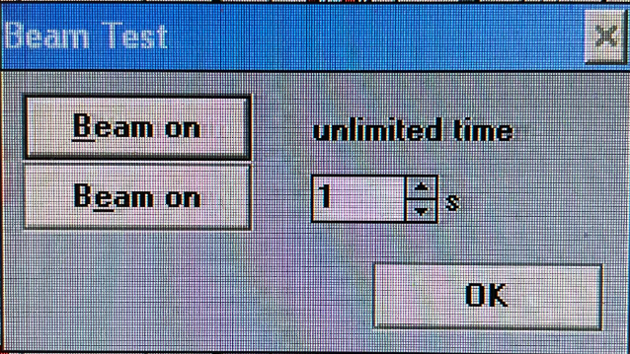**Step 13:** Record the power reading shown on-screen on the power meter on the record sheet in the appropriate location (described in Step 6 of the general instructions above).

**Step 14:** Open the door and remove the power monitor.

**Step 15:** Maximize the SCM screen. The power meter check is complete.

* 1. **Rofin Laser Etcher**

**Step 1:** Power on the machine following the instructions included in TA1263.

**Step 2:** Open the power meter program by scanning the barcode located on the front of the etching machine. The instructions will appear on screen as shown in Figure 9.

**Step 3:** Place the power meter as shown in Figures 1 & 2 above.

**Figure 8:** Power Meter Check Barcode

**Step 4:** Prepare the power meter for a reading following the general instructions included in Section 3 above. A series of dots will appear on screen when the meter is searching for a reading.

**Step 5:** Close the etcher door and run the program.

**Step 6:** The power meter will detect laser output and begin a 5 second on-screen countdown. It will then display the power reading.

**Step 7:** Once the meter is displaying a power reading, turn the beam off.

**Step 8:** Record the power reading shown on-screen on the power meter on the record sheet in the appropriate location (described in Step 6 of the general instructions above).

**Step 9:** Open the door and remove the power monitor. The power meter check is complete.

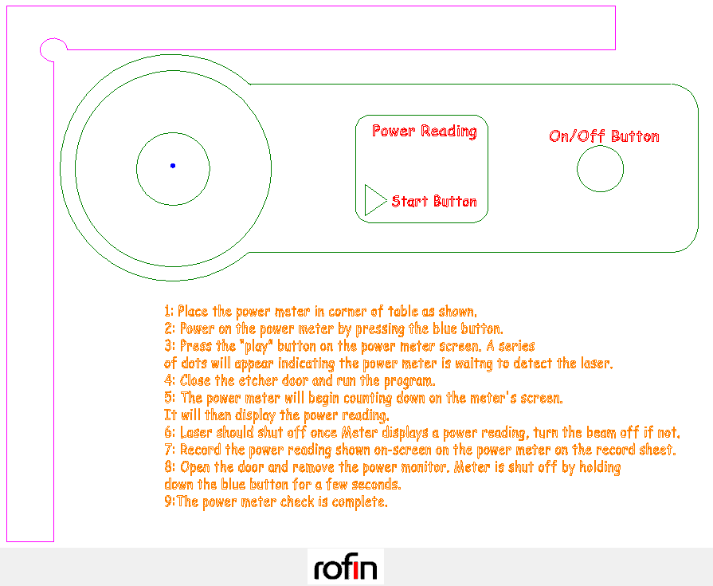

**Figure 9:** Rofin On-Screen Instructions