Purpose:

The purpose of this procedure is to describe the maintenance of the recirculating deionized (DI) water system used in the Microphones Dept. & FlexBeam Dept.

**Responsibilities:**

Microphones Dept. engineering/ management and FlexBeam Dept. engineering/ management are responsible for maintaining this procedure. Microphones Dept. and FlexBeam Dept. employees are responsible for carrying out this procedure.

**1.0 General Description of System**

The DI water system is installed in the room across from the Microphones Clean Room. It provides high purity water for various processes in the affected departments by deionizing city water. The purity of the water is achieved using a multi-stage, canister mixed-bed system and monitored with an in-line resistivity meter.

Incoming city water goes through a series of 5 ion exchange canisters, which deionize the water. See Figure 1.

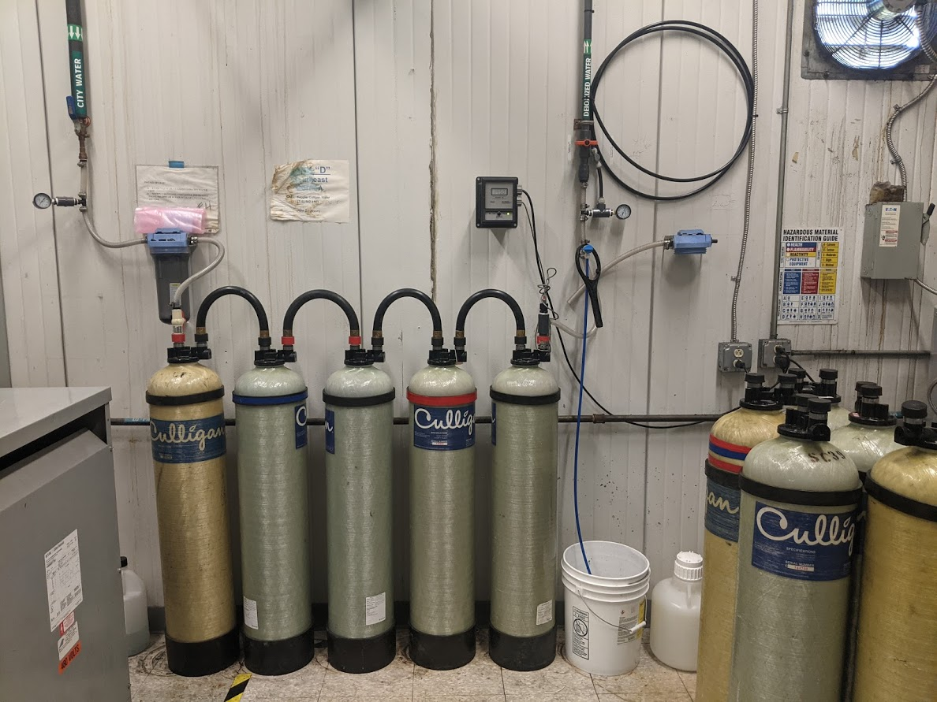

MB

MB

SA

SC

OF

Resistivity

Meter Display

Resistivity

Sensor

Outgoing

Flow Meter

Incoming

Flow Meter

Incoming

City Water

Outgoing

DI Water

Figure . Deionizing 5-Canister System

The level of deionization can be measured by the resistance of the water, as indicated by the resistance meter on the wall. After this stage, the resistance meter should indicate a reading of greater than 10 megohms. It should be noted that water must be flowing across the sensor in order to accurately measure the resistance of the water. See Figure 2.

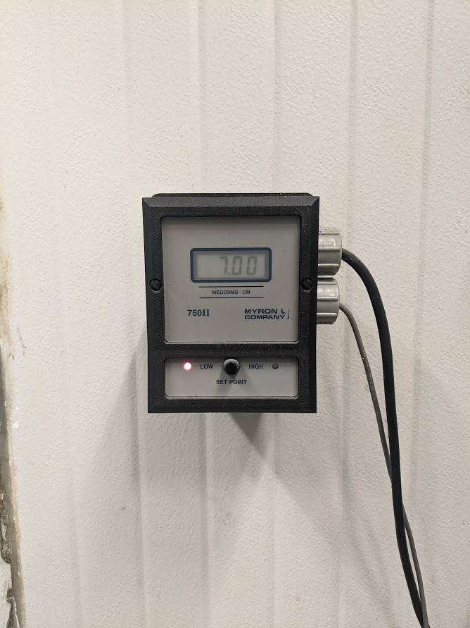 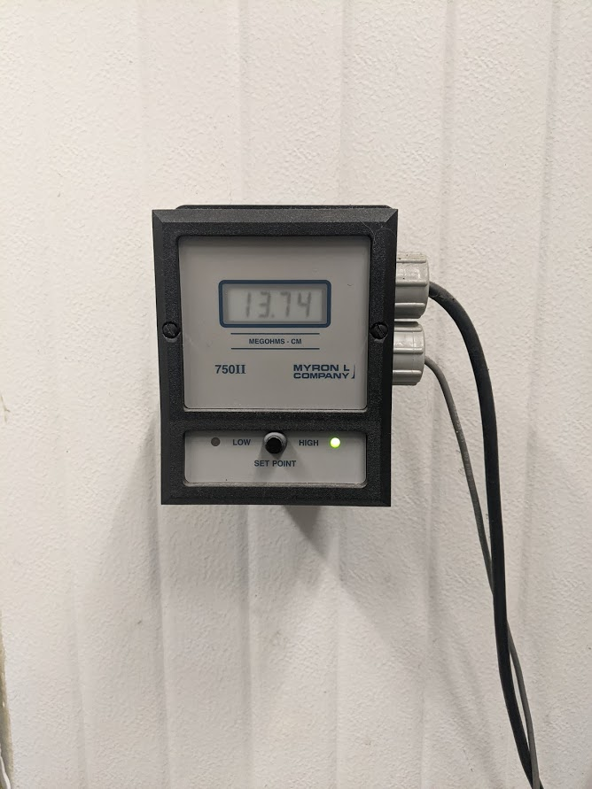

Water Flowing:

Green Light showing passing reading

No Water Flowing:

Red Light showing failing reading

Figure . Resistivity Meter Display

It is recommended to flow water through the system using the valve attached to the blue tube into the bucket. See Figure 3.

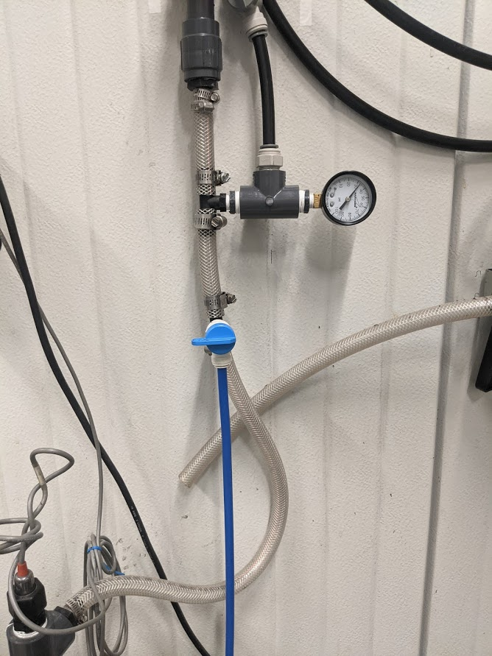

Figure . Bleed Valve

This deionized water feeds the process areas for the Microphones Dept. and the FlexBeam Dept. The Microphones Dept. uses this water in the Humidity Chambers as well as the wash sink spigots labeled as “DI Water” at the sink. These lines are re-routed to the FlexBeam Dept. for use in the Wash Areas.

The bank of canisters which treat the city water, are serviced by Keppler Culligan Water Conditioning. The Culligan canisters are recycled by them when replaced. A set of 5 replacement canisters should be ordered and kept on-hand. **NOTICE: Tanks MUST remain upright at all times.**

**2.0 System Checks**

Check the system daily to make sure it is operating. Read the resistance meter after the five canister system while the water is flowing approximately 5 seconds. It should read greater than 10 megohms. If the reading fails, change the filters per Section 3 (below).

**3.0 System Service**

3.1 If the system needs service, call Keppler Culligan at (716) 542-4501. Request a change of the “Bank D” canisters (also called tanks). The supplier should bring a new set of tanks within 1-3 days, switch them out with the exhausted tanks, and remove the exhausted tanks.

3.2 Tanks can be removed and installed by PCB employees. Proper PPE is required. Steel toe boots or protective toe caps are required. Change out tanks using the following steps:

3.3 Shut off valve for INCOMING City Water. Shut off both valves for OUTGOING DI Water. See Figure 4. Bleed as much water as possible out of tanks using Bleed Valve into bucket. See Figure 3.

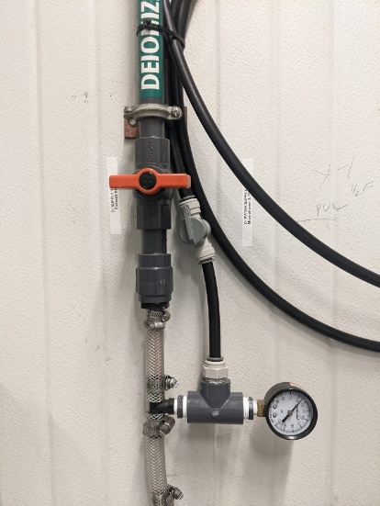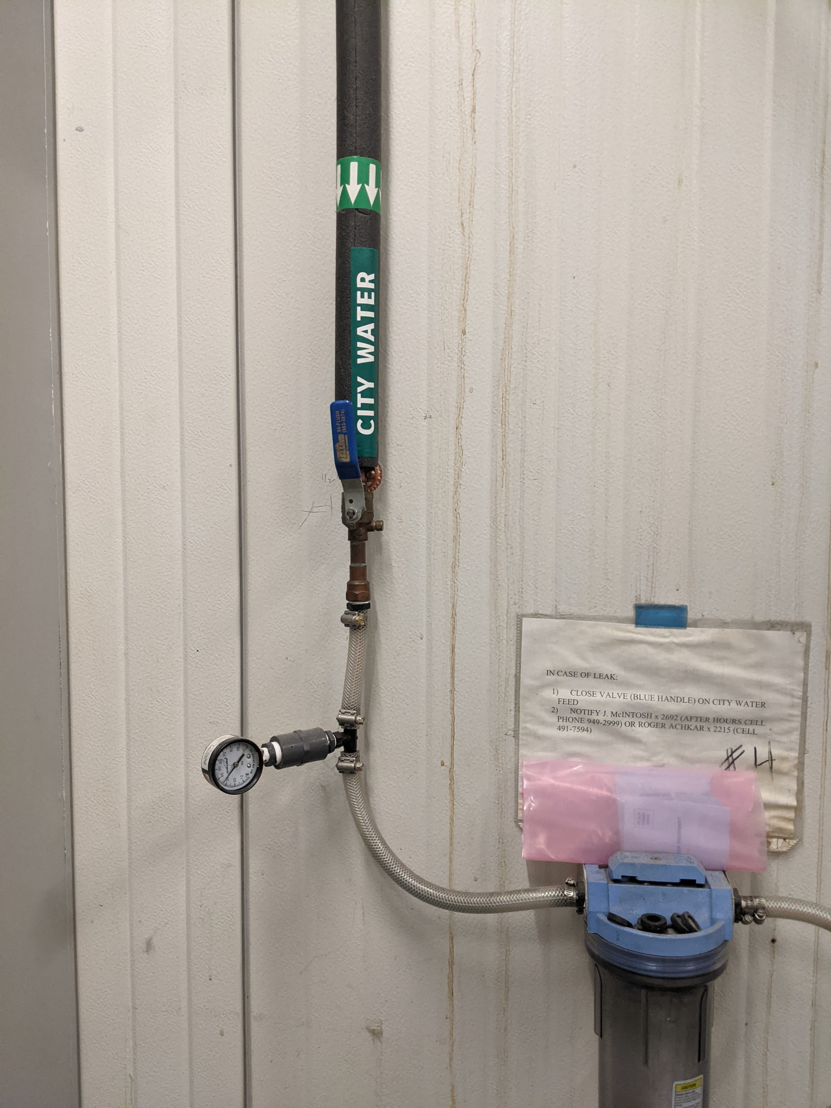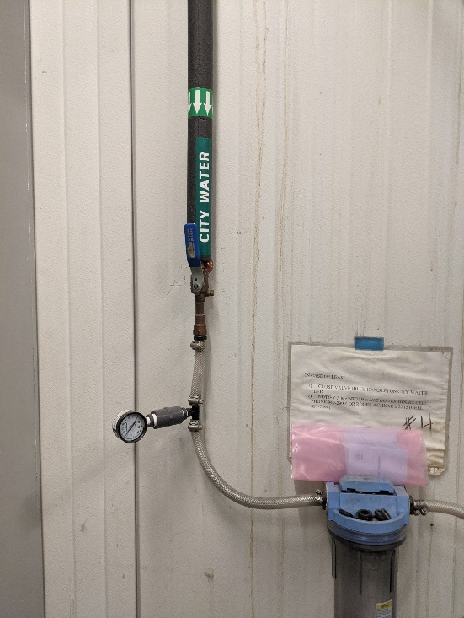 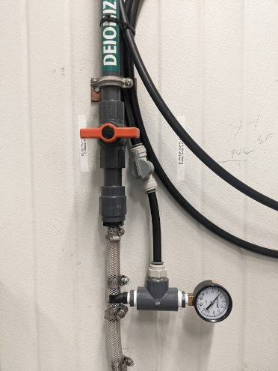

Figure . Shut Off Valves During Tank Change

3.4 Lift plastic collar to expose hose/ tank fitting joint. Tap the hose fitting with a hard object, like a wrench or pliers, to slide the hose off of the tanks. Be prepared for some excess water to spill. See Figure 5.

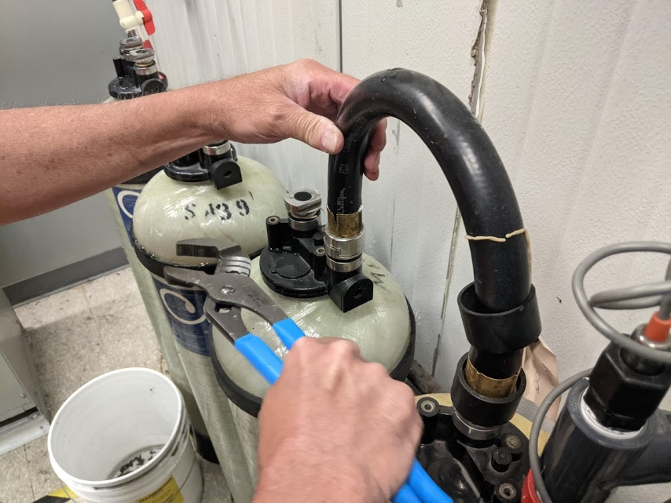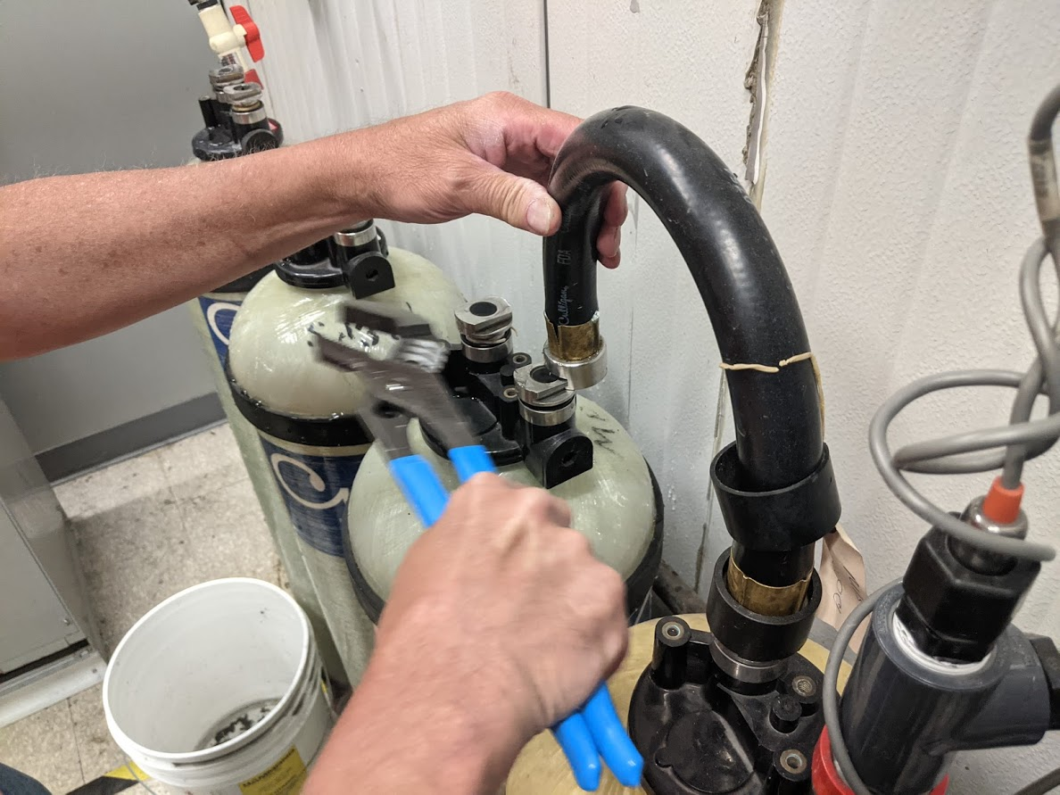

Figure . Removal of Hoses from Tanks - Slide Connectors

3.5 Remove the tanks in order. Observe the markings on the tanks to be sure that the tanks go back together in the same order.  
**NOTICE: Tanks MUST remain upright at all times.**

The proper order of tanks is:

1. OF (Carbon)

2. SC (Cation)

3. SA (Anion)

4. MB (Mixed Bed)

5. MB (Mixed Bed)

3.6 When replacing the tanks, inspect both rubber gaskets inside each hose for cracks, tears or pinches and to ensure proper seating in the channel. When new gaskets are needed, request more from Keppler Culligan and store near tanks. Hoses should be installed with the inlet side on the left and the outlet side on the right. See Figure 6.

 

Outlet

Side

Inlet

Side

Figure . Tanks in Order with Inlet on Left and Outlet on Right

3.7 With OUTGOING Valves closed and Bleed Valve open into bucket, turn INCOMING City Water Valve back on slowly. This will push air out of the system tanks (takes approx. 60 seconds). Once air bubbles are no longer seen in the bucket and water begins flowing steadily, turn off Bleed Valve. Turn on INCOMING City Water Valve fully.  
NOTICE: If Resistivity Meter does not appear to be reading a consistent, steady value then there may be air trapped on the Resistance Sensor. Loosen nut around Resistance Sensor slightly until a small amount of water can be seen leaking out of the line then tighten nut. See Figure 7.

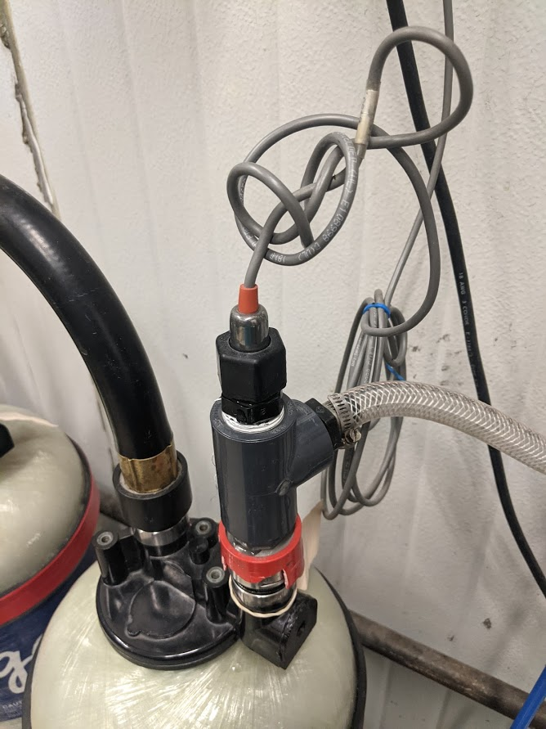

Figure . Resistance Sensor

3.8 Keep unused tanks capped to prevent anything from falling into the inlets. Anything that gets into the openings will get into the water system. See Figure 8.

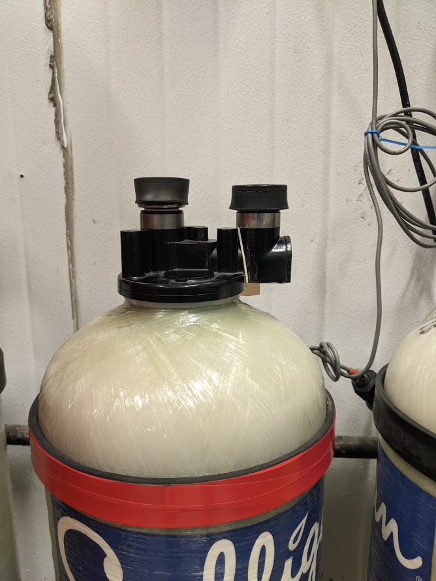 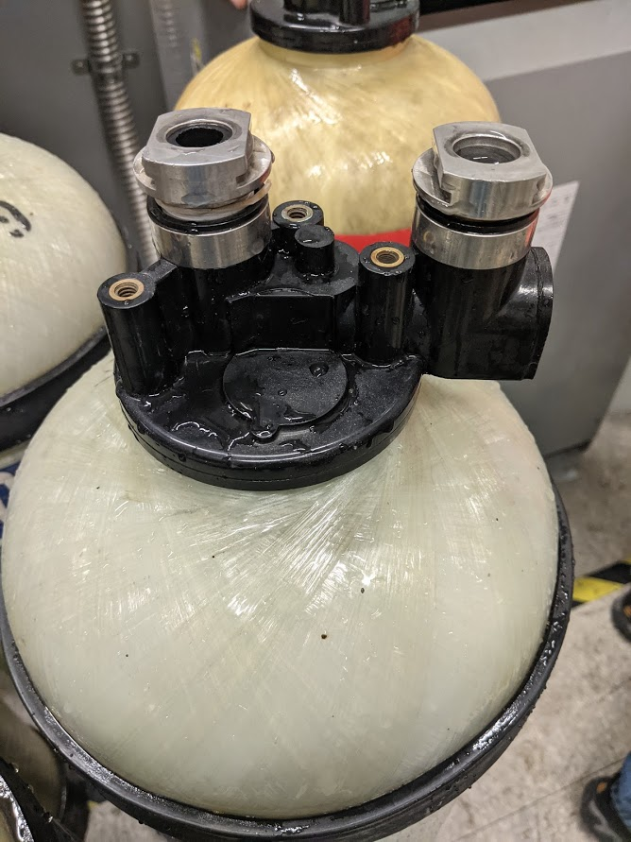

Figure . New Tank Remains Capped Until Put Into Service

3.9 Clean up any spills with a mop or paper towels.