PART #: XXXXXXXXXXXX PROGRAM #: XX
JOB#: _____________________ CREATED FROM BOM REV XX AND DRAWING REV XX

TRAY #1 SETUP: REPLACE HIGHLIGHTED TEXT WITH APPROPRIATE INFO
100-XXXX-XX  6  Mfg. Part Number  BOX: _____ | 100-XXXX-XX  4  Mfg. Part Number  BOX: _____ | 100-XXXX-XX  2  Mfg. Part Number  BOX: _____
100-XXXX-XX  5  Mfg. Part Number  BOX: _____ | 100-XXXX-XX  3  Mfg. Part Number  BOX: _____ | 100-XXXX-XX  1  Mfg. Part Number  BOX: _____
FRONT OF TRAY WHEN ON MACHINE

TRAY SETUP BY: _________ DATE: ________ CHECKED BY: __________ DATE: _______

Tray #1 Part Placement - Boxed Numbers On Image Correspond To Boxed Numbers On Tray Setup Above.
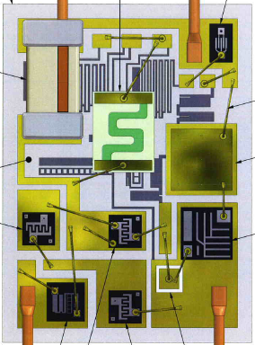
6
6
5
4
3
2
1

