1.0 Purpose 1

2.0 Responsibilities 1

3.0 Associated Documents 1

4.0 General Practice 1

4.1 Commonly used Terms: 1

5.0 Procedure 2

5.1 Job Header Report 2

5.2 Job Pick List 2

5.3 Job Operation Listing Report 4

5.4 Assembly Procedures 8

5.4.1 Basic Layout of an Assembly Procedure: 8

# Purpose

This user guide describes for New Hire Trainees how to read and interpret basic language, terms and layout of the documents in the job paperwork and of assembly procedures.

# Responsibilities

Operations management is responsible for maintaining this procedure.

The Production Training Coordinator and Production Authorized Trainers are responsible for carrying out this procedure.

# Associated Documents

ISO 9001, QAM, QSM, AS9100, TA1039, TA30

# General Practice

Each model manufactured at PCB is produced as part of a job, which has a unique number and set of documents, variously referred to as “job paperwork”, “job packet”, “router” or something similar. The document set accompanies the items being assembled at all stages and is signed by the Technicians/Machinists who work on the job. The standard documents produced for each job include the Job Header Report, Job Pick List, and Job Operation Listing Report, as well as the assembly procedure(s) needed for the model, as listed in the Job Operation Listing Report. Assembly procedures may not be printed because they can be accessed online. Other documents, such as drawings, may also be produced for the job and are attached to the job paperwork as “Doc-Trak” attachments from the Business System Database (BSD).

## Commonly used Terms:

**Bake Out** – to remove moisture from product by placing in oven.

**Bar code** – A sequence of numbers and vertical lines identifying a Job or operation. Used when entering data into Syteline data collection using an optical scanner.

**Cure** – to bring an epoxy to its full strength (hardening) with temperature from ambient to heated ovens.

**Detail** – Check for cosmetics, cleanliness, serial numbers, cal certs, etc. (e.g., nicks, dings, scratches, grease, general appearance).

**Mask (mask off)** – Shield part of something, by covering part of a surface using masking tape before painting or sandblasting.

**Operation** – A numbered item on the job paperwork’s router that contains the information needed for a work center Technician to complete a task, e.g., assembly, welding, calibration, machining, etc. The router usually contains numerous operations, beginning with step 5 listing the materials for the job, then step 10 and subsequent steps describing the tasks for each work center in turn, and ending with step 998 for rework as needed.

**Pot (potting)** – To fill, cover, cap and relieve strain with epoxy.

**Strip** – The removal of insulation or coating from a wire to expose the inner strand(s).

**Trim** – Add capacitor(s) to an element to bring sensitivity within the specified range.

**Zebra Label** – Printer labels used for identifying a sub-assembly, cable, quality box or sensor.

# Procedure

Each type of standard job document is illustrated in the following sections.

## Job Header Report

The job documentation starts with a Job Header Report that provides general information about the job, as shown below:

*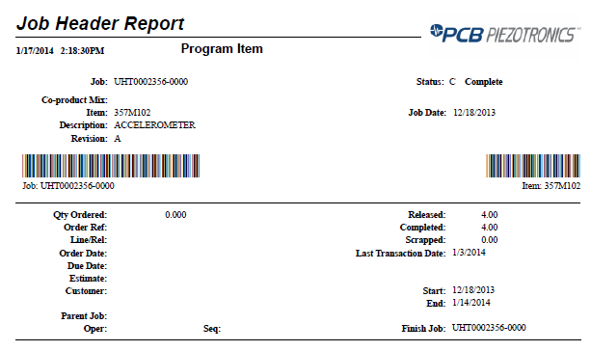

Product no., description and revision of product to be manufactured for job

Number of products to make for job

Job due date

Creation date of job paperwork

Job status

Unique ID number for job

## Job Pick List

The job documentation contains a Job Pick List that lists the materials and items, and their quantities, location and availability, needed for the job. An example Job Pick List page is shown below:

*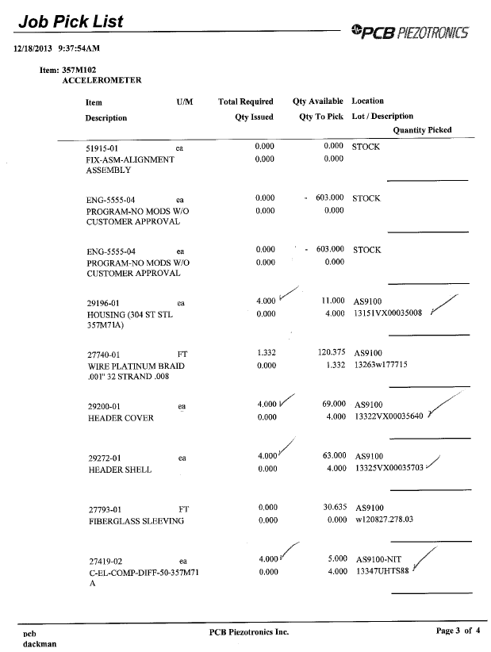

Item no. and description of component

Lot or description of component (see note below)

Location of component

Quantity picked for job

Quantity available in stock

Quantity needed for job

NOTE: Program and applicable ATEX product require lot numbers; example shown is for a program product and thus provides the lot number of the item.

## Job Operation Listing Report

The job documentation contains a Job Operation Listing Report, which provides two types of information unique to the product being built for the job: a bill of materials (BOM) and a routing of manufacturing operations, i.e., a “router”.

The BOM information in the Job Operation Listing Report, usually shown in the first operation (operation 5), specifies the materials, fixtures and other items (e.g., assembly procedures) needed for the job. When available, the BOM identifies each material’s “Bubble Number”, which corresponds to the number used to identify the item on the product’s drawing and may be referenced in the associated assembly procedure. When fixture numbers are available, the bubble numbers also identify them. Note that when the product incorporates a “phantom assembly[1]”, some Bubble Numbers will pertain to the phantom assembly’s drawing and fixture numbers rather than the main assembly’s drawing and fixture numbers.

NOTE: The BOM portion of the Job Operation Listing Report may not be fully contained in one section, i.e., operation 5; in some cases some BOM information may be provided within other operations.

The router information in the Job Operation Listing Report outlines the sequence of operations required to build the product. The first operation, operation 5, specifies the materials needed for the product, as described above, and also provides any notes regarding the product or its history as well as a signoff that the product’s associated assembly procedure has been reviewed. Each subsequent operation describes the work center that will perform the work, the tasks to complete for that operation, and any information unique to the model needed for that operation. The operations must be performed in order and each operation must be signed off before the job can proceed to the next operation, with the exception for cable assemblies noted in TA1039. The final operation, operation 998, is reserved for rework.

**NOTE**: For departments where the hardcopy of the Job Operation Listing has been discontinued (see IC1001), Job transactions in the BSD have replaced physical sign-offs.

Prior to beginning work on an operation, Technicians/Machinists must verify that the previous operation has been properly signed off. If it is not properly signed off, contact the supervisor. **NOTE:** For departments where the hardcopy of the Job Operation Listing has been discontinued (see IC1001), Job transactions in the BSD have replaced physical sign-offs.

**Note:** In the event a hardcopy router operation step is not signed-off, but department supervisor (minimum) confirms Syteline Shop-Trak reporting indicates operation was properly completed, the hardcopy router step may then by signed-off by the supervisor (minimum) by recording supervisor initials (or stamp) before the technician’s initials and date. Some examples: “MK/JL 02/18/2015” –or- “MK for JL 02/18/2015”.

Prior to product movement to the next sequential operation, review all work for quality and quantity.

Technicians/Machinists must initial and date the individual step or group of steps to signify completion and inspection. A controlled stamp issued to the technician/machinist by the QA department may be used in place of the technician’s initials to signify completion and inspection of the steps or group of steps performed. **NOTE:** For departments where the hardcopy of the Job Operation Listing has been discontinued (see IC1001), Job transactions in the BSD have replaced physical sign-offs.

**Note:** The Last Operation on the router is where the transaction is done to put product into inventory. Generally the last operation on PCB’s routers is 998.  Finished goods (sellable product) generally require a final inspection operation just prior to 998. In this instance, the routers should have an operation to route it to the Final Inspection work center (I.E. DFI01) followed by 998.  All other product not requiring final inspection or any other special inspection or stocking instructions, (generally sub-assemblies and accessories), only require the last operation to be 998. Technicians/Machinists are trained to deliver product to central inventory when the next operation on the router is 998.

Example Job Operation Listing Report pages are shown below; the first image is an example of a BOM information page and the second image is an example of a router information page:

*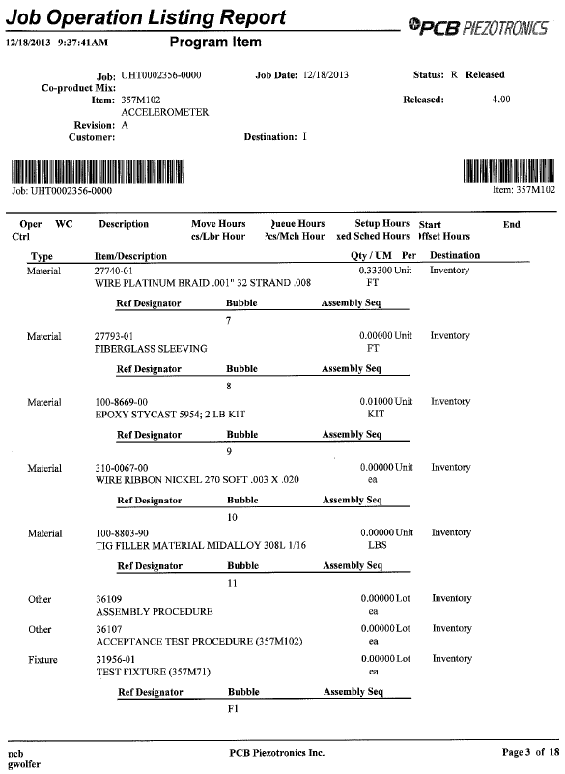

Job number

Fixture number

Type of item

Type of item

Type of item

Quantity and unit of measurement of item, e.g., 1/3 ft. = 4 in.

Item number and description

Bubble number

Product no., description and revision of product to be manufactured for job

Example BOM Information Page

*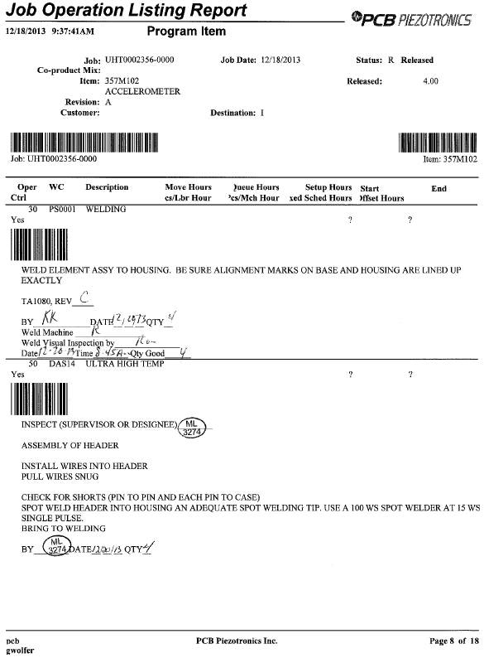

Operation number

Note

Note

Note

Task

Task

Task

Task

Operation number

Work center description (assembly work center)

Work center code

Signoff

Signoff

Op 50

Op 30

Signoff

Note

Task

Work center code

Work center description

Example Router Information Page

## Assembly Procedures

Assembly procedures contain detailed instructions for assembling products and may apply to more than one model. Most procedures are intended to follow along with the router section of a product’s job documentation (referenced in this section as “the router”), although some are designed to describe a procedure common to many products. The first type of procedure is typically listed on the product’s BOM, whereas the latter type (e.g., TA2816) is typically not listed on the BOM but instead is referenced from within another assembly procedure.

NOTE: The router is the controlling document; the assembly procedure must align with the router, not vice-versa. If steps in the assembly procedure differ from steps on the router, perform the steps as specified on the router.

Each assembly procedure should align with the router’s assembly operations (the operations performed in assembly work centers) and provides detailed instructions as needed for performing the task(s) in each operation; some tasks do not require detailed instructions but are included in the procedure for continuity. In assembly procedures using revision B or later of the assembly procedure template (TA088), the end of each assembly operation is indicated by a horizontal line, which indicates that the Assembly Technician should return to the router to determine the next step instead of proceeding directly to the next step in the procedure.

NOTE: Some older procedures may not be in close alignment with routers and may contain instructions for non-assembly operations (e.g., welding, calibration, machining, etching, etc.). These procedures also do not indicate when the Assembly Technician should return to the router and thus should only be performed along with careful review of the router.

### Basic Layout of an Assembly Procedure:

The first page of each assembly procedure provides the procedure’s title, document number, and revision history, a list of documents referenced in the procedure and, in newer procedures, a table of contents of all of the assembly tasks in the procedure. The title, which identifies the pertinent model(s) for the procedure, and the revision history table allow Assembly Technicians/Machinists to verify they are using the correct procedure, and version, to build the product. When a table of contents is provided, it uses horizontal lines to indicate the ends of the assembly operations.

The assembly procedure follows the same order as the router. Each of the tasks in the assembly procedure, which correspond to the tasks on the router, is indicated by a heading. If the task has detailed instructions, they will be contained in the section following the task heading. If a task does not have detailed instructions, it will immediately be followed by the heading of the next task. For newer procedures, when the task is the last task in an assembly operation, the last line in its section (or the heading itself if there are no detailed instructions for the task) will be followed by a horizontal line to indicate that it will be necessary to return to the router to determine the next step.

The detailed instructions in each task section are numbered in sequence and may be accompanied by unnumbered notes, which contain supplemental information for the instructions. Be aware that the router may also contain notes that may not be present in the assembly procedure. The task instructions in many cases are accompanied by photos or drawings to illustrate the actions to be performed. The assembly procedures may reference bubble numbers to identify materials, especial “zero quantity” items like epoxies, wires, etc. [e.g., “Pot solder joint with epoxy (item 2).”], or fixture numbers to identify fixtures. Assembly procedures may also reference other procedures; when that is the case, it is important to maintain the sequence of tasks specified on the router and primary assembly procedure. Example pages from an assembly procedure are shown below.

*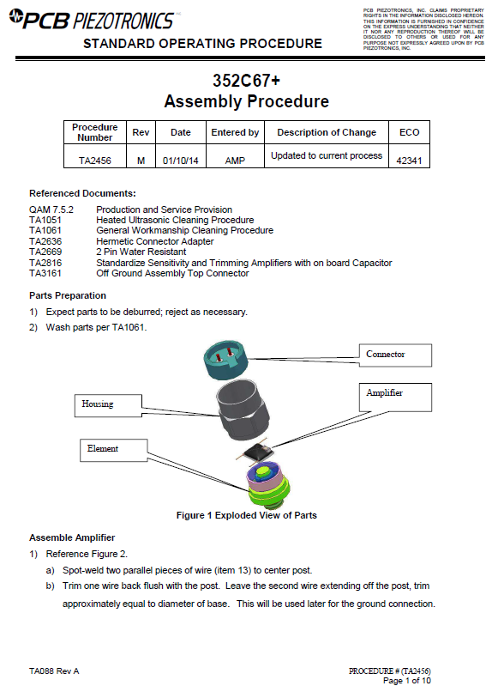

Bubble Number Reference

Procedure Number

Procedure Revision

Procedure Number

Procedure Title

Task Heading

Task Heading

Example Assembly Procedure Page, Earlier Format

*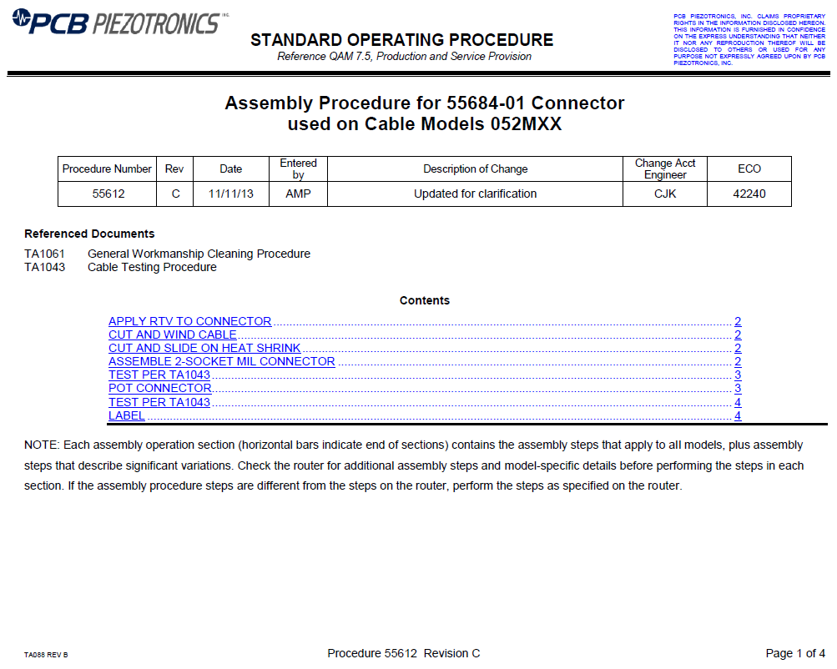

Horizontal line indicating end of operation on router

Initials of Engineer who implemented current revision

Procedure Number

Procedure Revision

Procedure Title

Procedure Number

Procedure Revision

Example Assembly Procedure Page 1, Current Format

*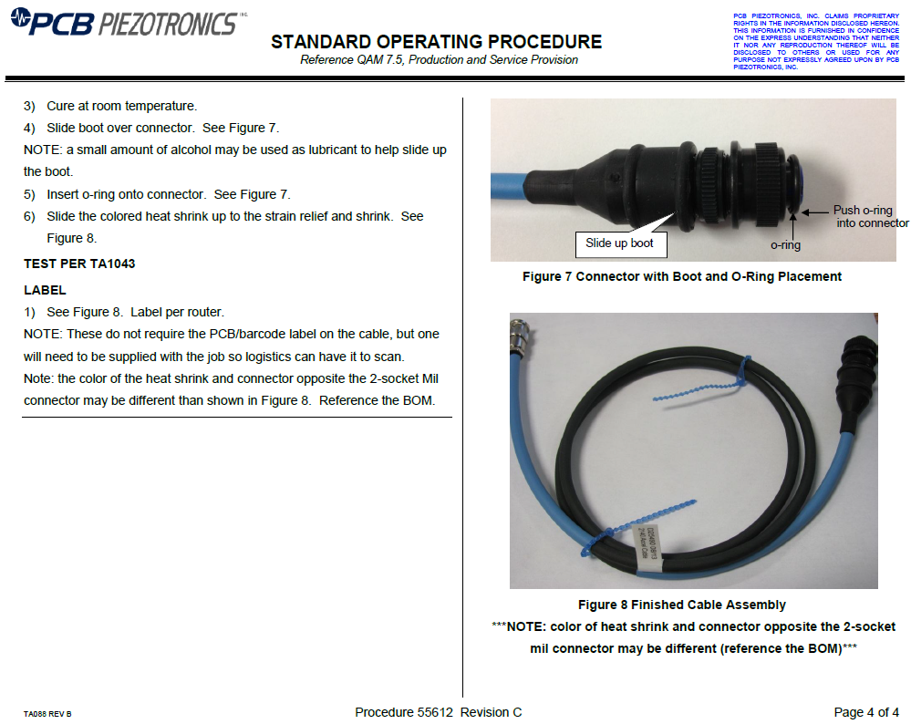

Images on same page as associated text

Images on same page as associated text

Horizontal line indicating end of operation on router and need to return to router for next step

Task Heading

Procedure Number

Procedure Revision

Task Heading

Example Assembly Procedure Last Page, Current Format

1. A “phantom assembly” is a subassembly that is built only when it is needed for a higher-level assembly. It usually has its own unique drawing and BOM but does not have its own router; the router information needed to build it is provided only on the main assembly’s router.