# Purpose:

To monitor and record data to qualify the system's accuracy.

# Procedure:

1. The equipment listed below is used during this test and is calibrated per ISO 10012-1 and former MIL-STD-45662A. The calibration records are on file.
   1. 2201 power supply
   2. 2221 power supply
   3. CAL250 calibrator
   4. PRM915 preamplifier
   5. PRM902 preamplifier
   6. PRM902LF preamplifiers (REF & UUT)
   7. 4192 Reference Standard Microphone or equivalent
   8. Daily Sensitivity Verification Microphone
   9. Daily Low Frequency Verification Microphone
   10. Low Frequency Reference Microphone
   11. Agilent 34401A Multimeter (or equivalent)
   12. DAQ Card
2. The equipment listed below is used during this test and no calibration is required.
   1. MTS microphone test system
   2. ADP005 capacitor
   3. Computer
   4. Break-out Box (BNC)
   5. All necessary cabling and adaptors

Microphone Calibration System Verification Procedure  
Note: Whenever a CAL250 Calibrator, a 2201 power supply or either a PRM902 or PRM915 preamplifier is altered or replaced, you must Recalibrate the CAL250; this includes battery changes in the CAL250.  
Note: Notify Engineer (or ATE) when a PRM902 is changed so they can alter the Sensitivity Correction value.

1. Open the Station Daily Verification (TC027) spreadsheet file appropriate for the Cal Station being used
   * 1. The file is located on the network. (R:\Calibration\General\CAL\Verification trends)
2. Perform a Voltage Insertion Sensitivity calibration per procedure IP601-10.
3. Install the Sensitivity Daily Verification Microphone on PRM915.
   * + 1. The SN for the Verification Microphone is indicated at the top of the “Voltage Insertion SYSCHECK” worksheet.
       2. If the Sensitivity Daily Verification Microphone is replaced, shocked or dropped, **inform engineering immediately**. It will need to be replaced or recalibrated per AT613-9 using a secondary system to ensure it did not shift. The Daily Sensitivity Verification Microphone should be on a regular PM schedule calibrated with a secondary system.
4. After Voltage Insertion calibration is complete, record the Technician Initials, Date, and Sensitivity in the “Voltage Insertion SYSCHECK” worksheet.
5. If the sensitivity is inside the yellow limit lines, the calibration system is in spec. Proceed to next step.
6. If the sensitivity is outside the red limits, **notify engineering immediately**.
7. If the sensitivity is outside the yellow Recal limits and inside the red limits, proceed to CAL250 Recalibration section of this procedure; after recalibration of the CAL250, repeat the Voltage Insertion calibration on the Daily Sensitivity Verification Microphone. Record new value in the “Voltage Insertion SYSCHECK” worksheet.
8. Perform a CAL250 Sensitivity calibration per procedure IP601-10.
9. Install the Sensitivity Daily Verification Microphone on PRM902.
10. The SN for the Verification Microphone is indicated at the top of the “CAL250 SYSCHECK” worksheet.
11. If the Sensitivity Daily Verification Microphone is replaced, shocked or dropped, **inform engineering immediately**. It will need to be replaced or recalibrated per AT613-9 using a secondary system to ensure it did not shift. The Daily Sensitivity Verification Microphone should be on a regular PM schedule calibrated with a secondary system.
12. After CAL250 calibration is complete, record the Technician Initials, Date, and Sensitivity in the “CAL250 SYSCHECK” worksheet.
13. Compare sensitivity values from Voltage Insertion and CAL250; they should be within 0.05 dB of each other.
14. If the sensitivity values are within 0.05 dB, the calibration system is in spec and ready to be used.
15. If the sensitivity values are not within 0.05 dB, **notify engineering immediately**.
16. If the sensitivity is outside the yellow limits and inside the red limits, proceed to CAL250 Recalibration section of this procedure; after recalibration of the CAL250 start over from beginning of this procedure.
17. Daily Verification microphone performance shifted (ex. Out of tolerance, large shift in output, dropped or shocked)  
    Note: A true shift in microphone performance can be confirmed by testing on multiple stations.
18. If Daily Verirication microphone is unusable, inform Supervisor immediately.
19. To proceed with validating calibration station, a previously confirmed good microphone may be used with approval from the Supervisor accompanied by their signature on the preflight checklist (TA160).
20. Acquire a microphone (preferably from inventory) that has completed 3rd Precalibration. Recall the calibration certificate to acquire the Voltage Insertion sensitivity in dB from: R:\Calibration\general\CAL\377SeriesMicrophones.
21. Install the new microphone on any station needing validation and perform Voltage Insertion sensitivity and CAL250 sensitivity steps from above. The sensitivity of the new microphone must be:
22. In tolerance if the sensitivity is **+/- 0.094 dB** from value on Calibration Certificate.
23. Needs recalibration of CAL250 if the sensitivity is **+/- 0.188 dB** from value on Calibration Ceritificate.
24. Out of tolerance if the sensitivity is greater than 0.188 dB from value on Calibration Certificate. DO NOT PROCEED with use of that station.
25. Record the sensitivity values in the Station Daily Verification (TC027) spreadsheet and the SN of the new microphone in the **NOTES** field.  
    NOTE: The spreadsheet may indicate that the value is Out of Tolerance. **DO NOT** refer to the spreadsheet for Pass/ Fail classification.
26. To qualify a new Daily Verification microphone for permanent use, see Appendix A.

Low Frequency Test  
Note: Whenever a low frequency preamplifier or 2221 power supply is changed, you must perform the Preamp Cal as described in procedure IP601-14.

1. Select Model “LowFreqVerify” from Model Select Window.
2. Enter the Serial Number of the Low Frequency Daily Verification Microphone.
3. If the Low Frequency Reference Microphone or Low Frequency Daily Verification Microphone is replaced, shocked or dropped, **inform engineering immediately**. It will need to be replaced or recalibrated to confirm the level of shift.
4. Calibrate the Low Frequency Daily Verification Microphone per IP601-10 with the following exceptions:
5. Perform the test using the Mic Verification button instead of Run Test.
6. Test button will display “Verifying” while running (Figure 1)

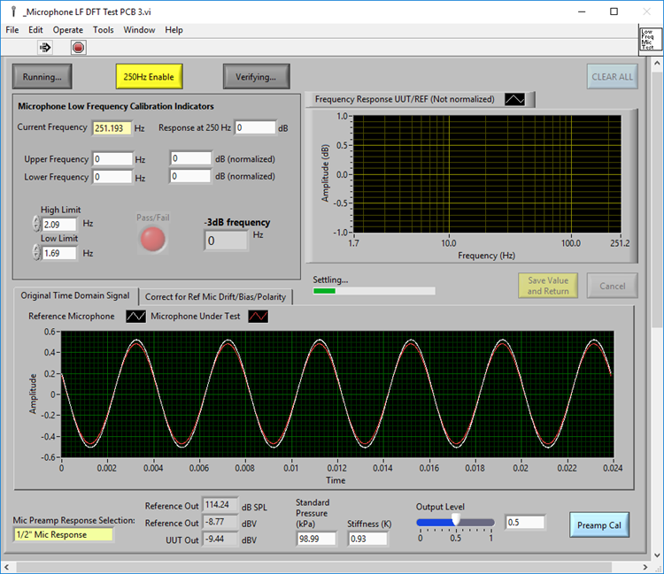

Figure 1. Low Frequency DFT Test Window

1. Once the -3dB test completes, the MicDailyStdVerifyUI window appears (Figure 2) indicating pass/fail and displays both a table with the last 10 Verification results and a % Deviation plot of the LF Corner of the last 10 Verification results.
2. Press <SAVE> button.
3. If the test displays a passing result, the calibration system is in spec and ready to be used.
4. If the test displays a failing result, confirm proper test set-up per IP601-10 and repeat test. If tests fails again, **inform engineering immediately**.
5. Press <EXIT> to close the verify window.

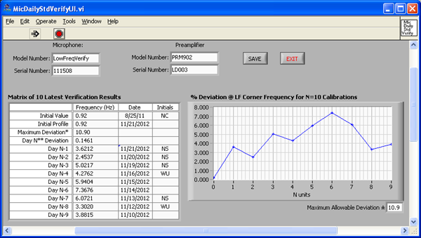

Figure 2. Low Frequency Daily Verify Window

# CAL250 Recalibration

1. Record the Technician Initials and Date in the RECAL worksheet.
2. Place 34401A multimeter near MTS calibration base. Insert Double Banana Plug-Female BNC adaptor into INPUT (Figure 3) with tab pointing down.

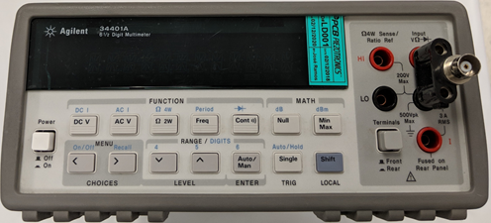 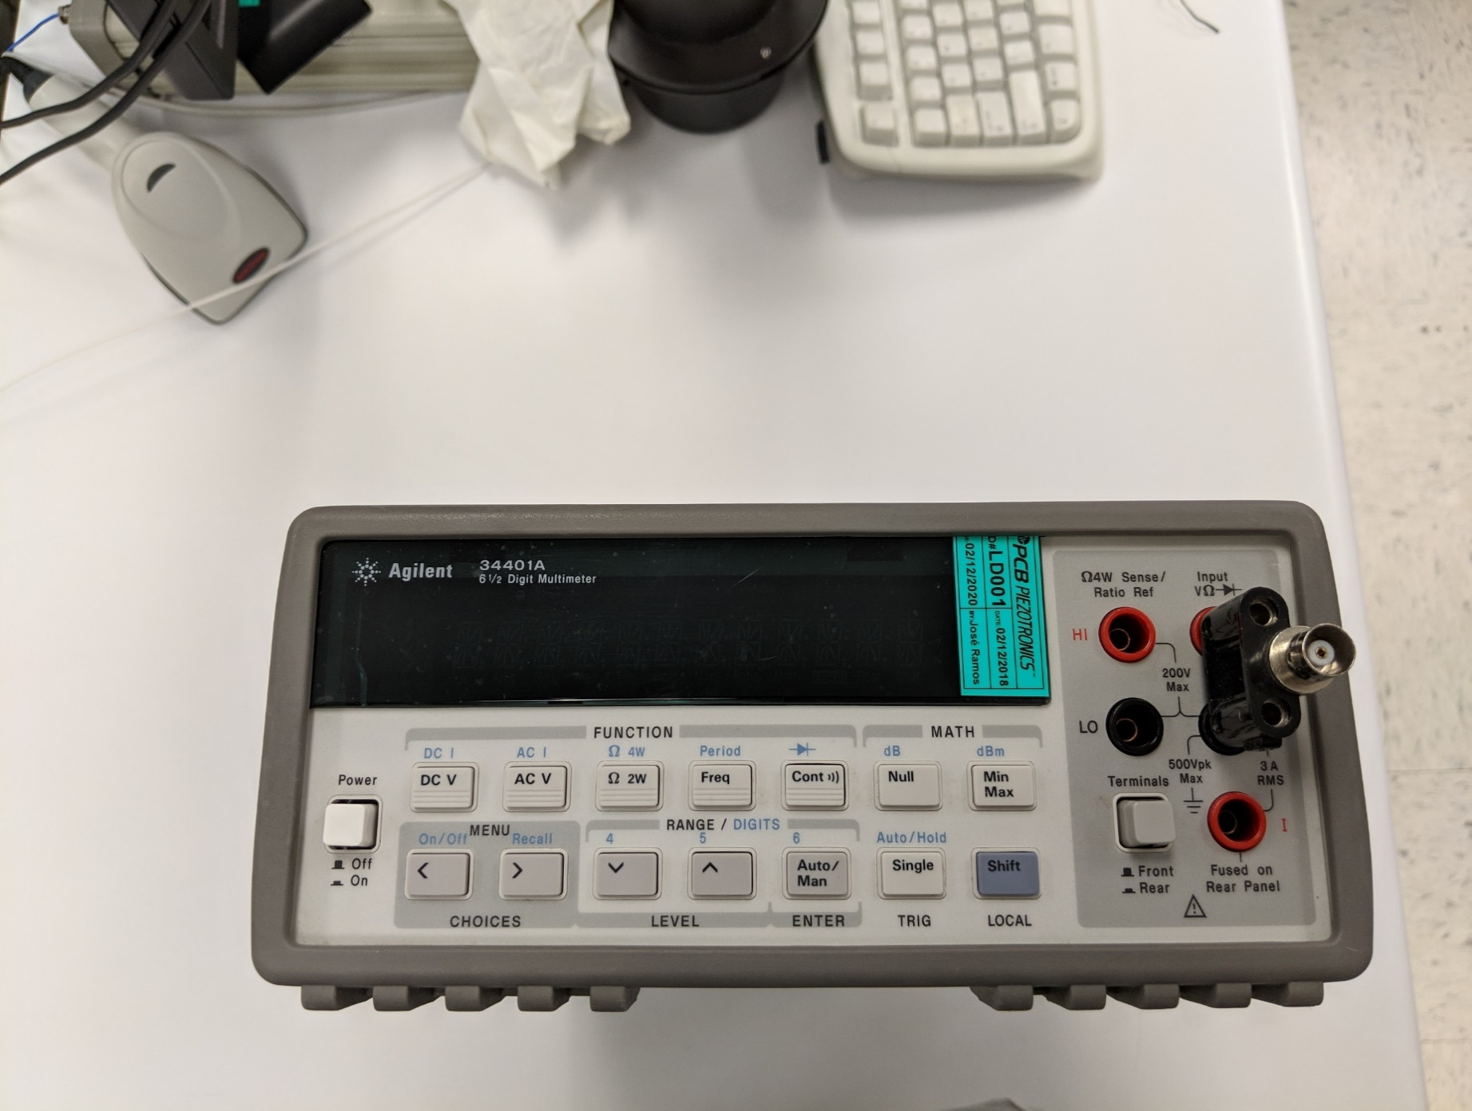

DC V

Tab Down

Figure 3. 34401A Multimeter

1. Use LEMO-to-BNC cable
2. Plug the LEMO connector into the MTS base.
3. Plug the BNC connector into the Double Banana Plug-Female BNC adaptor in the 34401A multimeter.
4. Turn the 34401A power ON
5. Set to read VOLTS DC (VDC).
6. Press DC V button.
7. Make sure that the 2201 is on, and the microphone bias is set to 200V.
8. When the voltage readings stablize (about 90 seconds), record this INITIAL VOLTAGE in the RECAL worksheet.
9. Target voltage is 199.95 to 199.99 volts (which accounts for impedance of voltmeter). Adjust the voltage (as needed), using an adjustment tool through the top of the 2201, by **very slightly** turning the potentiometer (variable resistor). After each adjustment allow the voltage to settle (about 45 seconds). Record this SET VOLTAGE in the RECAL worksheet of the Daily Verification file.
10. Remove the LEMO-to-BNC cable.
11. Setup the microphone calibration system for voltage insertion sensitivity test per procedure IP601-10.
12. Install Reference Standard Microphone (Model #4192) attached to a PRM915 into MTS base.
13. The most recently calibrated Reference Standard Microphone should be located in the work area.
14. The serial number of this microphone needs to be updated in the appropriate Precision Microphone Database file.
15. Information is in Equipment list.
16. File located on the network at R:\Calibration\vibration.
17. There should only be ONE Reference Standard Microphone accessible at a time.The rest of the Reference Standard microphones should be kept in the Microphone’s Lab until they are needed in production or are recalibrated at a certified metrology lab.
18. If a Reference Standard Microphone is shocked or dropped, **inform engineering immediately**. The microphone should be calibrated with a secondary system per AT613-9 to ensure it did not shift.
19. Select Calibrate CAL250 under Equipment tab in 377 Mic Cal program.
20. The Calibrate CAL250 window will open (Figure 4).

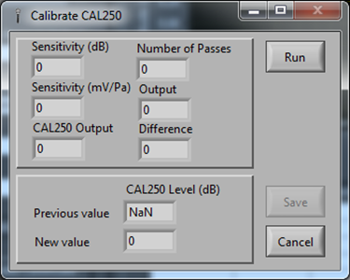

Figure 4. Calibrate CAL250

1. Set microphone bias voltage on the 2201 Power Supply to 200V output. Be sure CAL250 with appropriate adaptor is securely on microphone and plug the wire into the MTS base. Turn the calibrator on at the front switch of the MTS base. Allow calibrator to warm up for minimum 30 seconds.
2. Press the Run button. Calibrator Serial Number window appears (Figure 5).

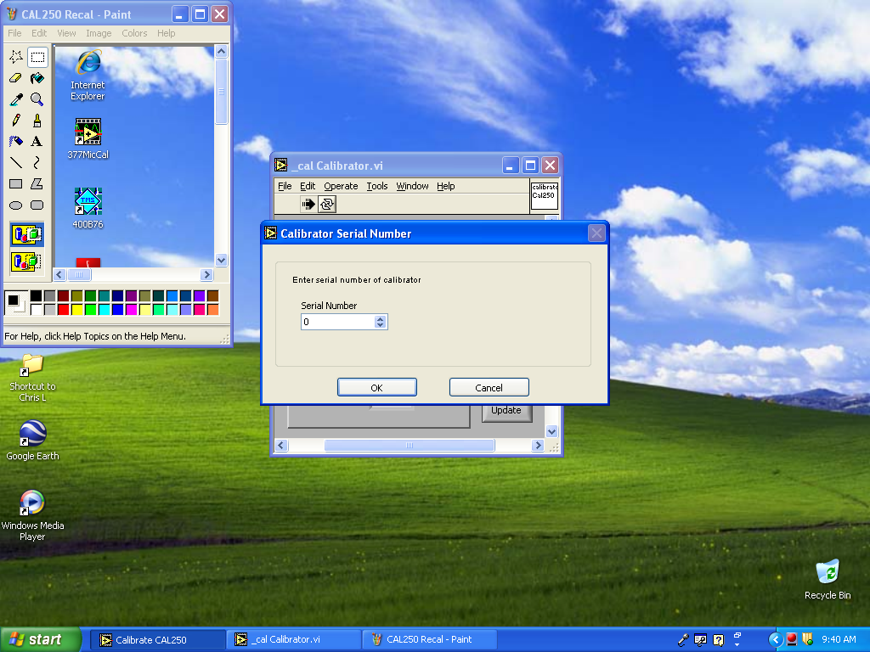

Figure 5. CAL250 Serial Number Window

1. Enter the CAL250’s serial number and click OK.
2. If the serial number does not match, go to C:\377MicCal, open the configuration settings notepad file “CAL250.ini” (Figure 6).
3. Change the Serial Number to that of the CAL250’s serial number and save it.
4. Repeat process.

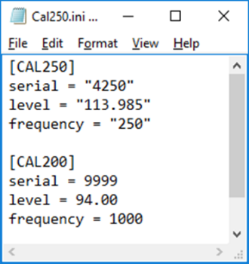

Figure 6. CAL250 Configuration File

1. Enter the sensitivity (dB value at 250Hz) of the Reference Standard Microphone (Model #4192) in the Calibrator window and click OK. This value should be on the outside of the microphone box.
2. The software will prompt to turn on the CAL250; the CAL250 should already be turned on. If switch was not turned on previously, allow the calibrator to warm-up for minimum 30 seconds. Press OK.
3. The software will then prompt to turn off the CAL250; turn the MTS base switch off. Press OK.
4. New values will appear in the CAL250 Calibrator Screen. Press Update.
5. Record the CAL250 Serial Number and the New Value of the CAL250 Level in the Recal worksheet of the Daily Verification file.
6. Important: Turn off the bias voltage on the 2201.

# Appendix A

Qualification of New Daily Verification microphone

1. Engineer is required for finalization of this process.
2. Select new microphone to use from Inventory location for 377B02 Main Assembly (ex. 25242-18).
3. Have new microphone SN issued from Inventory by planner or Inventory Control clerk.
4. Set-up for calibration of new microphone in Mics Lab per AT613-9 Insert Voltage Calibration section.
5. Open SENSITIVITY program from Calibration Programs folder on Desktop.
   1. Select Calibration Type – CALIBRATOR
6. Install Lab Standard microphone (B&K Model 4180) onto PRM915. Turn on 200V for External polarization.
   1. Lab Standard microphone has no grid cap and a thick, gold diaphragm ring.
   2. Handle Lab Standard microphone by plastic protective cap **AT ALL TIMES!!!**
   3. Once installed onto PRM915, remove protective cap and place microphone into CAL250.
7. Open most current ALL REFS SENSITIVITY file from: R:\Engineering\Microphones\Reference Standards
   1. Open tab for B&K 4180 in use.
   2. Enter last calibrated sensitivity value (in dB) from accredited lab [ex. DFM] into Microphone Sensitivity field of SENSITIVITY program.

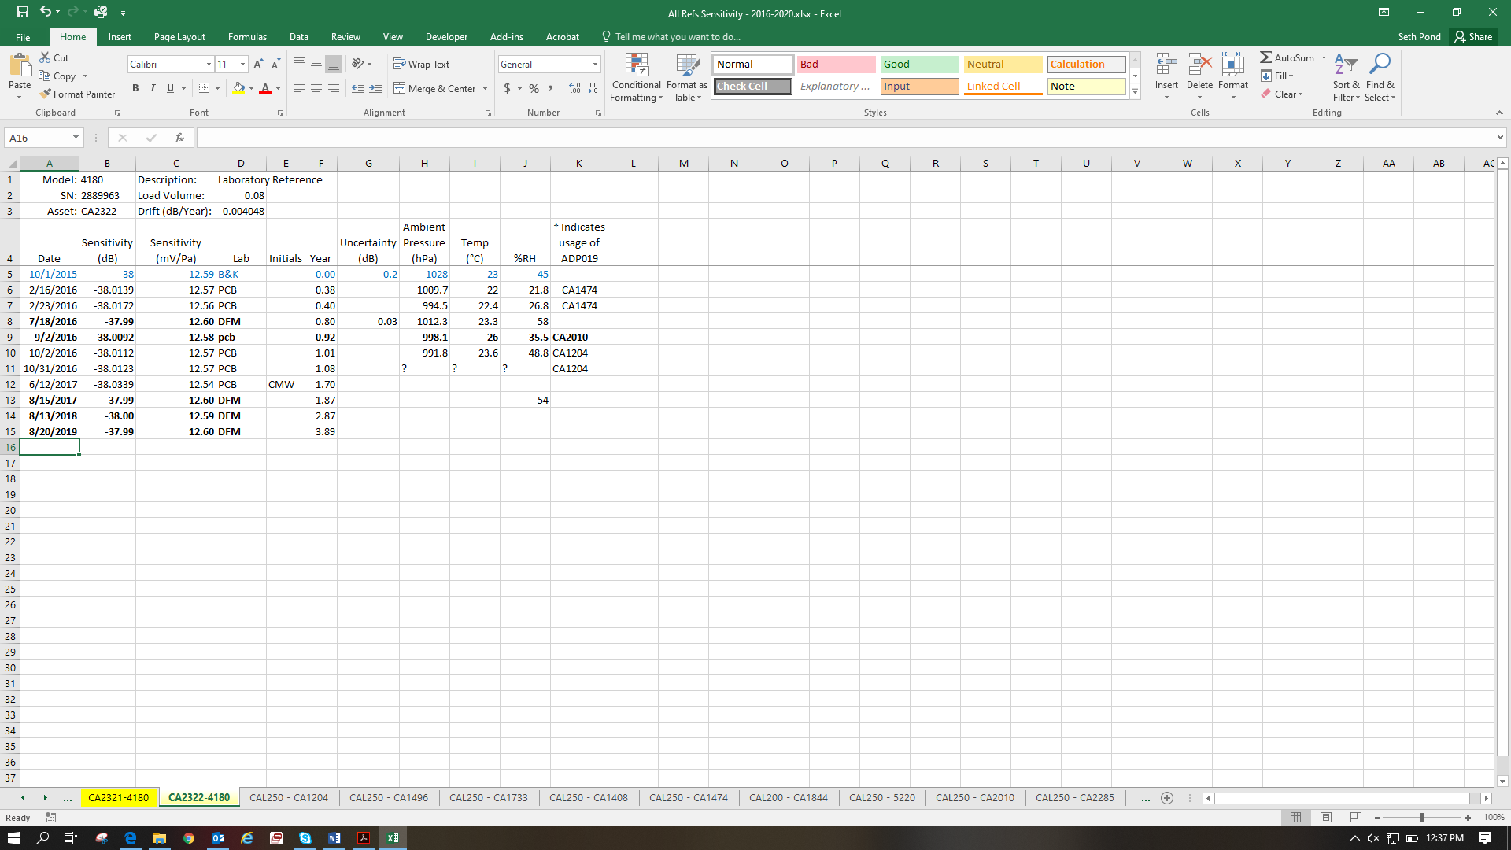

Most recent calibrated value



4180 Tab

Figure 7. ALL REFS SENSTIVITY File

1. Perform Voltage Insertion calibration of Lab Standard microphone per AT613-9.
2. After SPL value of Calibrator is established, open CAL250 tab in ALL REF SENSITIVITY file for asset number of CAL250 used. Complete all fields with information.

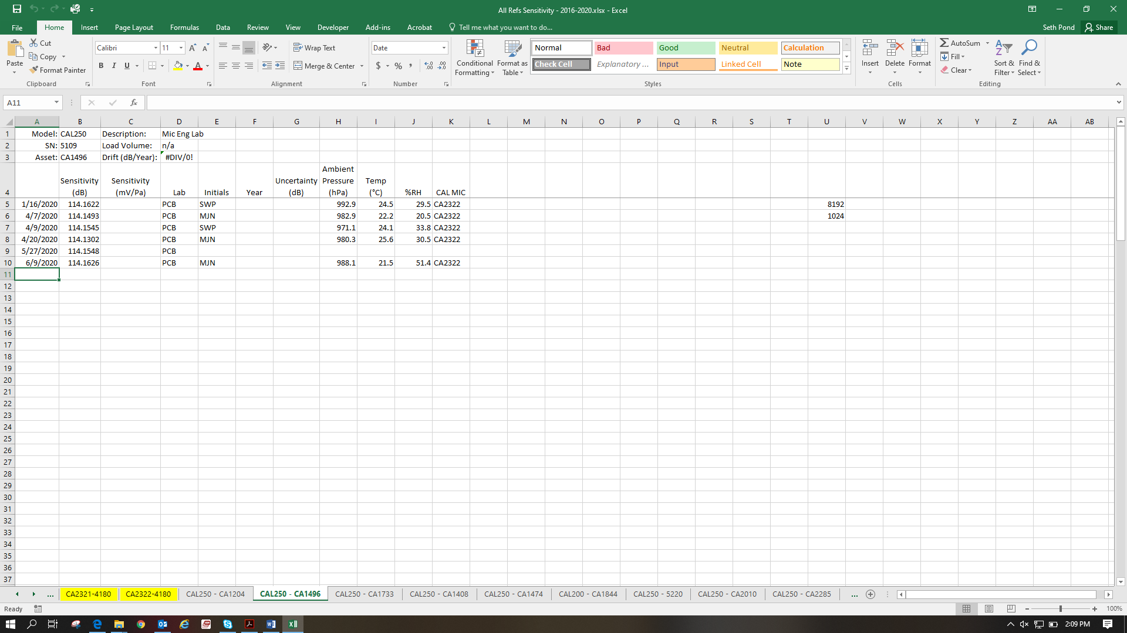

Update all fields



CAL250 Tab

1. Change Calibration Type to Microphone. Enter CAL250 SPL value into Calibrator Sound Pressure Level (in dB) field.
2. Turn off 200V. Install new Daily Verification microphone onto PRM915.
3. Perform Voltage Insertion sensitivity on new mic per AT613-9.
4. Ensure value is stable. Repeat calibration if necessary.
5. Provide to Engineer:
   1. Microphone SN.
   2. Microphone sensitivity.
6. Engineer:
   1. Inform QA dept. of the CA number of the Daily Verification asset along with the updated SN and sensitivity. Request new green CA stickers for new Daily Verification mic.
   2. Update all DAILY VERIFICATION TREND files with the new SN, nominal sensitivity, and test limits into the graphs.