900M12 System
Transverse Verification

Purpose:
The purpose of this procedure is to provide a means of verifying the 900M12 transverse test apparatus. This includes the verification of the resulting maximum transverse sensitivity and relative angle of maximum transverse measured on a pre-selected verification sensor as calculated through the system software. This test is performed weekly as used.

Responsibilities:
The Calibration Technical Manager is responsible to maintain this procedure. The Calibration test technicians are responsible to follow this procedure.

Affected Department / Product Group / Support Group:
TC vibration, IMI, AS9100, NC departments and including repairs

Associated Documents:
ISO 9001, QAM, QSM

Procedure:
- A suitable sensor is selected from stock and identified as the “verification sensor”. This sensor is qualified for use in the R&D department by meticulously measuring the transverse sensitivity and angle of maximum transverse on a shaker table. (A sample report is included in this procedure as figure #1). The location of the angle of maximum transverse is physically laser etched onto the verification sensor and is used for comparison during this process.
- Use the same test setup as described in the acceptance test AT-322-2. Mount the verification sensor onto the test apparatus and connect the output to the test signal conditioner input.
- Make a test profile for the verification sensor including the nominal sensor sensitivity, frequency, offset, number of samples and voltage level for the actuators. Once determined, this profile shall be used for all systems requiring verification.
- Run the transverse test and observe the performance of the verification sensor.
- The resulting polar plot generated for the verification sensor shall indicate the maximum transverse sensitivity and angle.
- Acceptable tolerance in transverse sensitivity is +/- 0.5% from the original value of the verification sensor obtained from the R&D result.
- Acceptable tolerance in maximum transverse angle is the position of the laser mark on the verification sensor relative to the mounting plate +/- 10 deg from the resulting polar plot display.

NOTE: This angle may display 180 degrees from the laser mark.

Example:

If the original R&D transverse sensitivity for the verification sensor is identified as 1.0 %, and the resulting polar plot of the verification result indicates a maximum angle of 50 deg, the acceptable deviation for a “pass” verification is 0.5% to 1.5% maximum transverse and the laser marking on the verification sensor should fall between 40 deg and 60 deg as observed on the test fixture plate.

- Any deviations in excess of the tolerances mentioned above shall be brought to the attention of the department supervisor. Transverse testing shall resume only after the cause of a failed verification is identified and corrected.

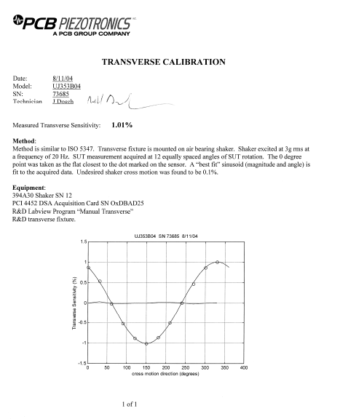
Figure #1

- The transverse software prompts the calibration technician to perform this test based on an approximate 7-day interval. The results are recorded into a verification database along with the technician initials as evidence of test application.
- The verification trend spreadsheet (TC027, located in R:\calibration\general\cal\verification trends\transverse verification.xls) is reviewed periodically and analyzed as part of the A2LA task group meeting.

Referenced Documents:
AT-322-2, TC027

Unusual Conditions:
N/A

