Specification Control

Purpose:

The purpose of this procedure is to insure that the specification used for reference during calibration for acceptance of products tested within the calibration department is the latest revision released from the drafting department.

Responsibilities:

The Calibration Technical Manager is responsible to maintain this procedure and the calibration technicians are responsible to follow this procedure.

Associated Documents:
ISO9001. ISO17025, QSM, QAM

Procedure:

- There are various locations for product specifications accessible by the calibration and other departments. The hierarchy is listed below:

- The most current products will most likely be located in the web spec database. When a finalized specification is released from drafting, it is published in the web spec database for access http://www.pcb.com/admin/products.
- Models less current or in lower demand may be accessed by using DOCTRACK in the Syteline System Database.

NOTE: The most current specifications and outline drawings are located in the ‘scanned originals’ directory on the G drive.

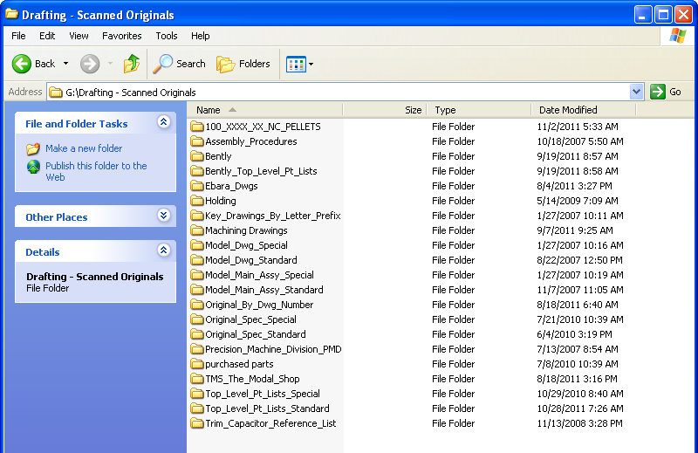
- Older models still in minimum demand may be accessed as a WORD document from the “G” drive in G:\USERS\specs\MODELS
- On occasion, customer supplied product returned for calibration may be an obsolete model and the specification has to be retrieved by contacting the drafting department for availability.
- Customer supplied product in the form of a competitor model that is sent in for calibration is referenced to the most current published specification on the manufacturers web site. Older models of competitor product specifications may also be available in a binder located in the marketing department.

- The individual performing a specific calibration is responsible to verify the latest revision of the specification for the product under test using the hierarchy above. Hard copies of the specification needed for reference are typically printed out by a calibration technician and placed with the job router for easy access.

- Any conflicts in obtaining specifications should be directed to the engineering department.

- If an error is noticed on the specification, it is up to the individual to report the error to the product engineer for correction.

Referenced Documents:

Product Specification and Outline/Installation Drawings

Unusual Conditions:

- If a specification cannot be located, it is up to the individual in need of the specification to contact drafting and obtain a copy of the latest revision. In a situation where the specification is not completed, a copy of the incomplete specification stamped REFERENCE ONLY may be used as a reference for acceptance and destroyed upon completion of final calibration of the product. (This situation is common during concurrent engineering of products and the sales department is aware of engineering changes that may occur before the product is finally released as a standard model.)

- Installation drawings for tri-axial accelerometers and/or other special applications may be accessed by using DOCTRACK in the Syteline System Database. Latest revisions of these installation drawings are verified along with product specifications when accessed.

