1. Click on the “Edit” icon to the left of the Line Item.

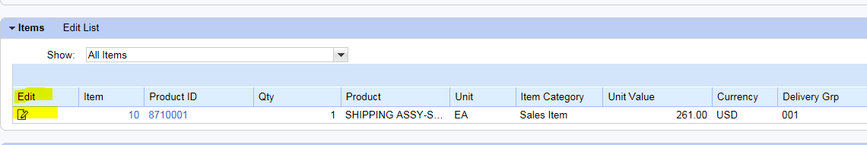

1. In the Rejection Reason field, click the drop down arrow to view the selections.

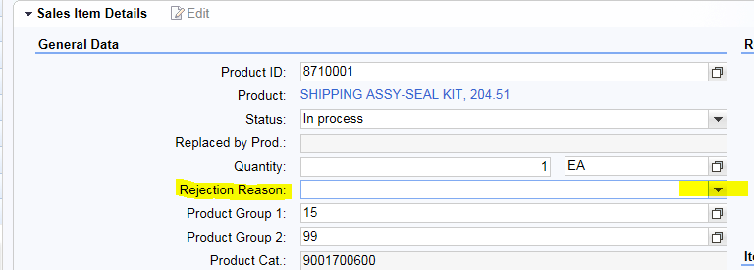

1. From here it is possible to back out of the Item Detail and save any changes.