How to Create and Submit a Warranty for Approval as a Requestor

02/13/2019

**Table of Contents:**Instructions for creating and submitting a Warranty for approval.

Before a Warranty Request can be submitted for Approval, the Site Number or Project Number must be obtained.  When possible, the Warranty should be related to the Opportunity the equipment record/project number is recorded on.  If no Project Number exists for the Warranty Request, the Warranty Request will be created from the Account Site.  
  
To start a Warranty Request, follow the steps outlined below:

Using Global Search, type in the Project Number or Site Number and click Search.  
  
  
Select the correct Opportunity or Account from the search results.  
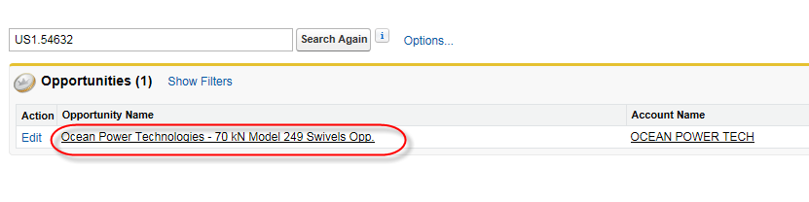  
  
Scroll to the bottom of the Account or Opportunity record page and click New Warranty from the Warranties related list.  
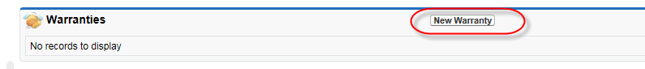  
  
On the New Warranty page in the Information Section, validate that the Account Name field is populated.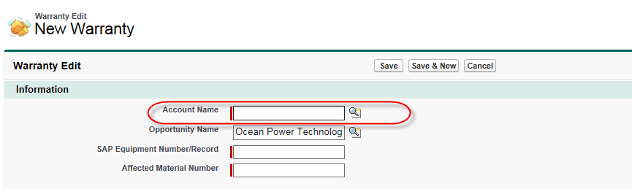

If the Account Name does not appear (likely if the Warranty is created from the Opportunity), click the looking glass next to the Account Name field.  
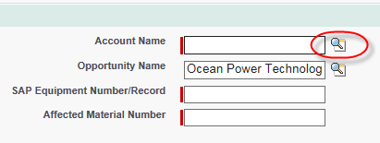

Click the radio button “All Fields” and enter the account number in the Search box. Click “Go”. Click on the Account Name in the search results area  
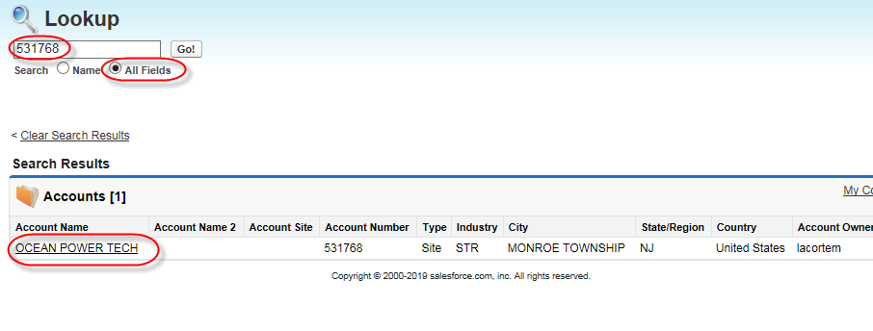  
Enter the following to complete the “information” section

* SAP Equipment Number/Record
* Affected Material Number
* Currency
* Warranty Categories drop down box

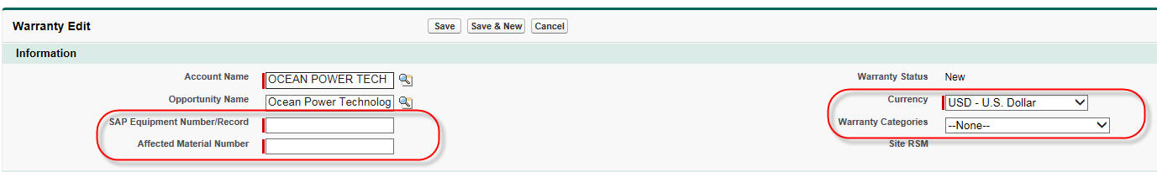

(Completed Information Section)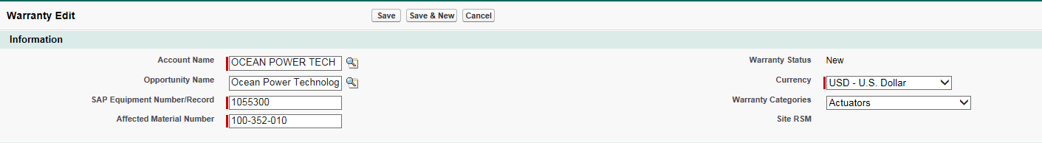

In the Warranty information section, complete all required fields. Fields that are required are indicated by a red bar to the left of the text box.  
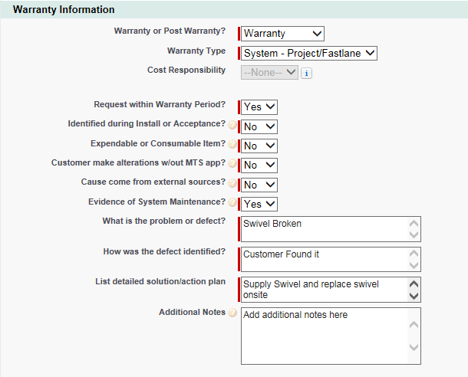

At the bottom of the warranty information section, you will find three boxes to enter the cost associated with this warranty request. Enter the cost for Engineering, FSE and Materials separately.

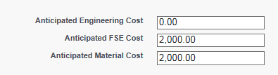

When all information above has been completed, click “Save” at the top of the Warranty screen

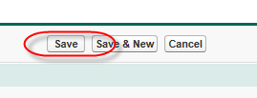

Once saved, you will notice a warranty number has been assigned. This does NOT mean you have submitted for approval.

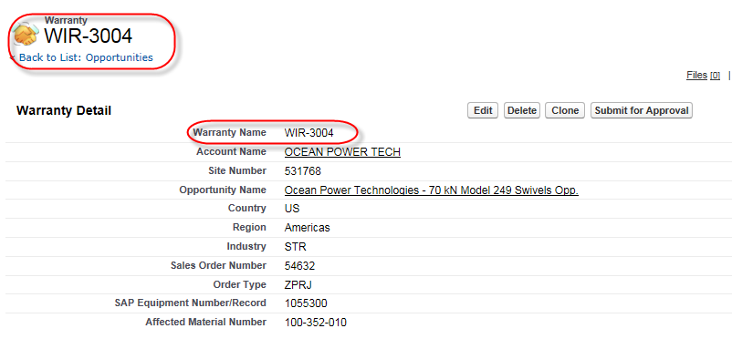

If you have an supporting documentation you would like attached to the warranty, scroll down on the Warranty page to find the “Files” section and click “Upload Files”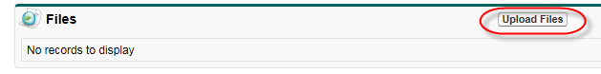  
In the pop up box, select your file(s) and click “Open”. When files finish uploading, click “close” on the below box.

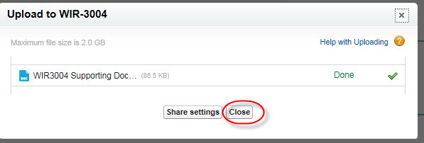

When all fields are complete, the Warranty is ready to be submitted for approval.  The Warranty Status will remain “New” until it is submitted. To submit for approval, click the “Submit for Approval” button.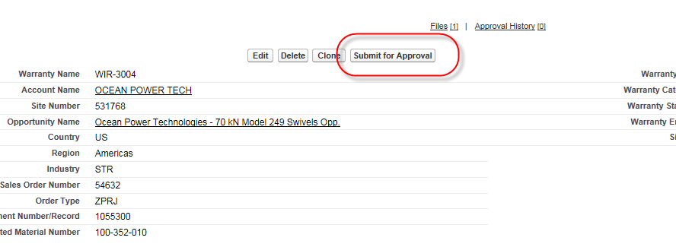

After submitting, I dialog box will inform you that after submitting, you may not be able to make changes. Click “OK”.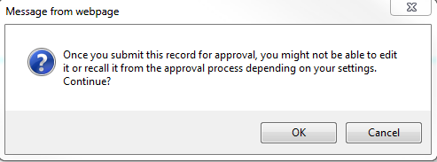

After Submitting for Approval the Warranty Status will update to Pending Review.  
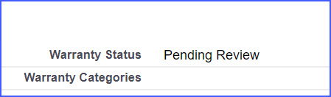

You can track where the approval is in the approval process under Approval History at the bottom of the page.  
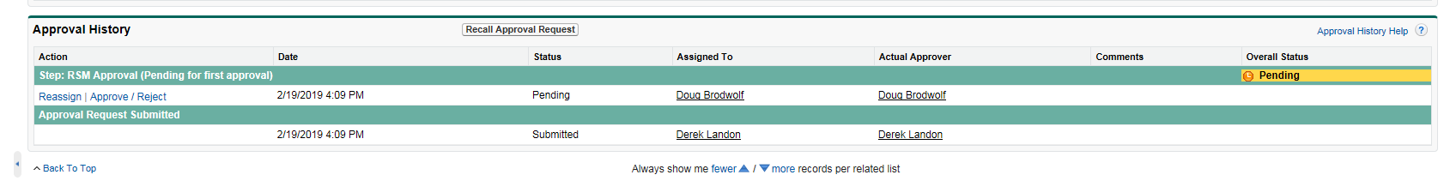

An email will notify the Warranty Requestor when the Warranty Request has been approved or denied.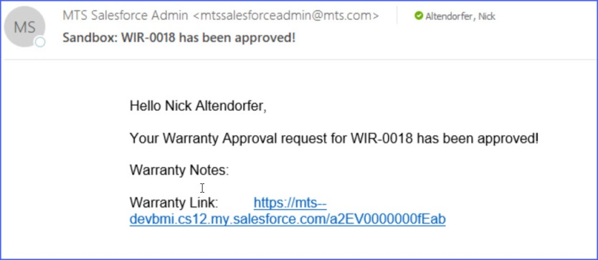  
After your warranty is approved and you have Service Order(s) created, go back into the Warranty record to enter the Service Order numbers. To do so, click “Edit” at the top of the Warranty record screen.

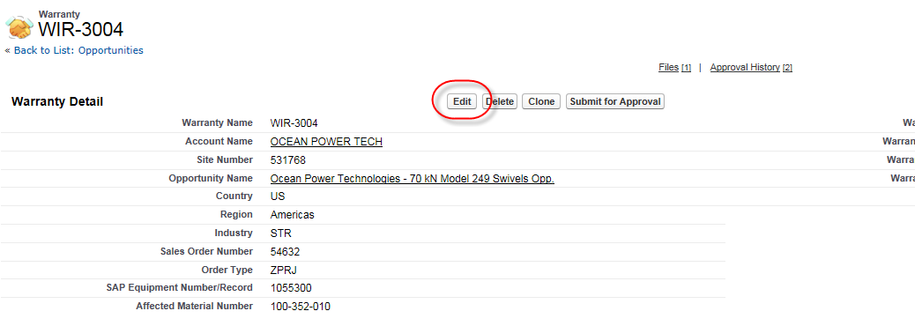

Scroll down to the “Service Information” section and enter your numbers in the Service Order Number(s) field. Click “Save”

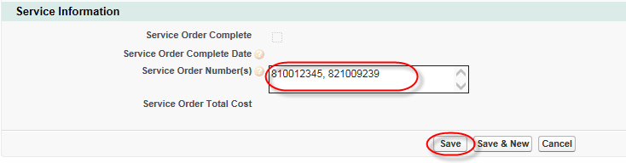

You are now done.