How to Approve or Deny a Warranty Request in Salesforce.com

02/21/2019

**Instructions for Approving or Denying a Warranty Request in Salesforce.**

Warranty approvers will be notified of Warranty Requests via email.  The email contains a summary of information related to the Warranty Request.  A link at the bottom of the email will open to the Warranty Request Page in Salesforce as long as you are logged into Salesforce when clicking the link.    
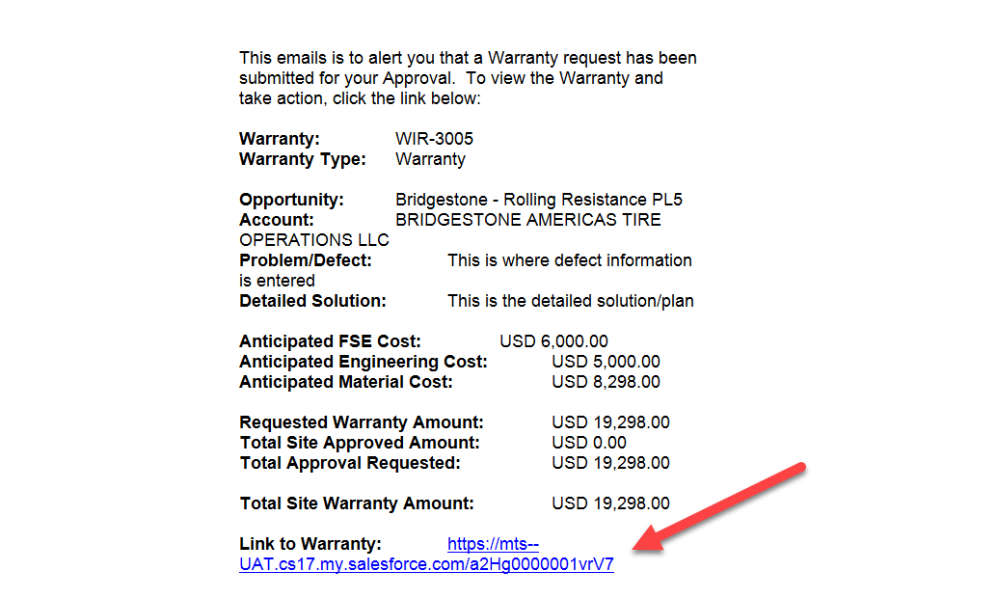  
  
To take action on the Warranty Request, simply click the hyperlink labeled “Link to Warranty” shown in the email above or open your homepage in Salesforce.  You can Approve/Deny or Reassign right from the homepage.  If you would like to view the Warranty Request Record, simply click the Warranty Name.  
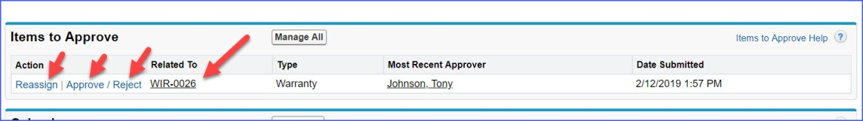

When reviewing the Warranty request, pay special attention to the areas highlighted below. They contain critical warranty information and supporting attached documentation.

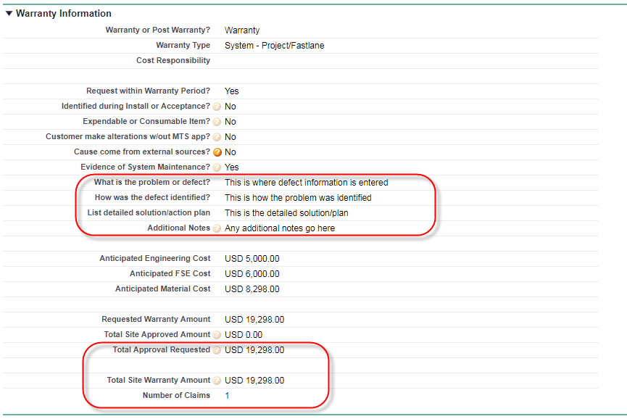

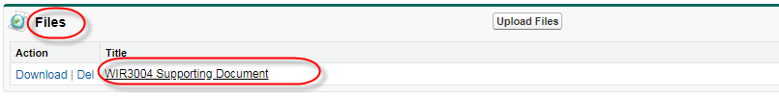

To review the Warranty approval history, scroll to the “Approval History” section at the bottom of the Warranty page.   The Approval History will show who has submitted the Warranty, who has approved the Warranty and who the next approver is.  
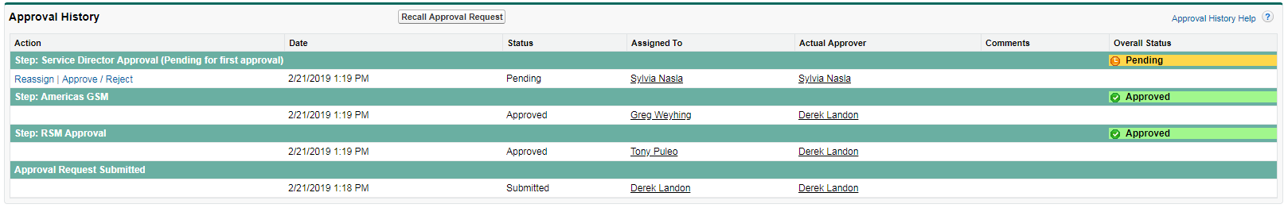  
You can reassign the record if necessary by clicking “Reassign”.  To Approve or Reject, click “Approve/Reject”.  
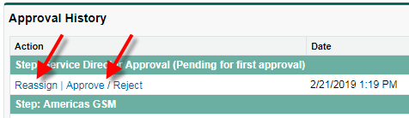  
  
Explain the action you took in the comments section and select “Approve” or “Reject”.  
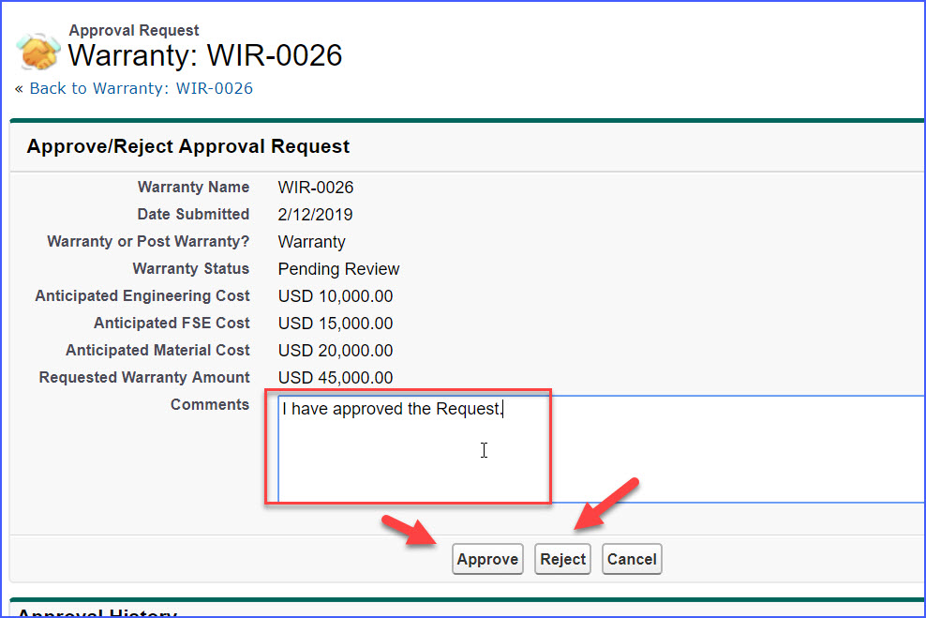  
  
If this is Final Approval/Rejection, an email will be sent to the Requestor notifying them of the result.  If more approvals are required, an email notification will be sent to the next approver.

Done